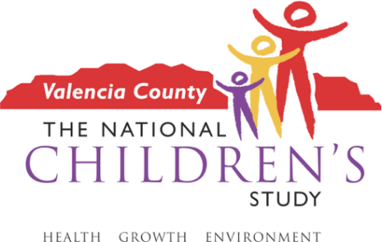
Interested?
Please call Donna Sedillo at 505-842-8932 or e-mail dsedillo@ori.org for more info.
We are recruiting parents/guardians of children ages 7-8 years old to join small group discussions with other parents about how best to teach young children about research participation in the National Children’s Study (NCS) using technology that is appropriate in this age group. This study is being conducted in 2 parts.
Part 1: The discussion groups will be 8-10 parents and take about 1-2 hours, daytime or evening.

Part 2: You and your child would be invited to come back for a family interview where we will get your child’s opinions about how to best inform children about the NCS. This will take about 1-2 hours, daytime or evening.
Refreshments and child care will be provided. If you participate in parts 1 and 2, you will receive $50 in gift cards and a small gift for your child, to thank you for your time.

Who can be a part of the discussion?
- Parents/guardians of a child ages 7-8 years old.
- Are willing to talk with others about their opinions on the best ways to talk to children about research participation and the types of technology appropriate for children in this age group.
- Are willing to have their child talk about their opinions on research participation.

We are not asking you to join an actual study where samples would be collected.
Would you like to participate in a group discussion with other parents of children ages 7-8 about how to talk to young children about a research study?

