OMB Control No. 0648-0213
Expiration Date: 01/31/2012

Catcher Processor Trawl Electronic Logbook (ELB)

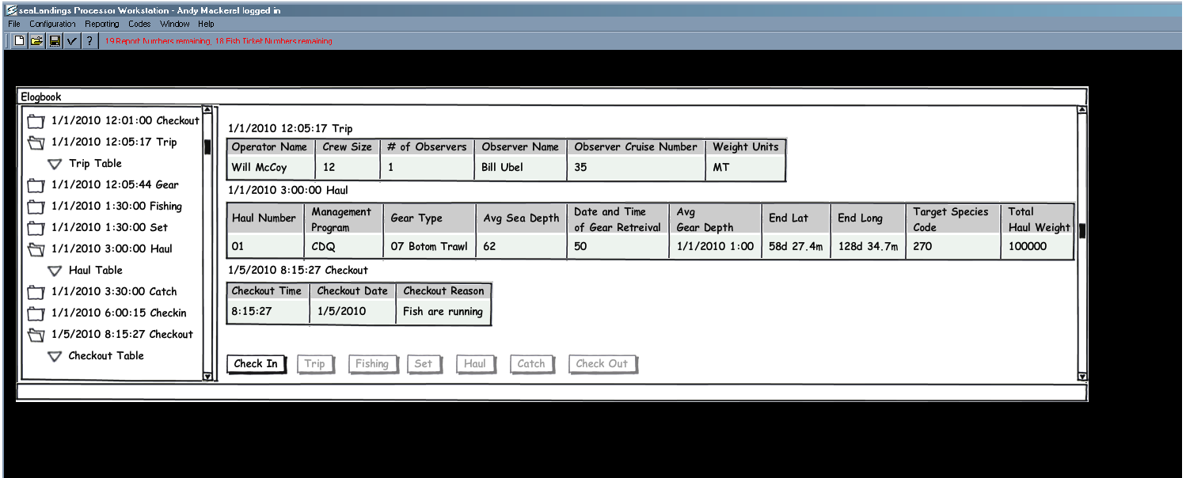
PUBLIC REPORTING BURDEN STATEMENT
Public reporting burden for this logsheet is estimated to average 30 minutes per response, including the time for reviewing the instructions, searching existing data sources, gathering and
maintaining the data needed, and completing and reviewing the collection of information . Send comments regarding this burden estimate or any other aspect of this collection of information,
including suggestions for reducing the burden, to Assistant Regional Administrator, Sustainable Fisheries Division, Alaska Region, NMFS, P.O. Box 21668, Juneau, AK 99802-1668.

ADDITIONAL INFORMATION
Before completing this logsheet please note the following: 1) Notwithstanding any other provision of the law, no person is required to respond to, nor shall any person be subject to a penalty for
failure to comply with, a collection of information subject to the requirements of the Paperwork Reduction Act, unless that collection of information displays a currently valid OMB Control Number.
2) This information is mandatory and is required to manage commercial fishing effort in the GOA and BSAI under 50 CFR 679 and under 402(a) of the Magnuson-Stevens Act
(16 U.S.C. 1801, et seq.); 3) Responses to this information request are confidential under section 402(b) of the Magnuson-Stevens Act as amended in 2006. It is also confidential under
NOAA Administrative Order 216-100, which sets forth procedures to protect confidentiality of fishery statistics.

