Building the Capacity of Charter Schools:
Effectively Serving Students with Disabilities

Tuesday, June 19, 2012

Evaluation Form

Public Burden Statement:
According to the Paperwork Reduction Act of 1995, no persons are required to respond to a collection of information unless such collection displays a valid OMB control number. Public reporting burden for this collection of information is estimated to average 10 minutes per response, including time for reviewing instructions, searching existing data sources, gathering and maintaining the data needed, and completing and reviewing the collection of information. The obligation to respond to this collection is voluntary. Send comments regarding the burden estimate or any other aspect of this collection of information, including suggestions for reducing this burden, to the U.S. Department of Education, 400 Maryland Ave., SW, Washington, DC 20210-4537 or email ICDocketMgr@ed.gov and reference the OMB Control Number 1800-0011. Note: Please do not return the evaluation form to this address.

Please take a few minutes to complete this survey. The purpose of the survey is to obtain information about how well the event met its objectives and your needs. Your feedback will assist us in planning high-quality events in the future.

Please indicate your level of agreement with the following statements: | Strongly Agree | Agree | Disagree | Strongly Disagree | Not Sure/ Does Not Apply
- The event was well organized.
- The information was presented in a clear and comprehensible manner.
- The event increased my knowledge about special education in charter schools.
- The speakers were knowledgeable about the topics discussed.
- The information, resources, and materials that were shared will be of value to my organization.
- There were opportunities for meaningful discussion.
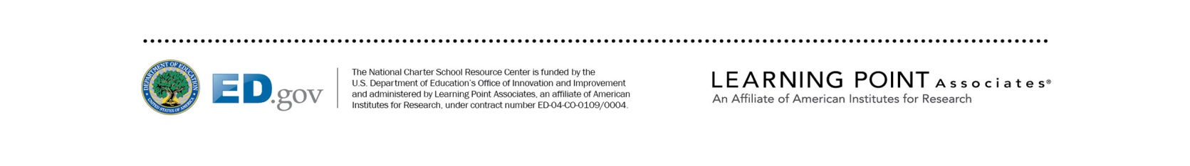

Please indicate how helpful the following sessions were to you: | Very Helpful | Helpful | Somewhat Helpful | Not Helpful | Not Sure/  Does Not Apply
- Opening keynote address
- Panel focused on reinventing the delivery of special education
- First breakout session that you attended.

Title:_______________
- Second breakout session that you attended.

Title:_______________
- Afternoon keynote address

Please indicate how you would rate the event overall: | Excellent | Good |  | Fair |  | Poor
- Quality
- Relevance
- Usefulness
- To what extent were your expectations met? | Expectations  Exceeded |  | Expectations  Met |  | Expectations  Not Met
- If your expectations were not met, please explain.

- What was most valuable about the event?

- How could the event have been improved?

