Post Card Reminder (Mail Version)

Date

Dear Sir/Madam:

Recently, you were sent a link to a questionnaire about your participation in the recent Bioblitz at Saguaro National Park. This is part of the National Park Service’s ongoing effort to engage people with their parks and with scientific activities conducted in the parks. Findings from the questionnaire will help the National Park Service enhance Bioblitz participant experiences and develop new ways of connecting citizens with their parks. If you have already completed the questionnaire, we express our sincere appreciation.

If you haven’t already completed the questionnaire, please complete it and submit within the next week. We understand that you are busy but are looking to forward to receiving your feedback. If you have any questions about the survey, please call my office at: (979) 862-3794.

Thank You!
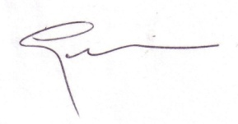
Gerard Kyle, Ph.D
Texas A&M University

OMB Control Number: 1024-0224
Expiration Date:

Postcard Reminder (e-mail version)

Date

Dear Sir/Madam:

Recently, you were sent a link to a questionnaire about your participation in the recent Bioblitz at Saguaro National Park. This is part of the National Park Service’s ongoing effort to engage people with their parks and with scientific activities conducted in the parks. Findings from the questionnaire will help the National Park Service enhance Bioblitz participant experiences and develop new ways of connecting citizens with their parks. If you have already completed the questionnaire, we express our sincere appreciation.

If you haven’t already completed the questionnaire, please complete it and submit within the next week. We understand that you are busy but are looking to forward to receiving your feedback.

You can access the survey by clicking on the following link: www.survey.com

If you have any questions about the survey, please call my office at: (979) 862-3794.

Thank You!

Gerard Kyle, Ph.D
Texas A&M University

OMB Control Number: 1024-0224
Expiration Date:

Follow Up Letter – (e-mail version)

Texas A&M Banner

Date

Dear John/Jane Doe:

Last week you participated in a short interview about your involvement in the Saguaro National Park Bioblitz. At the end of the interview, you indicated that you would be willing to participate in a more extensive survey about your experience. The National Park Service (NPS) has partnered with researchers at Texas A&M University to study Bioblitz participation. This investigation is part of the NPS’s ongoing effort to engage people with their parks and with scientific activities conducted in the parks. Findings from this questionnaire will help the NPS enhance Bioblitz participant experiences and develop new ways of connecting citizens with their parks.

Provided below is web link to our online survey. Your participation in this study is voluntary, but very important. Your answers will remain anonymous. Once the study is complete, all names and addresses will be destroyed and only aggregated results will be reported to the NPS. We WILL NOT sell or distribute your name and address to any other party. The questionnaire should take approximately 30 minutes to complete.

If you have any questions or concerns about completing the questionnaire or about being in this study, please contact me at 979-862-3794.

To access the questionnaire online, please click on the following web address:
WWW.SURVEY.COM
You will be directed to the survey. The survey will close in approximately three weeks.

We appreciate and value your time and opinion.

Sincerely,
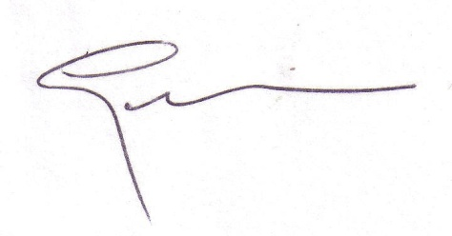
Gerard Kyle
Associate Professor
Texas A&M University

OMB Control Number: 1024-0224
Expiration Date:

Follow-up reminder (mail version)

Texas A&M Letterhead

Date

Name/Address

Dear John/Jane Doe:

Last week you participated in a short interview about your involvement in the Saguaro National Park Bioblitz. At the end of the interview, you indicated that you would be willing to participate in a more extensive survey about your experience. The National Park Service (NPS) has partnered with researchers at Texas A&M University to study Bioblitz participation. This investigation is part of the NPS’s ongoing effort to engage people with their parks and with scientific activities conducted in the parks. Findings from this questionnaire will help the NPS enhance Bioblitz participant experiences and develop new ways of connecting citizens with their parks.

Please find enclosed our survey questionnaire, along with a postage-paid return envelope. Your participation in this study is voluntary, but very important. Rest assured, your answers will remain anonymous. Only aggregated results will be reported to the National Park Service. Once the study is complete, all names and addresses will be destroyed. We WILL NOT sell or distribute your name and address to any other party. The questionnaire should take approximately 30 minutes to complete.

If you have any questions or concerns about completing the questionnaire or about being in this study, please contact me at 979-862-3794.

Sincerely,
Gerard Kyle
Associate Professor
Texas A&M University

OMB Control Number: 1024-0224
Expiration Date:

