Voice-of-Customer Surveys

for StopBullying.gov

Site-Level Survey for Visitor Feedback

Introductory Text
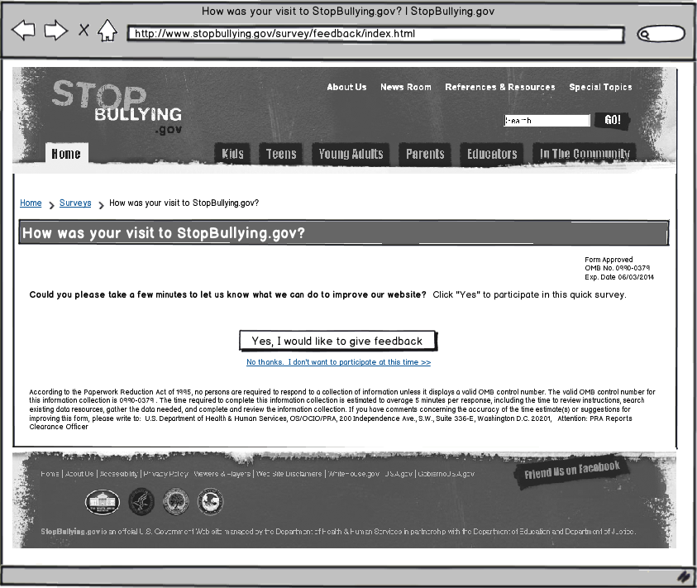

Questions
- What were you looking for on StopBullying.gov today?
  - Learn basic information about bullying (what it is, what the warning signs are)
  - Find out how I can prevent bullying
  - Learn how I can take action in my school/community
  - Find information on how to get help
  - Find research on bullying
  - Get news and updates about StopBullying.gov
  - I had nothing specific in mind when I came to the website today.
  - Other: ______________________
- Were you able to find what you were looking for?
  - Yes
  - Partially
  - No
[If Q2 response is YES]
- How long did it take to find the information?
  - Immediately
  - Few minutes
  - A long time
- Did you find the information helpful?
  - Yes
  - Partially
  - No
[If Q4 response is YES]
- What did you like best about the content?
- Based on today’s visit, how would you rate the following?
  - Your experience during your visit
  - How the website looks
  - How you can get around the website
- How can we improve StopBullying.gov?
[If Q4 response is PARTIALLY or NO]
- What can we do to make the information more helpful?
- Based on today’s visit, how would you rate the following:
  - Your experience during your visit
  - How the website looks
  - How you can get around the website
- What can we do to make StopBullying.gov better?
[If Q2 response is PARTIALLY or NO]
- What information were you looking for and did not find on StopBullying.gov?
- Based on today’s visit, how would you rate the following:
  - Your experience during your visit
  - How the website looks
  - How you can get around the website
- What can we do to make StopBullying.gov better?

Thank You Text
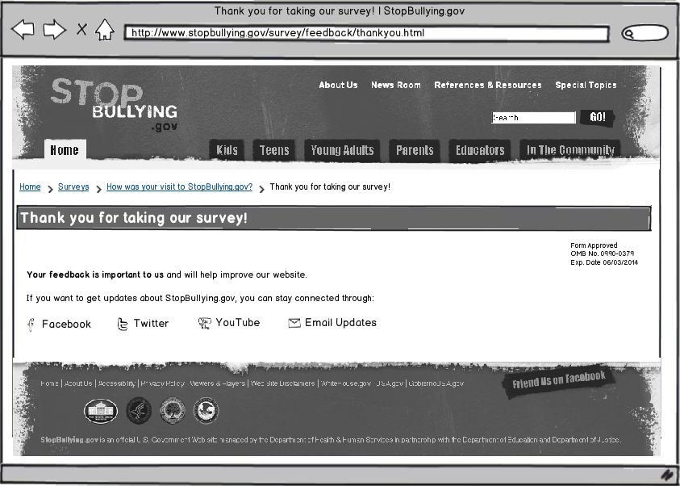

Page-Level Survey

Layout
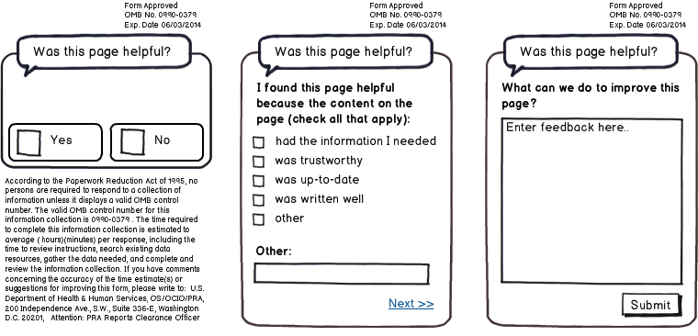

Questions
- Was this page helpful?
  - Yes
  - No
[IF Q1 RESPONSE is YES]
- I found this page helpful because the content on the page: (check all that apply)
  - Had the information I needed
  - Was trustworthy
  - Was up-to-date
  - Was written well
  - Other: ____________________________
- What can we do to improve this page?
[IF Q1 RESPONSE is NO]
- I did not find this page helpful because the content on the page: (check all that apply)
  - Had too little information
  - Had too much information
  - Was confusing
  - Was out-of-date
  - Was poorly written
  - Other: ____________________________
- What can we do to improve this page?

