English iClaim AllElse
Screen Package
Version 1.6

Social Security Administration

May 20, 2011

Table of Contents
[To update the table of contents, select the message below and press F9]

1. Pages 4
1.1. Changes to Document 4
1.2. ent002_Welcome 5
1.3. ini001-r3_Preparers Contact Info 6
1.4. ini001-r3_Preparers Contact Info Foreign 7
1.5. ini001-d3_Preparers Contact Info 8
1.6. ini001-d3_Preparers Contact Info Foreign 9
1.7. ini002-d1_Applicant Identification 10
1.8. ini002-d1_01_Applicant Identification 11
1.9. apn001-d1_Application Number 12
1.10. apn001-m1_Application Number 13
1.11. adi003-1_Disability 14
1.12. fam003-d1_Children 15
1.13. ear005-1-b_Other_Pensions_Annuities 16
1.14. ear005-1-e_Other_Pensions_Annuities 17
1.15. ear005-r1-c_Other_Pensions_Annuities 18
1.16. wst001-1-a_When to Start Retirement Benefits 19
1.17. wst001-1-a_01_When to Start Retirement Benefits 20
1.18. bni002-r1_b_Benefit Information 21
1.19. bni003-1_Benefit Information 22
1.20. bni004-1_Benefit Information 23
1.21. bni005-1_Benefit Information 24
1.22. dsq001-1_Ability To Work 25
1.23. dsq002-1_Disability Payments 26
1.24. dsq003-1_Dependents 27
1.25. dsq004-1_Authorization 29
1.26. rem001-m_Remarks 30
1.27. rem002-r1-cancellation 31
1.28. ovs001-d1-b_Overall Summary 32
1.29. ovs001-r1-e_Overall Summary 36
1.30. ovs001-m1-g_Overall Summary 42
1.31. ovs001-d3-d_Overall Summary 45
1.32. ovs001-r3-c_Overall Summary 50
1.33. ovs001-m3-f_Overall Summary 56
1.34. snd001-d1_Send This Application 58
1.35. snd001-m1_Send This Application 59
1.36. snd001-d3_Send This Application 60
1.37. snd001-m3_Send This Application 61
1.38. snd001-r3_Send This Application 62
1.39. rec001-d1-b_Evidence and Receipt 63
1.40. rec001-r1-e_Evidence and Receipt 68
1.41. rec001-m1-g_Evidence and Receipt 73
1.42. rec001-r3-c_Evidence and Receipt 77
1.43. rec001-d3-d_Evidence and Receipt 82
1.44. rec001-m3-f_Evidence and Receipt 87
1.45. wtn001- d1_What's Next 90
1.46. wtn001- d1_What's Next-Expanded 91
1.47. wtn001- m1_What's Next 93
1.48. wtn001- r3_What's Next 95
1.49. wtn001- d3_What's Next 96
1.50. wtn001- m3_What's Next 98
2. Messages 100
2.1. MSG-Confirm Delete of Table Entry 100
2.2. msg006_YouCannotApplyforMedicareOnly 101
2.3. msg017_SignIn Problem 102
2.4. msg025_Your Time Has Expired 103
2.5. msg029_LimitOnNumberOfRestartsOnPartialApplication 104
2.6. msg030_We Are Processing Your Request 105
2.7. msg047-a_Change Your Answer 106
2.8. msg047-b_Change Your Answer 107
2.9. msg113_Limit on Number of Requests 108
2.10. msg151_Cannot Match Your Zip Code 109

- Pages
  - Changes to Document
5/16/2011:
- Based on Based on the PAS Forum information gathering session the following changes have been made to the Welcome and What’s Next pages
  - ENT001 – language and page layout changes
    - Myself link goes to:http://www.socialsecurity.gov/info/isba/disability/firstpartydib.htm
    - Someone else link goes to: http://www.socialsecurity.gov/info/isba/disability/thirdpartytype.htm
    - Changed the button label from “Continue Application” to “Return to a Saved Application”
    - Modified the links in the “You may also want to review” section

    - Page template change
      - Language removed: Form Approved
      - Expiration date removed
      - Footer added with links

  - WTN001 – all pages first and third party – language placement changes. Helpful Information, Medicare Information, and Helpful Health Care Websites will be displayed “collapsed” by default. The Contact Information will be displayed “expanded” by default.
    - Disability version:
      - modified language in the “What’s Next” section
      - Added link for video
      - Link for Adult Disability Checklist goes to: http://www.ssa.gov/hlp/radr/10/ovw001-checklist.htm,
      - Provide language to offer a Spanish-speaking applicant an alternative to exiting the application.

- Correction to REM002-R1, language change from “Sign Now” to “Submit Now”

5/20/11
- Updated the ENT002 screen with the correct Privacy Act Statement

  - ent002_Welcome
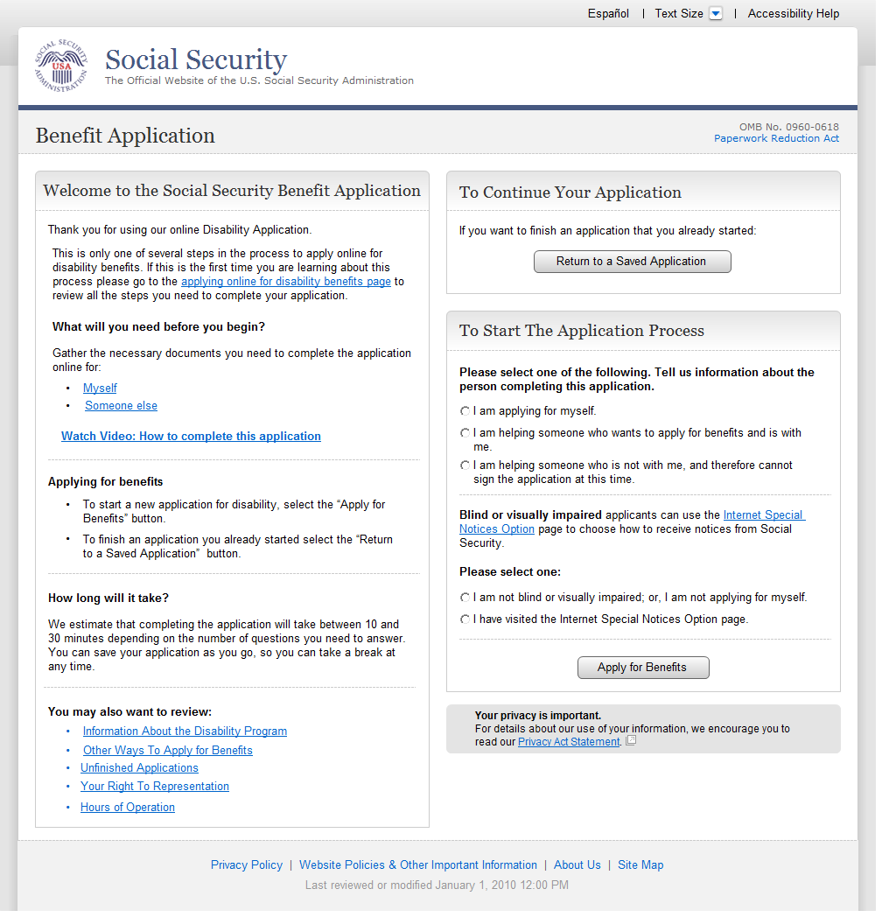
  - ini001-r3_Preparers Contact Info
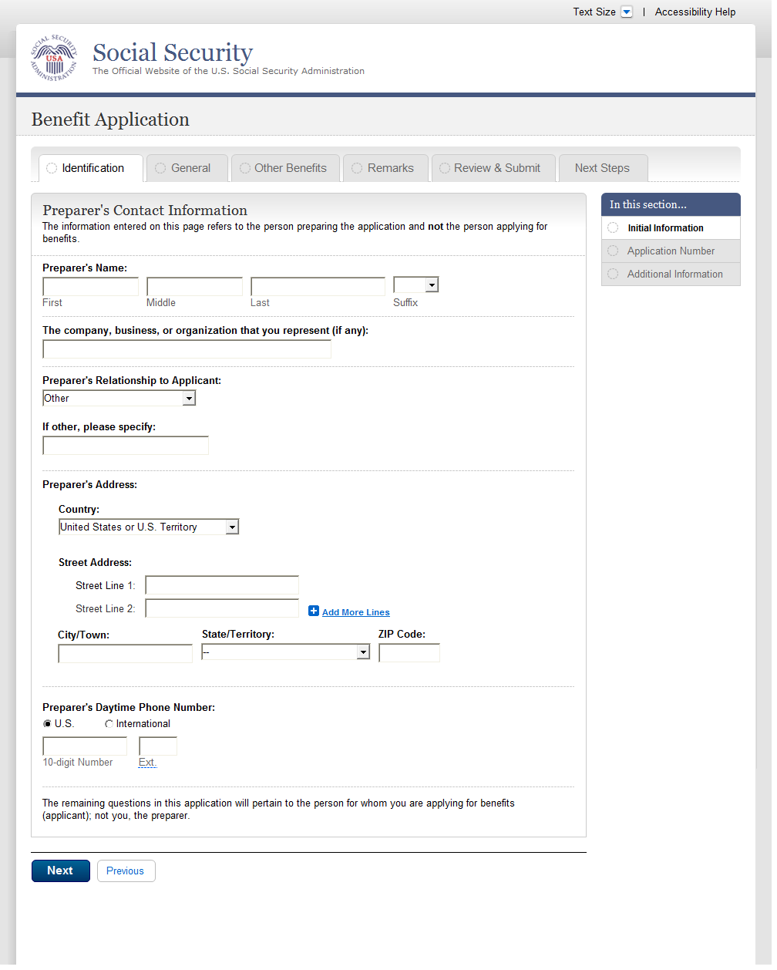
  - ini001-r3_Preparers Contact Info Foreign
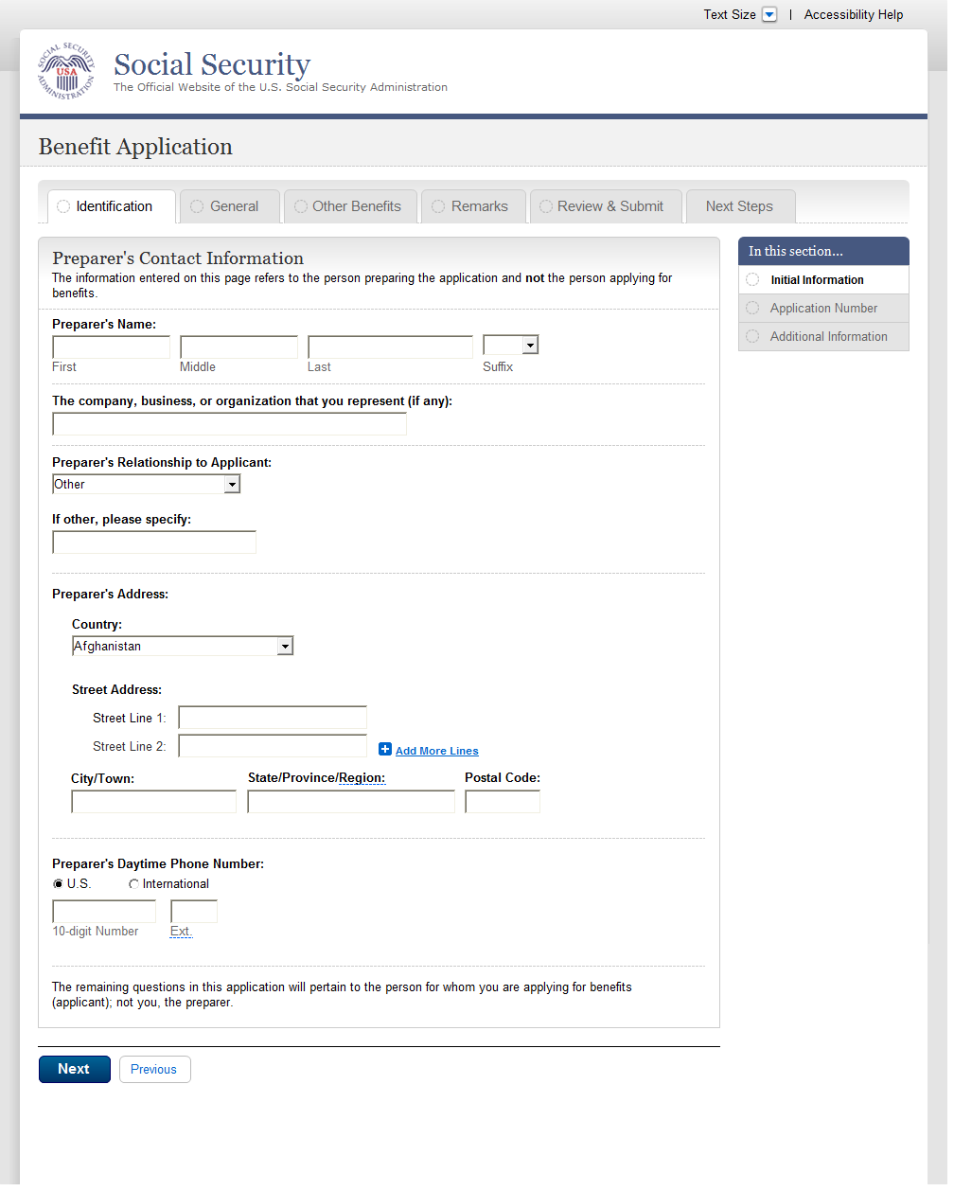
  - ini001-d3_Preparers Contact Info
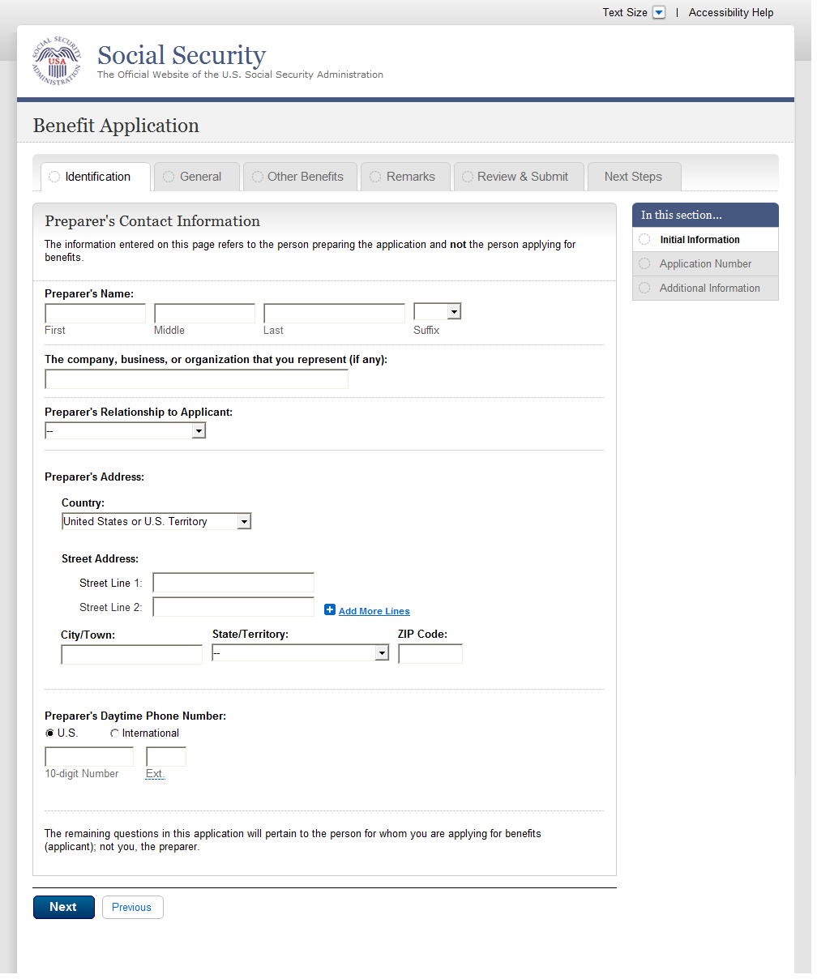
  - ini001-d3_Preparers Contact Info Foreign
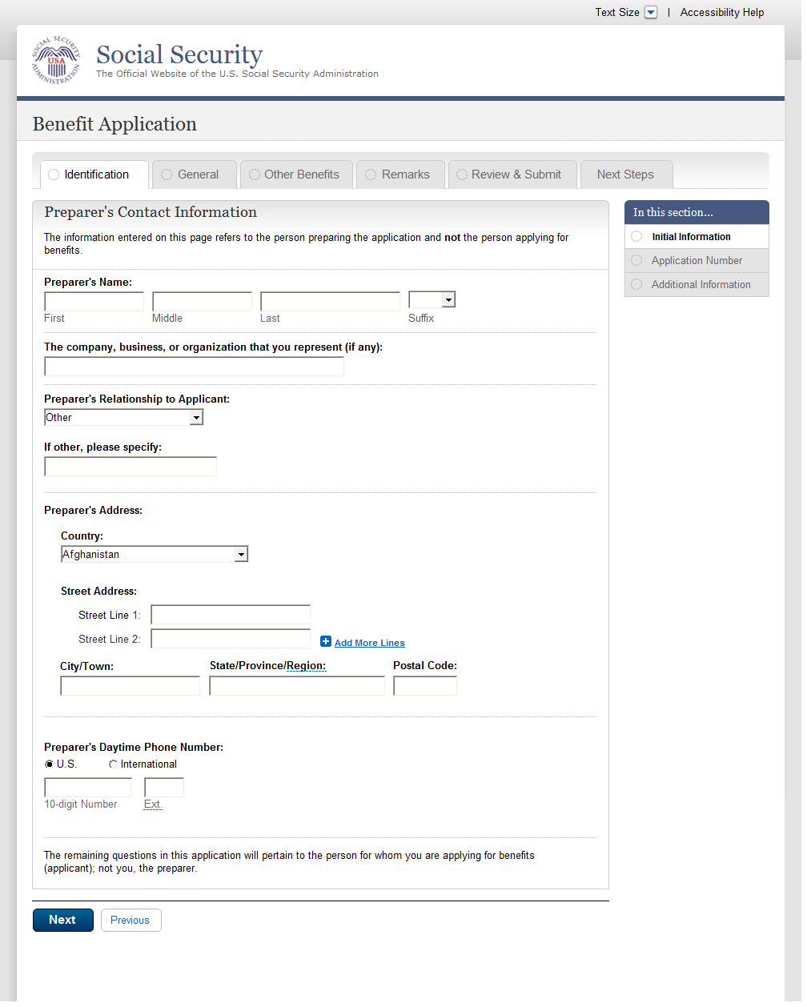
  - ini002-d1_Applicant Identification
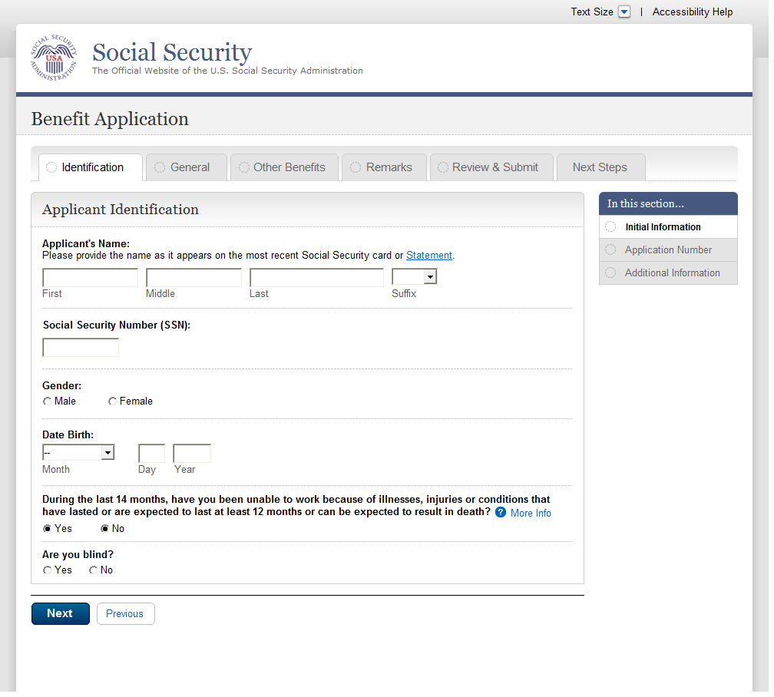
  - ini002-d1_01_Applicant Identification
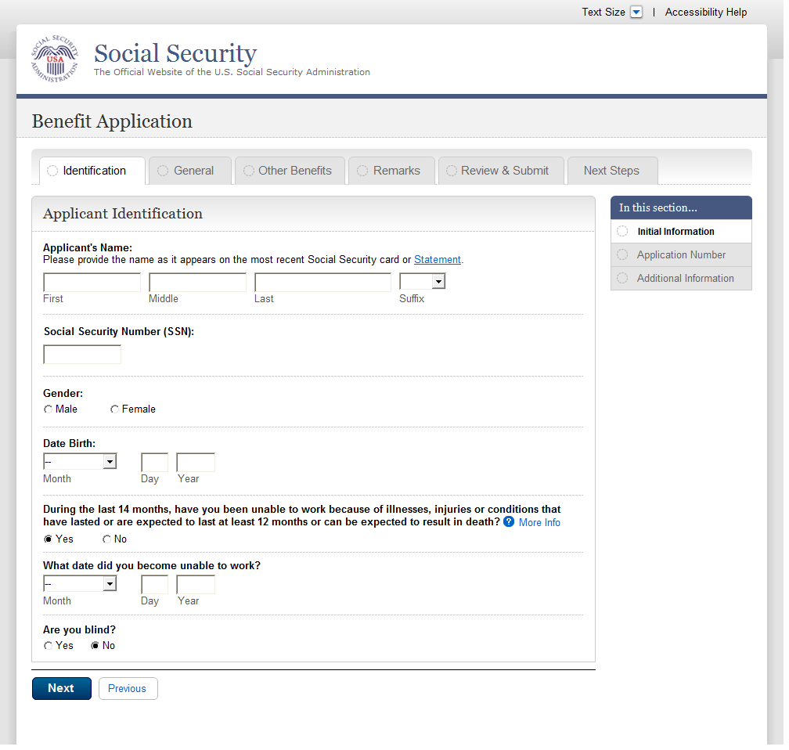
  - apn001-d1_Application Number
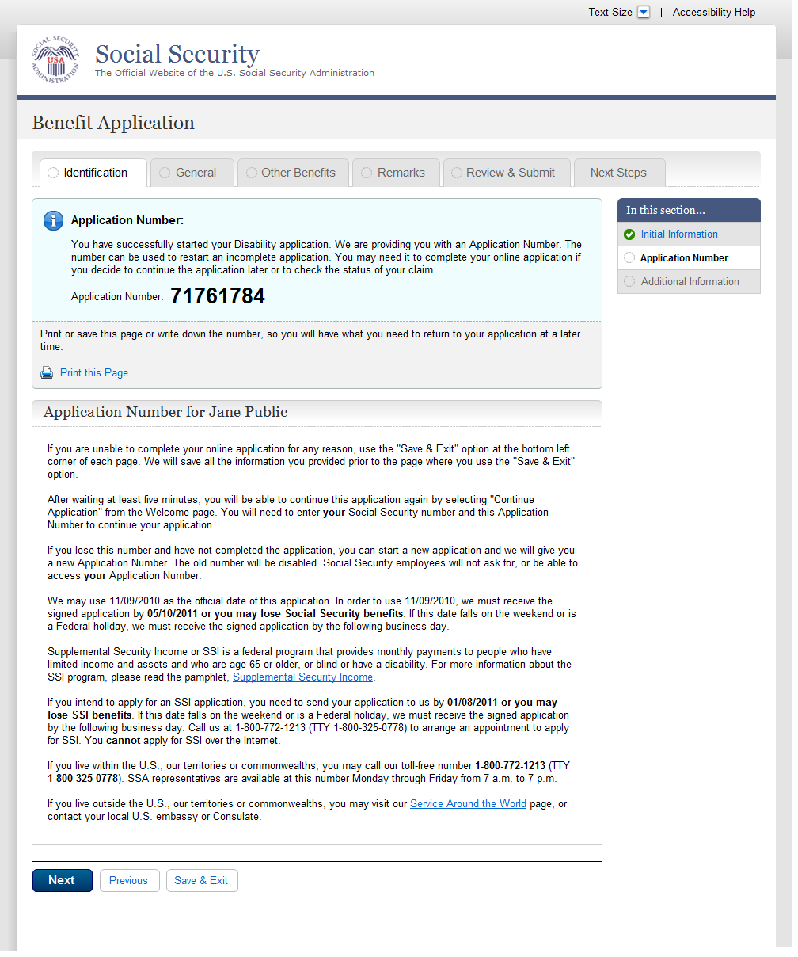
  - apn001-m1_Application Number
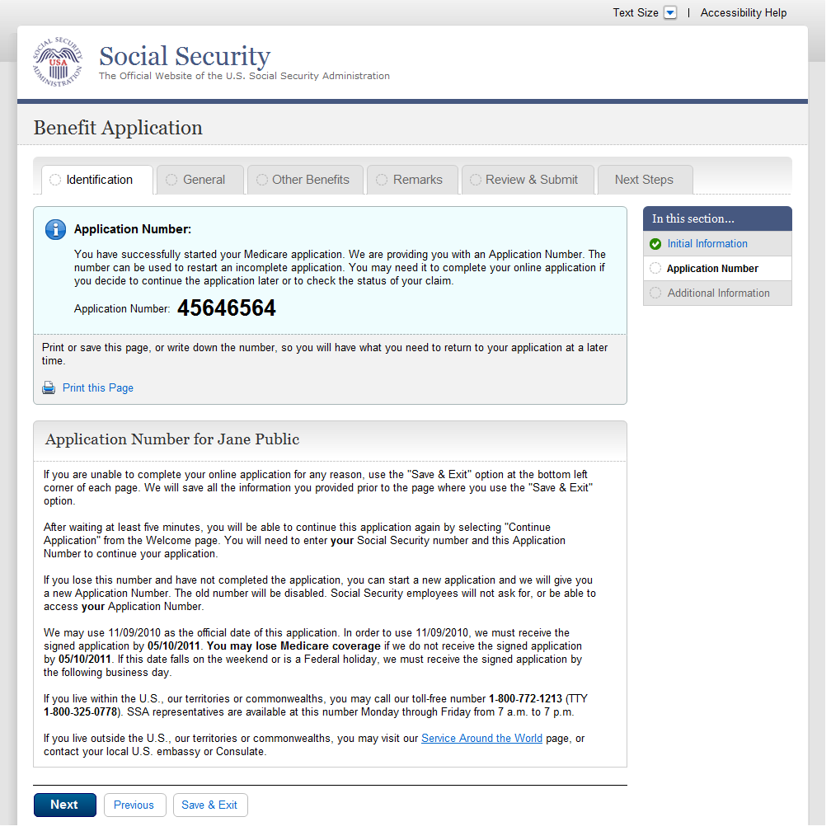
  - adi003-1_Disability
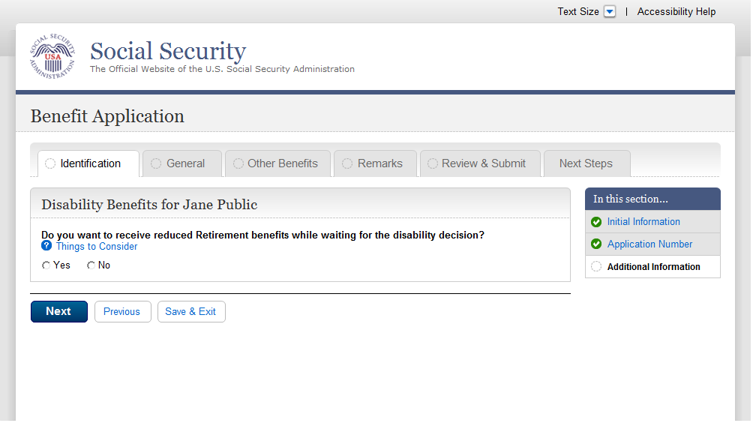
  - fam003-d1_Children
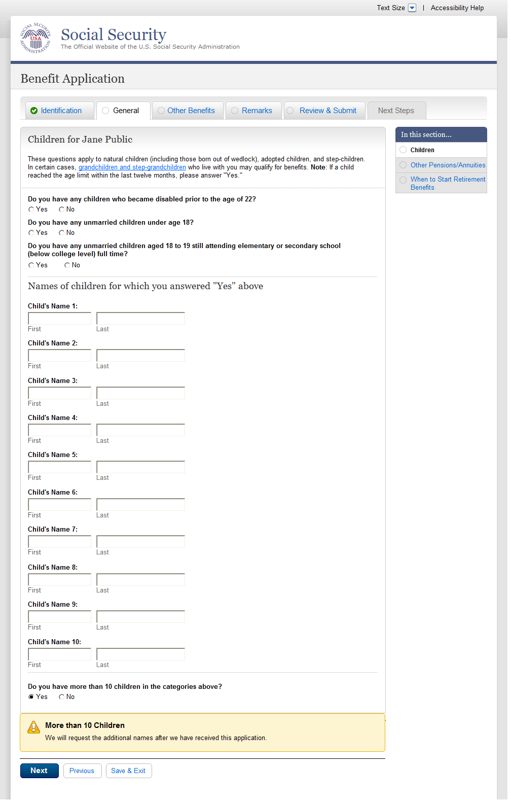
  - ear005-1-b_Other_Pensions_Annuities
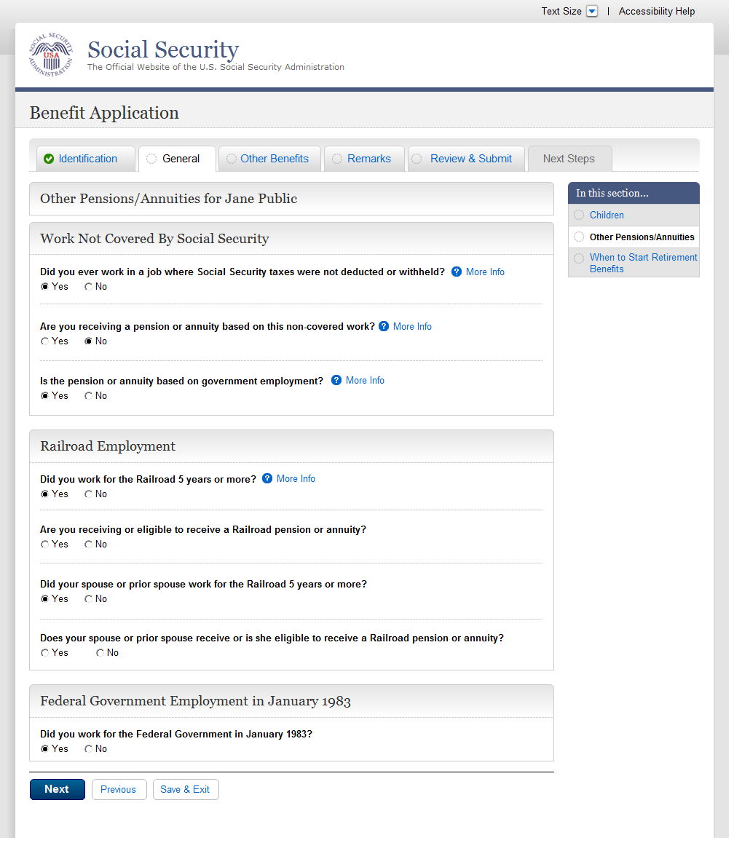
  - ear005-1-e_Other_Pensions_Annuities
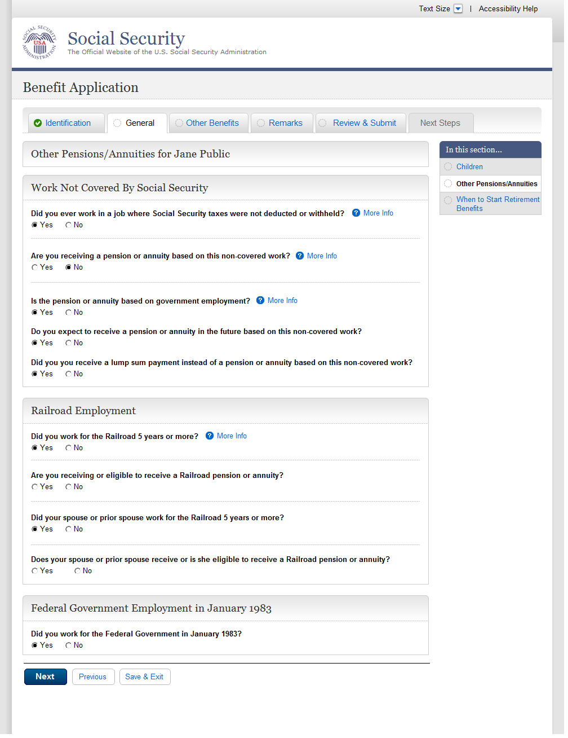
  - ear005-r1-c_Other_Pensions_Annuities
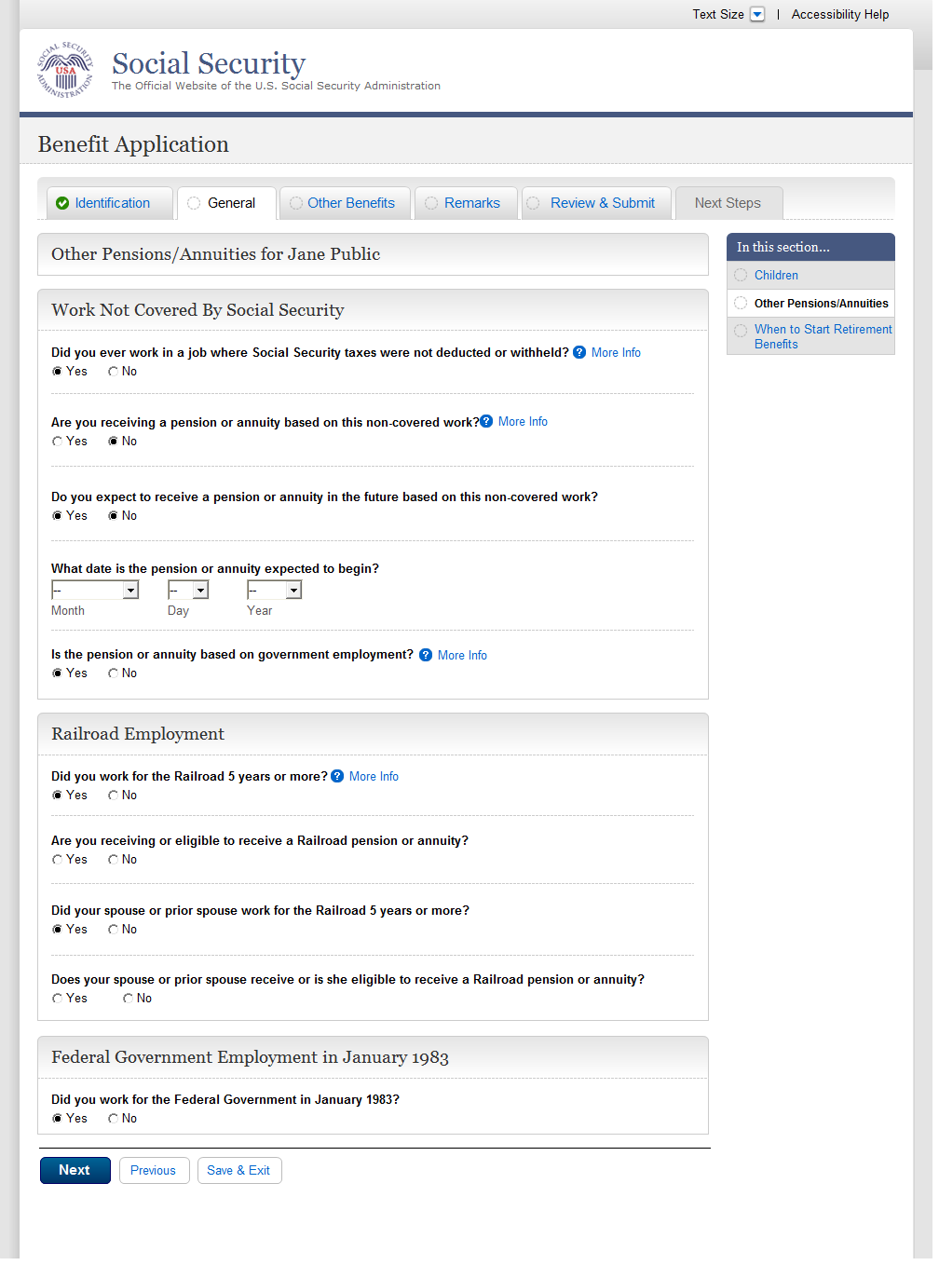
  - wst001-1-a_When to Start Retirement Benefits
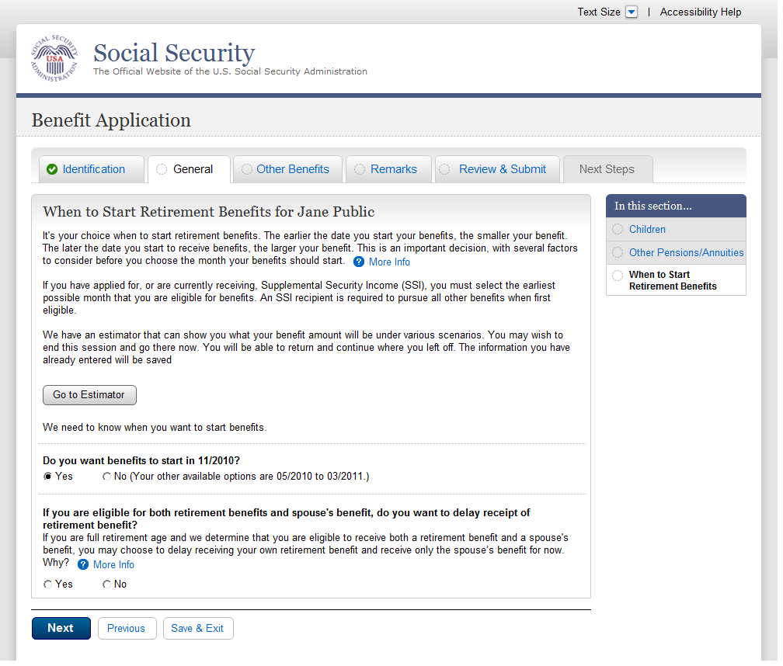
  - wst001-1-a_01_When to Start Retirement Benefits
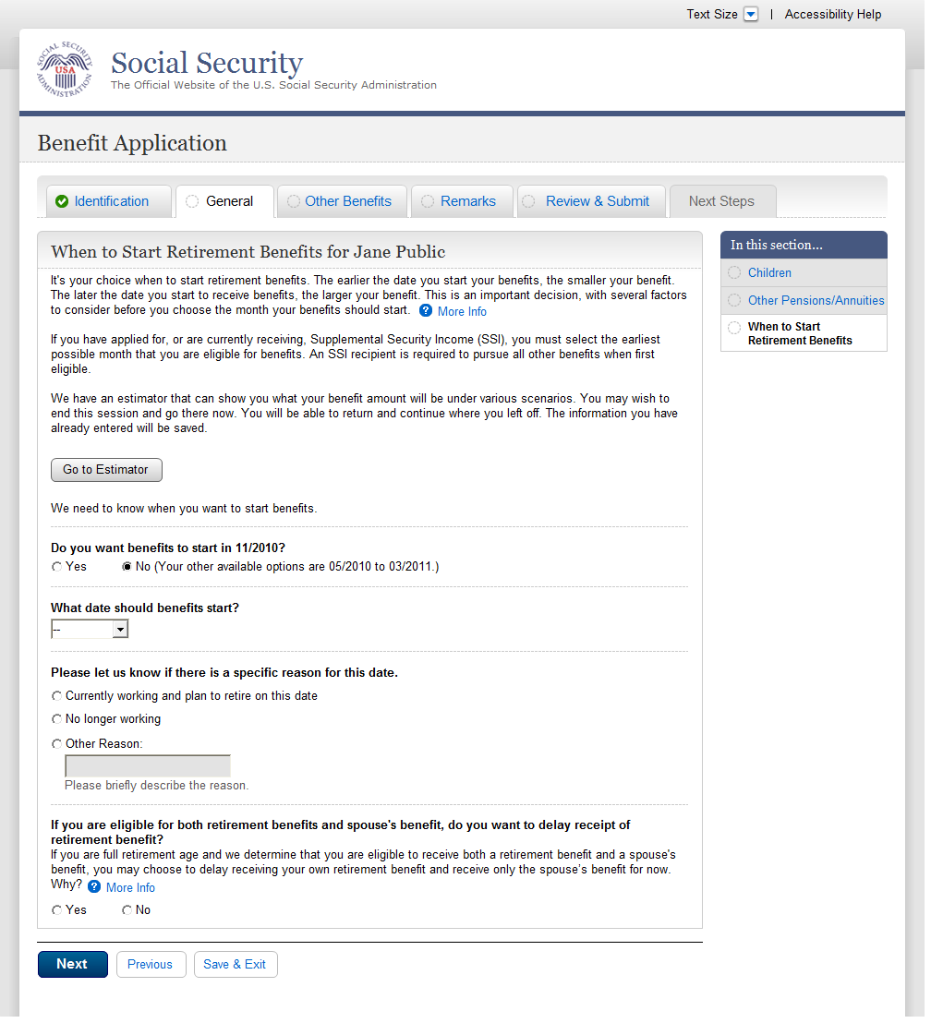
  - bni002-r1_b_Benefit Information
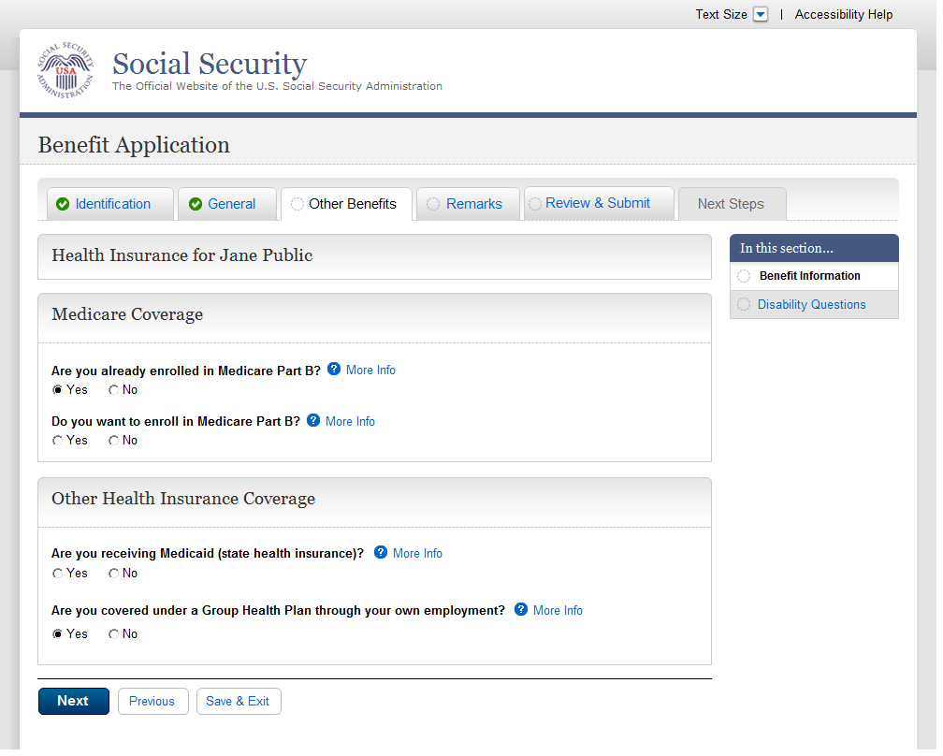
  - bni003-1_Benefit Information
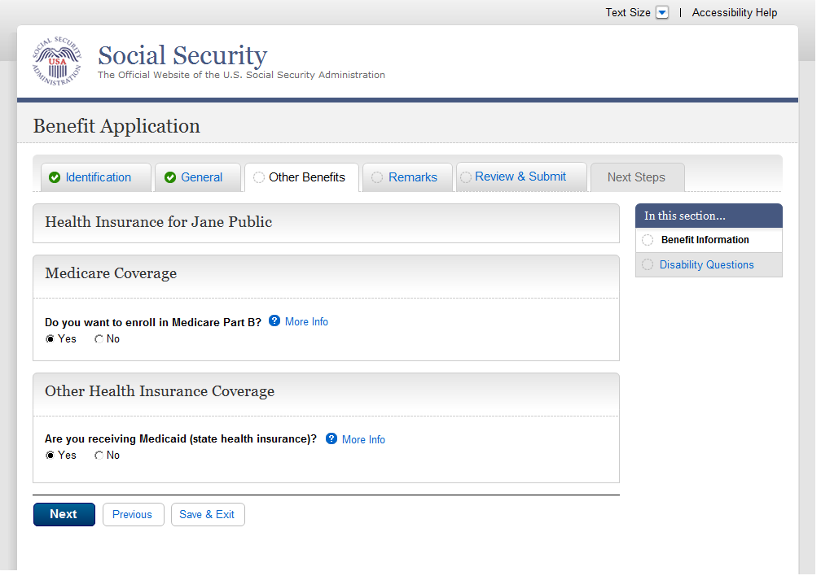
  - bni004-1_Benefit Information
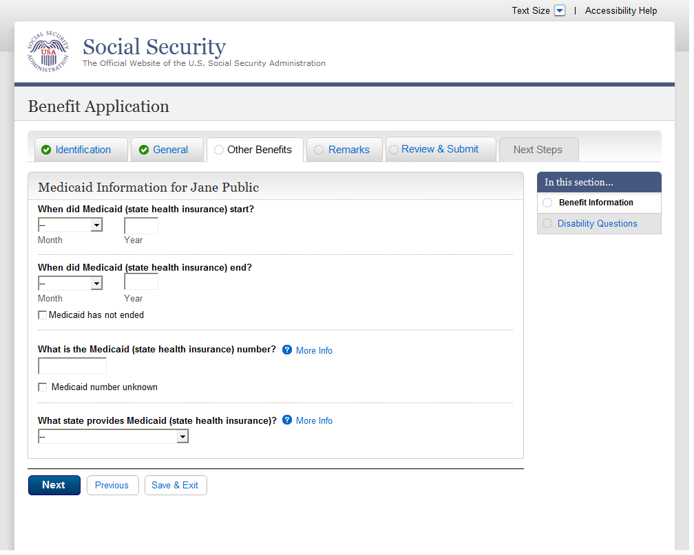
  - bni005-1_Benefit Information
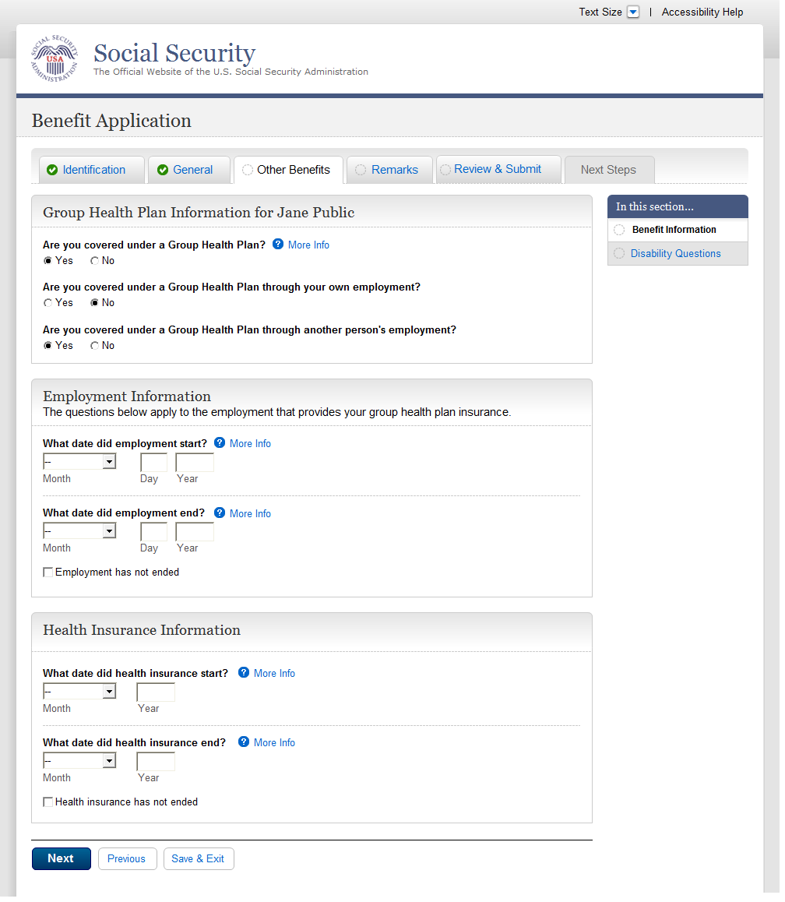
  - dsq001-1_Ability To Work
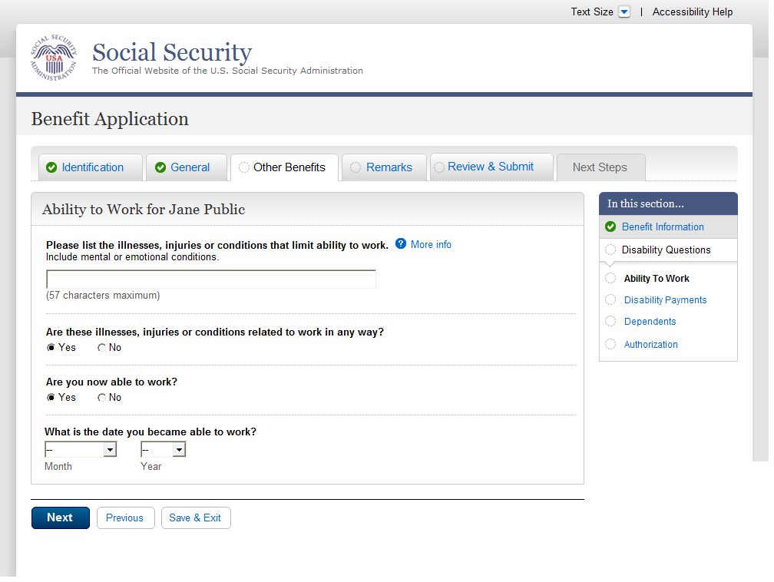
  - dsq002-1_Disability Payments
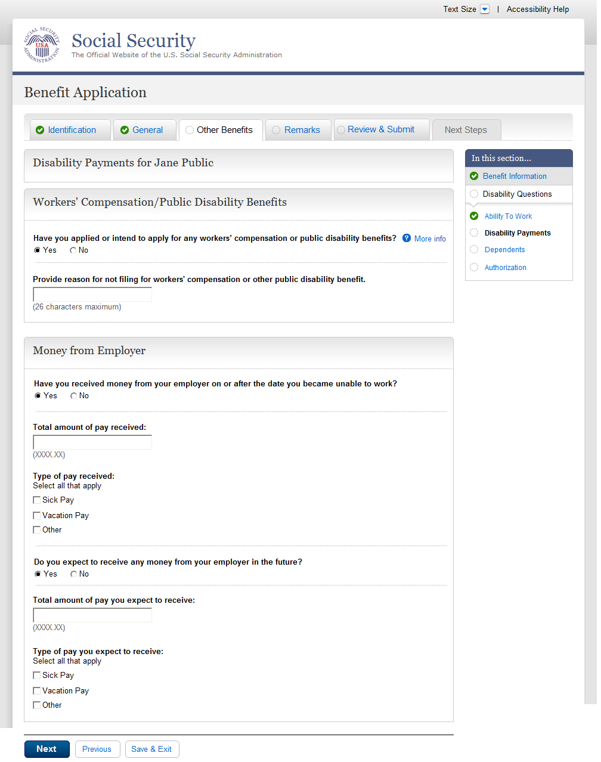
  - dsq003-1_Dependents
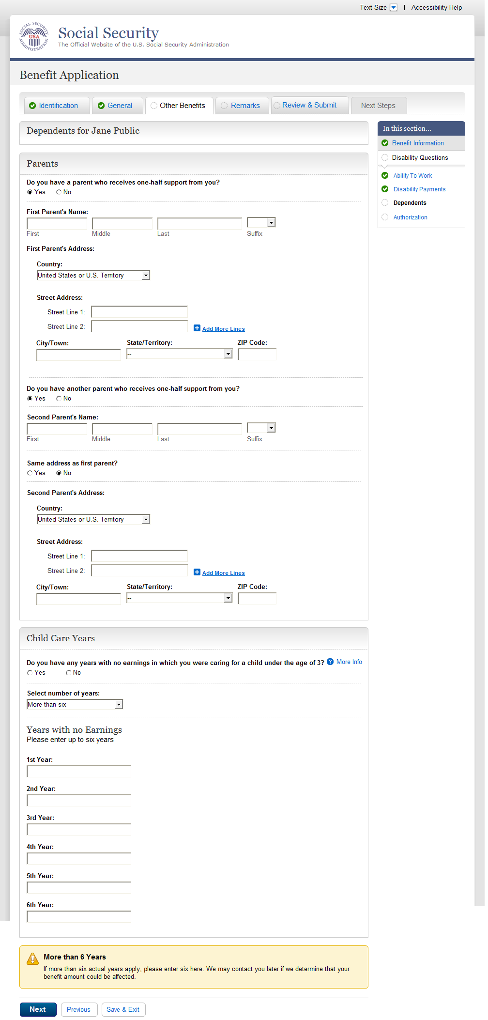
  - dsq004-1_Authorization
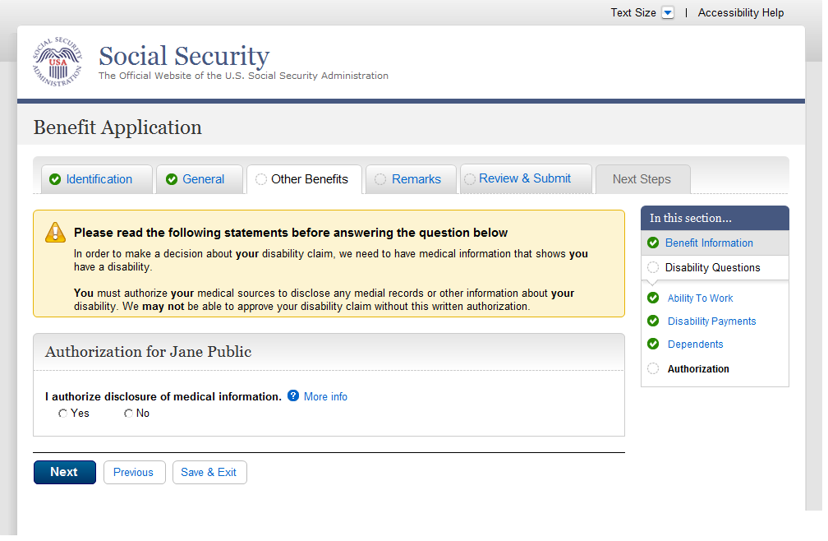
  - rem001-m_Remarks
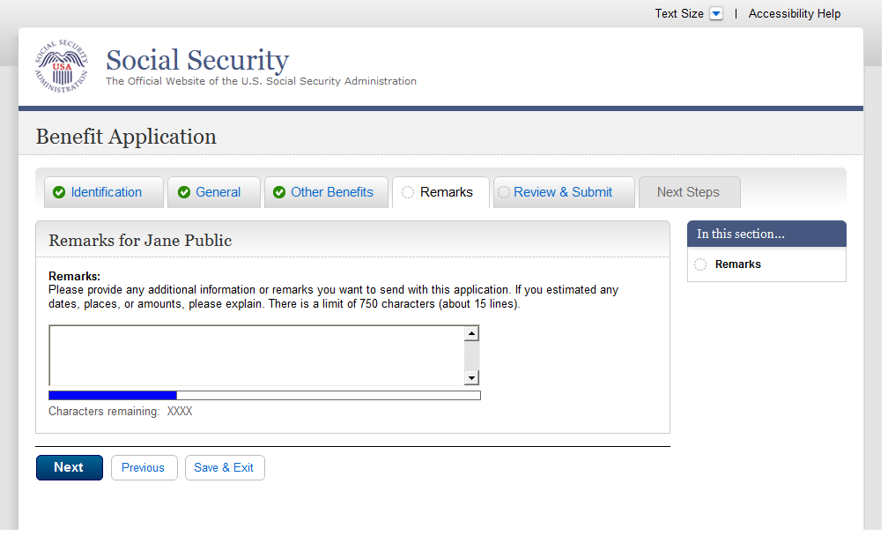
  - rem002-r1-cancellation
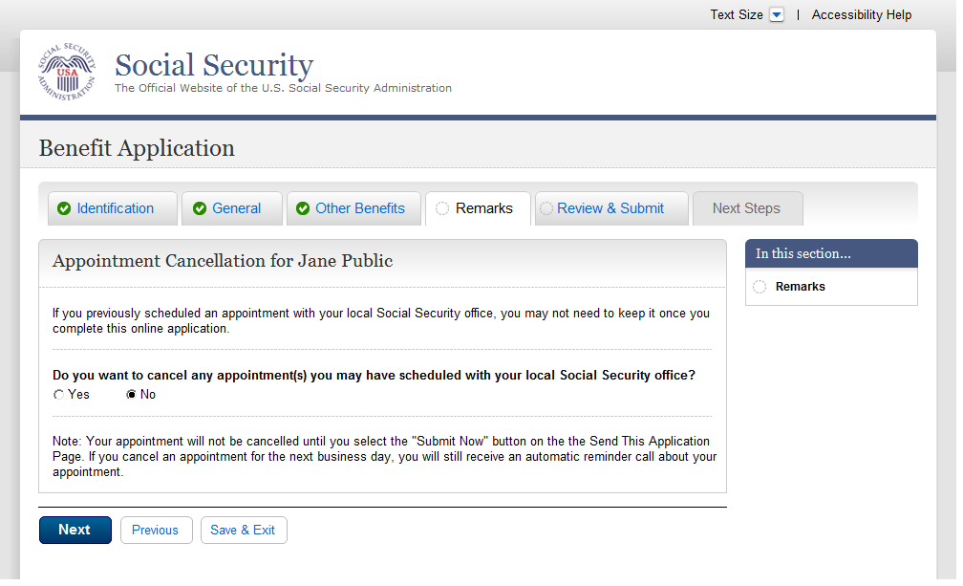
  - ovs001-d1-b_Overall Summary
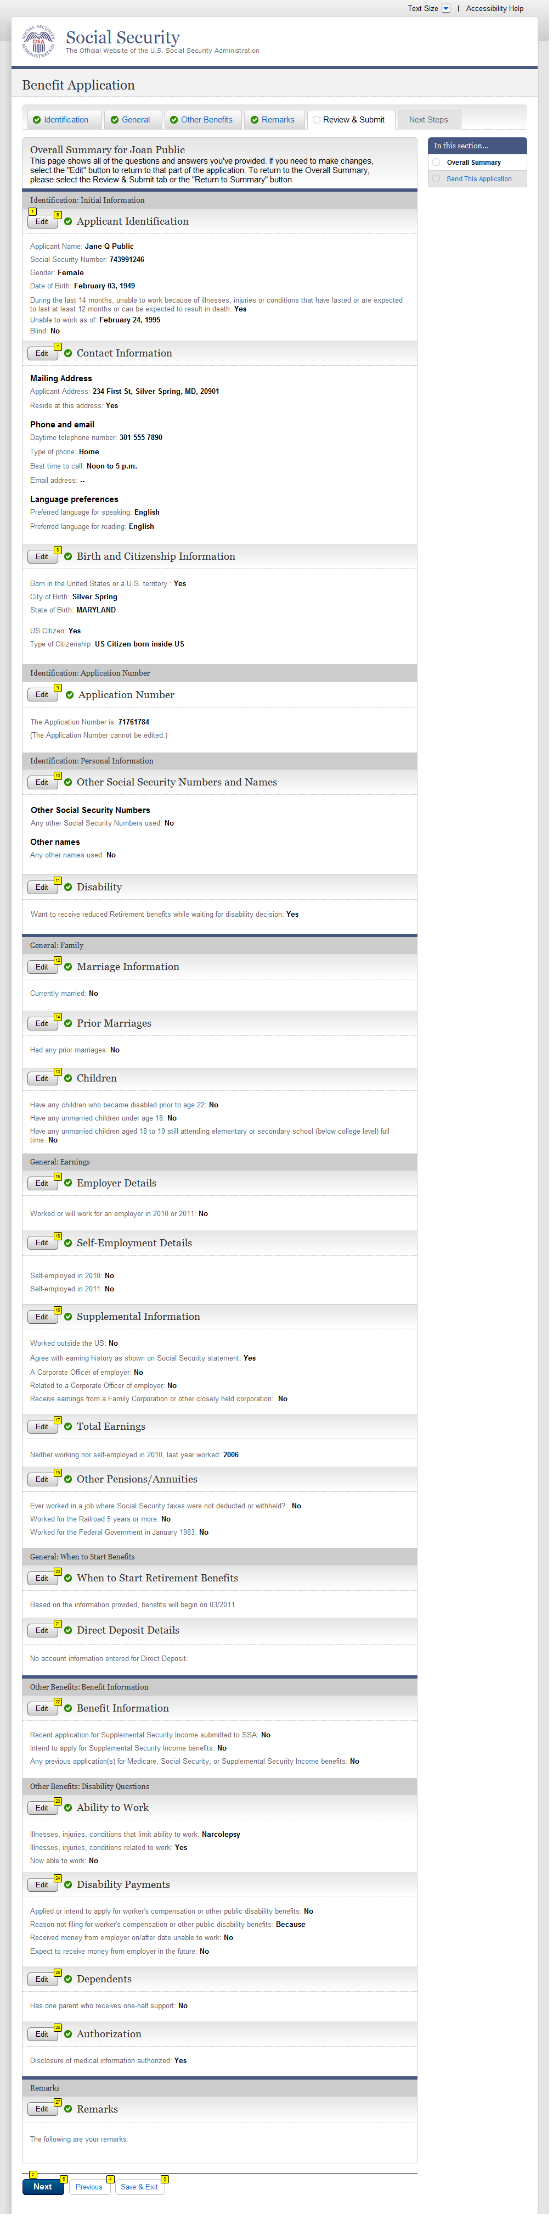
  - ovs001-r1-e_Overall Summary
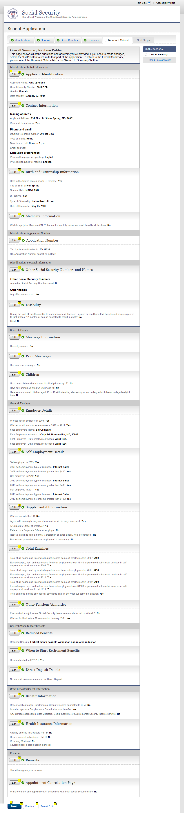
  - ovs001-m1-g_Overall Summary
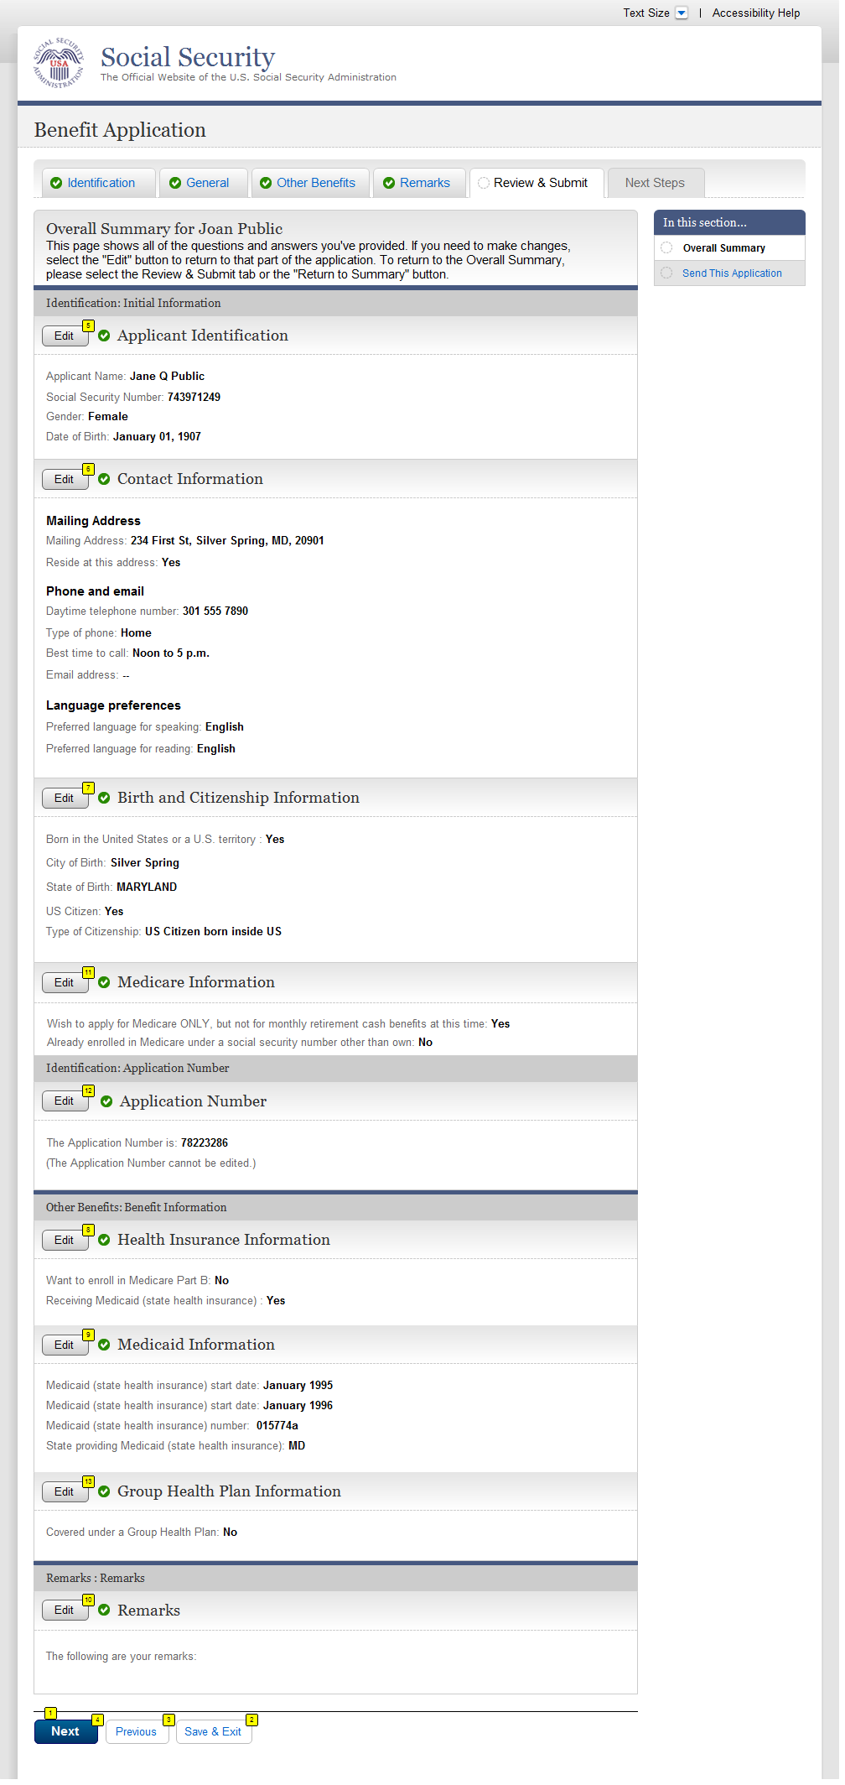
  - ovs001-d3-d_Overall Summary
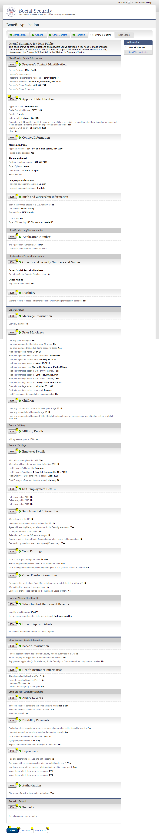
  - ovs001-r3-c_Overall Summary
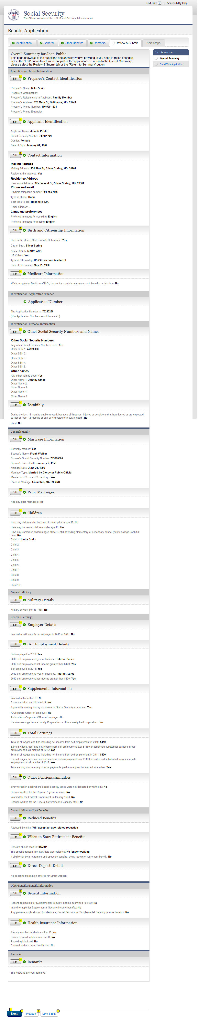

  - ovs001-m3-f_Overall Summary
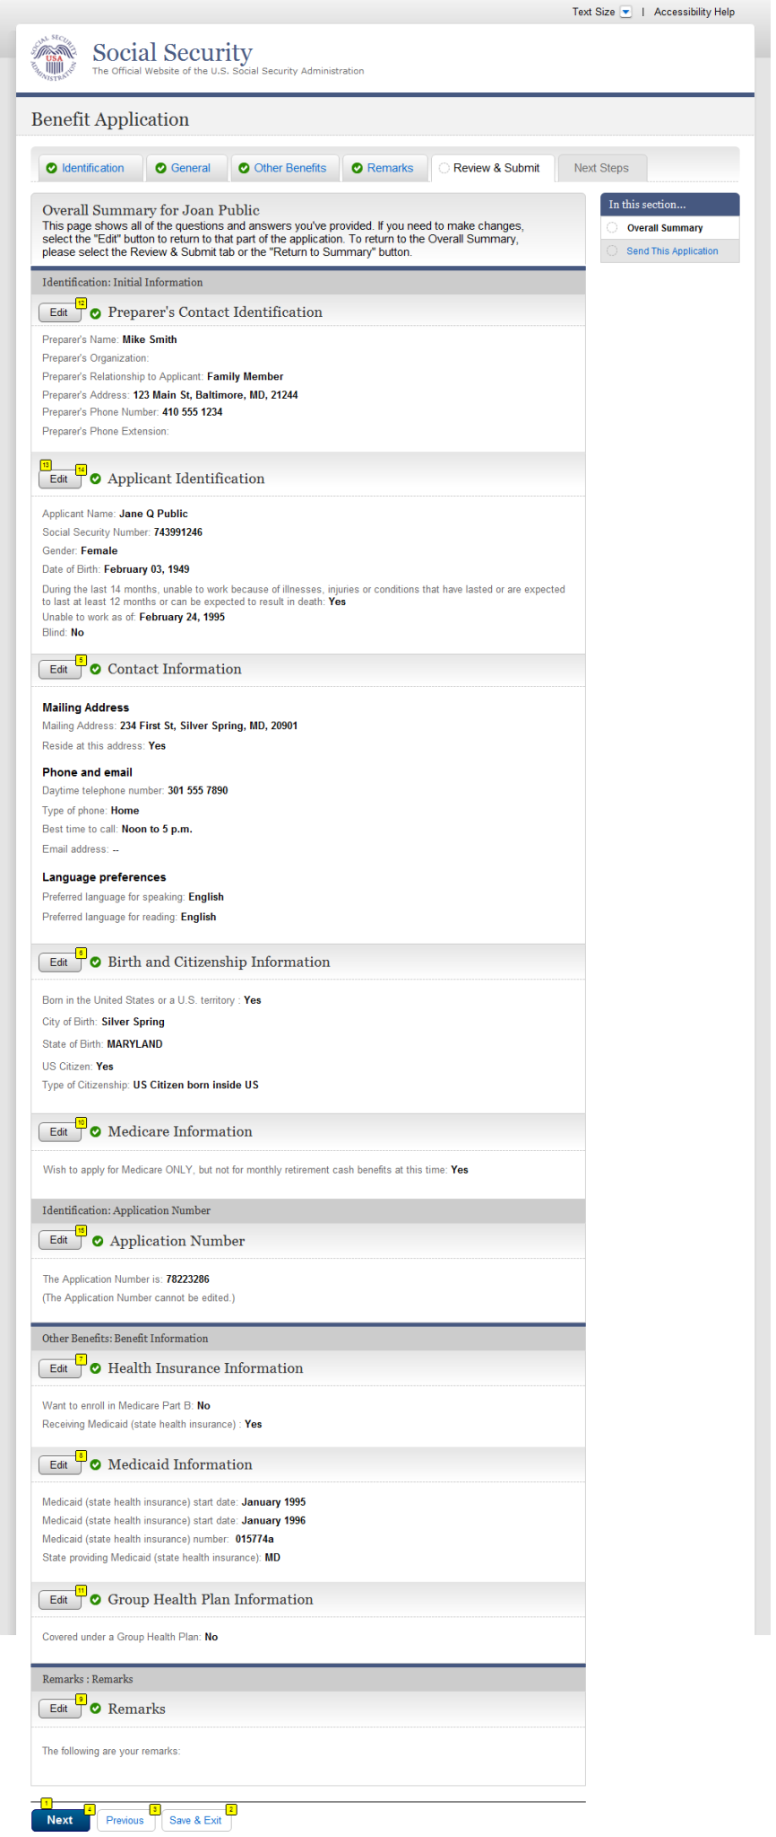
  - snd001-d1_Send This Application
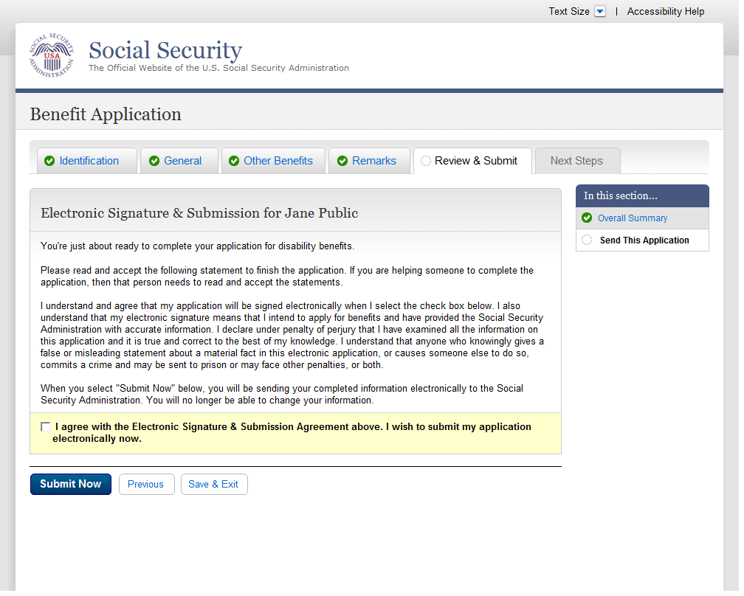
  - snd001-m1_Send This Application
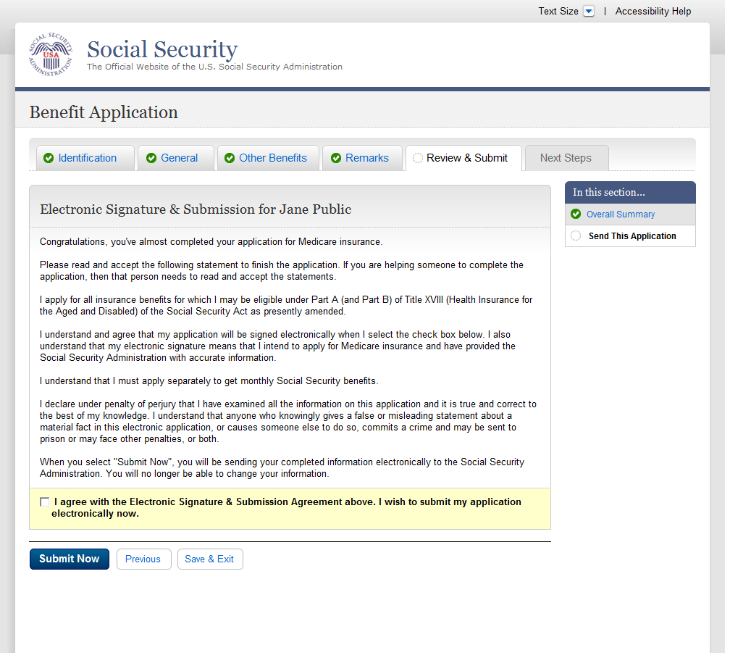
  - snd001-d3_Send This Application
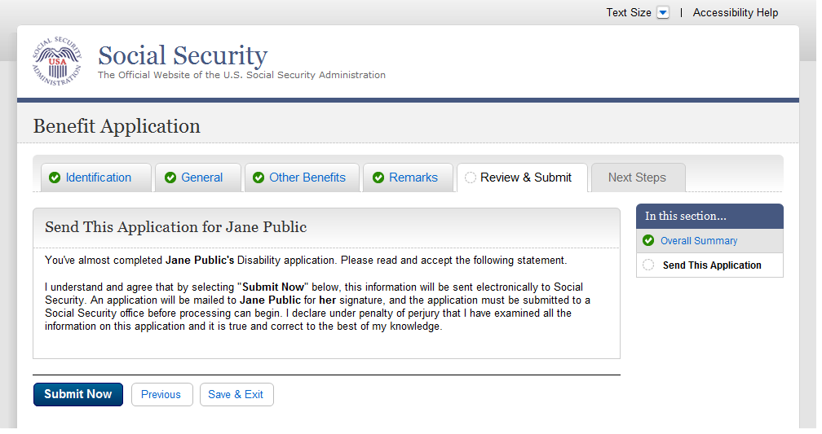
  - snd001-m3_Send This Application
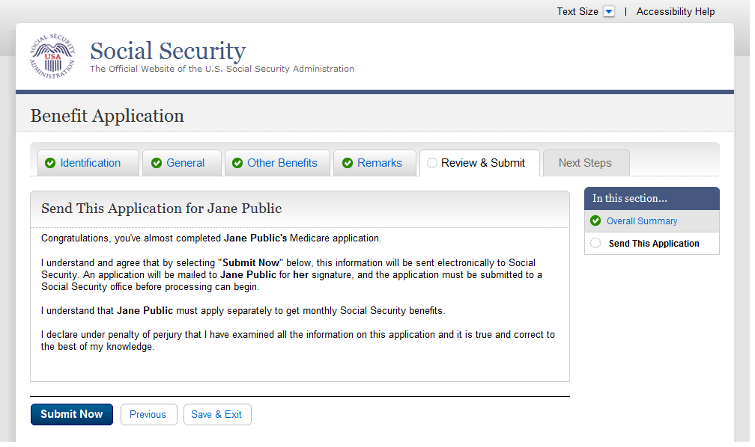
  - snd001-r3_Send This Application
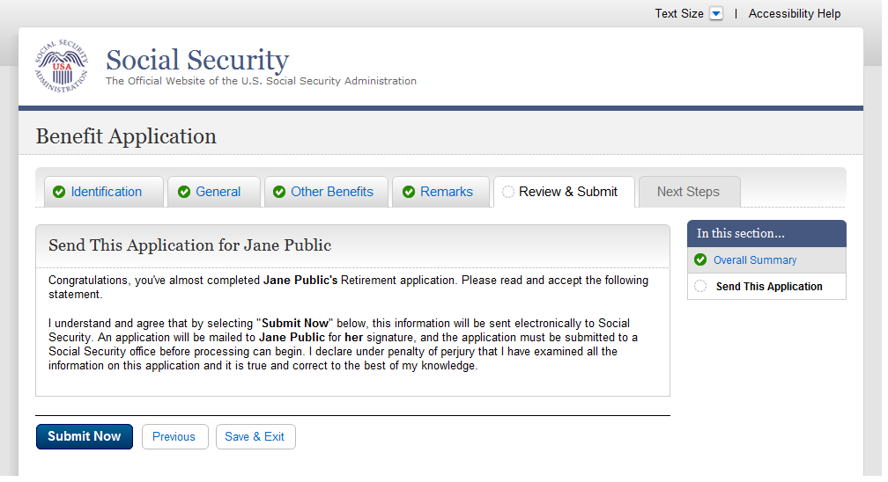
  - rec001-d1-b_Evidence and Receipt
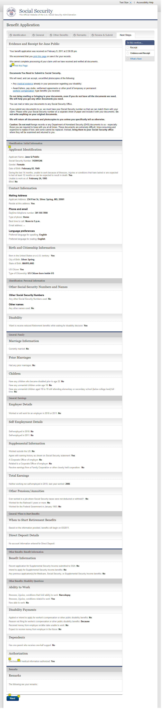
  - rec001-r1-e_Evidence and Receipt
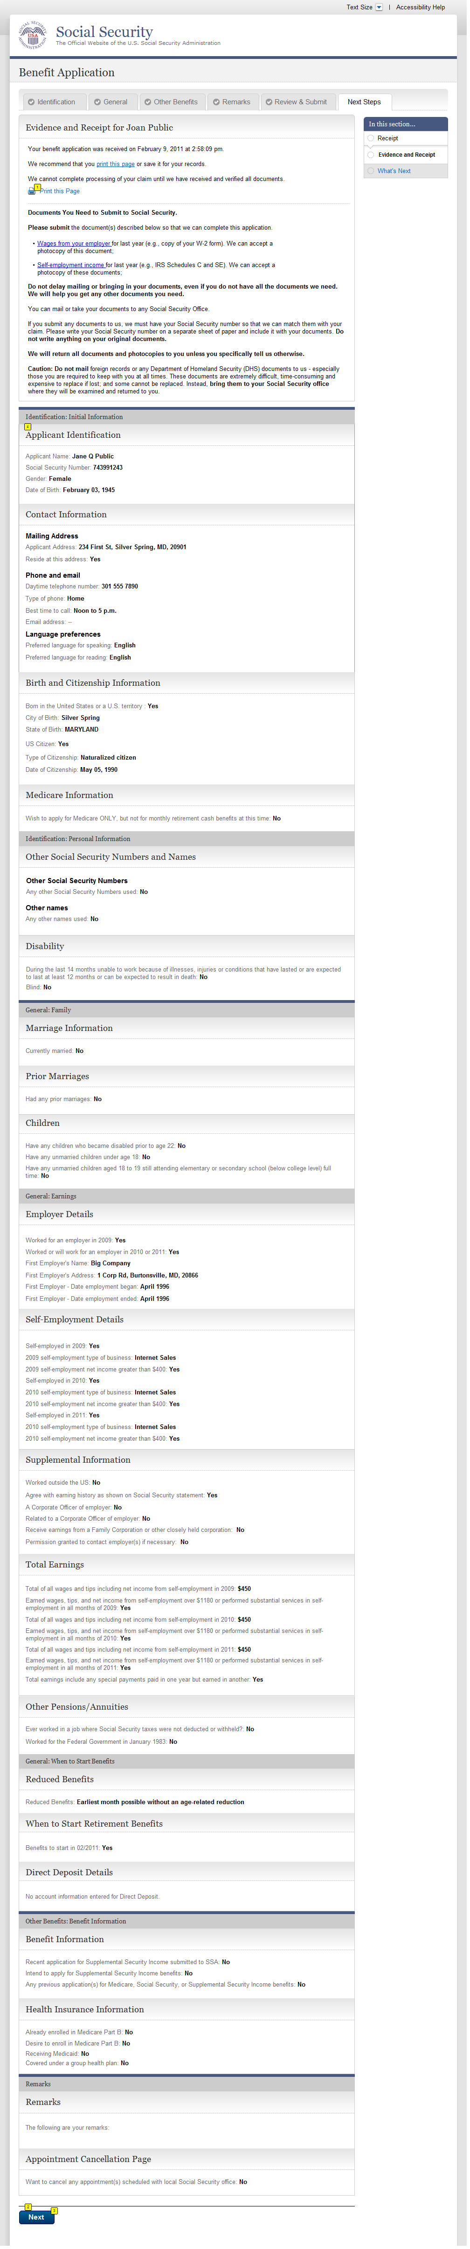
  - rec001-m1-g_Evidence and Receipt
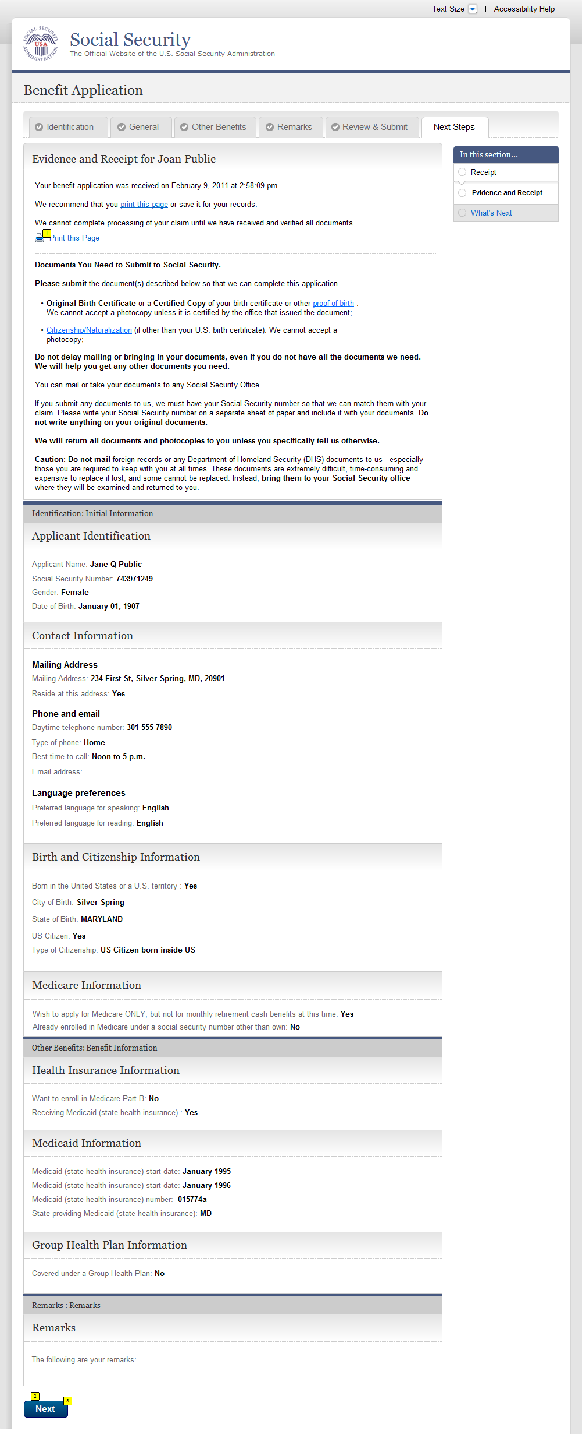
  - rec001-r3-c_Evidence and Receipt
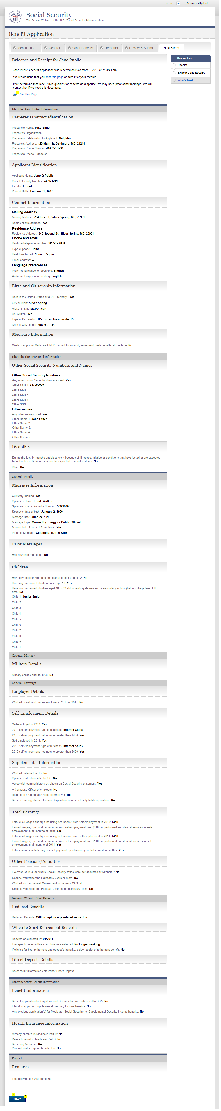
  - rec001-d3-d_Evidence and Receipt
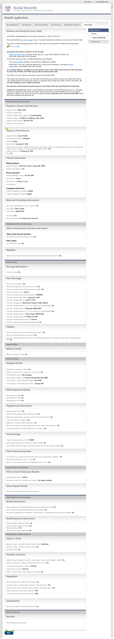
  - rec001-m3-f_Evidence and Receipt
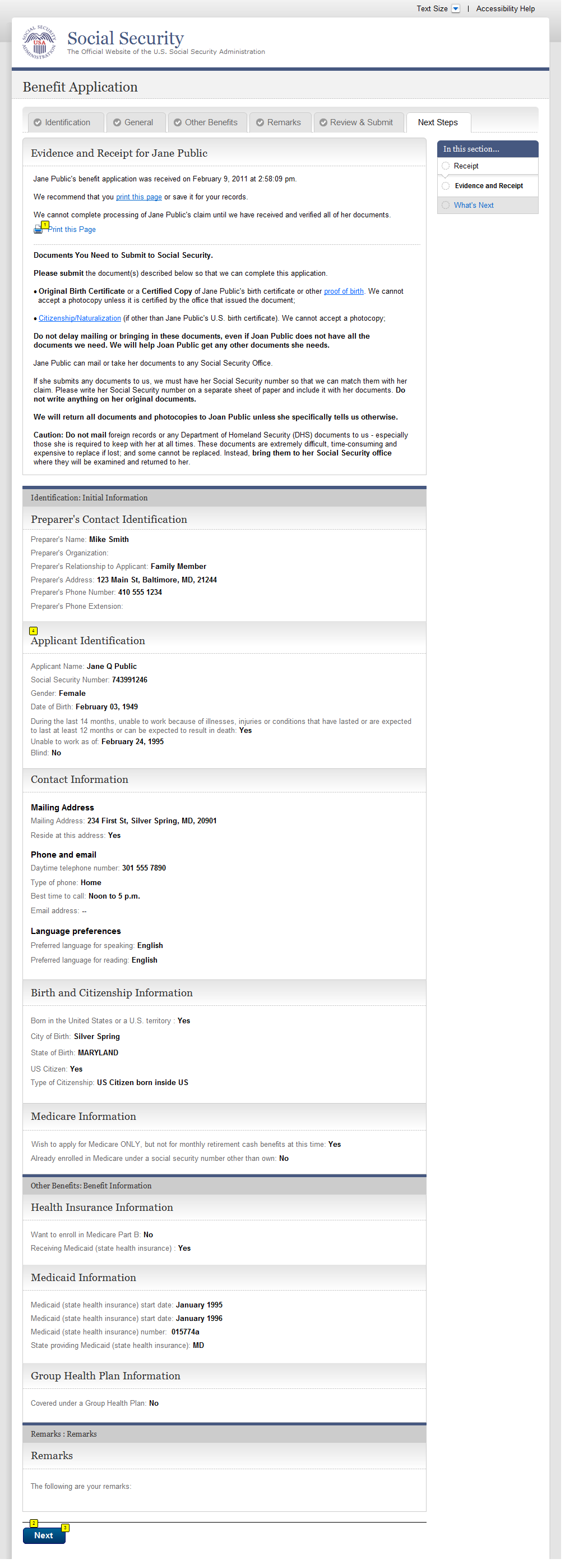
  - wtn001- d1_What's Next
Default display will show Contact information expanded and all other sections collapsed.
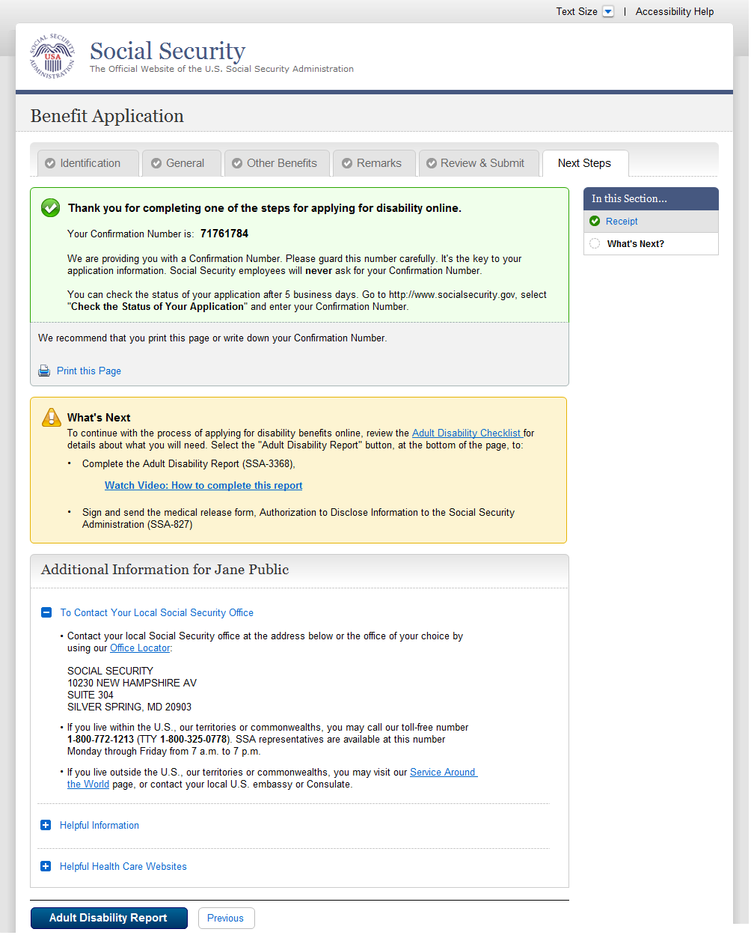
  - wtn001- d1_What's Next-Expanded
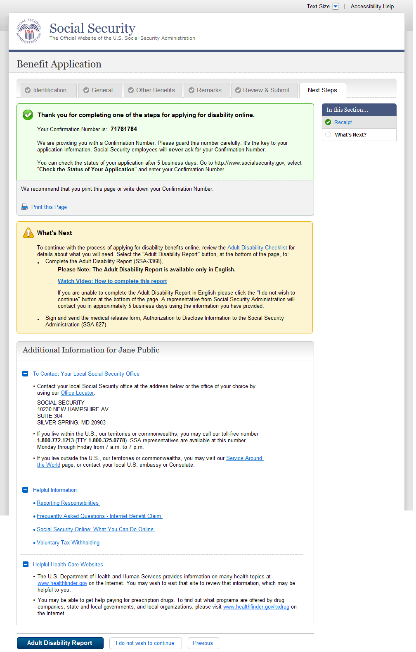

  - wtn001- m1_What's Next
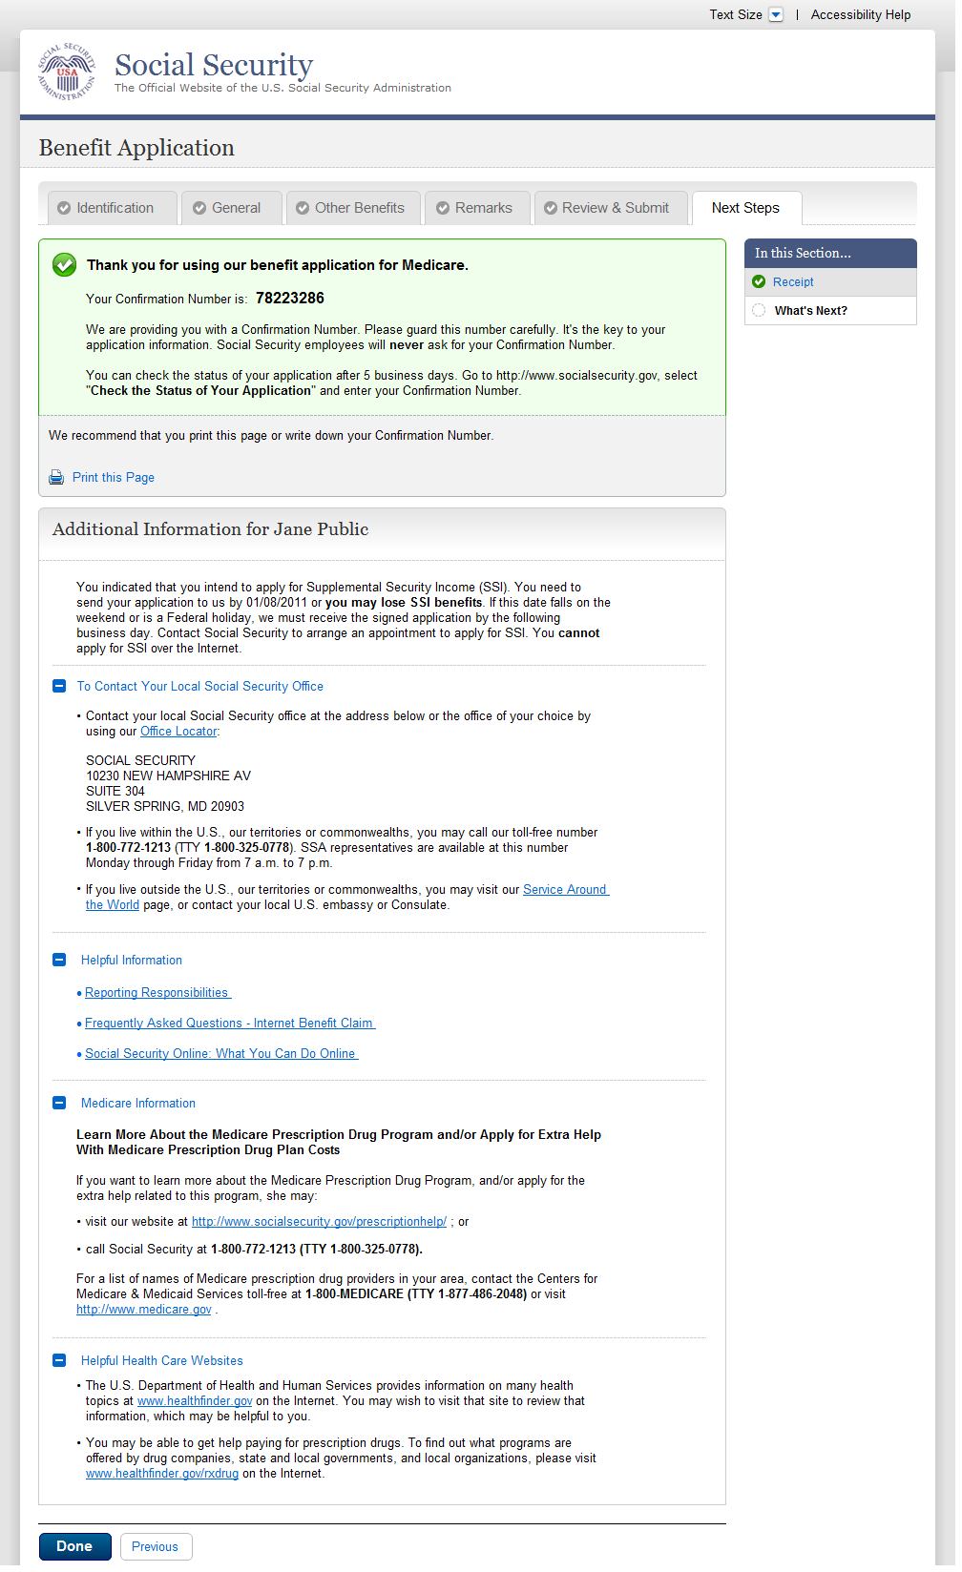

  - wtn001- r3_What's Next
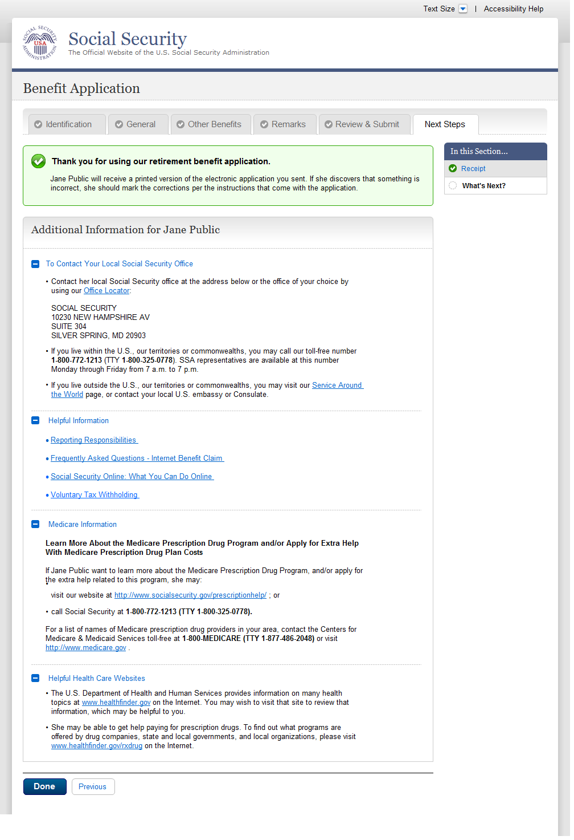
  - wtn001- d3_What's Next
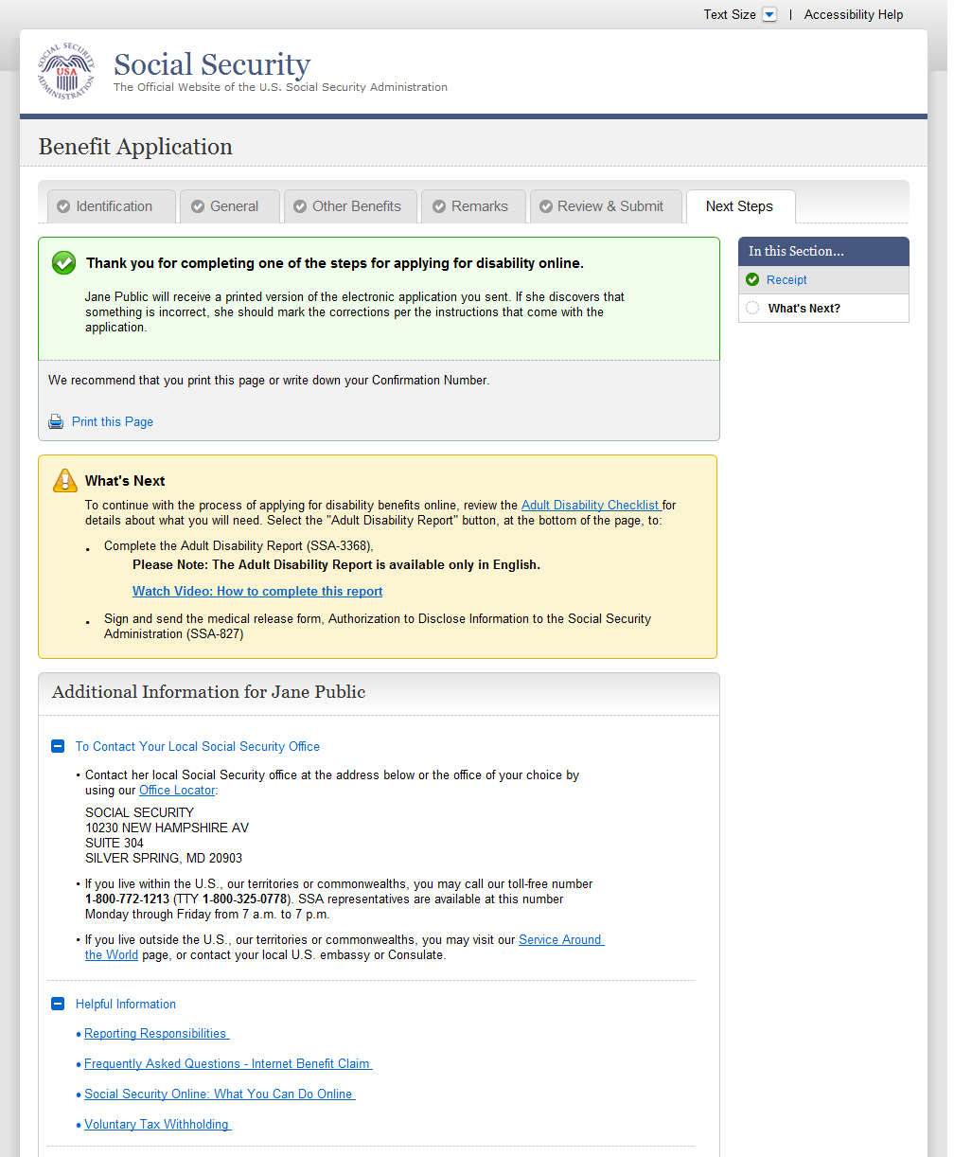
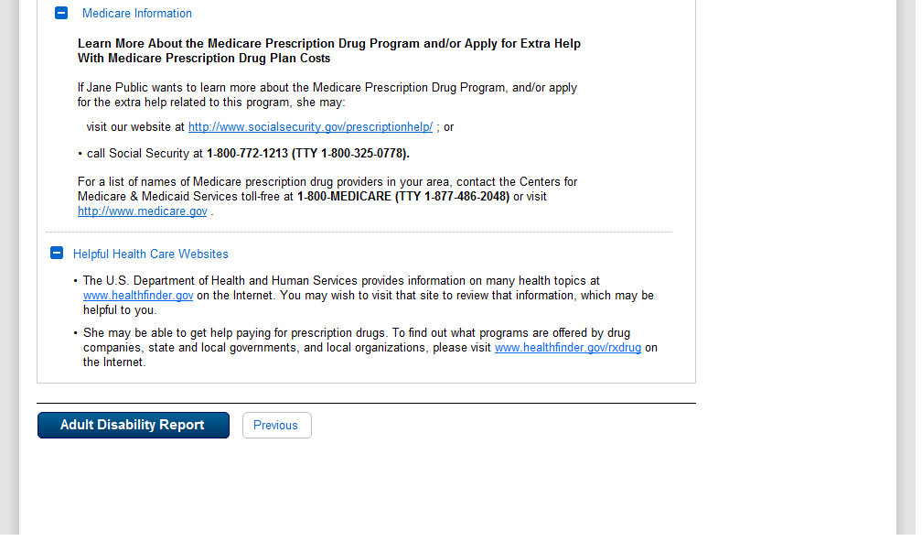

  - wtn001- m3_What's Next
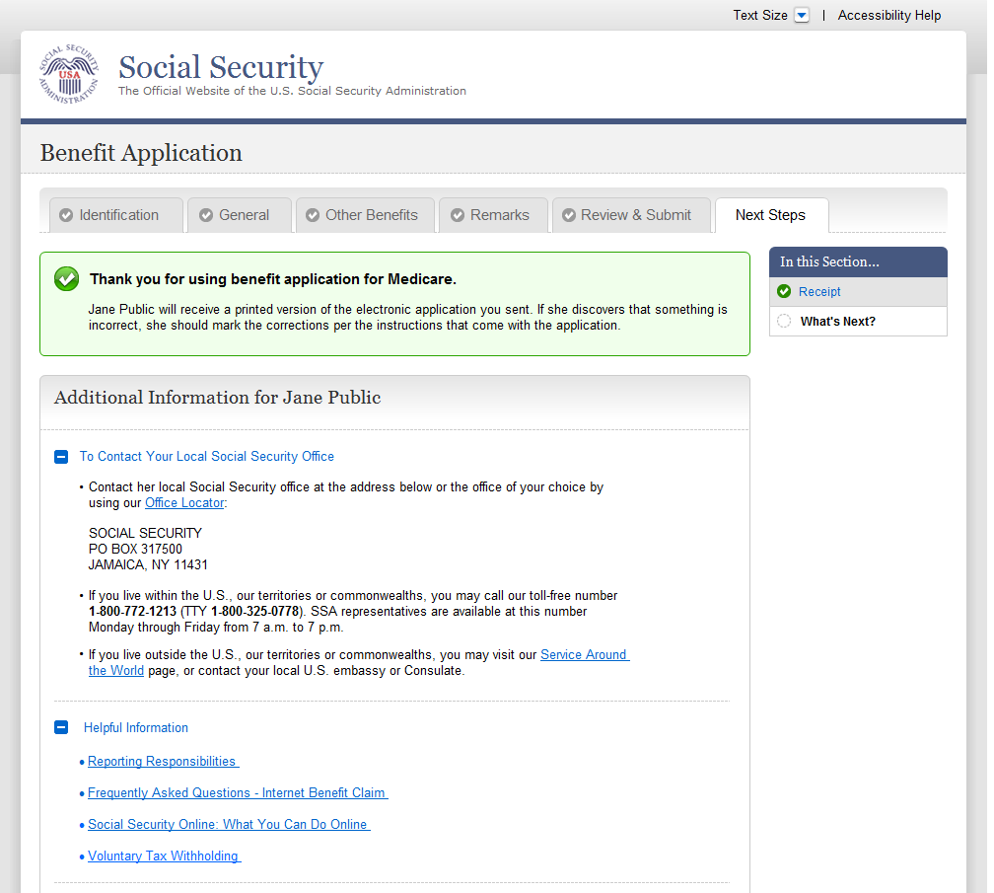
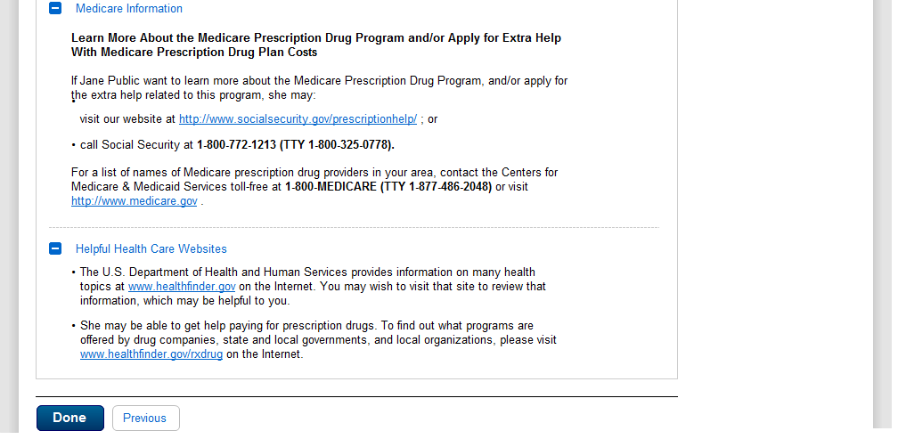

- Messages
  - MSG-Confirm Delete of Table Entry
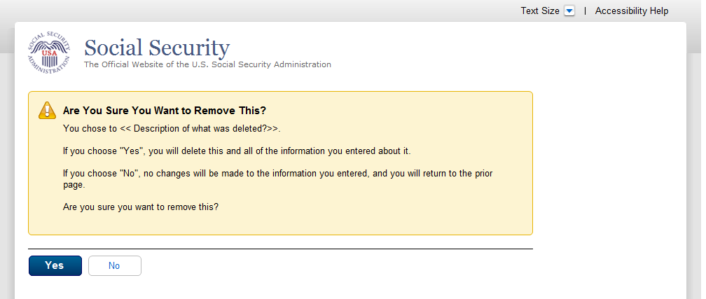
  - msg006_YouCannotApplyforMedicareOnly
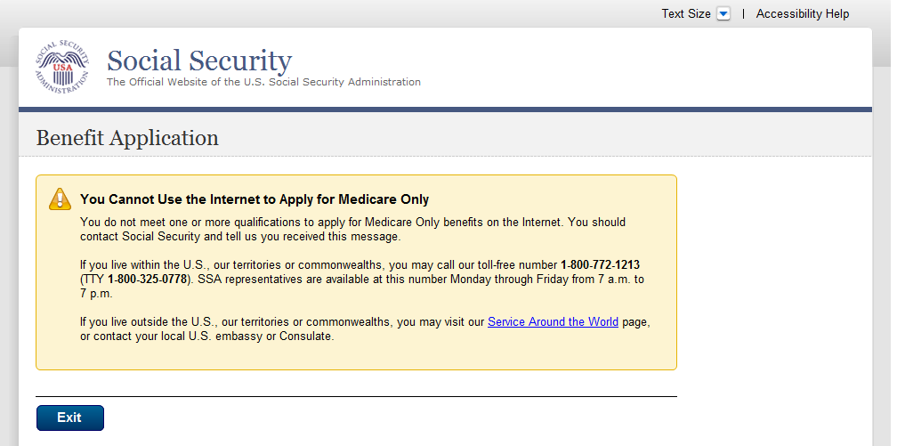
  - msg017_SignIn Problem
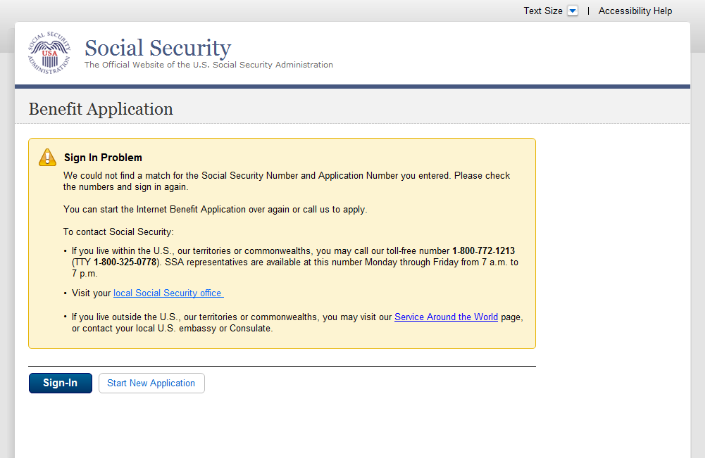
  - msg025_Your Time Has Expired
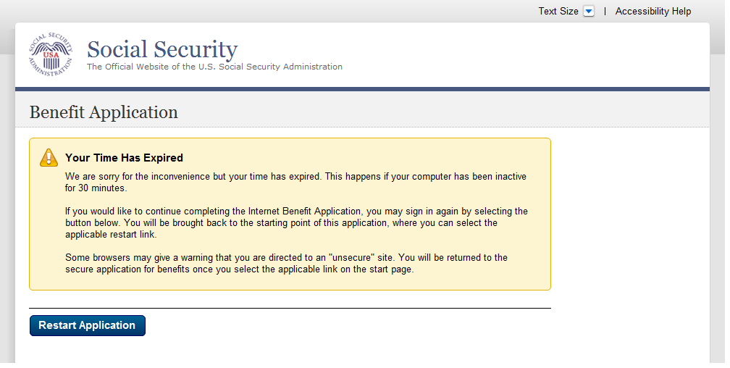
  - msg029_LimitOnNumberOfRestartsOnPartialApplication
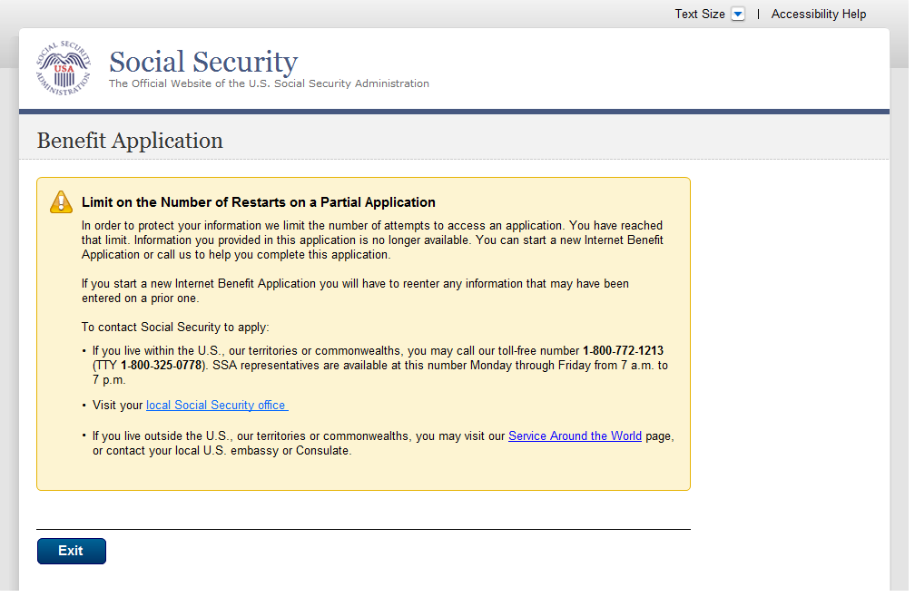
  - msg030_We Are Processing Your Request
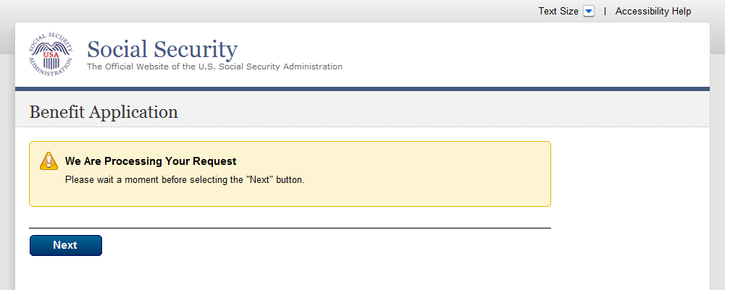
  - msg047-a_Change Your Answer
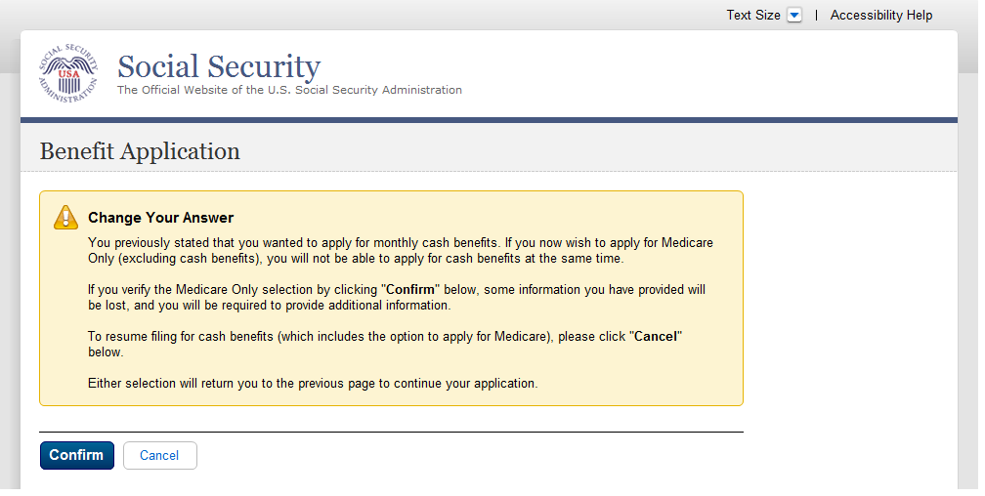
  - msg047-b_Change Your Answer
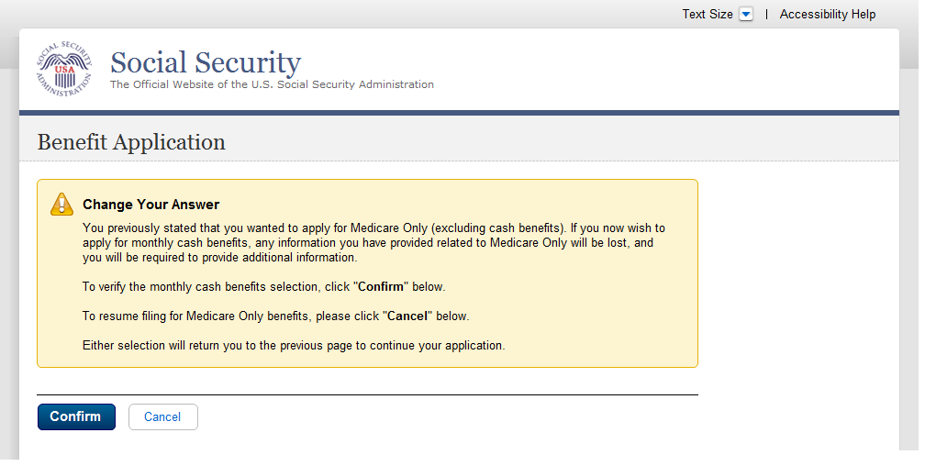
  - msg113_Limit on Number of Requests
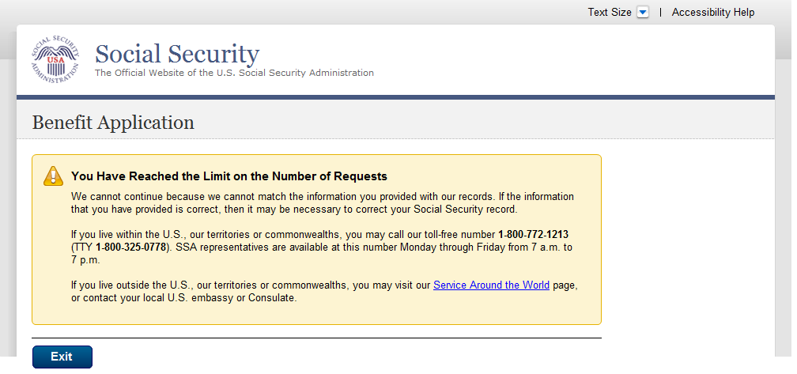
  - msg151_Cannot Match Your Zip Code
