

Public reporting burden of this collection of information is estimated to average 744 hours per year for the Registry Study, 1,383 hours per year for the Cohort Study, and 5 hours per year for Monitoring, including the time for reviewing instructions, searching existing data sources, gathering and maintaining data needed, and completing and reviewing the collection of information. An agency may not conduct or sponsor, and a person is not required to respond to a collection of information unless it displays a currently valid OMB control number. Send comments regarding this burden estimate or any other aspect of this collection of information, including suggestions for reducing this burden to CDC Reports Clearance Officer; 1600 Clifton Road NE, MS D-74, Atlanta, Georgia 30333; ATTN: PRA (0920-XXXX)

Tracking Database System

Overview
A tracking database system (TDBS) was developed by the Coordinating Center to assist local SEARCH centers with case identification and validation. All centers may use this TDBS but are not mandated to. The TDBS will also assist center personnel in assigning Patient Identification (PID) numbers, maintaining Patient information and prompting for Patient communication. The TDBS is available, via download, from the Search web site. The Coordinating Center will work with each center not using the TDBS to assure that their local database is able to perform key functions, i.e., Patient identification assignment, code restrictions, and download of key registration data. The remainder of this section provides a description of procedures of the TDBS developed by the Coordinating Center.

Assigning a Patient Identification Number
A PID is a consistent identification number that follows the Patient throughout the SEARCH study. The P ID is in the form:
5
4
3
2
1
B
B
A

where A is the site number, BB is the sub-site number, and 12345 is a 5-digit number that references the Patient within the study.
A PID is generated automatically by the TDBS when a center enters a case.

Directions for using Search TDB

Starting the Database
- Open the Search TDBS Access database. It will be a file name that resembles the following name: SearchTrackv04_004.mdb. | 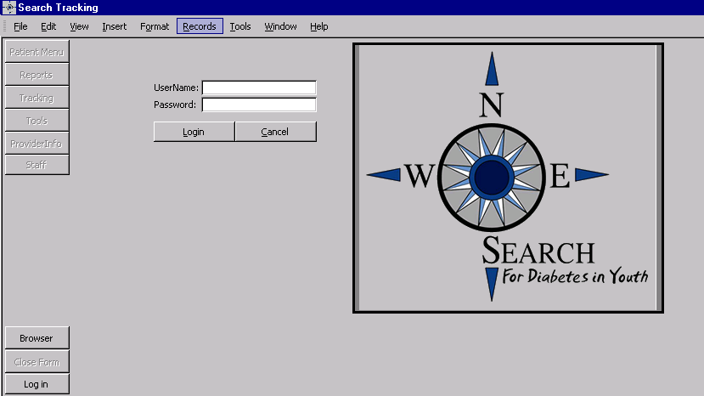
- Upon opening the database, the user will be presented with a log in screen. The user must enter a verified username and password to be able to use the system
- Once login is complete, a series of buttons located on the left side of the screen, will allow the user to navigate through different components of the system

The Patient Menu
The Patient Menu contains five tabs: “Pat Info,” “Case,” “Address,” “Phone,” “Guardian.”

Patient Information Tab
- The user (person entering data) can enter personal information about the patient on this page. Patient information held in this field is: name, date of birth, sex, race, social security number, tribe, birth county and state, and mother’s maiden name.

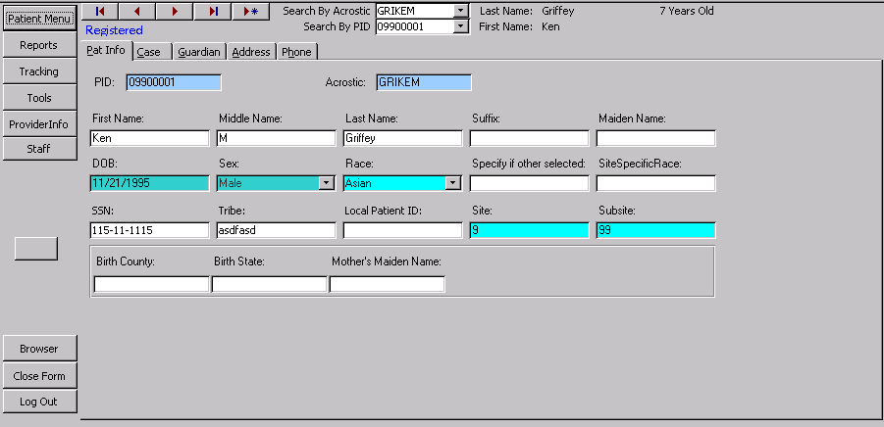

The following is a table of fields for the Patient Information Tab:
Field | Description | Options
PID | An automated field that will appear when a case is selected.
Acrostic | An automated field that will appear when a case is selected.
Patient Name | Text fields are provided to enter the Patient’s first, middle, and last name. Additional fields are provided for a suffix, e.g., Jr., for the Patient’s name as well as the ability to document the Patient’s maiden name, if necessary. | Text fields
Date of birth | Numerical display of the Patient’s date of birth in MM/DD/YY format | Numerical text field
Sex | Patient’s sex | Female, male
Race | Patient’s race | American Indian  Asian  Black/African American  Hispanic  Native Hawaiian or other  White  Other  Unknown
Race specification | If race was designated as other, this text field allows for the specific type designated by the Patient | Text field
Site specific race | This text field is for center use when a specific race requires notation that is indigenous to that center | Text field
SSN | This is a numerical text field for entering the Patient’s social security number. This is for local use only | Numerical text field
Tribe | Text filed to document center specific tribes | Text field
Local Patient ID | Numerical text field for identification of a corresponding center identification number. This is for local use only. | Numerical text field
Birth county; birth state | Text field for elements necessary for eligibility | Text field
Mother’s maiden name | Patient identifier for center use only | Text field

The Case Tab
The user can enter case specific information on this page. This is also the page where the user registers or un-registers a patient.
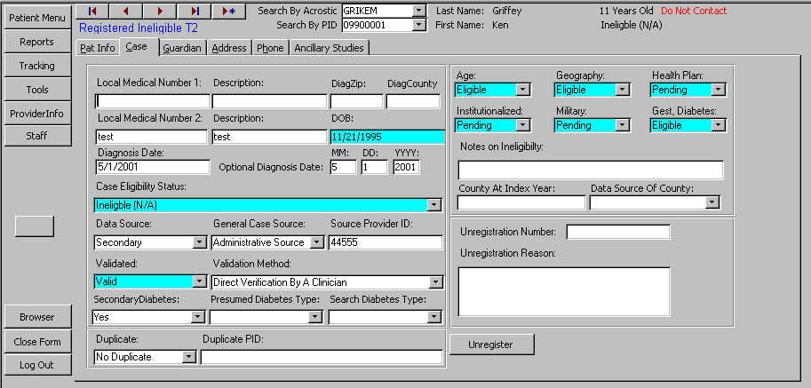

- If a patient has chosen not to participate in the study, a warning is displayed at the top of the page.
- Likewise, registered, duplicate, or ineligible will be displayed according to the patient’s information.
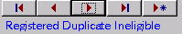

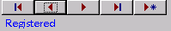
The following is a table of fields for the Case Tab:
Field | Description | Options
Local medical record numbers | Center specific medical record numbers. For local use only | Text field
Diagnosis date | A numerical text field to enter the date the Patient was diagnosed with diabetes. Use this field if the entire date is known (MM/DD/YY) | Numerical text field
Diagnosis month, day, year | Numerical text fields used when only a portion of the Patient’s date of diabetes diagnosis is known. | Numerical text field
Case status | Drop-down box to determine the status of the particular case | Prevalent  Incident with corresponding year  Unknown  Ineligible
Data source | Drop-down box to determine if the information provided was a primary source (the Patient) or secondary source (anyone else). | Primary  Secondary
General case source | Drop-down box to determine the source of case identification | Administrative source  Clinical source  Death Certificate  Self-referral or other
Source provider ID | Text field provided for center use to denote a specific identifier for physicians that Patient information may be shared with. | Text field
Validated | Drop-down box identifying the validation status of a case | Validated  Needs validation  Not validated
Verification method | Drop-down box identifying the method used to validate a case | Medical record review  Direct validation by clinician  Clinically verified by database search  Death certificate  Self report
Secondary diabetes | Drop-down box signifying if the Patient has been diagnosed with secondary diabetes | Yes/No/Unknown
Presumed diabetes type | Text field indicating the presumed diabetes type | Text field
SEARCH diabetes type | Drop-down box to determine the Patient’s diabetes type based on SEARCH criteria | Type 1  Type 1a  Type 2  Hybrid  Unknown
Duplicate | Drop-down box indicating if the Patient is or is not a duplicate case | Primary Record  Duplicate Record  No Duplicate (Default Value)
Duplicate PID | Numerical text field to be completed if the Patient is a duplicate case. The number to be entered is the duplicate number (the PID that will be archived) | Numerical text field
The following fields are drop-down boxes to determine eligibility – all options are the same
Age | Eligibility by age | Eligible  Pending (Default for all)  Ineligible
Geography | Eligibility by geography | Eligible  Pending (Default for all)  Ineligible
Health Plan | Eligibility by health plan membership | Eligible  Pending (Default for all)  Ineligible
Institutionalized | Eligibility by non-institutionalization | Eligible  Pending (Default for all)  Ineligible
Military | Eligibility by non-military status | Eligible  Pending (Default for all)  Ineligible
Gestational diabetes | Eligibility by non gestational diabetes | Eligible  Pending (Default for all)  Ineligible
Lock this record | This field only appears if Allow Record Locking is checked. It is located on the Admin tab in the tools section. When Allow Record Locking is checked, not edits are allowed to be performed to the record. | Checkbox
DiagZip | The zip code of the home where the participant was living when he or she was diagnosed with diabetes. | Text field
DiagCounty | The county of the home where the participant was living when he or she was diagnosed with diabetes. | Text field

- For Zip code and county at diagnosis, use the following strategy:
a) use IPS information first;
b) if IPS is not available, use registration zip code/county;
c) if IPS is not available and more accurate zip code/county information becomes (beyond b) available, then sites should go ahead and use the information deemed most valid.

It is understood that the order of events is different across sites. If the site typically starts with registering a case (hence will start with entering a zip code/county based on registration information/med record), then obtains an IPS, then the zip code/county at diagnosis field should be updated based on the self-reported information. (10/07)

Address Tab
The address tab contains information regarding the Patient’s address. The “primary” field indicates which address will be used for the Patient’s mailing address. Primary must be set to YES if the address entered is the mailing address. A backup copy of all changes is made so that previous addresses can be tracked.

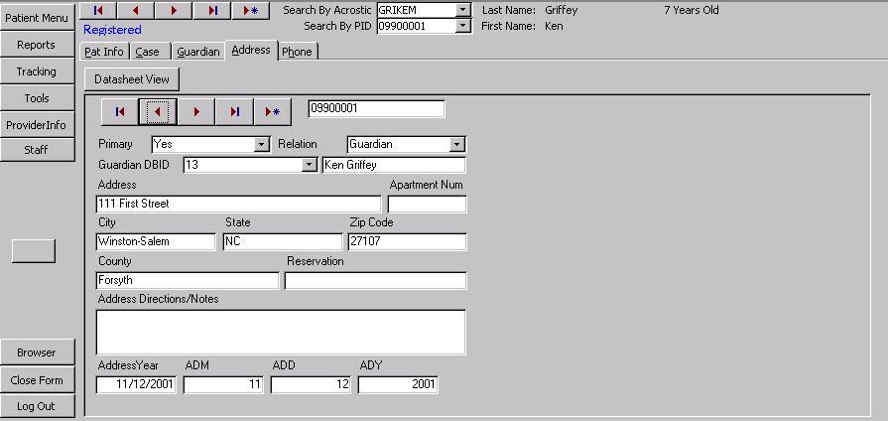

Field | Description | Options
Primary | Drop-down box designating if the address provided is to be considered the primary address for Patient contact | Yes/No
Relation | A drop-down box that allows the user to indicate if this address is for a patient, a guardian, or someone else. | Guardian  Patient  Other
Guardian DBID | A drop-down box that allows the user to select the guardian to assign to the current address if the address is not specific for the patient | Numeric field
Address  Apt. number  City, State, Zip  Reservation  County | Text fields denoting the Patient’s exact address. The reservation field is completed if the Patient resides on a reservation. | Text field
Address directions/notes | For center use to document any specific information regarding the Patient’s address. For local use only | Text field
Address year | Numerical text field denoting the year the documented address was valid | Numerical text field
ADM/ADD/ADY | Specific numerical text fields denoting the month, day, and year the documented address is valid | Numerical text field

Phone Tab
Contact information is stored on this page. Like Address Information, a backup copy of all information is made. The phone tab contains contact information.

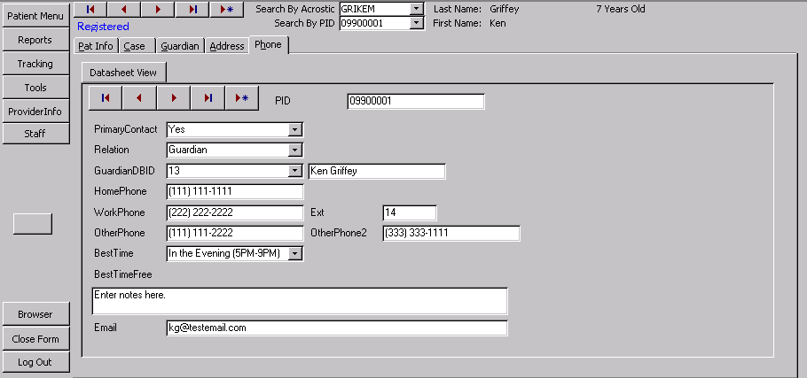

Field | Description | Options
Primary contact | Drop-down box designating if the telephone number provided is to be considered the primary number for Patient contact | Yes/No
Relation | A drop-down box that allows the user to indicate if this address is for a patient, a guardian, or someone else. | Guardian  Patient  Other
Guardian DBID | A drop-down box that allows the user to select the guardian to assign to the current address if the address is not specific for the patient | Numeric field
Extension | Numerical text field to add an extension to the above documented telephone number. | Numerical text field
Other phone | Numerical text field indicating an alternate phone number | Numerical text field
Home Phone | Numerical text field indicating the Patient’s home phone number | Numerical text field
Work phone | Numerical text field indicating the Patient’s work phone number | Numerical text field
Other phone2 | Numerical text field indicating a second alternate phone number | Numerical text field
Best time | Drop-down box denoting the best time to contact the patient | Evening 5-9 PM  During the day 9A – 5 P  Weekend  Day / Evening  Evening / Weekend  Day / Weekend  Anytime
Email | Text field denoting an email address that can be used to contact the Patient | Text field
BestTimeFree | Text field allowing for free text regarding best times to contact the Patient. For local use only | Text field

Guardian Tab
The Guardian tab is where information is stored on guardians. Multiple guardians can be entered.
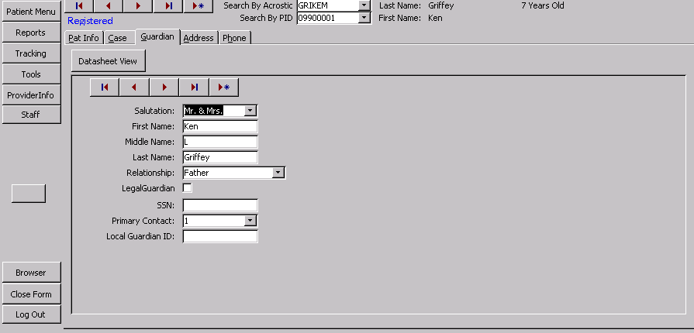
Field | Description | Options
Salutation | Drop-down box denoting the type of salutation to be used when labels are printed | Mr. & Mrs.  Mrs.  Mr.  Dr. & Mrs.  Dr.  Drs.
Name | Text field denoting the Patient’s Parent or Legal guardian’s first, middle, and last name | Text field
Local Guardian ID | Text field allowing the centers to designate a specific identification number for the Guardian. For local use only | Text field
Relationship | Drop-down box denoting the relationship of the Guardian field to the Patient | Patient  Mother and Father  Mother  Father  Grandmother  Grandfather  Uncle  Aunt  Legal guardian  Foster parent  Child Protective Services  Other  Husband  Wife  Significant other  Step mother  Step father  Spouse
Primary contact | Drop-down box denoting the person that should be contacted for the Patient. | Yes/No
SSN | Numerical text for the entry of the Guardian’s social security number | Numerical text field
LegalGuardian | Check box denoting that the person identified within this tab is the Patient’s legal guardian

Reports Menu
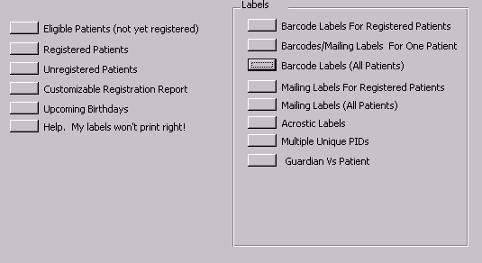

The reports menu will allow the user to print various reports and labels.
- Eligible Patients (not yet registered): Returns a list of patients who can be registered.
- Registered Patients: Returns a list of registered patients.
- Unregistered Patients: Returns a list of unregistered patients.
- Customizable Registration Report: Lets the user create a report by picking county, zip-code, and registration status.
- Upcoming Birthdays: Returns a list of upcoming birthdays.
- Help, My labels won’t print right!: Gives instructions on how to make labels print correctly. Access 2000 has a known bug that causes reports and labels to lose margins when it closes.
- Barcode Labels for Registered Patients: Returns a sheet of labels with barcodes for all registered patients.
- Barcode/Mailing Labels for One Patient: Allows the user to print a whole sheet of mailing labels or barcode labels for one patient.
- Barcode Labels All Patients: Returns a sheet of labels with barcodes for all patients in the tracking database.
- Mailing Labels for Registered Patients: Returns a sheet of mailing labels for all registered patients.
- Mailing Labels (All Patients): Returns a sheet of mailing labels for all patients in the tracking database.
- Acrostic Labels: A set of labels containing acrostics for all registered patients.
- Multiple Unique PIDs: Allows the user to print labels (mailing, barcodes, or acrostics) for a set of PIDS that the user selects.
- Guardian vs. Patients: Lets the user select a group of PIDS, generate labels for this group, and dictate if the labels are addressed to parents or patients.

Tracking Menu
The Tracking Menu provides centers the ability to track the status of each patient. It provides information regarding mailings, information/questionnaires completed, and visits both scheduled and completed.

Consents Tab
The Consents tab is where information about consents the Patient or their Parent/Legal guardian have signed or need to sign is stored. Note that a backup copy of every record change is made so that there will be a complete audit trail.
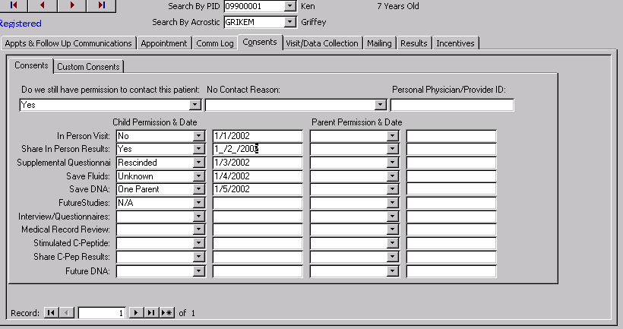

Field | Description | Options
Permission to contact Patient | Drop-down box signifying SEARCH personnel’s ability to contact the Patient. Note: If NO is selected, a red flag will be displayed at the top of the page when this Patient’s file is accessed. | Yes/No
No contact reason | Drop-down box designating the reason this Patient no longer wishes to be contacted. | Consent denied  Consent withdrawn  Death  Unknown  Denies Diabetes
Personal Physician/Provider ID | Text field provided for center use to denote a specific identifier for physicians that Patient information may be shared with. | Text field
In-Person visit  Share In Person Results  Suppl. Question.  Save Fluids  Save DNA  Future studies  Interview Question. | Drop-down box stating the status of the Patient’s consent for that particular set of data. The field along side of the drop-down box is to enter the date the consent was obtained.  A second set of similar boxes are provided for the Parent/Legal guardian consents | No  Yes  Rescinded  Unknown  One Parent  N/A  Date is a numerical text field
Medical Record review
Stimulated C-pep
Share C-pep results
Future DNA

Appointment Tab
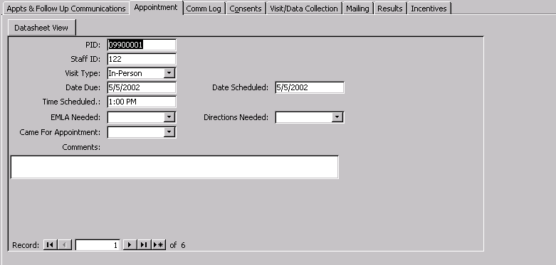

Field | Description | Options
PID | Patient Identification Number.
Staff ID | A 3-digit code assigned to all SEARCH personnel. This code will be selected either by a designated person at each center or by an individual and given to a designated individual at their center. This Staff Identification number will be used for the TDBS as well as forms completed and data entered. The Project Manager will provide a copy of all Staff ID codes to the Coordinating Center. | 3-digit numerical text
Visit type | Drop-down box designating the type of visit being referenced. | In-Person  IPS (via phone)  Blood Re-draw  Stimulated C-peptide  Urine only  Other
Date due | Numerical text field denoting the date the above visit is due. | Numerical text field
Date Scheduled | Numerical text field denoting the date the above visit was scheduled. | Numerical text field
Time scheduled | Time field denoting the time of day the appointment is scheduled for. | Time field – non-military time
EMLA needed | Drop-down box denoting if the Patient requires EMLA cream to be applied prior to obtaining a blood sample. | Yes/No
Directions needed | Drop-down box denoting if the Patient requires any type of directions for the scheduled visit. | Yes/No
Came for Apt | Drop-down box designating if the Patient kept the scheduled appointment. | Yes/No
Comments | Text field allowing description of Patient instructions needed for the scheduled visit. Example: directions to the center; fasting instructions for obtaining laboratory specimen; instructing the Patient to bring family information. | Text field

Mailing Tab
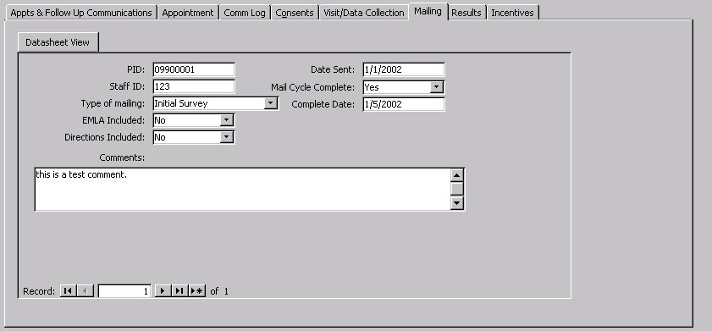

Field | Description | Options
PID | Automatic Patient Identification Number. This number automatically appears in this field when a case is selected.
Staff ID | A 3-digit code assigned to all SEARCH personnel. | 3-digit numerical text
Type of mailing | Drop-down box designating the type of visit the mailing is to provide information for. | Initial Participant Survey  In-Person Visit  Stimulated C-peptide  Annual Follow-up  Other
EMLA needed | Drop-down box denoting if the Patient requires EMLA cream to be applied prior to obtaining a blood sample. | Yes/No
Directions needed | Drop-down box denoting if the Patient requires any type of directions for the scheduled visit. | Yes/No
Date sent | Numerical field denoting the date the specific information was sent. | Numerical text field
Mail Cycle completed | Drop-down box designating if the Patient responded to the mailing. | Yes/No
Complete Date | Numerical text field denoting the date the cycle was complete. | Numerical text field
Comments | Text field allowing description of Patient instructions needed for the mailing. Example: form completion instructions; fasting instructions for obtaining laboratory specimen; instructing the Patient to bring family information. | Text field

Results Tab
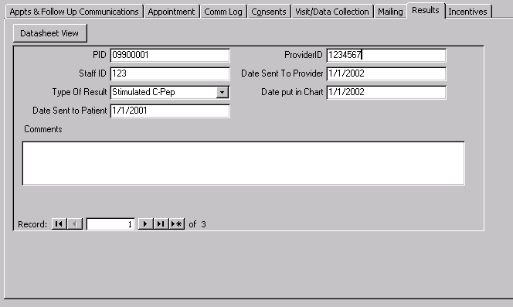

Field | Description | Options
PID | Automatic Patient Identification Number. This number automatically appears in this field when a case is selected.
Staff ID | A 3-digit code assigned to all SEARCH personnel. | 3-digit numerical text
Type of Result | Drop-down box denoting the type of test results are available from. Only a single test can be designated at one time. | Core  Blood Redraw  DAA only  C-peptide  Stimulated C-peptide  Urine Only  Other
Date sent to Patient | Numerical text field denoting the date the result was sent to the Patient. Note: Section 15 provides model letters that can be used when sending SEARCH results to the Patient/Parent/Provider | Numerical text field
Provider ID | Identification number of the Provider approved to share SEARCH information with. Local use only. | Text field
Date sent to Provider | Numerical text field denoting the date the results were sent to the designated provider. | Numerical text field
Date put in chart | Numerical text field denoting the date the results were filed in the Patient’s medical record | Numerical text field
Comments | Text field providing space for notes personnel wish to enter regarding the results. | Text field

Communication Log Tab
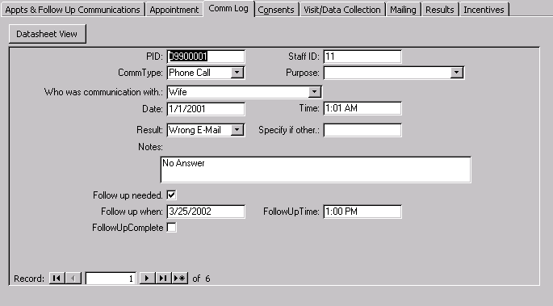

Field | Description | Options
PID | Automatic Patient Identification Number. This number automatically appears in this field when a case is selected.
Staff ID | A 3-digit code assigned to all SEARCH personnel. | 3-digit numerical text
Comm Type | Drop-down box denoting the type of communication that was made with the Patient/Parent/Guardian | Phone call  Email  Letter  Fax  Other
Who was communicated with | Drop-down box denoting the individual SEARCH personnel communicated with. | Patient  Mother and Father  Mother  Father  Grandmother  Grandfather  Uncle  Aunt  Legal guardian  Foster parent  Child Protective Services  Other  Husband  Wife  Significant other  Step mother  Step father  Spouse
Date | Numerical text field denoting the date SEARCH personnel spoke with the above designated person | Numerical text field
Time | Time field noting the time the contact was made | Time field
Result | Drop-down box denoting the result of the communication attempt. | Contact made  Left message  No answer  Wrong number  Disconnected  Wrong email  Other
Specify | If ‘Other” is selected in the above field, enter the reason in this text field. | Text field
Notes | Text field to describe any information regarding the communication. | Text field
Follow up needed | Check this if a follow up communication is needed. | Checkbox
Follow up when | What date should the user call back? | Date
Follow up time | What time should the user call back? | Time
Follow up complete | This is a check box. Until it is checked, the current message will show up in the appointment list as a scheduled task. | Checkbox

Visit/Data Collection Tab
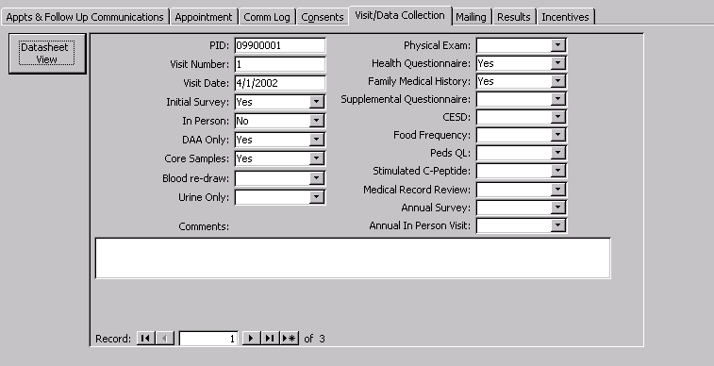

Field | Description | Options
PID | Automatic Patient Identification Number. This number automatically appears in this field when a case is selected.
Visit number | Numerical text field denoting the visit number | Numerical text field
Visit Date | Numerical text field denoting the date of the visit | Numerical text field
The following fields are visit types with drop-down boxes denoting if that item was performed at the above designated visit.
Initial Survey  In-Person  DAA Only  Core samples  Blood re-draw  Urine only  Physical exam  Health Question  Family medical history  Supp. Question.  Depression Question.  Food Frequency  Peds QL  Stimulated C-peptide  Medical Record Review  Annual Survey  Annual In-Person Visit | Drop-down box denoting if this item was performed. | Yes  No  Refused  NA
Comments | Text field explaining any information regarding these procedures. | Text field

Incentives Tab
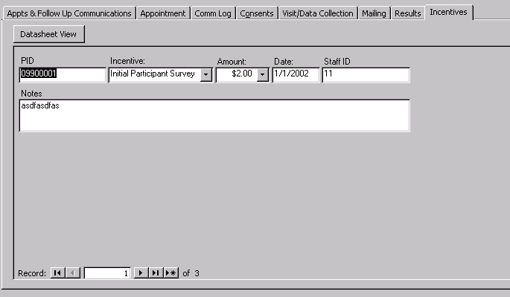

Field | Description | Options
PID | Automatic Patient Identification Number. This number automatically appears in this field when a case is selected.
Incentive | Drop-down box denoting the reason for the incentive. | Initial Patient Survey  In-Person Visit-Patient  In-Person Visit-Parent  Stimulated C-peptide  Custom  Not eligible for additional incentive
Amount | Drop-down box denoting the incentive amount | $0.00  $2.00  $20.00  $40.00
Date | Numerical text field denoting the date the Patient/Parent was given the incentive | Numerical text field
Staff ID | A 3-digit code assigned to all SEARCH personnel. | 3-digit numerical text
Notes | Text field for any information relating to incentives | Text field

Appointments and Follow-up Communications
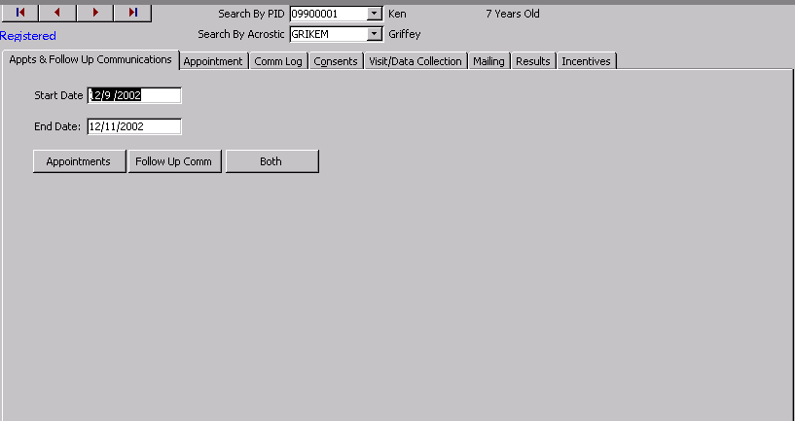

The user can review appointments and follow up communications by entering a start date and end date and then selecting what to review.

Tools Menu
The tools menu is where scheduling and tracking information are entered. This field is a center based/driven menu based on the centers needs.
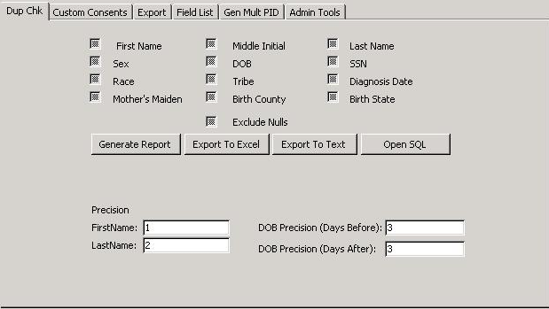
- Duplicate Check: Allows the user to find potential duplicate cases, based on user defined criteria. The user can refine the search using the precision fields.
- Custom Consents: Since each clinic is unique, each one will have the ability to enter custom consents not covered by the main categories on the Consents tab of the Patient Menu.
- Export: Exports registered Patients to text file and uploaded to the SEARCH web site.
- Field List Report: Allows the user to generate a report showing all fields in any table.
- Gen Mult PID: After importing data from a local database, allows for the assignment of multiple PIDs at once.
- Admin Tools: Several items that allow for customization of the system.

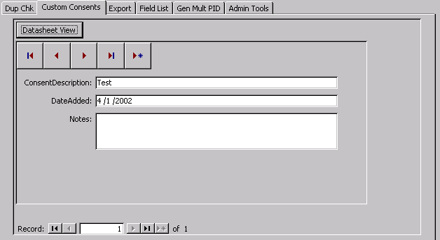

Field | Description | Options
Consent description | Text field allowing any center to designate their own specific consent type based on the requirements of their IRB. | Text field
DateAdded | Text filed denoting the date the special consent was added. | Text field
Notes | Text field explaining any information about the specific consent. | Text field

Export and Field List
Information that is sent to the Coordinating Center from individual sites is controlled from the “Export” tab and the “Field List” tab. From the “Field List” tab, a clinic can turn off fields that they are not allowed to share with the coordinating center. The information that controls the admin piece is in a table.

The admin piece can be seen below. Each clinic can simply uncheck any field in order to remove it from the export that is uploaded to the coordinating center.
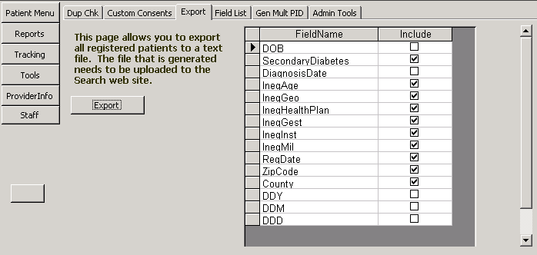

The table holding the field names that are exported is seen below. As can be seen, there is a column for mandatory fiedls. Those fields marked mandatory do not show up in the admin export tool. They are automatically added to the data set. However, it is possible for each clinic to open this table and uncheck mandatory. By doing so, these newly unchecked fields will show up in the admin tools so that it can be removed from the data set. This can be bypassed as well by simply unchecking the “include” for the desired field. If this is done, the specific field will not be uploaded regardless of the state of the mandatory check box. This will enable each clinic to remove DOB, diagnosis date, and provider as well as any other fields that should not be shared going forward.

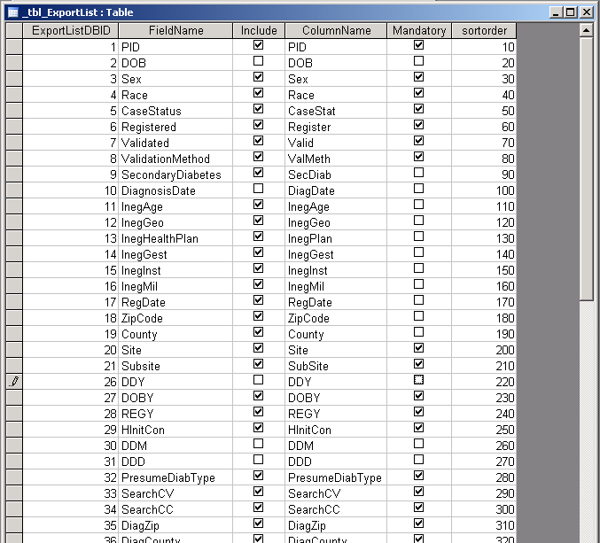

Here is a list of current fields (note that -1 means checked):

_tbl_ExportList
ExportListDBID | FieldName | Include | ColumnName | Mandatory | sortorder
1 | PID | -1 | PID | -1 | 10
2 | DOB | 0 | DOB | 0 | 20
3 | Sex | -1 | Sex | -1 | 30
4 | Race | -1 | Race | -1 | 40
5 | CaseStatus | -1 | CaseStat | -1 | 50
6 | Registered | -1 | Register | -1 | 60
7 | Validated | -1 | Valid | -1 | 70
8 | ValidationMethod | -1 | ValMeth | -1 | 80
9 | SecondaryDiabetes | -1 | SecDiab | 0 | 90
10 | DiagnosisDate | 0 | DiagDate | 0 | 100
11 | InegAge | -1 | InegAge | 0 | 110
12 | InegGeo | -1 | InegGeo | 0 | 120
13 | InegHealthPlan | -1 | InegPlan | 0 | 130
14 | InegGest | -1 | InegGest | 0 | 140
15 | InegInst | -1 | InegInst | 0 | 150
16 | InegMil | -1 | InegMil | 0 | 160
17 | RegDate | -1 | RegDate | 0 | 170
18 | ZipCode | -1 | ZipCode | 0 | 180
19 | County | -1 | County | 0 | 190
20 | Site | -1 | Site | -1 | 200
21 | Subsite | -1 | SubSite | -1 | 210
26 | DDY | 0 | DDY | 0 | 220
27 | DOBY | -1 | DOBY | -1 | 230
28 | REGY | -1 | REGY | -1 | 240
29 | HInitCon | -1 | HInitCon | -1 | 250
30 | DDM | 0 | DDM | 0 | 260
31 | DDD | 0 | DDD | 0 | 270
32 | PresumeDiabType | -1 | PresumeDiabType | -1 | 280
33 | SearchCV | -1 | SearchCV | -1 | 290
34 | SearchCC | -1 | SearchCC | -1 | 300
35 | DiagZip | -1 | DiagZip | -1 | 310
36 | DiagCounty | -1 | DiagCounty | -1 | 320
37 | outsideWindow | -1 | outsideWindow | -1 | 330
38 | PrevStat2009 | -1 | PrevStat2009 | -1 | 340
39 | reascertainment | -1 | reascertainment | -1 | 350
40 | SearchCVD | -1 | SearchCVD | -1 | 360
41 | P2009ProvType | -1 | P2009ProvType | -1 | 370
42 | P2009ProvTypeDate | -1 | P2009ProvTypeDate | -1 | 380
43 | Elig2009County | -1 | Elig2009County | -1 | 390
44 | Elig2009Zip | -1 | Elig2009Zip | -1 | 400

Data is sent to the coordinating center in a text file that is uploaded through the secure website. The button labeled “Export” seen in the image below will create the file once it is clicked. Then, the user logs into the website, selects the file, and uploads it.

The file has the following format (this is all test data):

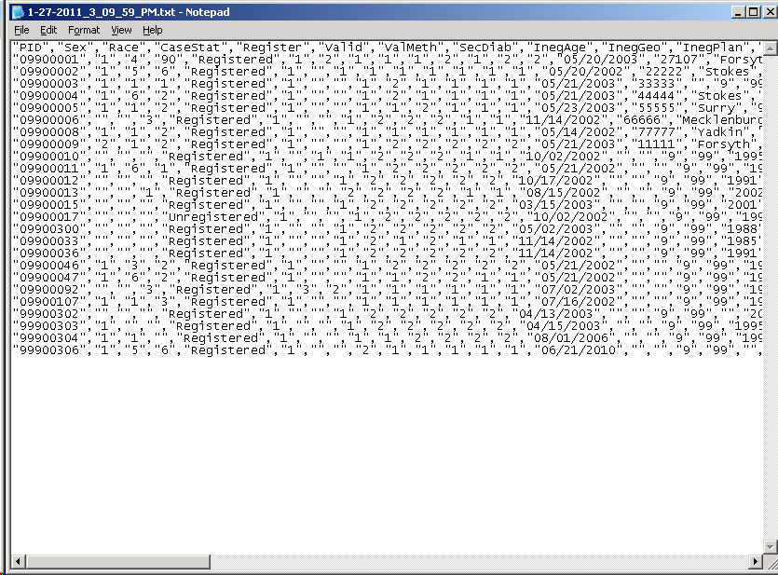

It is important to note that in Search 3, the Coordinating Center will not be collecting DOB, diagnosis date, or information about health care providers.

Admin tools
Field | Description | Options
Advanced Security | By checking this field, the user will not allow Access menus to be displayed or bypass the login screen on startup. It “locks” the form to the open state so that tables and queries cannot be accessed | Checkbox
Open Error Log | Used for debugging when unforeseen errors happen
Open Session Log | Allows the user to see who has logged in at what time.
Re-register a patient | Allows the user to re-register a patient who has been unregistered by accident.
Change Site or Subsite Code | Allows the user to change the default site and subsite used by the tracking system. Could be useful for mass importing data from a subsite where the PID was not generated.
Allow Record Locking | If checked, all patient records marked as locked will not be editable. Records are locked on the patient form. | Checkbox

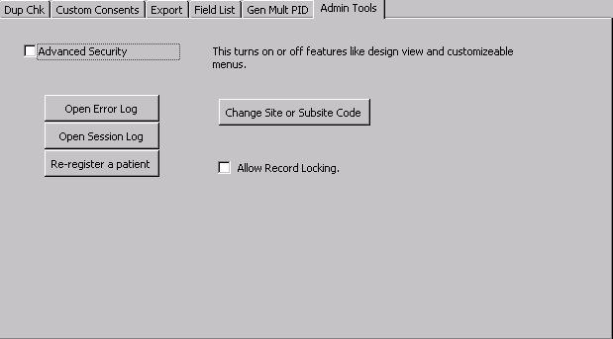

Staff
In this section, the user enters information about staff members and their access to various areas of the TDB. This section will be customized by each center based on their specific needs and requirements.

