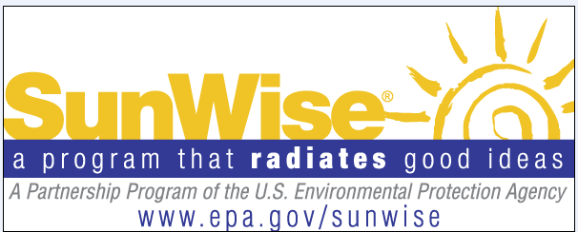
SunWise Program Student Survey
Opt-Out Form

Your child is being asked to take part in two brief surveys given by his/her teacher before and after your child participates in the SunWise Program. These simple, 10-minute questionnaires elicit basic information on the knowledge, attitudes, and practices of children relating to sun exposure.
Teachers who volunteer to participate will provide students with a double-sided, one-page anonymous survey. After students complete the survey in the spring, teachers will lead SunWise lessons. Based on SunWise’s recommendations, teachers will administer the second survey about one year later to see if changes in sun protection have been made. Student survey responses are voluntary and anonymous. Children may skip questions they do not wish to answer; however, we hope that they will answer as many questions as they can. The results from the student surveys are used to gauge program effectiveness and also to help guide materials development.
The valid OMB control number for this information collection is 2060-0439. Children's responses are protected from disclosure by federal statute (PL 107-279 Title I, Part C, Sec. 183). All responses may be used only for statistical purposes and may not be disclosed or used in identifiable form for any other purpose, unless otherwise compelled by law. Data from multiple individuals will be combined to produce statistical reports.

If you have any questions or concerns about the protection of the information you provide or your child’s rights in this survey, please contact Rob Landolfi at the U.S. Environmental Protection Agency at 202-343-9161 or landolfi.robert@epa.gov.

OPT-OUT AGREEMENT

NOTE: If you will allow your child to participate in the study, you do not need to return this form. If you do not want your child to take part in this study, please complete, sign, and return this form in the enclosed envelope to your child’s school.

I have read the letter and the information above.

❒ I DO NOT consent to my child’s participation in the SunWise Program survey.

CHILD’S NAME:
First and last name

Sign your name:
Signature of parent/guardian Date

Print your name:
First Middle Last

