Attachment H – Sample Reports
Part 1 - Summary of evaluator needs

Number of evaluators responding :
Overall level of experience in program evaluation

General knowledge assessment

 | Not at all | General knowledge | Used or could use | Taught or could teach | Priority for training
Guiding principles | 1 | 2 | 5 | 0
Joint Committee Program Standards | 2 | 3 | 3 | 0
CDC Framework | 0 | 4 | 3 | 1
Multiple approaches | 1 | 5 | 1 | 1

Common areas identified for requesting technical assistance
Technical assistance requested for | Percent requesting | Respondents that can teach this
Designing evaluations using mixed methods | 88%
Collecting observational data | 75%
Using logic models to guide questions | 75%
Budgeting for evaluation | 75%
Resolving conflicts | 75%
Synthesizing evaluation findings | 62%
Developing action plans | 62% | (respondent id)
Tailoring evaluation findings for community groups | 62%

Common Organizational supports for evaluation

List of states with evaluators in strongly supportive organizations (>7 agree or strongly agree responses)
[respondents]

List of states with evaluators in non-supportive organizations

Organizational Availability of data and use of information

Part 2 - Assessment of NACP Evaluation Technical Assistance

Level of interaction with ETA over past year:
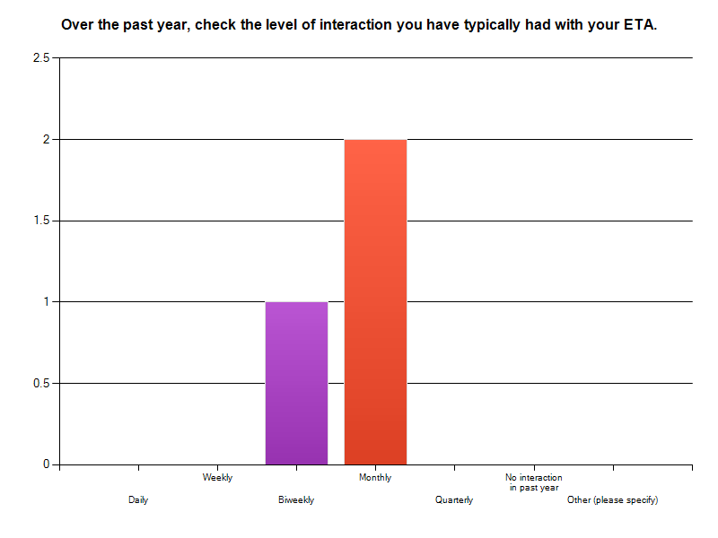

Satisfaction with level of interaction: 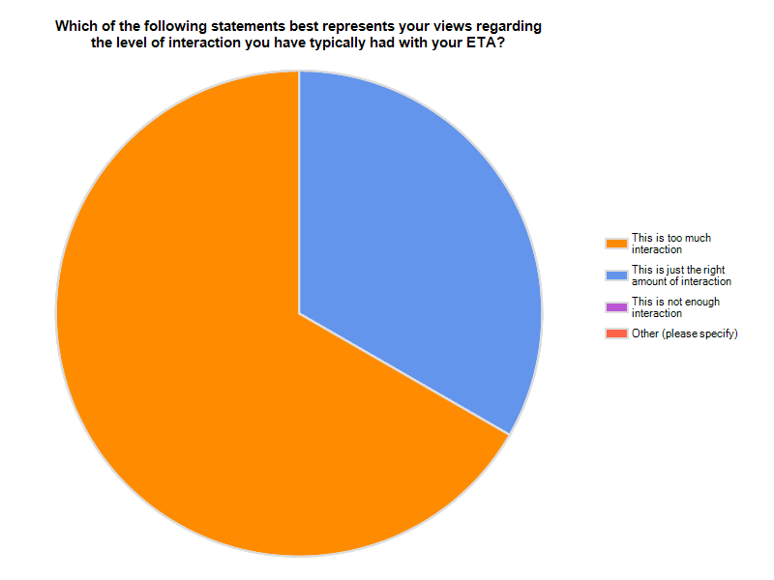
Ideal level of interaction: narrative responses compiled and reviewed for common themes.

Topics addressed and satisfaction with advice or resources provided:

 | Adequate Advice/ Resources Provided | Inadequate Advice/ Resources Provided | Not Applicable (N/A) | Response  Count
a. Evaluation Planning | 100.0% (3) | 0.0% (0) | 0.0% (0) | 3
b. Evaluation Implementation | 0.0% (0) | 0.0% (0) | 100.0% (3) | 3
c. General Problem Solving | 100.0% (3) | 0.0% (0) | 0.0% (0) | 3
d. Applying Evaluation Standards | 33.3% (1) | 33.3% (1) | 33.3% (1) | 3
e. Engaging Stakeholders | 66.7% (2) | 33.3% (1) | 0.0% (0) | 3
f. Describing the Program | 33.3% (1) | 33.3% (1) | 33.3% (1) | 3
g. Focusing the Design | 66.7% (2) | 0.0% (0) | 33.3% (1) | 3
h. Gathering Credible Evidence | 66.7% (2) | 0.0% (0) | 33.3% (1) | 3
i. Interpreting Findings/Justifying Conclusions | 0.0% (0) | 0.0% (0) | 100.0% (3) | 3
j. Ensuring Use/Disseminating Findings | 33.3% (1) | 0.0% (0) | 66.7% (2) | 3

Overall quality of interaction with ETA:
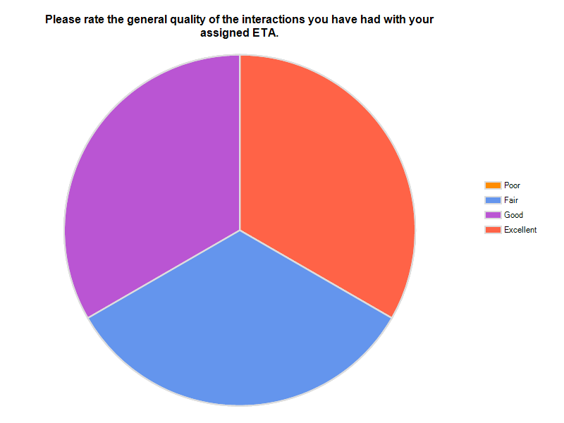
How ETA has helped:
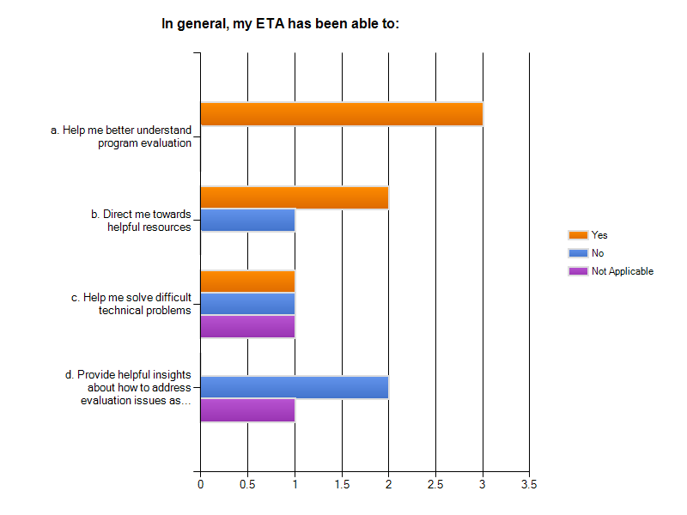

Use of resources:
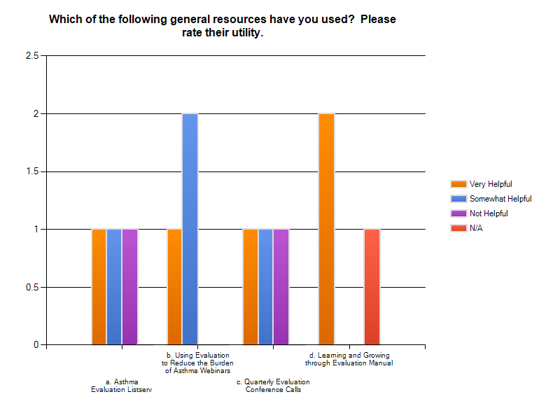
How can we improve evaluation TA? This is a narrative response and we will analyze for common themes, utilizing atlas-ti software, as appropriate. Atlas-ti is a commonly used software package used to for qualitative data analyses.

