FMS Data Elements Document | 2010
FMS data elements document captures the data elements that are collected from the applicants and alumni of various CDC fellowship programs. |  | EIS Application

Attachment 3 – Sample Data Elements Document, EIS Fellowship Application

Table of Contents
1 Introduction 6
1.1 Document Structure 6
2 Login and Registration Pages 7
2.1 Login Page 7
2.2 Registration Page 8
2.3 Forgot Your E-mail? 10
2.4 Forgot Your Password? 12
2.5 Reset Password 15
3 Application Instructions 16
4 Status Page and Application Submission 18
4.1 Authorization 19
4.2 Pre-Submission Validation 20
5 Contact Information 21
6 Education 25
6.1 High School Education 26
6.2 College/University Education 27
7 Postgraduate Training and Skills 30
7.1 Clinical Training 32
7.2 Board Certification 33
7.3 Additional Training 34
8 Work and Volunteer Experience 35
8.1 Work Experience 36
8.2 Volunteer Experience 38
9 Publications, Presentations, Grants 40
9.1 Publication 42
9.2 Presentation 43
9.3 Research Grants 44
10 Honors and Awards 45
11 Personal Statement 47
12 Applicant Survey 48
13 Letters of Recommendation 53
14 Withdraw Application 56
15 Appendix A – E-mails 57
15.1 Applicant Reset Password Information 57
15.2 Application Submission Confirmation 57
15.3 Application Submission Reminder 58
15.4 Interview Invitation for US Applicants 59
15.5 Interview Invitation for International Applicants 60
15.6 Interview Confirmation for US Applicants 61
15.7 Interview Confirmation for International Applicants 61
16 Appendix B – Changes In Other Programs 62
16.1 PHIFP Differences 62
16.1.1 Contact Infortmation 62
16.1.2 Self-Assessment of Skills 62
16.2 PHPS Differences 63
16.2.1 Self-Assessment of Skills 63
16.3 Hubert differences 64
16.3.1 Contact Information 64
16.3.2 College/University Education 64
16.3.3 Project Ranking 64
16.3.4 Self-Assessment of Skills 64
16.4 Epi elective differences 65
16.4.1 Assignment Preference 65
16.5 PEF Differences 66
16.5.1 College/University Education 66
16.5.2 Work Papers 66
16.5.3 Research experience 66
16.5.4 Assignment Overview and Ranking 66
16.5.5 Self-Assessment of Skills 66
16.6 PMRF differences 67
16.6.1 Education 67
16.6.2 College/University Education 67
16.6.3 Additional Course 67
16.6.4 Clinical Training 67
16.6.5 Work and Volunteer Experience 67
16.6.6 Work Experience 68
16.6.7 Volunteer Experience 68
16.6.8 Monographs and Reports 68
16.6.9 Personal Statement 68
16.6.10 Applicant Survey 68
16.6.11 Peer References 68
16.7 PHAP differences 69
16.7.1 Contact Information 69
17 Appendix C – List Of Values 70
17.1 Countries 70
17.2 States 72
17.3 Secret Questions 73
17.4 Visa Types 73
17.5 College Education Statuses 73
17.6 Degrees 73
17.7 Major Classifications 74
17.8 License Statuses 75
17.9 Languages 75
17.10 Proficiencies 76
17.11 Clinical Titles 76
17.12 Specialties 76
17.13 Board Statuses 78
17.14 Program Names 78
17.15 Research Roles 79
17.16 Research Grant Amounts 79
17.17 Honor Types 79
17.18 Hear About Us Options 79
17.19 Areas of Interests 80
17.20 Information Science Skills 80
17.21 Computer Science Skills 80
17.22 Information System Skills 81
17.23 Project Management Skills 81
17.24 Public Health and Health Care Skills 81
17.25 Information Tehnology Skills 81
17.26 Skill Level 81
17.27 Computer Skills 81
17.28 Transcript Analysis Types 82
17.29 Projects 82
17.30 Statistical Software Skills 82
17.31 Subject Areas 82
17.32 Projects List 83
17.33 Research Roles 83
17.34 Research Roles 83
17.35 PMRF Programs 84
17.36 Course Status Values 84
17.37 Corps Ranks 84
17.38 Work Experience Types 84
17.39 CIO 84

Introduction
The purpose of this document is to list all the data elements collected online from the applicants that wish to apply for the Epidemic Intelligence Service (EIS) program. The data elements are grouped by the high level entities in the system.
The Fellowship Management System (FMS) online application system is a streamlined application for the Centers for Disease Control and Prevention (CDC) fellowships where the applicants can submit their information online as well as track the various statuses of the application (i.e., all materials received, whether they are invited for interview). FMS is a robust flexible framework and has been successfully tailored for the various CDC fellowships including EIS.

Document Structure
This document is broken down by the major sections of the application process. The application instructions and login & registration pages are documented as the separate sections. A section has its own chapter that is further divided by subsections where applicable. Each section/subsection contains:
- Table that lists the data elements (column name), column label, high level entity, list of values and the figure number where the column are displayed.
- Screen-shots to illustrate the instructions and label of the data elements.
The consolidated lists of values are documented in Appendix C.
The emails generated by system are documented in Appendix A, and the data element differences between the EIS and other programs are documented in Appendix B.

Login and Registration Pages

Login Page
Column Name | Column Label | Entity | Figure | List of Values
E-Mail | E-mail | Person | Figure 2.1—A | N/A
Password | Password | Person | Figure 2.1—A | N/A
Table 2.1
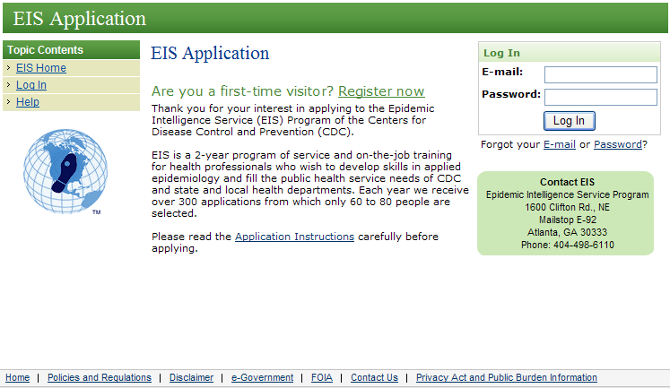
Figure 2.1—A

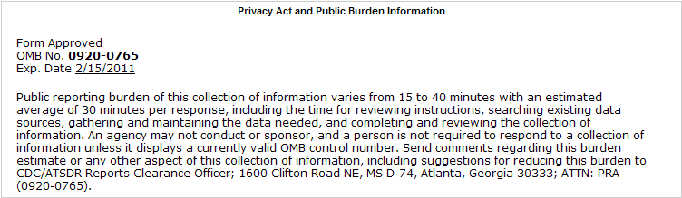 Figure 2.1—B

Registration Page
Column Name | Column Label | Entity | Figure | List of Values
First Name | First Name | Person | Figure 2.2—A | N/A
Middle Name | Middle Name | Person | Figure 2.2—A | N/A
Last Name | Last Name | Person | Figure 2.2—A | N/A
E-Mail | E-mail Address | Person | Figure 2.2—A | N/A
Phone Country Code | Country Code | Person | Figure 2.2—A | Countries
Phone Number | Primary Phone | Person | Figure 2.2—A | N/A
Password | Password | Person | Figure 2.2—B | N/A
Secret Question | Secret Question | Person | Figure 2.2—B | Secret questions
Secret Answer | Secret Answer | Person | Figure 2.2—B | N/A
Table 2.2

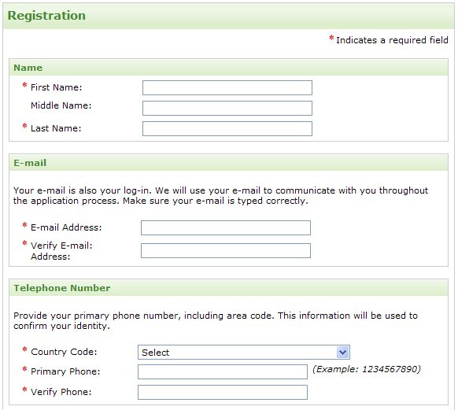
Figure 2.2—A

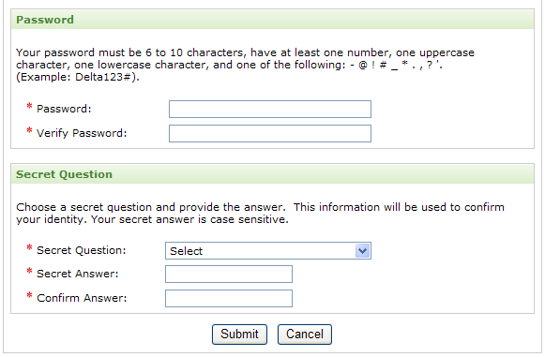
Figure 2.2—B

Forgot Your E-mail?
Column Name | Column Label | Entity | Figure | List of Values
First Name | First Name | Person | Figure 2.3—A | N/A
Middle Name | Middle Name | Person | Figure 2.3—D | N/A
Last Name | Last Name | Person | Figure 2.3—A | N/A
E-Mail | New E-mail | Person | Figure 2.3—D | N/A
Phone Country Code | Country Code | Person | Figure 2.3—A | Countries
Phone Number | Primary Phone Number | Person | Figure 2.3—A | N/A
Password | Password | Person | Figure 2.3—D | N/A
Secret Question | Secret Question | Person | Figure 2.3—B | Secret questions
Secret Answer | Secret Answer | Person | Figure 2.3—B | N/A
Table 2.3

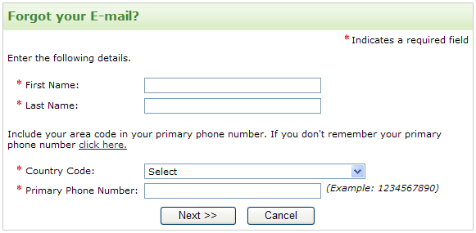
Figure 2.3—A

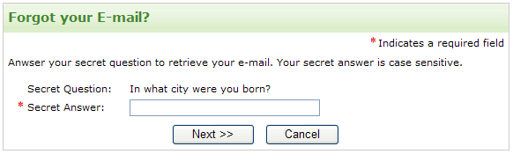
Figure 2.3—B

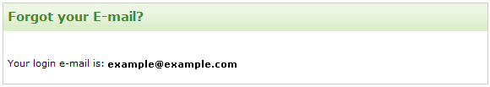
Figure 2.3—C

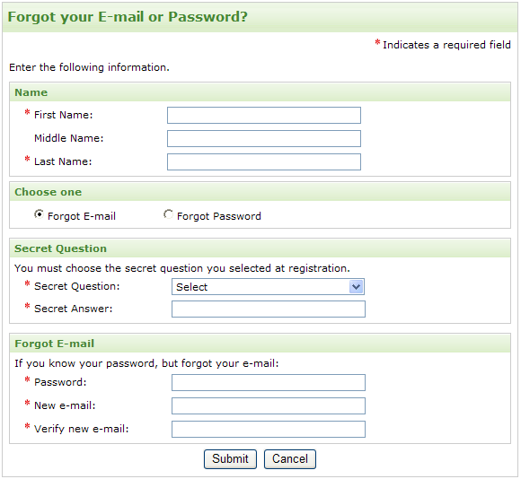
Figure 2.3—D

Forgot Your Password?
Column Name | Column Label | Entity | Figure | List of Values
First Name | First Name | Person | Figure 2.4—A | N/A
Middle Name | Middle Name | Person | Figure 2.4—D | N/A
Last Name | Last Name | Person | Figure 2.4—A | N/A
E-Mail | Login E-mail | Person | Figure 2.4—A | N/A
Phone Country Code | Country Code | Person | Figure 2.4—A | Countries
Phone Number | Primary Phone Number | Person | Figure 2.4—A | N/A
Password | Password | Person | Figure 2.4—C | N/A
Secret Question | Secret Question | Person | Figure 2.4—B | Secret questions
Secret Answer | Secret Answer | Person | Figure 2.4—B | N/A
Table 2.4

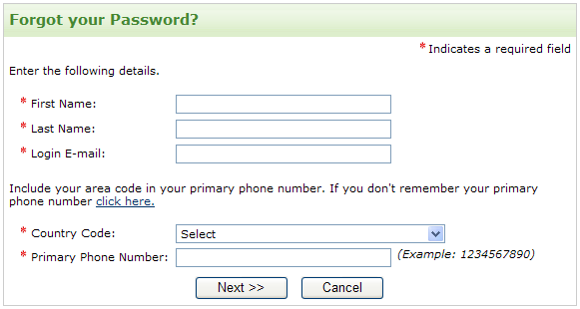
Figure 2.4—A

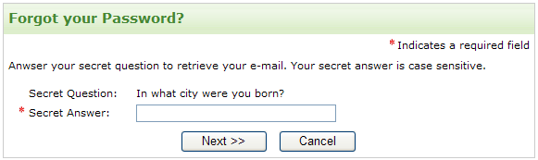
Figure 2.4—B

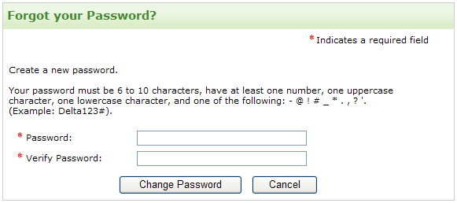
Figure 2.4—C
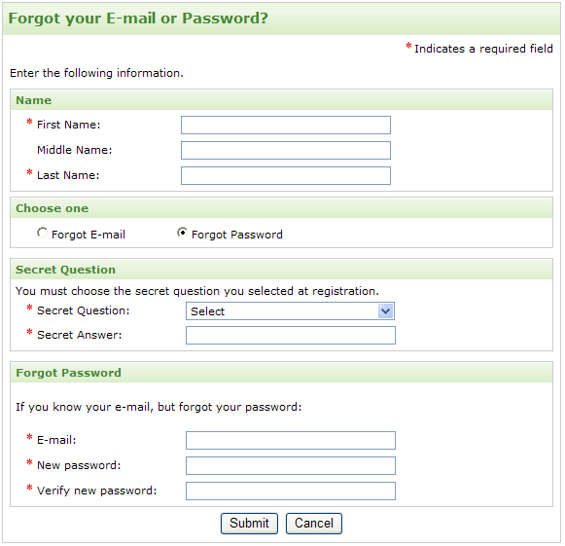
Figure 2.4—D

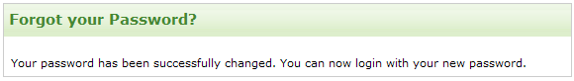
Figure 2.4—E

Reset Password
Column Name | Column Label | Entity | Figure | List of Values
E-Mail | E-mail | Person | Figure 2.5—A | N/A
Password | Current Password | Person | Figure 2.5—A | N/A
Secret Question | Secret Question | Person | Figure 2.5—A | Secret questions
Secret Answer | Secret Question Answer | Person | Figure 2.5—A | N/A
Table 2.5

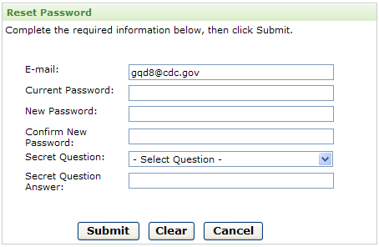
Figure 2.5—A

Application Instructions

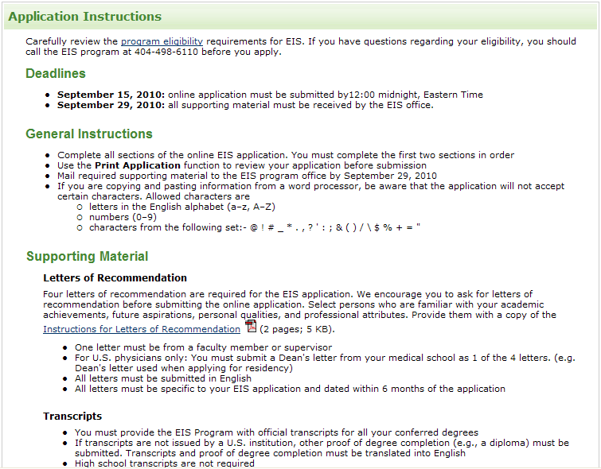
Figure 2.5—A
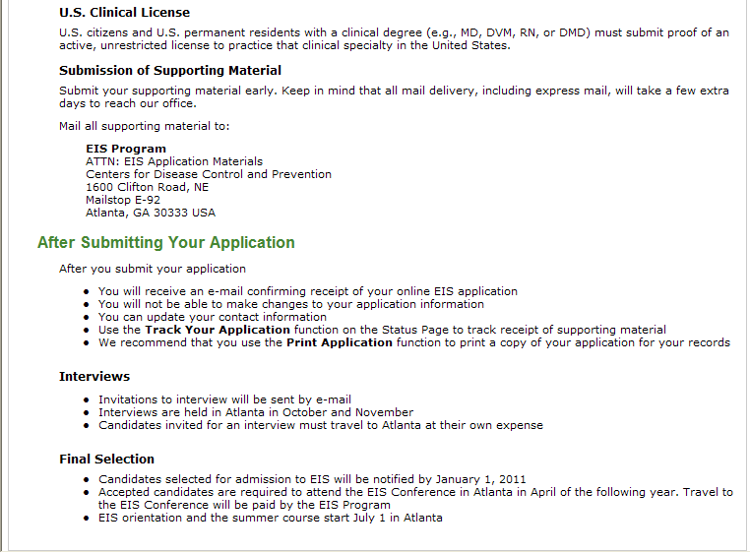
Figure 2.5—B

Status Page and Application Submission

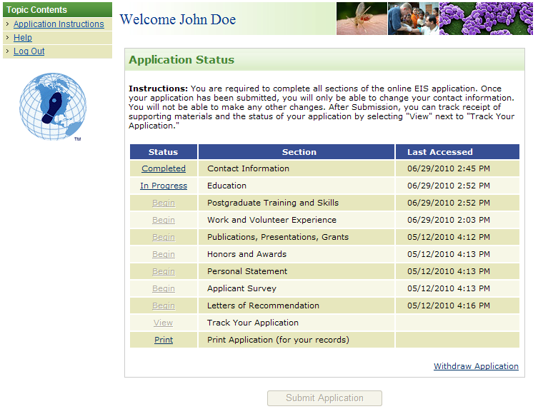
Figure 4

Authorization
Column Name | Column Label | Entity | Figure | List of Values
Terms agree | I certify that all information submitted in this online EIS application and any supporting materials are complete and accurate. I understand that my application will be rejected if the information I have provided is deemed to be false. | Application | Figure 4.1—A | N/A
Table 4.1

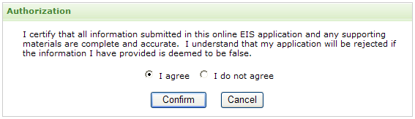
Figure 4.1—B

Pre-Submission Validation
Column Name | Column Label | Entity | Figure | List of Values
From date | Date From | Time- gap | Figure 4.2—A | N/A
To date | To | Time- gap | Figure 4.2—B | N/A
Gap explanation | Explanation | Time- gap | Figure 4.2—C | N/A
Table 4.2

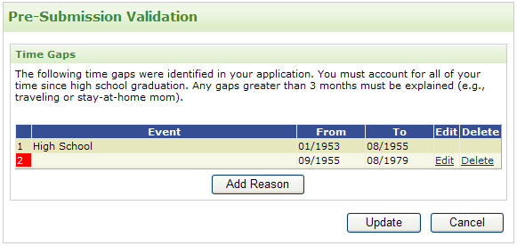
Figure 4.2—D

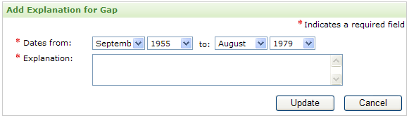
Figure 4.2—E

Contact Information
Column Name | Column Label | Entity | Figure | List of Values
First name | First name | Person | Figure 4.2—A | N/A
Middle name | Middle name | Person | Figure 4.2—A | N/A
Last name | Last name | Person | Figure 4.2—A | N/A
Suffix | Suffix | Person | Figure 4.2—A | N/A
Other name | Any other names that appear on your academic record | Person | Figure 4.2—A | N/A
E-Mail | E-Mail | Person | Figure 4.2—B | N/A
Mailing address line 1 | Address | Person | Figure 4.2—A | N/A
Mailing address line 2 |  | Person | Figure 4.2—A | N/A
Mailing address line 3 |  | Person | Figure 4.2—A | N/A
Mailing address country | Country | Person | Figure 4.2—A | Countries
Mailing address state | State | Person | Figure 4.2—A | States
Mailing address city | City | Person | Figure 4.2—A | N/A
Mailing address zip code | Zip/Postal code | Person | Figure 4.2—A | N/A
Phone country code | Country code | Person | Figure 4.2—B | Countries
Phone number | Primary phone | Person | Figure 4.2—B | N/A
Work phone number | Work | Person | Figure 4.2—B | N/A
Alternate phone number | Alternate | Person | Figure 4.2—B | N/A
Citizenship | Select your country of citizenship | Person | Figure 4.2—B | Countries
U.S. permanent resident | Are you a U.S. permanent resident? | Person | Figure 4.2—C | N/A
Green card number | Green card number | Person | Figure 4.2—D | N/A
Green card expiration date | Expiration | Person | Figure 4.2—D | N/A
Currently live in the U.S | Do you currently live in the U.S? | Person | Figure 4.2—C | N/A
Visa type | Visa type | Person | Figure 4.2—C | Visa types
Visa expiration date | Expiration | Person | Figure 4.2—C | N/A
Emergency contact name | Name | Person | Figure 4.2—B | N/A
Emergency contact relationship to you | Relationship to you | Person | Figure 4.2—B | N/A
Emergency contact phone | Telephone | Person | Figure 4.2—B | N/A
Emergency contact e-mail | E-mail | Person | Figure 4.2—B | N/A
Table 5
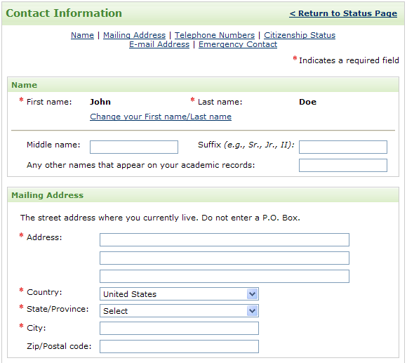
Figure 4.2—A

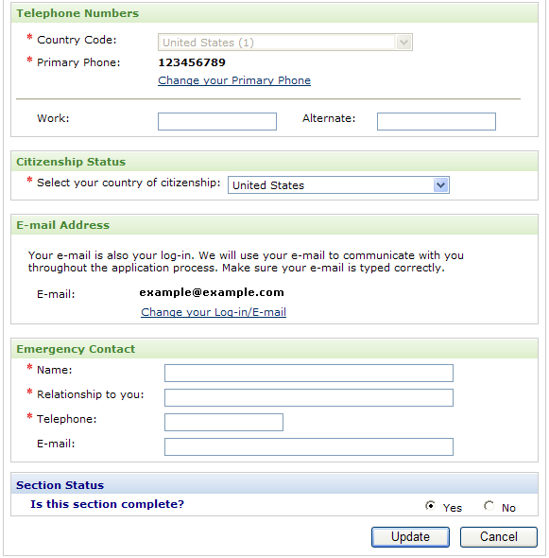
Figure 4.2—B

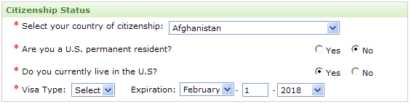
Figure 4.2—C

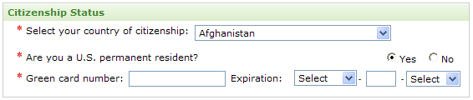
Figure 4.2—D

Education

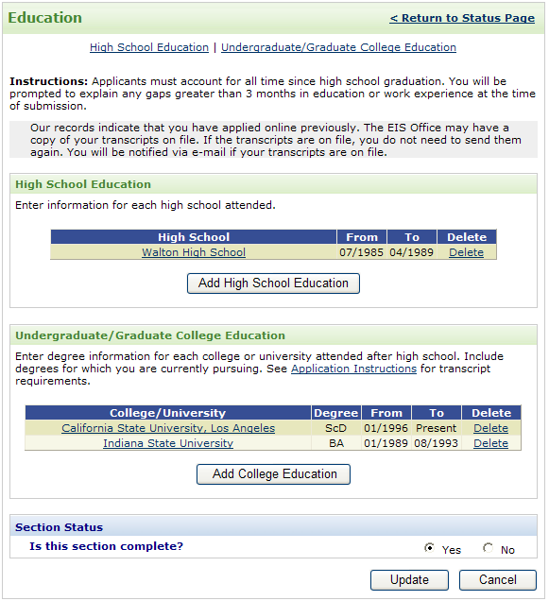
Figure 6

High School Education
Column Name | Column Label | Entity | Figure | List of Values
Name | High School | High school education | Figure 6.1—A | N/A
Country | Country | High school education | Figure 6.1—A | Countries
State | State | High school education | Figure 6.1—A | States
City | City | High school education | Figure 6.1—A | N/A
From date | Attended from | High school education | Figure 6.1—A | N/A
To date | To | High school education | Figure 6.1—A | N/A
GPA | Grade Point Average | High school education | Figure 6.1—A | N/A
Academic honor | Did you receive an academic honor at this institution? | High school education | Figure 6.1—A | N/A
Academic honor type | Type | High school education | Figure 6.1—A | N/A
Table 6.1

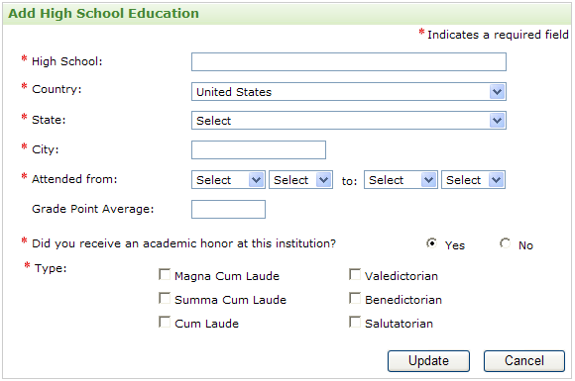
Figure 6.1—A

College/University Education
Column Name | Column Label | Entity | Figures | List of Values
Country | Country | College education | Figure 6.2—A | Countries
State | State/Province | College education | Figure 6.2—A | States
Name | College/University | College education | Figure 6.2—A | College names
From date | Attended from | College education | Figure 6.2—A | N/A
To date | To | College education | Figure 6.2—A | N/A
Status | Status | College education | Figure 6.2—A | College education statuses
Degree | Degree | College education | Figure 6.2—A | Degrees
Degree date expected | Date expected | College education | Figure 6.2—A | N/A
Major | Major | College education | Figure 6.2—A | N/A
Major classification | Major classification | College education | Figure 6.2—A | Major classifications
Minor | Minor/certificate/  specialty | College education | Figure 6.2—A | N/A
GPA | Grade Point Average | College education | Figure 6.2—A | N/A
Complete Thesis | Did you complete a thesis/dissertation/equivalent? | College education | Figure 6.2—A | N/A
Thesis | Title | College education | Figure 6.2—A | N/A
Academic honor | Did you receive an academic honor at this institution? | College education | Figure 6.2—A | N/A
Academic honor type | Type | College education | Figure 6.2—A | N/A
Degree Incomplete Reason | Reason | College education | Figure 6.2—B | N/A
Active unrestricted  U.S. license | Do you have or are you expecting an active unrestricted U.S. license to practice your specialty? | College education | Figure 6.2—A | N/A
License status | Status | License | Figure 6.2—D | Licenses statuses
Issuing state | Issuing state | License | Figure 6.2—D | States
License number | License number | License | Figure 6.2—D | N/A
Expiration date | Expiration date | License | Figure 6.2—D | N/A
Expected date | Expected date | License | Figure 6.2—D | N/A
Table 6.2
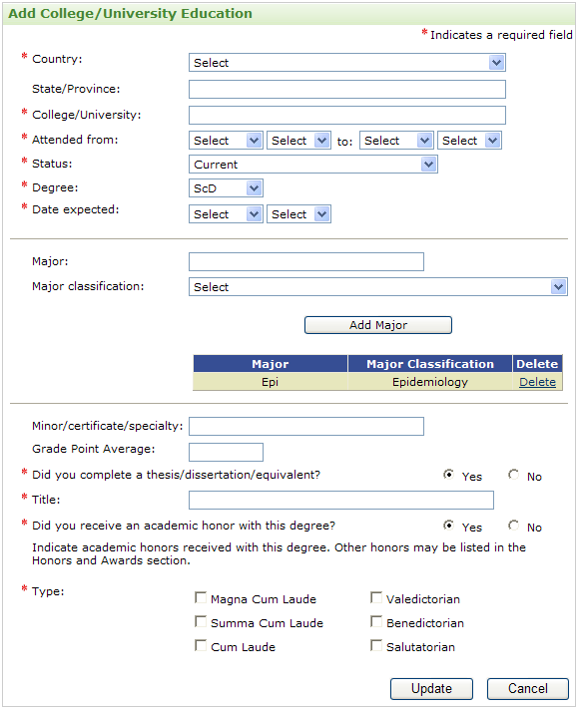
Figure 6.2—A

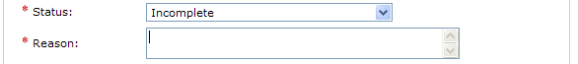
Figure 6.2—B

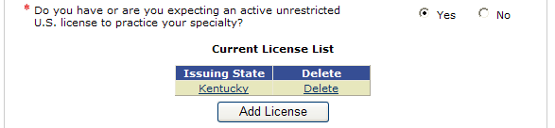
Figure 6.2—C

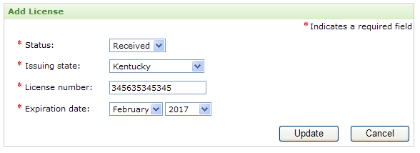
Figure 6.2—D

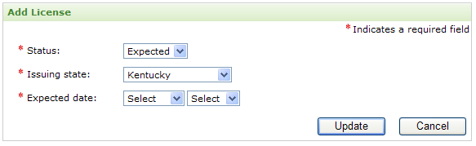
Figure 6.2—E

Postgraduate Training and Skills
Column Name | Column Label | Entity | Figure | List of Values
Has clinical training | Do you have postgraduate clinical training? | Person | Figure 6.2—A | N/A
Is Board certified | Are you Board certified or Board eligible in the United States? | Person | Figure 6.2—A | N/A
Has additional training | Did you complete additional training not entered in the Education section? | Person | Figure 6.2—A | N/A
Language name | Secondary Language | Language | Figure 6.2—A | Languages
Native language | Primary Language | Language | Figure 6.2—A | Languages
Reading skill | Read | Language | Figure 6.2—A | Proficiencies
Writing skill | Write | Language | Figure 6.2—A | Proficiencies
Speaking skill | Speak | Language | Figure 6.2—A | Proficiencies
Table 7
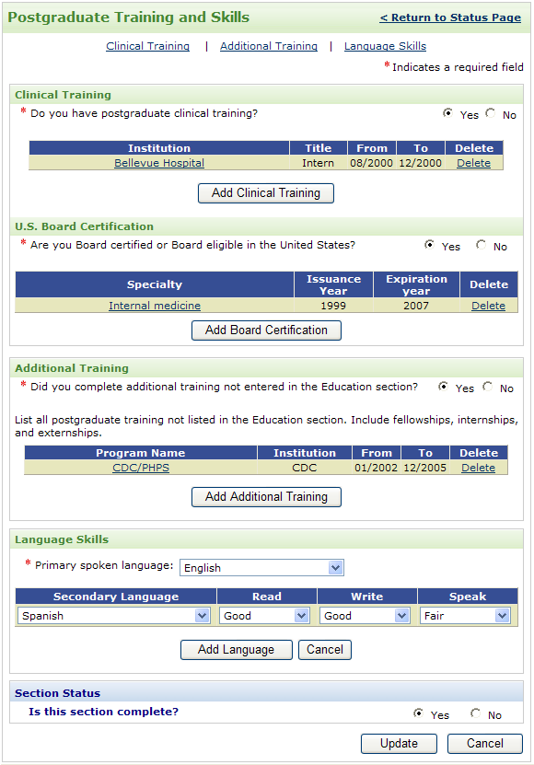
Figure 6.2—A

Clinical Training
Column Name | Column Label | Entity | Figure | List of Values
Title | Title | Clinical Training | Figure 7.1—A | Clinical title
Specialty | Specialty | Clinical Training | Figure 7.1—A | Specialties
Institution name | Institution name | Clinical Training | Figure 7.1—A | N/A
Country | Country | Clinical Training | Figure 7.1—A | Countries
State | State/Province | Clinical Training | Figure 7.1—A | States
City | City | Clinical Training | Figure 7.1—A | N/A
From date | Dates from | Clinical Training | Figure 7.1—A | N/A
To date | To | Clinical Training | Figure 7.1—A | N/A
Table 7.1

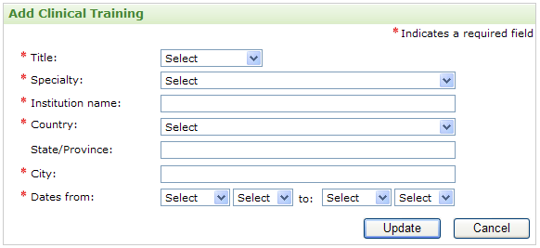
Figure 7.1—A

Board Certification
Column Name | Column Label | Entity | Figure | List of Values
Status | Status | Board Certification | Figure 7.2—A | Board statuses
Specialty | Specialty | Board Certification | Figure 7.2—A | Specialties
Most recent issuance date | Most recent issuance date | Board Certification | Figure 7.2—A | N/A
Most recent expiration date | Most recent expiration date | Board Certification | Figure 7.2—A | N/A
Expected date | Expected date | Board Certification | Figure 7.2—B | N/A
Table 7.2

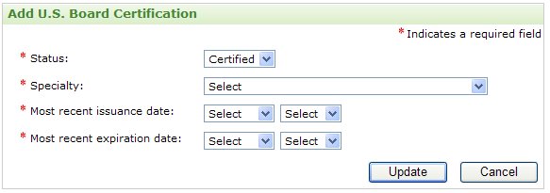
Figure 7.2—A

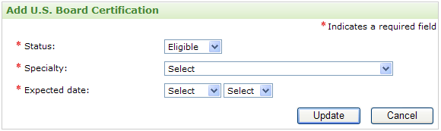
Figure 7.2—B

Additional Training
Column Name | Column Label | Entity | Figure | List of Values
Program name | Program name | Additional Training | Figure 7.3—A | Program names
Other program name | Specify program name | Additional Training | Figure 7.3—A | N/A
Description | Description | Additional Training | Figure 7.3—A | N/A
Institution name | Institution name | Additional Training | Figure 7.3—A | N/A
Country | Country | Additional Training | Figure 7.3—A | Countries
State | State/Province | Additional Training | Figure 7.3—A | States
City | City | Additional Training | Figure 7.3—A | N/A
From date | Dates from | Additional Training | Figure 7.3—A | N/A
To date | To | Additional Training | Figure 7.3—A | N/A
Table 7.3

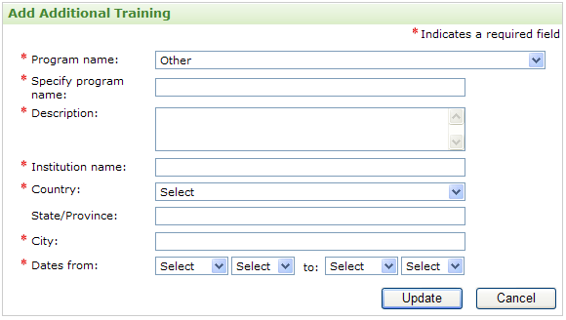
Figure 7.3—A

Work and Volunteer Experience
Column Name | Column Label | Entity | Figure | List of Values
Has work experience | Do you have work experience? | Person | Figure 7.3—A | N/A
Has volunteer experience | Do you have community or volunteer service experience? | Person | Figure 7.3—A | N/A
Table 8

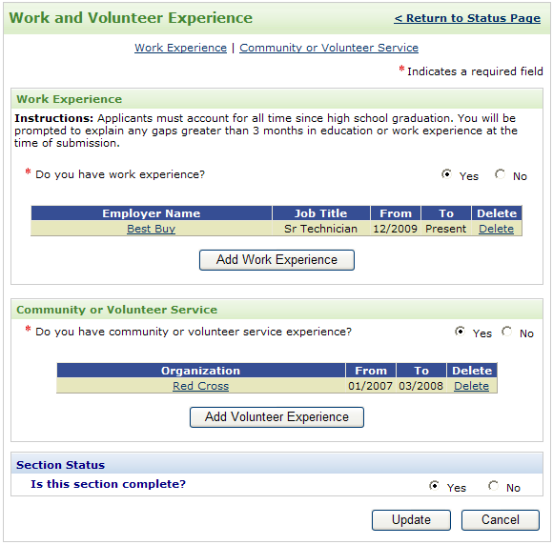
Figure 7.3—A

Work Experience
Column Name | Column Label | Entity | Figure | List of Values
Name | Employer | Work experience | Figure 8.1—A | N/A
Address Line 1 | Address | Work experience | Figure 8.1—A | N/A
Address Line 2 |  | Work experience | Figure 8.1—A | N/A
Address Line 3 |  | Work experience | Figure 8.1—A | N/A
Country | Country | Work experience | Figure 8.1—A | Countries
State | State/Province | Work experience | Figure 8.1—A | States
City | City | Work experience | Figure 8.1—A | N/A
Zip code | Zip/Postal code | Work experience | Figure 8.1—A | N/A
From date | Dated from | Work experience | Figure 8.1—A | N/A
To date | To | Work experience | Figure 8.1—A | N/A
Job title | Job title | Work experience | Figure 8.1—A | N/A
Hours per week | Hours per week | Work experience | Figure 8.1—A | N/A
Job duties and responsibilities | Job duties/ Responsibilities | Work experience | Figure 8.1—A | N/A
Reason for leaving | Reason for leaving | Work experience | Figure 8.1—A | N/A
Supervisor name | Supervisor name | Work experience | Figure 8.1—A | N/A
Contact supervisor | May we contact your supervisor? | Work experience | Figure 8.1—A | N/A
Supervisor Phone | Phone | Work experience | Figure 8.1—A | N/A
Supervisor E-mail | E-mail | Work experience | Figure 8.1—A | N/A
Reason not to contact supervisor | Reason | Work experience | Figure 8.1—B | N/A
Table 8.1
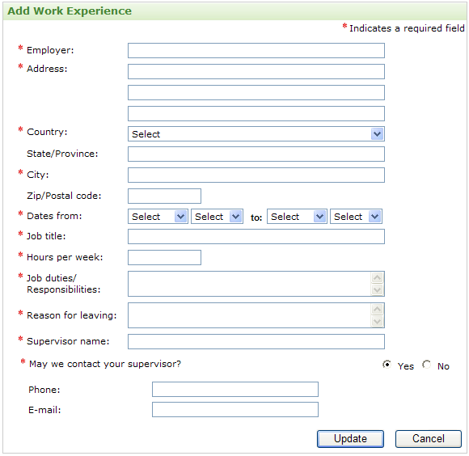
Figure 8.1—A

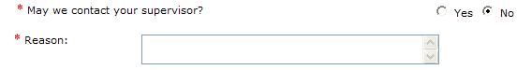
Figure 8.1—B

Volunteer Experience
Column Name | Column Label | Entity | Figure | List of Values
Name | Organization | Volunteer experience | Figure 8.2—A | N/A
Address Line 1 | Address | Volunteer experience | Figure 8.2—A | N/A
Address Line 2 |  | Volunteer experience | Figure 8.2—A | N/A
Address Line 3 |  | Volunteer experience | Figure 8.2—A | N/A
Country | Country | Volunteer experience | Figure 8.2—A | Countries
State/Province | State/Province | Volunteer experience | Figure 8.2—A | States
City | City | Volunteer experience | Figure 8.2—A | N/A
Zip code | Zip/Postal code | Volunteer experience | Figure 8.2—A | N/A
From date | Dated from | Volunteer experience | Figure 8.2—A | N/A
To date | To | Volunteer experience | Figure 8.2—A | N/A
Title | Title | Volunteer experience | Figure 8.2—A | N/A
Hours per week | Hours per week | Volunteer experience | Figure 8.2—A | N/A
Duties and Responsibilities | Duties/ Responsibilities | Volunteer experience | Figure 8.2—A | N/A
Reason for leaving | Reason for leaving | Volunteer experience | Figure 8.2—A | N/A
Supervisor name | Supervisor name | Volunteer experience | Figure 8.2—A | N/A
Contact supervisor | May we contact your supervisor? | Volunteer experience | Figure 8.2—A | N/A
Supervisor Phone | Phone | Volunteer experience | Figure 8.2—A | N/A
Supervisor E-mail | E-mail | Volunteer experience | Figure 8.2—A | N/A
Reason not to contact supervisor | Reason | Volunteer experience | Figure 8.2—B | N/A
Table 8.2
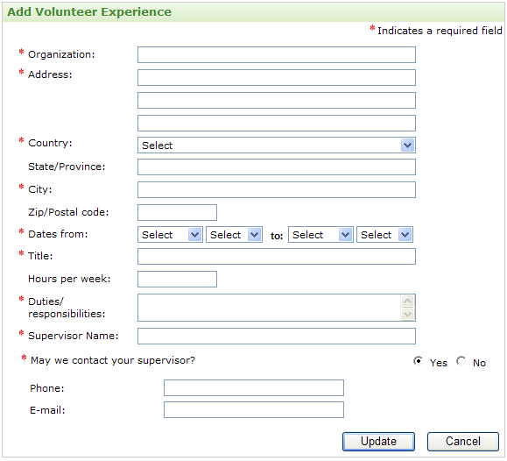
Figure 8.2—A

Figure 8.2—B

Publications, Presentations, Grants
Column Name | Column Label | Entity | Figure | List of Values
Has published | Have you published articles? | Person | Figure 8.2—A | N/A
Has professional presentations | Have you made professional presentations? | Person | Figure 8.2—A | N/A
Has research grants | Have you been awarded research grants? | Person | Figure 8.2—A | N/A
Table 9
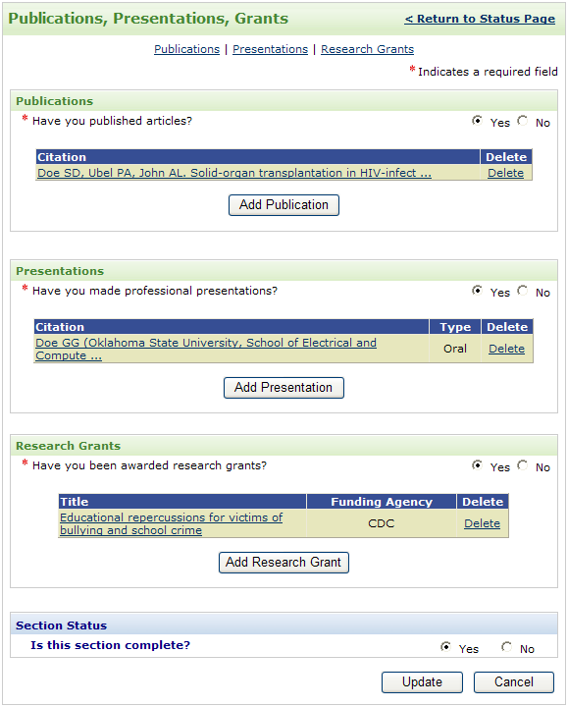
Figure 8.2—A

Publication
Column Name | Column Label | Entity | Figure | List of Values
Citation | Publication citation | Publication | Figure 9.1—A | N/A
Table 9.1

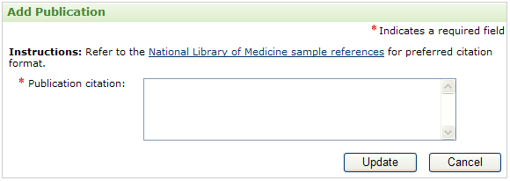
Figure 9.1—A

Presentation
Column Name | Column Label | Entity | Figure | List of Values
Presentation Type | Type of presentation | Presentation | Figure 9.2—A | N/A
Citation | Citation | Presentation | Figure 9.2—A | N/A
Table 9.2

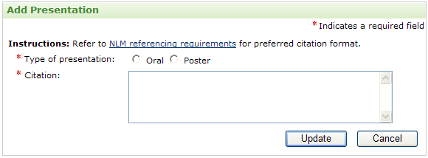
Figure 9.2—A

Research Grants
Column Name | Column Label | Entity | Figure | List of Values
Title | Title | Research grant | Figure 9.3—A | N/A
Role | Your Role | Research grant | Figure 9.3—A | Research roles
Date | Date | Research grant | Figure 9.3—A | N/A
Funding agency | Funding agency | Research grant | Figure 9.3—A | N/A
Amount awarded | Amount awarded | Research grant | Figure 9.3—A | Research grant amounts
Table 9.3

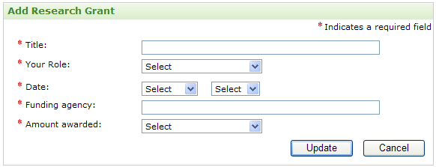
Figure 9.3—A

Honors and Awards
Column Name | Column Label | Entity | Figure | List of Values
Has honors and awards | Have you received or earned any honors or awards? | Person | Figure 9.3—A | N/A
Organization | Name of organization bestowing honor or award | Honor Or Award | Figure 9.3—B | N/A
Name | Name of honor or award | Honor Or Award | Figure 9.3—B | N/A
Type | Type | Honor Or Award | Figure 9.3—B | Honor Types
Date | Date | Honor Or Award | Figure 9.3—B | N/A
Table 10

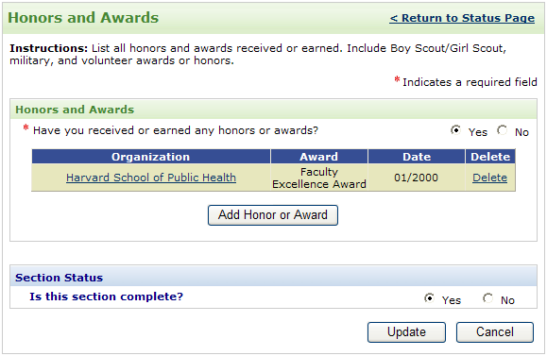
Figure 9.3—A
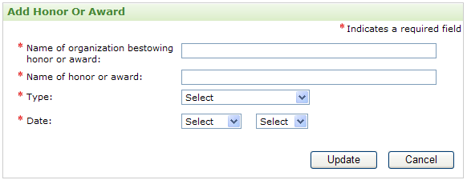
Figure 9.3—B

Personal Statement
Column Name | Column Label | Entity | Figure | List of Values
Personal statement | Personal statement | Personal statement | Figure 9.3—A | N/A
Table 11

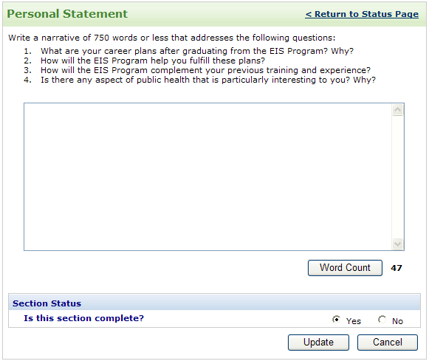
Figure 9.3—A

Applicant Survey
Column Name | Column Label | Entity | Figure | List of Values
Applied before | Have you submitted an application to EIS before? | Applicant Survey | Figure 9.3—A | N/A
Applied Year | Indicate years applied | Applicant Survey | Figure 9.3—A | N/A
Applied Epi Elec | Did you participate in the CDC Epidemiology Elective Program for Medical and Veterinary students? | Applicant Survey | Figure 9.3—A | N/A
Epi Elec Year | Indicate year | Applicant Survey | Figure 9.3—A | N/A
Applied CDC Exp | Did you participate in The CDC Experience Applied  Epidemiology Fellowship? | Applicant Survey | Figure 9.3—A | N/A
Applied CDC Exp Year | Indicate year | Applicant Survey | Figure 9.3—A | N/A
Hear about program | How did you hear about EIS? | Applicant Survey | Figure 9.3—B | Hear about us options
Most critical | Which of these was most critical in your decision to apply to EIS? | Applicant Survey | Figure 9.3—B | Hear about us options
Areas of Interest ranking | Which EIS assignment areas are of interest to you? | Applicant Survey | Figure 9.3—C | Areas of Interests
Assignment location preference | What is your preference for location of EIS assignment? | Applicant Survey | Figure 9.3—D | N/A
Assignment location preference states | Indicate state preferences | Applicant Survey | Figure 9.3—D | N/A
Assignment location constraints | Do you have geographic constraints on EIS assignments? | Applicant survey | Figure 9.3—E | N/A
Location constraints explanation | If yes, explain | Applicant survey | Figure 9.3—E | N/A
Table 12

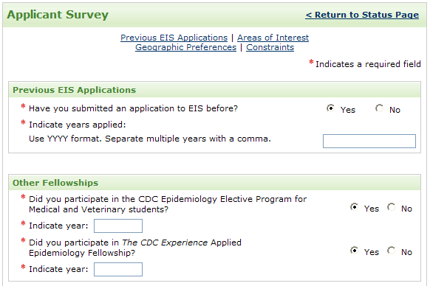
Figure 9.3—A

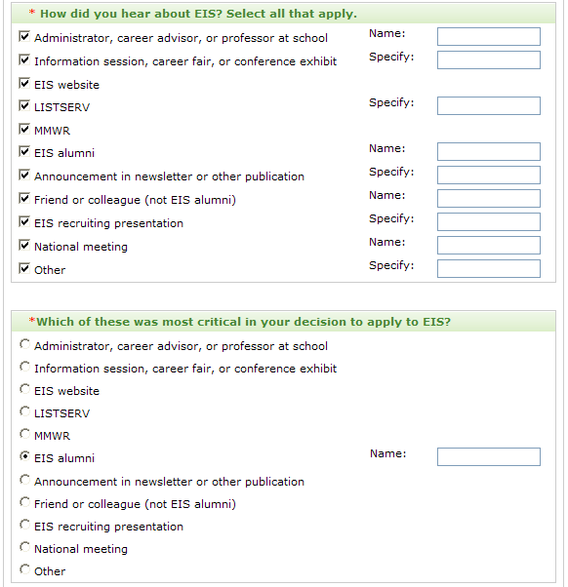
Figure 9.3—B
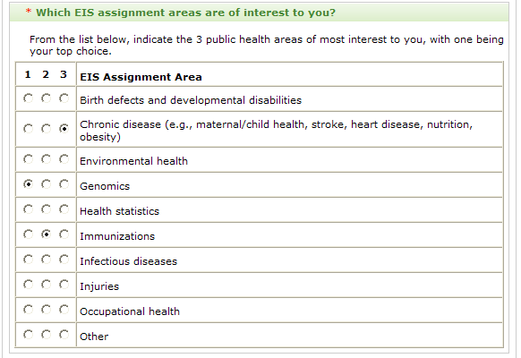
Figure 9.3—C

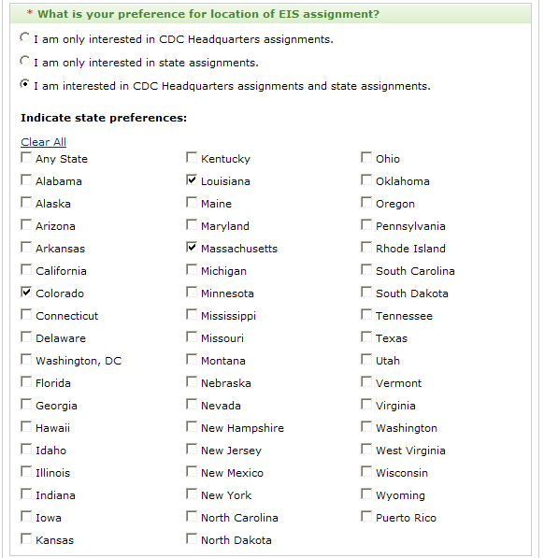
Figure 9.3—D
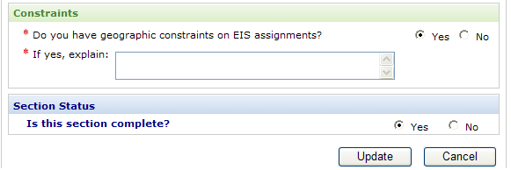
Figure 9.3—E

Letters of Recommendation
Column Name | Column Label | Entity | Figure | List of Values
Name | Name | Letters of recommendations | Figure 9.3—B | N/A
Dean of medical school | Check if dean of medical school | Letters of recommendations | Figure 9.3—B | N/A
Organization | Organization | Letters of recommendations | Figure 9.3—B | N/A
Title | Title | Letters of recommendations | Figure 9.3—B | N/A
Phone | Phone | Letters of recommendations | Figure 9.3—B | N/A
E-mail | E-mail | Letters of recommendations | Figure 9.3—B | N/A
Address Line 1 | Mailing Address | Letters of recommendations | Figure 9.3—B | N/A
Address Line 2 |  | Letters of recommendations | Figure 9.3—B | N/A
Address Line 3 |  | Letters of recommendations | Figure 9.3—B | N/A
Country | Country | Letters of recommendations | Figure 9.3—B | Countries
State | State/Province | Letters of recommendations | Figure 9.3—B | States
City | City | Letters of recommendations | Figure 9.3—B | N/A
Zip code | Zip/Postal code | Letters of recommendations | Figure 9.3—B | N/A
Relationship to you | Relationship to you | Letters of recommendations | Figure 9.3—B | N/A
Table 13
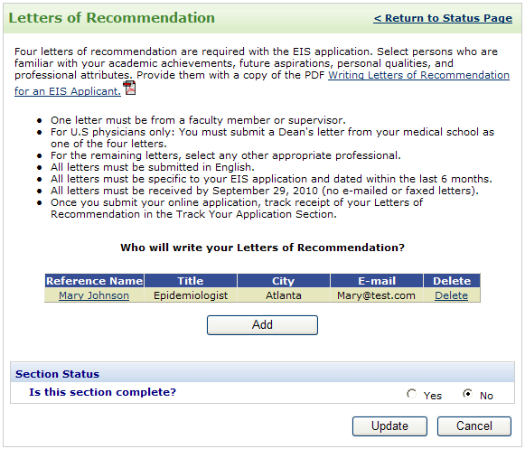
Figure 9.3—A
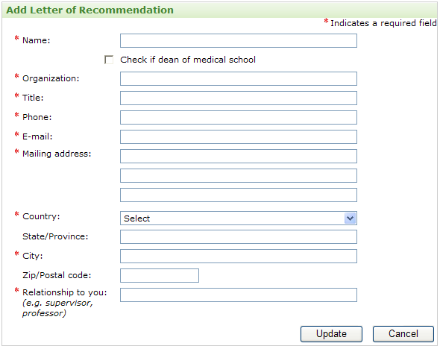
Figure 9.3—B

Withdraw Application
Column Name | Column Label | Entity | Figure | List of Values
Withdrawal Reason | Provide reason for withdrawal | Application | Figure 9.3—A | N/A
Table 14

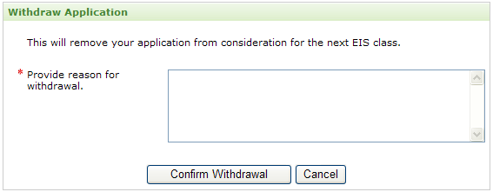
Figure 9.3—B

Appendix A – E-mails

Applicant Reset Password Information
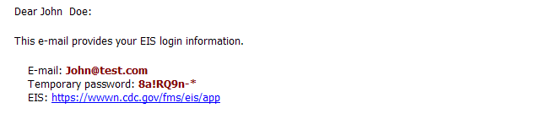
Figure 15-A

Application Submission Confirmation
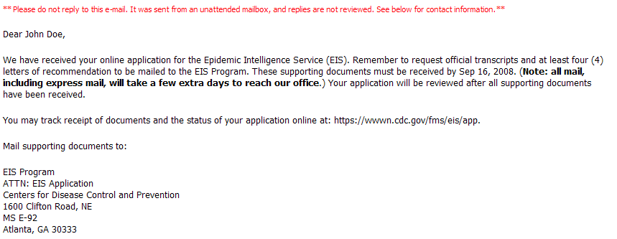
Figure 15-B

Application Submission Reminder
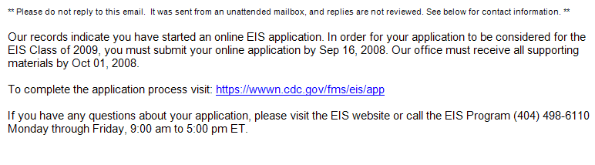
Figure 15-c

Interview Invitation for US Applicants
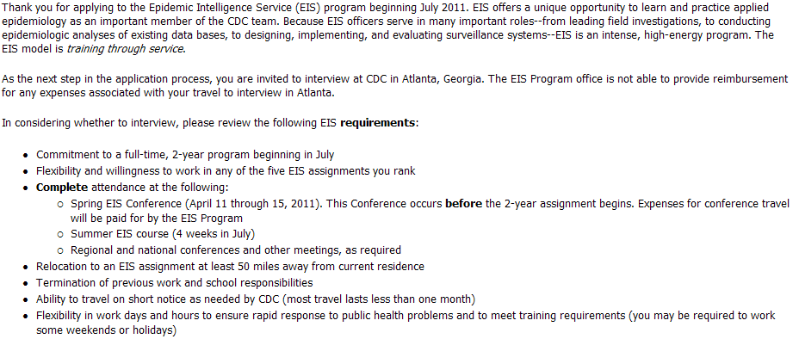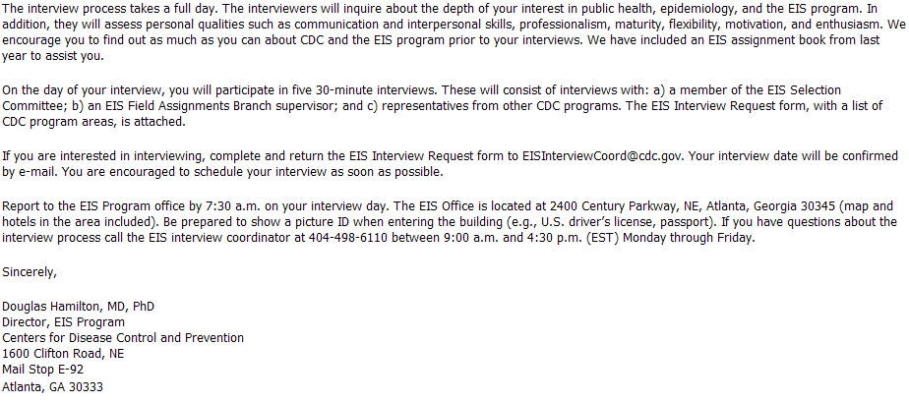
Figure 15-g

Interview Invitation for International Applicants
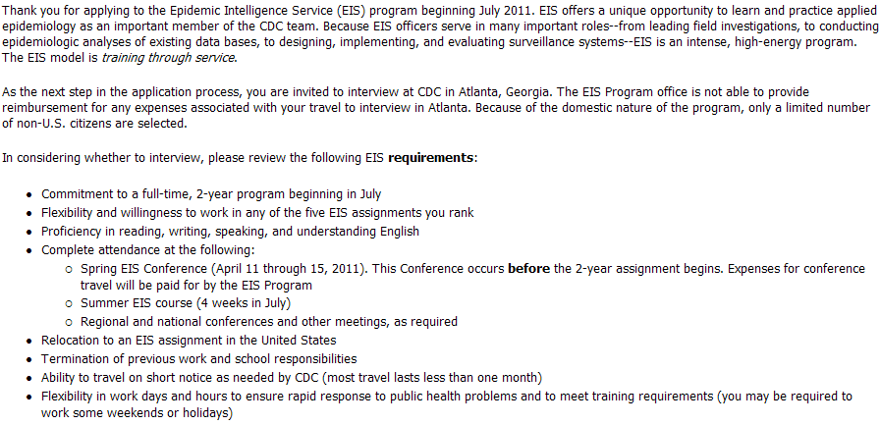
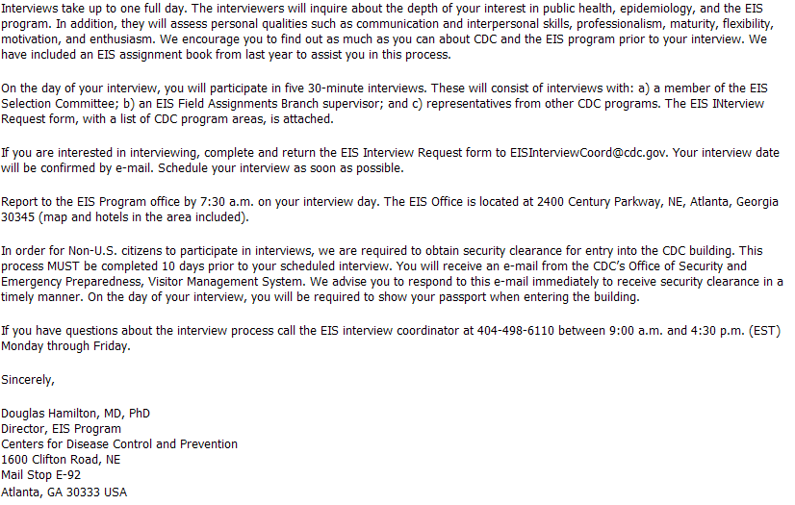
Figure 15-e

Interview Confirmation for US Applicants
 Figure 15-f

Interview Confirmation for International Applicants
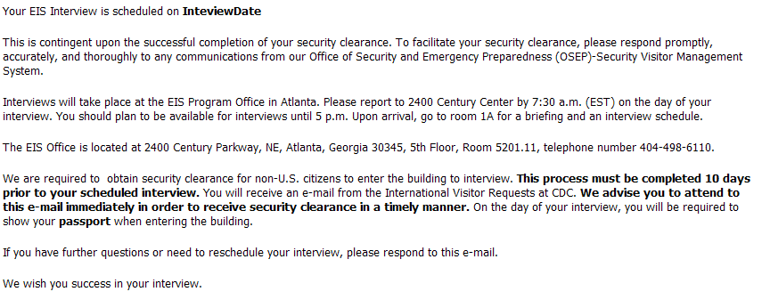
Figure 15-d

Appendix B – Changes In Other Programs

PHIFP Differences

Contact Infortmation
Column Name | Column Label | Entity | List of Values
Fax Number | Fax | Person | N/A

Self-Assessment of Skills
Column Name | Column Label | Entity | List of Values
Information Science Skill type | Skill type | Skill Assessment | Information Science Skills
Information Science Skill Level | Skill level | Skill Assessment | Skill Levels
Information Science Experience | Experience | Skill Assessment | N/A
Computer Science Skill type | Skill type | Skill Assessment | Computer Science Skills
Computer Science Skill Level | Skill level | Skill Assessment | Skill Levels
Computer Science Experience | Experience | Skill Assessment | N/A
Information Systems Skill type | Skill type | Skill Assessment | Information Systems Skills
Information Systems Skill Level | Skill level | Skill Assessment | Skill Levels
Information Systems Experience | Experience | Skill Assessment | N/A
Project Management Skill type | Skill type | Skill Assessment | Project Management Skills
Project Management Skill Level | Skill level | Skill Assessment | Skill Levels
Project Management Experience | Experience | Skill Assessment | N/A
Public Health and health care Skill type | Skill type | Skill Assessment | Public Health and health care Skills
Public Health and health care Skill Level | Skill level | Skill Assessment | Skill Levels
Public Health and health care Experience | Experience | Skill Assessment | N/A
Information Technology Skill type | Skill type | Skill Assessment | Information Technology Skills
Information Technology Level | Skill level | Skill Assessment | Skill Levels
Information Technology Experience | Experience | Skill Assessment | N/A

PHPS Differences

Self-Assessment of Skills
Column Name | Column Label | Entity | List of Values
Computer Skills type | Skill type | Skill Assessment | Computer Skills
Computer skill Level | Skill level | Skill Assessment | Skill Levels
Transcript Analysis type | Transcript Analysis type | Transcript Analysis | Transcript Analysis types
Hours | Hours | Transcript Analysis | N/A

Hubert differences

Contact Information
Column Name | Column Label | Entity | List of Values
Health Insurance | Health Insurance | Person | N/A

College/University Education
Column Name | Column Label | Entity | List of Values
Year in school | Year in school | College education | N/A
Is Public | Is Public | College education | N/A
Clinical Rotations | Clinical Rotations | College education | N/A

Project Ranking
Column Name | Column Label | Entity | List of Values
Project | Project | Project Ranking | Projects list
Rank | Rank | Project Ranking | 1,2,3,4,5

Self-Assessment of Skills
Column Name | Column Label | Entity | List of Values
Statistical Software Skills type | Skill type | Skill Assessment | Statistical Software Skills
Statistical Software Skill Level | Skill level | Skill Assessment | Skill Levels
Other statistical skill | Other statistical skill | Skill Assessment | N/A
Laboratory Skill | Laboratory Skill | Skill Assessment | N/A

Epi elective differences

Assignment Preference
Column Name | Column Label | Entity | List of Values
First choice from | Time frame first choice from date | Assignment Preference | N/A
First choice to | Time frame first choice to date | Assignment Preference | N/A
Second choice from | Time frame second choice from date | Assignment Preference | N/A
Second choice to | Time frame second choice to date | Assignment Preference | N/A
Subject Area Preference | Subject Area Preference | Assignment Preference | Subject Areas
Project Name | Project Name | Assignment Preference | Projects list
Rank | Rank | Assignment Preference | 1,2,3,4,5
Supervisor Name | Supervisor Name | Assignment Preference | N/A

PEF Differences

College/University Education
Column Name | Column Label | Entity | List of Values
Thesis Title | Thesis Title | College education | N/A
Thesis Abstract | Thesis Abstract | College education | N/A

Work Papers
Column Name | Column Label | Entity | List of Values
Title | Title | Work Paper | N/A
Abstract | Abstract | Work Paper | N/A

Research experience
Column Name | Column Label | Entity | List of Values
Title | Title | Research Experience | N/A
Institution | Institution | Research Experience | N/A
Your role | Your role | Research Experience | Research roles
Specify role | Specify role | Research Experience | N/A
Dates from | Dates from | Research Experience | N/A
Dates to | Dates to | Research Experience | N/A
Description | Description | Research Experience | N/A

Assignment Overview and Ranking
Column Name | Column Label | Entity | List of Values
Project Rank | Project Rank | Project Rank | 1,2,3,4,5

Self-Assessment of Skills
Column Name | Column Label | Entity | List of Values
Computer software skill | Computer software skill | Skill Assessment | Computer software skills
Skill level | Skill level | Skill Assessment | Skill Levels
Economic and public health data | Economic and public health data | Skill Assessment | N/A

PMRF differences

Education
Column Name | Column Label | Entity | List of Values
Select Program | Select Program | Person | PMRF programs
Have current license | Do you have current, unrestricted license | Person | N/A

College/University Education
Column Name | Column Label | Entity | List of Values
Are you board certified? | Are you board certified? | College education | N/A
Certification body | Certification body | College education | N/A

Additional Course
Column Name | Column Label | Entity | List of Values
Country | Country | Course work | Countries
State | State/Province | Course work | States
Name | College/University | Course work | College names
From date | Attended from | Course work | N/A
To date | To | Course work | N/A
Expected date | Expected date | Course work | N/A
Course status | Course status | Course work | Course status values
Credits | Number of credits | Course work | N/A
Course Name | Course Name | Course work | N/A

Clinical Training
Column Name | Column Label | Entity | List of Values
Accredited by ACGME | Accredited by ACGME | Clinical training | N/A

Work and Volunteer Experience
Column Name | Column Label | Entity | List of Values
Current USPHS commissioned corps officer | Current USPHS commissioned corps officer | Person | N/A
Corps Rank | Corps Rank | Person | Corps Ranks

Work Experience
Column Name | Column Label | Entity | List of Values
Accomplishments | Accomplishments | Work Experience | N/A

Volunteer Experience
Column Name | Column Label | Entity | List of Values
Accomplishments | Accomplishments | Volunteer Experience | N/A

Monographs and Reports
Column Name | Column Label | Entity | List of Values
Citation | Citation | Monographs | N/A

Personal Statement
Column Name | Column Label | Entity | List of Values
Current EIS officer | Current EIS officer or graduate within past two years | Personal statement | N/A
Public health practice summary | Public health practice summary | Personal statement | N/A

Applicant Survey
Column Name | Column Label | Entity | List of Values
Work Experience area | Your work experience? | Applicant Survey | Work Experience Types

Peer References
Column Name | Column Label | Entity | List of Values
Name | Name | Peer References | N/A
Organization | Organization | Peer References | N/A
Title | Title | Peer References | N/A
Phone | Phone | Peer References | N/A
E-mail | E-mail | Peer References | N/A

PHAP differences

Contact Information
Column Name | Column Label | Entity | List of Values
College address line 1 | College address | Person | N/A
College address line 2 |  | Person | N/A
College address line 3 |  | Person | N/A
College address country | College country | Person | Countries
College address state | College state | Person | States
College address city | College city | Person | N/A
College address zip code | College zip/postal code | Person | N/A
College address from date | College address from date | Person | N/A
College address to date | College address to date | Person | N/A
Cell phone | Cell phone | Person | N/A
Naturalization number | Naturalization number | Person | N/A
Communication e-mail | Communication e-mail | Person | N/A

Appendix C – List Of Values

Countries

- Afghanistan
- Albania
- Algeria
- Andorra
- Angola
- Anguilla (U.K.)
- Antigua and Barbuda
- Argentina
- Armenia
- Aruba
- Australia
- Austria
- Azerbaijan
- Azores
- Bahamas, The
- Bahrain
- Bangladesh
- Barbados
- Belarus
- Belgium
- Belize
- Benin
- Bermuda (U.K.)
- Bhutan
- Bolivia
- Bosnia and Herzegovina
- Botswana
- Brazil
- British Indian Ocean Territory (U.K.)
- British Virgin Islands
- Brunei
- Bulgaria
- Burkina Faso
- Burma (Myanmar)
- Burundi
- Cambodia
- Cameroon
- Canada
- Canary Islands (Spain)
- Cape Verde
- Cayman Islands (U.K.)
- Central African Republic
- Chad
- Chile
- China
- Christmas Island (Australia)
- Cocos (Keeling) Islands (Australia)
- Colombia
- Comoros
- Congo, Democratic Republic of the
- Congo, Republic of the
- Cook Islands (New Zealand)
- Costa Rica
- Côte d'Ivoire
- Croatia
- Cuba
- Cyprus
- Czech Republic
- Denmark
- Djibouti
- Dominica
- Dominican Republic
- Easter Island (Chile)
- Ecuador
- Egypt
- El Salvador
- Equatorial Guinea
- Eritrea
- Estonia
- Ethiopia
- Falkland Islands (Malvinas)
- Falkland Islands (U.K.)
- Faroe Islands (Denmark)
- Fiji
- Finland
- France
- French Guiana (France)
- French Polynesia (France)
- Gabon
- Gambia, The
- Georgia
- Germany
- Ghana
- Gibraltar (U.K.)
- Greece
- Greenland (Denmark)
- Grenada
- Guadeloupe
- Guatemala
- Guinea
- Guinea-Bissau
- Guyana
- Haiti
- Honduras
- Hong Kong SAR (China)
- Hungary
- Iceland
- India
- Indonesia
- Iran
- Iraq
- Ireland
- Israel
- Italy
- Jamaica
- Japan
- Jordan
- Kazakhstan
- Kenya
- Kiribati
- Korea, North
- Korea, South
- Kosovo
- Kuwait
- Kyrgyzstan
- Laos
- Latvia
- Lebanon
- Lesotho
- Liberia
- Libya
- Liechtenstein
- Lithuania
- Luxembourg
- Macau SAR (China)
- Macedonia
- Madagascar
- Madeira Islands (Portugal)
- Malawi
- Malaysia
- Maldives
- Mali
- Malta
- Marshall Islands
- Martinique (France)
- Mauritania
- Mauritius
- Mayotte (France)
- Mexico
- Micronesia, Federated States of
- Moldova
- Monaco
- Mongolia
- Montenegro
- Montserrat (U.K.)
- Morocco
- Mozambique
- Namibia
- Nauru
- Nepal
- Netherlands Antilles
- Netherlands, The
- New Caledonia (France)
- New Zealand
- Nicaragua
- Niger
- Nigeria
- Niue (New Zealand)
- Norfolk Island (Australia)
- Northern Mariana Islands (U.S.)
- Norway
- Oman
- Other
- Pakistan
- Palau
- Panama
- Papua New Guinea
- Paraguay
- Peru
- Philippines
- Pitcairn Islands (U.K.)
- Poland
- Portugal
- Qatar
- Réunion (France)
- Romania
- Russia
- Rwanda
- Saint Helena (U.K.)
- Saint Kitts and Nevis
- Saint Lucia
- Saint Pierre and Miquelon (France)
- Saint Vincent and the Grenadines
- Samoa
- San Marino
- São Tomé and Príncipe
- Saudi Arabia
- Senegal
- Serbia
- Seychelles
- Sierra Leone
- Singapore
- Slovakia
- Slovenia
- Solomon Islands
- Somalia
- South Africa
- Spain
- Sri Lanka
- Sudan
- Suriname
- Swaziland
- Sweden
- Switzerland
- Syria
- Taiwan
- Tajikistan
- Tanzania
- Thailand
- Timor-Leste (East Timor)
- Togo
- Tokelau (New Zealand)
- Tonga
- Trinidad and Tobago
- Tunisia
- Turkey
- Turkmenistan
- Turks and Caicos Islands (U.K.)
- Tuvalu
- Uganda
- Ukraine
- United Arab Emirates
- United Kingdom
- United States
- Uruguay
- Uzbekistan
- Vanuatu
- Venezuela
- Vietnam
- Western Sahara
- Yemen
- Zambia
- Zimbabwe

States

- Alabama
- Alaska
- Arizona
- Arkansas
- California
- Colorado
- Connecticut
- Delaware
- Washington, DC
- Florida
- Georgia
- Hawaii
- Idaho
- Illinois
- Indiana
- Iowa
- Kansas
- Kentucky
- Louisiana
- Maine
- Maryland
- Massachusetts
- Michigan
- Minnesota
- Mississippi
- Missouri
- Montana
- Nebraska
- Nevada
- New Hampshire
- New Jersey
- New Mexico
- New York
- North Carolina
- North Dakota
- Ohio
- Oklahoma
- Oregon
- Pennsylvania
- Rhode Island
- South Carolina
- South Dakota
- Tennessee
- Texas
- Utah
- Vermont
- Virginia
- Washington
- West Virginia
- Wisconsin
- Wyoming
- Puerto Rico
- Guam
- American Samoa
- U.S. Virgin Islands
- Alberta
- British Columbia
- Manitoba
- New Brunswick
- Newfoundland and Labrador
- Nova Scotia
- Nunavut
- N.W.T.
- Ontario
- Quebec
- Saskatchewan
- Yukon
- Australian Capital Territory
- New South Wales
- Northern Territory
- Queensland
- South Australia
- Tasmania
- Victoria
- Western Australia
- Andra Pradesh
- Arunachal Pradesh
- Assam
- Bihar
- Chhattisgarh
- Goa
- Gujarat
- Haryana
- Himachal Pradesh
- Jammu and Kashmir
- Jharkhand
- Karnataka
- Kerala
- Madya Pradesh
- Maharashtra
- Manipur
- Meghalaya
- Mizoram
- Nagaland
- Orissa
- Punjab
- Rajasthan
- Sikkim
- Tamil Nadu
- Tripura
- Uttaranchal
- Uttar Pradesh
- West Bengal
- Andaman and Nicobar Islands
- Chandigarh
- Dadar and Nagar Haveli
- Daman and Diu
- Delhi
- Lakshadeep
- Pondicherry

Secret Questions
- In what city were you born?
- In what city was your mother born?
- In what city was your father born?
- What was the name of your first pet?
- What was your high school mascot?
- What is your favorite color?

Visa Types
- F-1
- H-1B
- J-1
- O-1
- TN

College Education Statuses
- Current
- Graduated (Degree Program)
- Completed (Nondegree Program)
- Incomplete

Degrees

- AA
- AAS
- AB
- AD
- ADN
- AM
- AS
- ASN
- BA
- BAC
- BBA
- BCE
- BDS
- BEng
- BFA
- BHB
- BIE
- BM
- BMBS
- BMed
- BNSc
- BNurs
- BPharm
- BS
- BS/BA
- BSc
- BSChE
- BScN
- BSE
- BSEE
- BSFS
- BSJ
- BSME
- BSPH
- BSN
- BVS
- BVSc
- DCH
- DDS
- DHA
- DHS
- DHSc
- DMD
- DNSc
- DO
- DPA
- DPE
- DPH
- DPhil
- DPM
- DPT
- DrPH
- DrS
- DrSc
- DSc
- DScD
- DScH
- DScVM
- DVM
- EdD
- JD
- LLB
- LLD
- MA
- MAS
- MAT
- MB
- MBA
- MBBCh
- MBBS
- MBChB
- MCPS
- MD
- MDCM
- MDiv
- MEd
- MFA
- MHA
- MHS
- MHSc
- MHSE
- MMS
- MN
- MNS
- MOH
- MOT
- MPA
- MPAS
- MPH
- MPharm
- MPhil
- MPHTM
- MPP
- MPVM
- MRP
- MS
- MSVPH
- MSc
- MScPH
- MSD
- MSHSA
- MSM
- MSN
- MSPH
- MSPM
- MSW
- MTM&H
- MUS
- MVSc
- OD
- PA
- PharmD
- PhB
- PhD
- PNP
- PsyD
- RN
- SB
- ScB
- ScD
- ScM
- SM
- SMHyg
- VMD

Major Classifications
- Biological, biomedical, or animal sciences
- Business, management
- Community health, public health
- Decision or quantitative sciences
- Economics (agricultural, applied, health)
- Engineering, industrial engineering, operations research
- Environmental, occupational sciences
- Epidemiology
- Global, international health
- Health education
- Informatics (public health, clinical, nursing)
- Health services administration, health policy analysis
- Health services research, quantitative policy analysis
- Information technology, information science, computer science
- Liberal arts, general studies, humanities, language, literature
- Maternal and child health
- Mathematical sciences, statistics, biostatistics
- Physical or chemical sciences
- Political science, law
- Public administration, policy analysis
- Social/behavior science (anthropology, social work, psychology)

License Statuses
- Received
- Expected

Languages

- Afrikaans
- Albanian
- Amharic
- Arabic (Egyptian)
- Aramaic
- Armenian
- Assamese
- Aymara
- Azerbaijani
- Basque
- Belarusian
- Bengali
- Bislama
- Bosnian
- Bulgarian
- Burmese
- Catalan
- Cebuano
- Cherokee
- Mandarin
- Croatian
- Czech
- Danish
- Dutch
- Egyptian
- English
- Estonian
- Finnish
- French
- Georgian
- German
- Greek
- Guarani
- Gujarati
- Creole (Haitian)
- Hausa
- Hawaiian
- Hebrew
- Hindi
- Hungarian
- Icelandic
- Irish
- Italian
- Japanese
- Javanese
- Kannada
- Kazakh
- Khmer
- Korean
- Lao
- Latvian
- Lithuanian
- Macedonian
- Malagasy
- Malayalam
- Marathi
- Mongolian
- Nahuatl
- Navajo
- Nepali
- Norwegian
- Oriya
- Oromo
- Farsi
- Polish
- Portuguese
- Punjabi
- Pashto
- Romanian
- Romany
- Russian
- Sanskrit
- Serbian
- Slovak
- Slovenian
- Somali
- Spanish
- Swahili
- Swedish
- Tagalog
- Tajik
- Tamil
- Telugu
- Thai
- Tibetan
- Tok Pisin
- Turkish
- Turkmen
- Ukrainian
- Urdu
- Uzbek
- Vietnamese
- Welsh
- Xhosa
- Yiddish
- Yoruba
- Zapotec
- Zulu
- Arabic (Levantine)
- Arabic (Modern Standard)
- Arabic (Moroccan)
- Indonesian (Not Specified)
- Bahasa Melayu
- Balochi
- Berber
- Cantonese
- Dari
- Ilokano
- Inuit
- Kurdi
- Kyrgyz
- Lakota
- Ojibwa
- Quechua
- Quiche
- Uyghur
- Yucatec Maya
- Arabic (Not Specified)
- Chinese (Not Specified)
- Creole (Not Specified)
- Malay

Proficiencies
- Poor
- Fair
- Good
- Excellent

Clinical Titles
- Intern
- Fellow
- Resident
- Chief Resident

Specialties

- Aerospace medicine
- Medical toxicology
- Undersea and hyperbaric medicine
- Allergy and immunology
- Clinical and laboratory immunology
- Anesthesiology
- Adult Cardiothoracic Anesthesiology
- Critical care medicine
- Pain medicine
- Pediatric anesthesiology
- Colon and rectal surgery
- Dermatology
- Dermatopathology
- Procedural dermatology
- Emergency medicine
- Medical toxicology
- Pediatric emergency medicine
- Sports medicine
- Undersea and hyperbaric medicine
- Family medicine
- Geriatric medicine
- Sports medicine
- Internal medicine
- Cardiovascular disease
- Clinical cardiac electrophysiology
- Critical care medicine
- Endocrinology, diabetes, and metabolism
- Gastroenterology
- Geriatric medicine
- Hematology
- Hematology and oncology
- Infectious disease
- Interventional cardiology
- Nephrology
- Oncology
- Pulmonary disease
- Pulmonary disease and critical care medicine
- Rheumatology
- Sports medicine
- Transplant hepatology
- Medical genetics
- Molecular genetic pathology
- Neurological surgery
- Endovascular surgical neuroradiology
- Neurology
- Child neurology
- Clinical neurophysiology
- Neuromuscular medicine
- Neurodevelopmental disabilities
- Pain medicine
- Vascular neurology
- Nuclear medicine
- Obstetrics and gynecology
- Occupational medicine
- Medical toxicology
- Undersea and hyperbaric medicine
- Ophthalmology
- Orthopaedic surgery
- Adult reconstructive orthopaedics
- Foot and ankle orthopaedics
- Hand surgery
- Musculoskeletal oncology
- Orthopaedic sports medicine
- Orthopaedic surgery of the spine
- Orthopaedic trauma
- Pediatric orthopaedics
- Otolaryngology
- Neurotology
- Pediatric otolaryngology
- Pain medicine
- Palliative and hospice care
- Pathology-anatomic and clinical
- Blood banking/transfusion medicine
- Chemical pathology
- Cytopathology
- Forensic pathology
- Hematology
- Medical microbiology
- Neuropathology
- Pediatric pathology
- Selective pathology
- Pediatrics
- Adolescent medicine
- Neonatal-perinatal medicine
- Pediatric cardiology
- Pediatric critical care medicine
- Pediatric emergency medicine
- Pediatric endocrinology
- Pediatric gastroenterology
- Pediatric hematology/oncology
- Pediatric infectious diseases
- Pediatric nephrology
- Pediatric pulmonology
- Pediatric rheumatology
- Pediatric sports medicine
- Developmental-behavioral pediatrics
- Physical medicine and rehabilitation
- Pain medicine
- Pediatric rehabilitation
- Spinal cord injury medicine
- Plastic surgery
- Craniofacial surgery
- Hand surgery
- Preventive medicine (CDC PMR/F ONLY)
- Preventive medicine (General/PH)
- Medical toxicology
- Undersea and hyperbaric medicine
- Psychiatry
- Addiction psychiatry
- Child and adolescent psychiatry
- Forensic psychiatry
- Geriatric psychiatry
- Pain medicine
- Psychosomatic medicine
- Radiation oncology
- Radiology, diagnostic
- Abdominal radiology
- Cardiothoracic radiology
- Endovascular surgical neuroradiology
- Musculoskeletal radiology
- Neuroradiology
- Nuclear radiology
- Pediatric radiology
- Vascular and interventional radiology
- Sleep medicine
- Surgery
- Hand surgery
- Pediatric surgery
- Surgical critical care
- Vascular surgery
- Vascular surgery — Integrated
- Thoracic surgery
- Congenital Cardiac Surgery
- Urology
- Pediatric urology
- Transitional year
- Internal Medicine/Pediatrics

Board Statuses
- Certified
- Eligible

Program Names
- American Society for Microbiology Fellowship
- Association of Schools of Public Health Fellowship/Internship (ASPH)
- Association for Prevention Teaching and Research (APTR) Fellowship (formerly Association for Teachers of Preventive Medicine)
- Association of Public Health Labs Environmental Laboratory Fellowship (APHL)
- The CDC Experience Applied Epidemiology Fellowship
- CSTE/CDC Applied Epidemiology Fellowship
- Emerging Infectious Disease Laboratory Program (EID)
- Emerging Leaders Program (ELP)
- Epidemiology Elective for Medical/Veterinary Students
- James A. Ferguson Emerging Infectious Diseases Summer Research Fellowship Program
- Fogarty/Ellison Overseas Fellowship in Global Health and Clinical Research Training
- Hispanic-Serving Health Professions Fellowship (HSPHS)
- Hubert Fellowship in International Health
- Presidential Management Fellowship (PMF)
- Prevention Effectiveness Fellowship Program (PEFP)
- Preventive Medicine Residency (non-CDC)
- Preventive Medicine Residency/Fellowship (PMR/F-CDC)
- Project IMHOTEP Summer Research Intern Program
- Public Health Informatics Fellowship Program (PHIFP)
- Public Health Prevention Service (PHPS)
- Public Health Sciences Institute Internship
- Public Health Summer Fellowship Program

Research Roles
- Principal Investigator
- Co-Investigator
- Investigator
- Evaluator

Research Grant Amounts
- $0 to $5,000
- $5,001 to $10,000
- $10,001 to $50,000
- $50,001 to $100,000
- $100,001 to $500,000
- $500,001 to $1,000,000
- $1,000,001 or more

Honor Types
- Civil
- Military
- Uniformed Services

Hear About Us Options
- Administrator, career advisor, or professor at school
- Information session, career fair, or conference exhibit
- Website
- LISTSERV
- MMWR
- alumni
- Announcement in newsletter or other publication
- Friend or colleague (not alumni)
- Recruiting presentation
- National meeting
- Professor
- Peer (friend, fellow, student, or co-worker)
- Supervisor at work
- CDC employee
- State/local health department employee
- Current or former prevention specialist/PHPS member
- Other

Areas of Interests
- Birth defects and developmental disabilities
- Chronic disease (e.g., maternal/child health, stroke, heart disease, nutrition, obesity)
- Environmental health
- Genomics
- Health statistics
- HIV, Hepatitis, STDs, TB
- Immunizations
- Infectious diseases
- Injuries
- Occupational health
- Infectious diseases (e.g., HIV, hepatitis, STDs, TB, etc.)
- Preparedness and emergency response
- Health policy and diplomacy
- Injury prevention and control
- International health
- Occupational safety and health
- Maternal and child health
- Health disparities and vulnerable populations
- Global Health
- General/consulting
- General - public health practice

Information Science Skills
- Decision support systems
- Knowledge management
- Information retrieval techniques
- Information technology standards (e.g., XML, ISO 9001, TCP/IP)

Computer Science Skills
- Programming and scripting languages (e.g., Java, Visual Basic, C++, Python, PHP, PERL)
- Database modeling and design
- Distributed computing (e.g., clusters, grid computing, architectures)

Information System Skills
- Information system project planning
- Information system evaluation
- Results dissemination and promotion

Project Management Skills
- Leadership experience (e.g., change management, manage a diverse team)
- Project management techniques (e.g., plan and deploy multiple-stage projects, agile development methods)

Public Health and Health Care Skills
- Public health knowledge applied to information systems
- Coding standards applied to information systems (e.g., HL7, LOINC, ICD9, SNOMED)

Information Tehnology Skills
- Systems development life cycle
- Specialized software (e.g., Dreamweaver, Protégé, Flash, Arcview, SAS)
- Specialized hardware applications (e.g., personal digital assistants, cellular phones)

Skill Level
- Select
- None
- Basic
- Intermediate
- Advanced

Computer Skills
- Word Processing (e.g., MS® Word®, WordPerfect®, Word Pro®)
- Presentation Software (e.g., MS® PowerPoint®, Apple® Keynote®)
- Spreadsheets (e.g., MS® Excel®, Quattro®)
- Statistical Software (e.g., SAS®, STATA®, SPSS®, Epi-Info™)
- Databases (e.g., MS® Access®, FileMaker Pro®, Paradox®)
- Web Development (e.g., Dreamweaver®, Adobe® Flash®, DHTML, CSS)

Transcript Analysis Types
- Management, administration, policy
- Health education and promotion
- Biological, physical, environmental sciences
- Behavioral, social sciences
- Statistical sciences, epidemiology

Projects
- Evaluation of Lymphatic Filariasis Transmission
- Molecular Epidemiological Studies on Food and Waterborne Parasites
- Population-based Surveillance Program
- Surveillance of Acute Encephalitis Syndrome, Bangladesh
- Surveillance of Acute Meningitis Encephalitis Syndrome, Bellary
- Surveillance Systems for Rift Valley Fever in Egypt
- Ecological Investigation of Ugandan Orthopoxviruses
- Sentinel Surveillance for Avian Influenza Preparedness
- Population-based Surveillance for Emerging Infectious Diseases, Kibera Informal Housing Settlement
- Population-based Surveillance for Emerging Infectious Diseases, Lwak
- Causes of Community-Acquired Pneumonia in Rural Thailand
- Global Rabies Surveillance, Prevention, and Control
- Sentinel Surveillance for Avian Influenza Preparedness

Statistical Software Skills
- SAS®
- STATA®
- SPSS®
- Epi-Info™

Subject Areas
- I have no preference. I will work in any subject area.
- I want to be assigned to a specific supervisor in a subject area.
- I want to select specific subject areas.

Projects List
- Agency for Toxic Substances and Disease Registry (NCEH-ATSDR)
- Arctic Investigations Program (part of NCPDCID)
- Division of Vector-Borne Infectious Diseases (part of NCZVED)
- Indian Health Service (IHS)
- National Center for Chronic Disease Prevention and Health Promotion (NCCDPHP)
- National Center for Health Statistics (NCHS)
- National Center for HIV/AIDS, Viral Hepatitis, STD, and TB Prevention (NCHHSTP)
- National Center for Immunization and Respiratory Diseases (NCIRD)
- National Center for Injury Prevention and Control (NCIPC)
- National Center for Preparedness, Detection, and Control of Infectious Diseases (NCPDCID)
- National Center for Zoonotic, Vector-Borne, and Enteric Diseases (NCZVED)
- National Center on Birth Defects and Developmental Disabilities (NCBDDD)
- National Institute for Occupational Safety and Health (NIOSH)
- Office of Genomics and Disease Prevention (OGDP)

Research Roles
- Primary Investigator
- Secondary Investigator
- SME
- Research Assistant
- Other

Research Roles
- @RISK®
- GAUSS®
- LINDO®
- MINITAB®
- SASS®
- STATA®
- TREEAGE®
- Crystal Ball®
- LIMDEP®
- MATLAB®
- MS® Access®
- SPSS®
- SUDAAN®
- Visual Basic®
- Other

PMRF Programs
- Preventive Medicine Fellowship
- Preventive Medicine Residency

Course Status Values
- Current
- Completed

Corps Ranks
- O-3 LT
- O-4 LCDR
- O-5 CDR
- O-6 CAPT

Work Experience Types
- National or federal level or CDC headquarters
- State or local health department
- Both State or local health department and National or federal level or CDC headquarters
- Other

CIO
- Coordinating Office for Global Health
- Coordinating Office for Terrorism Preparedness and Emergency Response
- National Center for Environmental Health/ Agency for Toxic Substances and Disease Registry
- National Center for Injury Prevention and Control
- National Center for Health Marketing
- National Center for Health Statistics
- National Center for Public Health Informatics
- National Center on Birth Defects and Developmental Disabilities
- National Center for Chronic Disease Prevention and Health Promotion
- Agency for Toxic Substances and Disease Registry
- Office of Genomics and Disease Prevention
- National Center for HIV/AIDS, Viral Hepatitis, STD, and TB Prevention
- National Center for Immunization and Respiratory Diseases
- National Center for Preparedness, Detection, and Control of Infectious Diseases
- National Center for Zoonotic, Vector-Borne, and Enteric Diseases
- National Institute for Occupational Safety and Health
- OD/ Immunization Safety Office
- OD/ Office of Workforce and Career Development
- EIS Field Assignments Branch
- Office of the Chief Science Officer
- National Office of Public Health Genomics
- Office of the Chief Information Security Officer
- Office of Strategy and Innovation
- OD/ Office of Workforce and Career Development
- Office of Chief of Public Health Practice
- Office of Health and Safety
- National Center for Emerging and Zoonotic Infectious Diseases
- Center for Global Health

