OMB Control# 1660-0072
Expiration Date: 2/28/2011
PAPERWORK BURDEN DISCLOSURE NOTICE
Public reporting burden for this data collection is estimated to average 5 hours per response. The burden estimate includes the time for reviewing instructions, searching existing data sources, gathering and maintaining the needed data, and completing, and submitting this form. This collection of information is required to obtain or retain benefits. You are not required to respond to this collection of information unless it displays a valid OMB control number. Send comments regarding the accuracy of the burden estimate and any suggestions for reducing this burden to: Information Collections Management, Department of Homeland Security, Federal Emergency Management Agency, 500 C Street, SW, Washington, DC, 20472, and Paperwork Reduction Project (1660-0072). NOTE: Do not send your completed form to the above address.
Cost Estimate:
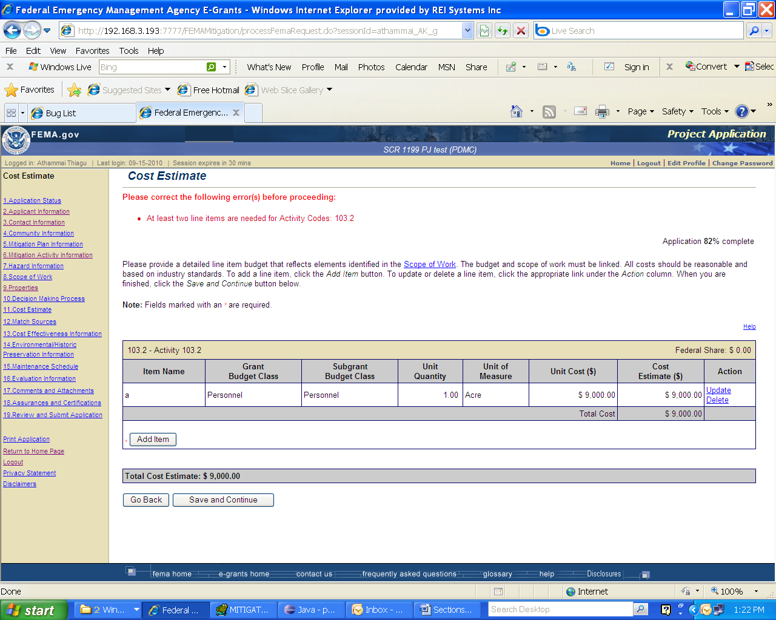
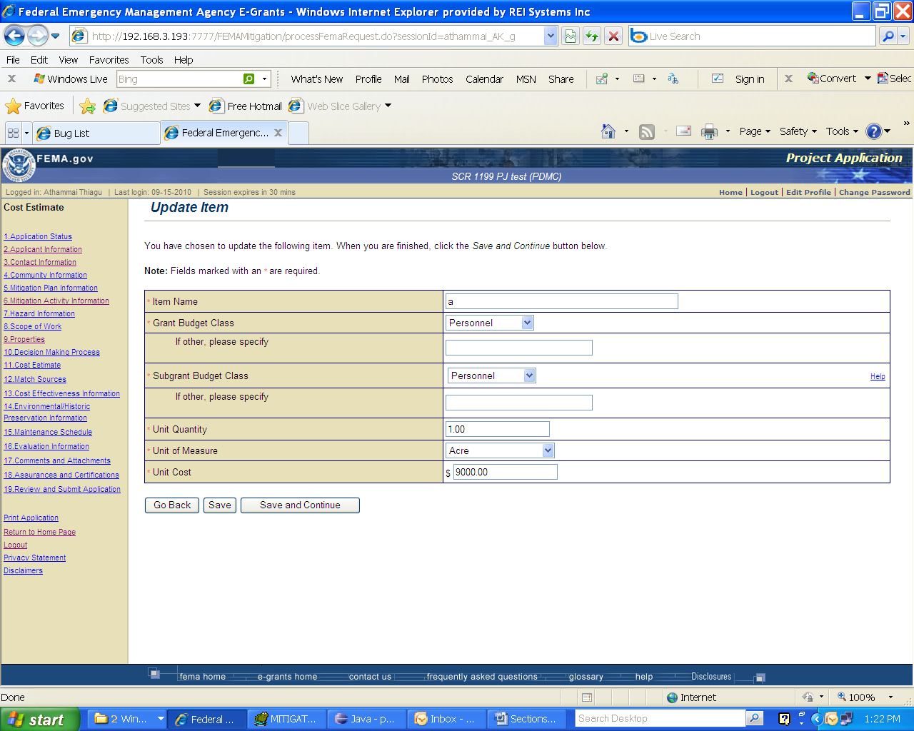

Match Sources:
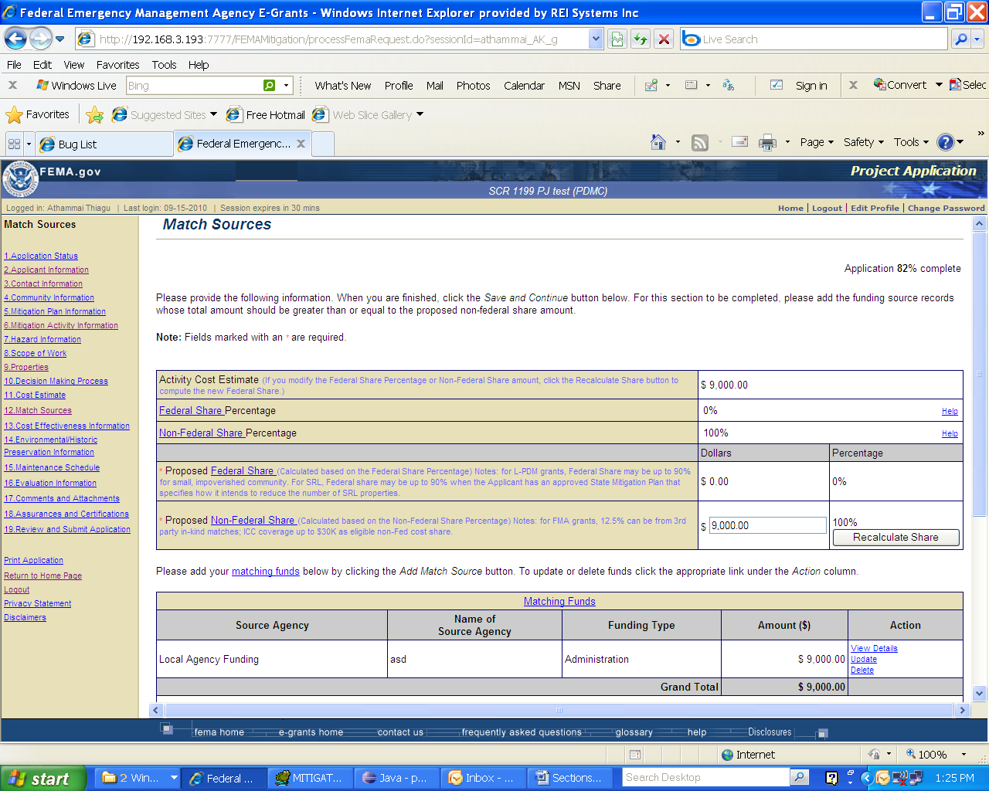
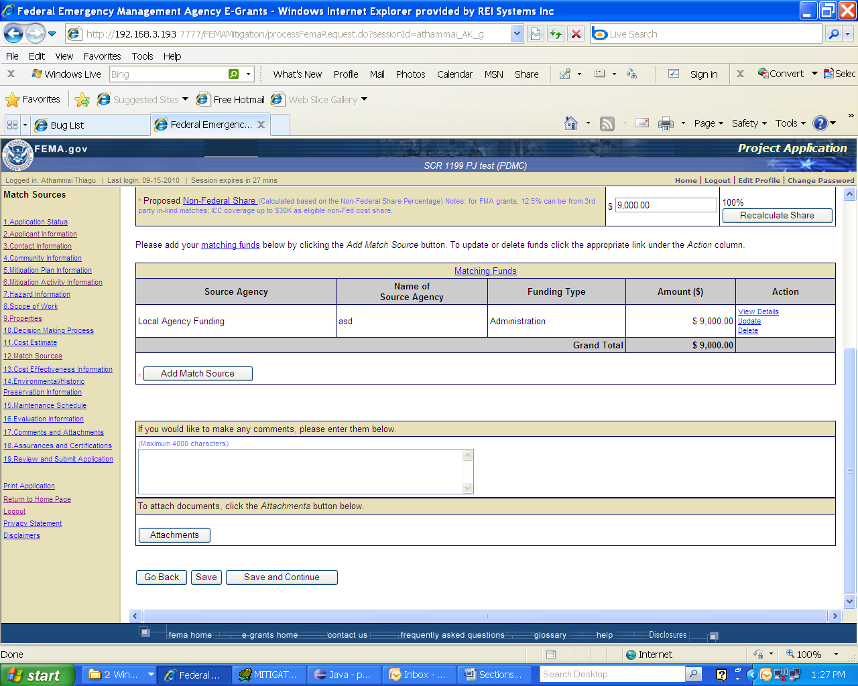
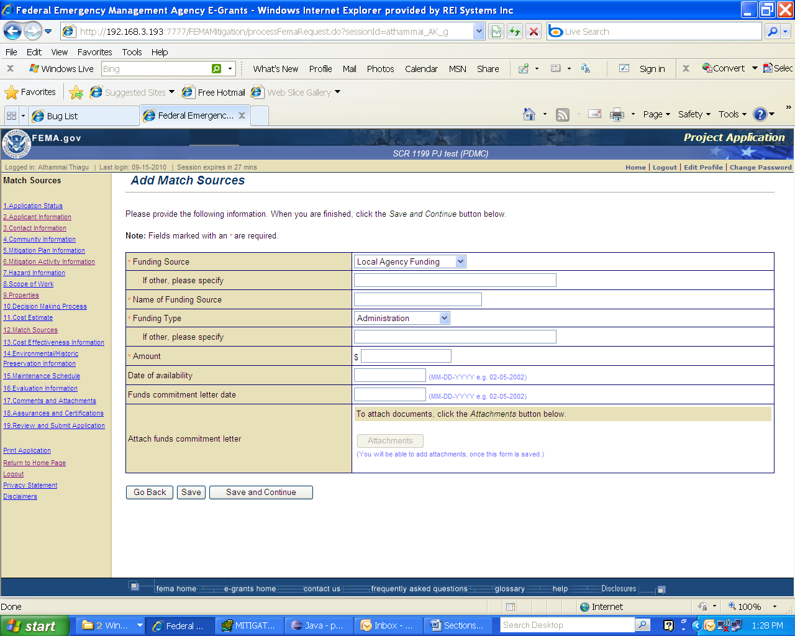
Cost Effectiveness Information:
