Attachment 4-3A: Burden Statement for LHQ
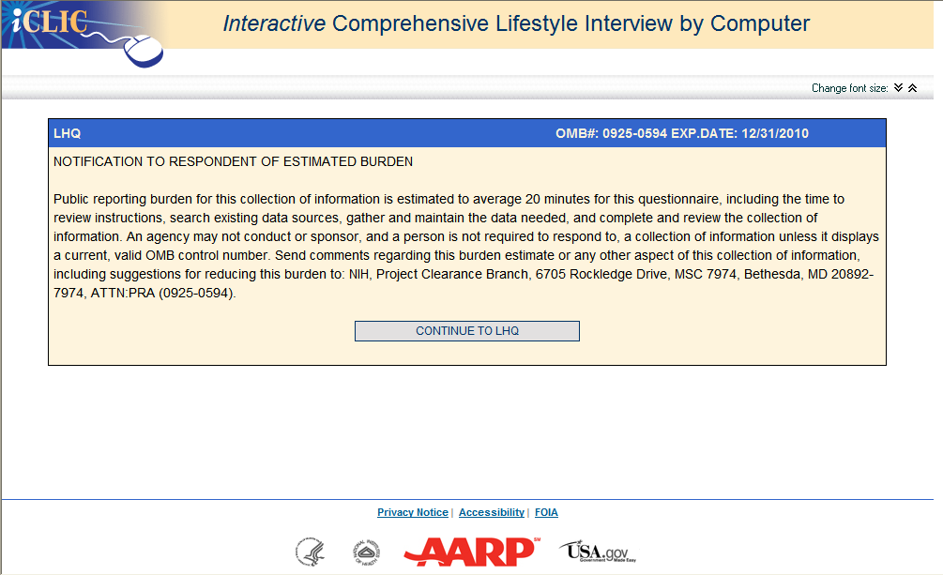

Attachment 4-3B: Screenshot of the LHQ

