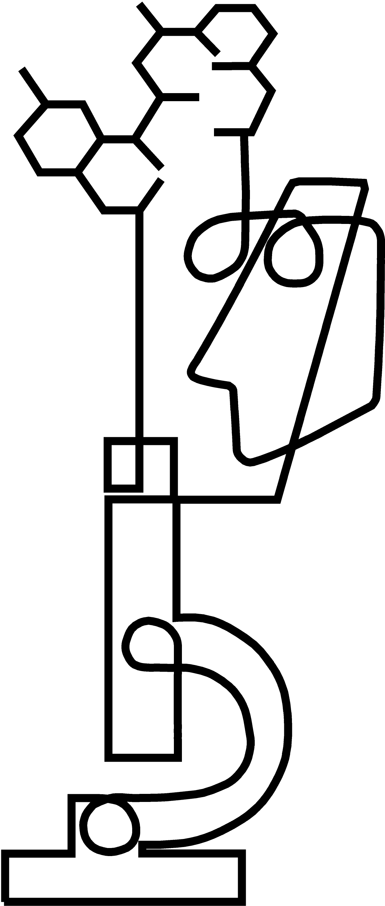

POSTDOCTORAL FELLOWSHIPS AT THE NIH

Pharmacology Research Associate (PRAT) Program
PROGRAM The PRAT Program is a competitive postdoctoral fellowship program to pursue research in one of the laboratories of the National Institutes of Health (NIH) or the Food and Drug Administration (FDA). It is intended for individuals with backgrounds in the basic or clinical sciences who wish to obtain advanced experience in an area of pharmacology, or for those with a pharmacology background to gain experience
in new fields.

RESEARCH Research opportunities in pharmacology are broadly defined and can include, for example, molecular pharmacology, biochemistry, signal transduction mechanisms, drug metabolism, immunopharmacology, chemistry and drug design, endocrinology, cell biology, structural biology, neuroscience, gene therapy, or clinical pharmacology. To learn more about training opportunities at NIH in clinical pharmacology, see the ClinPRAT (Clinical Pharmacology Research Associate Program) Web site located at: http://www.nigms.nih.gov/Training/InstPostdoc/PostdocOverview-ClinPharm.htm.

APPLICANTS Applicants must have received a Ph.D. or a professional degree (M.D., D.D.S, D.O., D.V.M., or Pharm.D.) in
a basic or clinical science within the last five years, and they must be citizens or permanent residents of the U.S. Applicants may apply prior to coming to NIH or FDA, or they may have started postdoctoral research at NIH or FDA within the 12-month period prior to the application receipt deadline.

PRECEPTORS Applicants select a preceptor in advance. Preceptors are scientists at the NIH or FDA who have an interest in training fellows through this program, and who will indicate their commitment through formal submission of their credentials at the time of application. Eligible preceptors and descriptions of their research are available at the NIH world wide web site http://www.training.nih.gov/postdoctoral/search.asp and then search the NIH CRISP database.

APPLICATION The application process involves submission of the completed PRAT application form, which includes a brief research plan and short statement of relevance to pharmacology, the signed preceptor selection form, letters of recommendation, official graduate and undergraduate transcripts, and curricula vitae for both the applicant and the preceptor.

LOCATION Most research facilities are located in a beautiful, campus-like setting in Bethesda, Maryland. Other research facilities are located in Baltimore, Maryland; Frederick, Maryland; and Research Triangle Park, North Carolina.

APPOINTMENT Appointments are made at competitive salary levels commensurate with other fellowship opportunities at
the NIH. In addition, there is a monthly supplies allowance and an annual travel allowance. Individuals with professional degrees are eligible to become commissioned officers in the Public Health Service.

TIMETABLE January 29, 2010 completed applications due
February – April review of applications
May -June notification of candidates
September - October PRAT Fellowships begin*

* PRAT Fellowships are three-year appointments beginning in Fall of each year; however, earlier start dates though other mechanisms may be negotiated individually by the fellow with the preceptor and the host laboratory.

INFORMATION For further information, or for an application kit, contact:

PRAT Program Analyst/Assistant
NIGMS, NIH Telephone:(301) 594-3583
Room 2AS-43K Fax: (301) 480-2802
45 Center Drive E-mail: PRAT@NIGMS.NIH.GOV
Bethesda, MD 20892-6200 8/06

