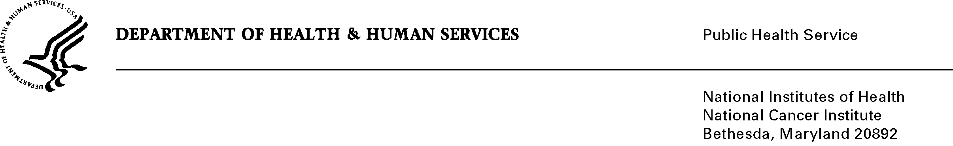
Date: June 14, 2010

To: Office of Management and Budget (OMB)

Through: Seleda Perryman, DHHS Report Clearance Officer
Mikia Currie, NIH Program Analyst, Project Clearance Branch
Vivian Horovitch-Kelley, NCI OMB Project Clearance Liaison, OMAA

From: Susan McMullen, RN, Director, Office of Patient Outreach and

Subject: The Survey of Health Care Professionals’ Awareness and Perceptions of the
National Cancer Institute’s Intramural Clinical Trials (NCI)

This is a request for OMB to approve the new submission titled, “The Survey of Health Care Professionals’ Awareness and Perceptions of the National Cancer Institute’s Intramural Clinical Trials (NCI)” for three years.

The purpose of the Survey of Health Care Professionals’ Awareness and Perceptions of the National Cancer Institute’s Intramural Clinical Trials (NCI) is to assess respondents’ awareness and knowledge of NCI and measure awareness of NCI clinical trials at the NIH Clinical Center in Bethesda, Md. The survey was disseminated electronically in July of 2006 and August of 2007 to members of the American Medical Association (AMA) with a primary specialty of gastroenterology, medical oncology, radiation oncology, hematology/oncology, thoracic surgery, colon & rectal surgery, gynecological oncology, surgical oncology, or head & neck surgery. This request is for a new survey that previously received two OMB approvals: one in 2006 as generic clearance OMB# 0925-0046-19, and the second in 2007 as generic OMB# 0925-0046-05.

This year’s survey has been slightly revised and will be sent to members of the same AMA primary specialty categories. Results of the previous surveys have been used to shape the outreach methods used by MMG and NCI to promote CCR’s trials, and this year’s survey will serve the same purpose.

