”Promoting HIV Testing among Low Income Heterosexual Young Adult Black Men”

0920-09CJ

Attachment 7. HIV Educational Packet
Common Ground Educational Brochures

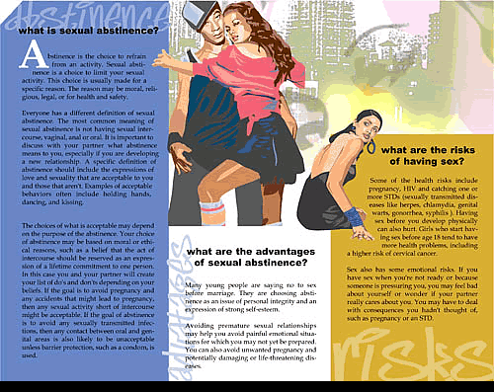

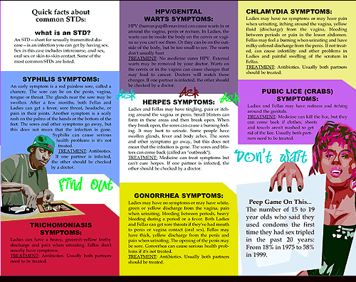

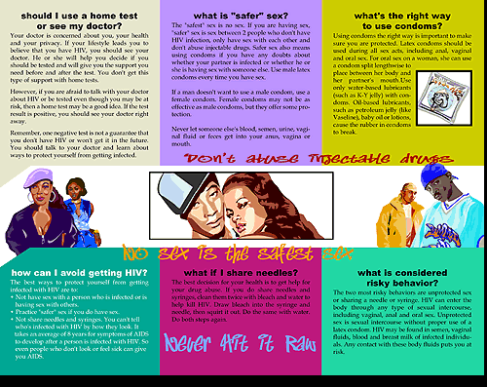



Resource Guide

Re-entry services

- Alpha School for Progressive Living
2400 Linden Boulevard
Brooklyn, New York, 11208
Phone: 718-257-5800
Website: www.alphaschoolcpl.org

- Brooklyn Homelink
444 Thomas S Boyland Street
Brooklyn, New York, 11233
Phone: 718-282-2308

- CASES (Center for Alternative Sentencing and Employment)
346 Broadway, 3rd Floor
New York, New York, 10013
Phone: 212-732-0076; 212-571-0292
Website: www.cases.org

- Center for NuLeadership on Urban Solutions
1637 Bedford Avenue, Room 220/32
Brooklyn, New York 11225
Phone: 718-270-5136; Fax: 718-270-6190
Website: www.mec.cuny.edu/spcd/caddi/nuleadership.asp

- ComAlert (Community and Law Enforcement Resources Together)
210 Joralemon St., 3rd Floor
Brooklyn, New York, 11201
Phone: 718-250-5557
Website: www.brooklynda.org

- Fortune Society
29-76 Northern Boulevard
Long Island City, New York
Phone: 212-691-7554; Fax: 212-255-4948
Website: www.fortunesociety.org

Health Services

- Department of Health and Mental Hygiene-Transitional Healthcare Coordination for Inmates:

In Brooklyn and Queens,
Brownsville Location:
259 Bristol St. 2nd Floor
Brooklyn, New York, 11212
Phone: 718-495-8234; 718-495-8235; 718-495-8564;
718-495-8565
Website: www.nyc.gov/health

In Manhattan and the Bronx,
Morrisania Location:
1309 Fulton Avenue, Room B21
Bronx, New York, 10456
Phone: 718-410-4939
Website: www.nyc.gov/health

HIV Education and HIV Testing Services

In Manhattan,

- Harlem United Community AIDS Center
Prevention Division
306 Lenox Avenue, 2nd Floor
New York, New York, 10027
Phone: 212-803-2888
Website: harlemunited.org

- Helen B. Atkinson Health Center
81 West 115th Street
New York, New York, 10026
Phone: 212-426-0088
Website: www.chnnyc.org

- Central Harlem:
2238 Fifth Avenue
New York, New York, 10037
Website: www.nyc.gov/health

- East Harlem:
158 East 115th Street
New York, New York, 10029
Website: www.nyc.gov/health

HIV Education and HIV Testing Services

In the Bronx,

- BAS (Bronx AIDS Services)
Prevention Center
953 Southern Boulevard, 2nd Floor
Bronx, NY 10459
Phone: 1-718-295-5690
Website: www.basnyc.org

- Bronx Health Center
975 Westchester Avenue
Bronx, New York, 10459
Phone: 718-320-4466
Website: www.chnnyc.org

- Morrisania
1309 Fulton Avenue
Bronx, New York, 10456
Phone: 718-410-4939
Website: www.nyc.gov/health

HIV Education and HIV Testing Services

In Brooklyn,
- CABS Health Center
94-98 Manhattan Avenue
Brooklyn, New York, 11206
Phone: 718-388-0390
Website: www.chnnyc.org

- Bedford Stuyvesant Health Center
485 Throop Avenue, 3rd Floor
Brooklyn, New York, 11221
Phone: 718-574-2462; 718-574-2453
Website: www.nyc.gov/health

- Fort Greene
295 Flatbush Avenue Extension, 2nd Floor
Brooklyn, New York, 11201
Website: www.nyc.gov/health

In Queens,
- Queens Health Center
97-04 Sutphin Boulevard
Jamaica, New York, 11435
Phone: 718-657-7088
Website: www.chnnyc.org

- Rockaway:
Joseph P. Addabbo Health Center
67-19 Rockaway Beach Boulevard
Queens, New York, 11692
Website: www.nyc.gov/health

In Staten Island,
- Richmond:
51 Stuyvesant Pace
Staten Island, New York, 10301

HIV Education and HIV Testing Services

Nationwide

- Center for Health Justice
A free HIV prevention and treatment hotline for incarcerated individuals
Phone: 1-888- 372-0888

Websites:

www.thebody.com

www.hivtest.org and enter your zip code

To access more information about these services or
to find out about other services in your community, call 311 & ask for Jail Release Services

THE BEATS PROJECT
Educational CD

There will be 10-12 songs mentioning HIV, HIV testing, prevention, risks included on the CD. Also included will be songs of empowerment and uplifting for Black men. All songs used in the CD will be cleared for use by each Record Label and publisher. In between the songs, there will be statistics given to reinforce the reality of HIV among the Black community. There will also be short scenarios centering around Black men. These scenarios will include the men engaging in dialogue with different people (sexual partner, friends/ respected elders, healthcare provider) discussing HIV prevention and testing. Even though the scenarios will be different, they will follow the same man.

Lay-Out

Intro

Song

- Stats
  - Black men are 6 times more likely to be incarcerated compared with white men
  - If the incarceration rate continues, 1 in 3 Black men will be in prison sometime in their lifetime
Song

  - Black men who have been released from prison face the challenges of finding a employment, a place to live, re-establishing relationships with family and partners, and dealing with the stigma of being in jail/prison
  - Young Black men are twice as likely to be unemployed than young white men

Scenario 1 (see attached script)

Song

Scenario 2 (see attached script)
HIV Stats
  - Prevalence of HIV among Black popl’n, Black men and incarcerated popl’n
  - Even though Blacks make up 13% of the US population, they make up 46% of HIV cases in the US
  - Black males made up 66% of males who contracted HIV through heterosexual sex
Song

Scenario 3 (see attached script)
- Background Info
  - Testing
  - The use of OraSure and OraQuick tests are quick and easy
  - Importance of testing is the relief of knowing your HIV status, you can protect your partners; and if you find out you are HIV positive you can get treatment and stay healthy
  - You can get tested at health departments, community clinics, sometimes your neighborhood clinic may have a mobile health van. To find additional places go to www.hivtest.org and enter your zip code.

Song

Credits

Song

Outro

Script of Scenarios
Scenario 1:
- Jamal has returned home from prison after serving 5 years of an 8 year sentence and getting parole. He asks Crystal, his girlfriend if she missed him. She answers yes and they engage in foreplay. Before things go any further, the Crystal hesitates and says to Jamal that she knows he has been out for over a week but this is the first time she is seeing him. He ignores her comment and she says that she knows he’s been over at Keisha’s (his baby mother’s) house and he replies that it was to see his son. Crystal gets upset and tells him she knows that he is still having sex with Keisha and he jokes that everyone has sex with Keisha. Jamal asks her why she is making a big deal out of it; she’s his real woman and he’s here now. Crystal walks away from Jamal, reaches for a condom and hands it to him. He asks, “What is this for, we stopped using them before I went in and I don’t wanna start again”. She says we need to be safe, that condoms help prevent the spread of HIV/AIDS and sexually transmitted diseases, plus everybody has sex with Keisha remember. Jamal turns it around on Crystal and asks her what she has been doing while he was locked up and accuses her of cheating/messing around. Their argument escalates and he walks out.
Scenario 2:
- Jamal and a friend are sitting in a mechanic shop (where he and his friends hang out). He discusses prison life (the conditions in prison (mean guards, bad food), missing his son, missing sex) and what it is like to be back out (following the conditions of his parole- get a job, report to a parole officer, no alcohol or drug use). He is in the middle of telling his friend about his fight with Crystal when Big Mike (BM) walks up. BM welcomes him back home and asks him what’s up. Big Mike (BM) is a former gang leader. He has been in and out of jail and prison since 16 and during his last bid, he served 20 years. He currently owns the mechanic shop and is a respected elder in the community, especially among the young Black men. Jamal tells BM about his time in prison and that he does not want to go back to prison because he missed his son growing up. Besides it seems that everything has changed while he has been inside, especially his relationship with Crystal. Jamal tells BM that Crystal tried to make him wear a condom after they have been together for more than 7 years. BM tells the men condoms not only prevent a girl from getting pregnant but HIV and other diseases. BM assures them that sex feels even better when you wear a condom, cause you’re not spending time worrying about what you may catch. The men listen as BM educates the young men about HIV (you can get HIV by having sex with a woman) and how to protect yourself (use a condom and don’t have multiple sex partners). BM tells them to be their ‘own man’ and that if you want to live to be an Old G, you have to be safe. He also shares with them that he always wears a condom and gets tested twice a year so he knows his HIV status.
Scenario 3:
- Jamal is waiting for the healthcare provider (HCP) to call him back into the exam room at the community health clinic to get the results from his HIV test. After speaking with BM and going home and making up with Crystal, he decided to get tested. He feels relieved to have taken BM’s advice to be his ‘own man’ because the HCP spoke with Jamal about HIV testing and answered his questions about the HIV and getting test. Jamal was happy to hear that there are rapid HIV tests, where you get back your results within an hour. He remembers the 5 years of his son’s life that he missed and vows not to cut short any more time with his son. The door opens and the HCP asks him if the test was as bad as he thought it would be. The HCP commends him for coming in to get tested. HCP also tells Jamal that his test results are private and will not be shared with anyone without his permission. HCP stresses that you should know your HIV status because if you are positive you can be treated sooner, that people who test positive for HIV can get care and live longer with HIV than with AIDS. This being said it is your responsibility to reduce the risk of getting HIV (not wearing a condom, number of partners, having had an STI). It ends with HCP saying I have your results…

