Notice of Visit / Interactive Address / Gallup Protocol (NAG) v4

Introduction:

Hello, my name is ___________. I work for the Census Bureau. Thanks for agreeing to help us today. Let me start by telling you a little about what we will be doing. Every ten years the United States conducts a census, or count, of everyone who is living in the United States. In the past the Census Bureau has mailed most households in the United States a paper census form and visited people who did not respond which cost a lot of taxpayers’ money. In an effort to reduce cost, we are considering alternative ways of contacting people.

This is a three part study. In the first part, I’m going to show you a Notice of Visit that is left on the door of respondents with whom we were unable to get in touch. We want to make sure the notice makes sense and is clear to respondents. In the second part, I’m going to ask you to enter your address into an interactive form that could be a part of the census on the internet in 2020. Finally, I will ask you some questions about alternative ways that the Census Bureau could collect data. For all of these questions, I’m interested in knowing if you find anything unclear or conusing.

Permission to Tape-Record:

Because it would be hard to keep track of everything you say today, we’re going to tape-record this session. [Hand respondent consent form.] Please read this over and sign it. I want you to know that your responses will be kept strictly confidential and will only be seen by Census employees involved in these projects. Your participation in this study is completely voluntary and you can decline to answer any particular question.

Think-out-loud Instructions:

As I said before, we are interested in how these questions work for you. So what I would like you to do is tell me everything you’re thinking as you come up with your answers. Instead of thinking to yourself, I’d like you to think out loud. I would like you to tell me everything you’re thinking as you hear the question and decide how to answer it. And sometimes I may ask you additional questions about the questions or your answers. There are no right or wrong answers. We are interested in how these questions work for you.

Because sometimes people take a while to get used to the idea of thinking out loud, I’d like to start out with a practice question. Can you tell me how many windows are in your house or apartment? [PROBE as appropriate to responses to this question.]

If not in the home:
Also, some of the questions will ask you about this address or this house, apartment, or mobile home. Pretend you are taking this survey in your home and answer about where you live.

Okay, let’s begin with the Notice of Visit, a sheet that is left at your door if you are not home when a Census interviewer comes by.

Part 1: Notice of Visit

Probes: In your own words, what does this notice say?
What is the purpose of this survey?
What are your options for completing the interview?
What will happen if you do not respond?
What do you think you would do if you received this notice of visit?

Please type the address into the web browser. (Note whether it is entered correctly)

Do you feel comfortable going online to fill out a survey? Why or why not?

Part 2: Address Question
<Have Respondent fill in on laptop>
(Note whether it is entered correctly)

The default screen shows the address fields for a Street Address, but respondents can also choose to report a Rural Route or a PO Box, which will alter the requested fields. The follow-up questions will depend on their selection for type of address.
Where did you live on May 15, 2013? (Help)

Please select the type of address associated with your residence.

Address Type: ● Street Address ○ P.O. Box ○ Rural Route

Address Number: _________ Street Name:________________ Unit Designation:_______________
For example: (5007) (N Maple Ave) (“Apt. A” or “Lot 3”)

City: ___________________ State: <drop-down> ZIP:________

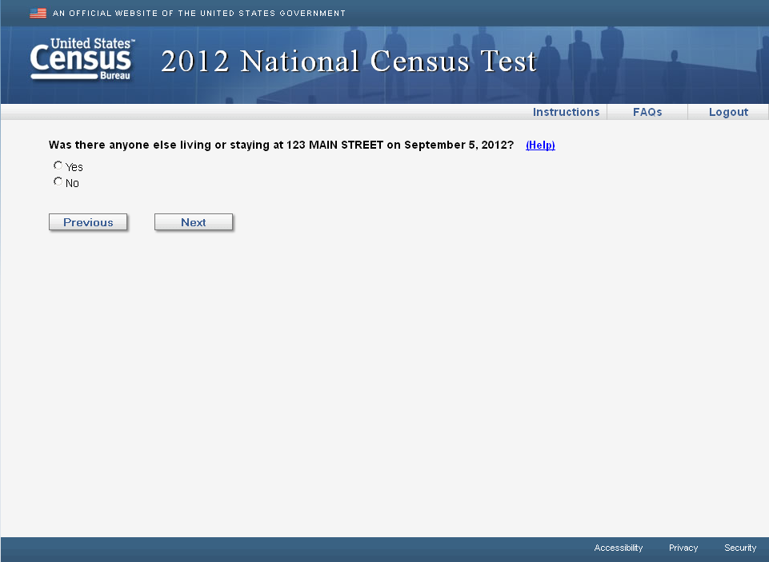

The above image will be the default view for the RESIDENCE screen. The screen will default to a “Street Address” type address with the option for respondents to change to “P.O. Box” or “Rural Route” (seen below).

Where did you live on May 15, 2013? (Help)

Please select the type of address associated with your residence.

Address Type: ○ Street Address ● P.O. Box ○ Rural Route

P.O. Box #: _________

City: ___________________ State: <drop-down> ZIP:________

Where did you live on May 15, 2013? (Help)

Please select the type of address associated with your residence.

Address Type: ○ Street Address ○ P.O. Box ● Rural Route

Rural Route Descriptor: <drop-down> Rural Route #:_______ Box #:________

City: ___________________ State: <drop-down> ZIP:________

For P.O. Box and Rural Route only, when the respond presses the “Next” button, we will also ask for a physical location description . Expand the current window to display the information below. The original information (located on PO Box or Rural Route) will remain active, allowing the responden to change their Address Type or alter the specific address elements.

Please provide a physical address such as:
● an address you would give to a shipping company if you wanted a package delivered to your home, or
● an address you would provide if you were requesting emergency services such as a 911 call, or
● a location description such as “The apartment over the Post Office on County Road 5” or “The blue house on
the northeast corner of Main Street and First Avenue”.

Probe: Was this easy or difficult to do?
What does “type of address” mean to you in this question?
How did you select your type of address?
What does “Address Number” mean to you in this question? How about Unit Designation?

If used Rural Route or Physical Address Fields:
Please tell me how you decided what to enter and where to enter it.
Was there anything you weren’t certain of?

Part 3: Gallup Study
For this part I am going to ask you some opinion questions. Please respond as you would if someone was calling you and asking these questions over the phone.

Set 4
- For the next census in 2020, if the Census Bureau got information, like your contact information, from a company that provides publicly accessible information, they may not need to ask you for this information on a questionnaire. If you knew that this information was being obtained from this company only to produce statistics, would you be strongly in favor of the Census Bureau getting your information from public records, somewhat in favor of it, neither in favor nor against it, somewhat against it, or strongly against it?
  - strongly in favor of this,
  - somewhat in favor of it,
  - neither in favor nor against it,
  - somewhat against it, or
  - strongly against it

Probe: In your own words, what is this question asking?
How did you choose your answer?

Now I will read you some reasons why some people like the idea of the Census getting your (name and age/income/contact information) from a company that provides publicly accessible information. For each statement, please tell me if this reason would make you strongly in favor of this, somewhat in favor of it, neither in favor nor against it, somewhat against it, or strongly against it.

Rotate order of frames:
Cost Frame
- The 2010 Census cost over $10 billion dollars. Getting your contact information from a company that provides publicly accessible information could reduce the cost for the 2020 Census and save government money.
  - strongly in favor of this,
  - somewhat in favor of it,
  - neither in favor nor against it,
  - somewhat against it, or
  - strongly against it

Probe: In your own words, what is this question asking?
How did you choose your answer?
What does it mean to save government money?

Social Good Frame
- Because some people choose not to respond to the Census, getting contact information from a company that provides publicly accessible information could help the Census Bureau get a better idea of population sizes and thus know how to distribute the seats in the U.S. House of Representatives.
  - strongly in favor of this,
  - somewhat in favor of it,
  - neither in favor nor against it,
  - somewhat against it, or
  - strongly against it

Probe: In your own words, what is this question asking?
How did you choose your answer?
What do you think is meant by “contact information”?
What does it mean to use information for statistics?
What is “a company that provides publicly accessible information”? Can you give me an example?

For those who answer at least one question against or DK/REF/Neither:
- You seem to be not in favor of/neither strongly in favor of nor against the Census obtaining your information from a company that provides publicly accessible information. Can you tell me why?

If the answer is privacy/confidentiality/trust/hate gov, ask:
- Which of the following best describes your concern? Are you most concerned: Rotate order, except last.
a. About the government having too much information about you?
b. That the information could be used against you?
c. That you might lose control of your information?
d. About not knowing what is going to happen to your information?
e. Another reason?

Probe: What does it mean for the government to have too much information about you? Can you give me an example?
How could the information be used against you? What kind of information is this question asking about?
What does it mean that you might lose control of your information? Can you give me an example?
- When it comes to this topic, which of the following do you think is most likely to be a threat to your personal information: Rotate order, except last.
a. Insecure IT Systems
b. A Government employee misusing your data
c. A Government agency using the information to get you in trouble
d. An unauthorized person, or hacker, gaining access to your data
e. Something else

Probe: What does an Insecure IT system mean? Can you give me an example?
What does it mean that a government employee is misusing your data? Can you give me an example?
What is data?
What does it mean for a Government agency using the information to get you into trouble? What types of information is this question asking about?

Set 1
- For the next census in 2020, if the Census Bureau got information that you already provided to the Social Security Administration, they may not need to ask you for this information on a questionnaire. If you knew that this information was being obtained from the Social Security Administration only to produce statistics, and that your personal information would remain unavailable to the public, would you be strongly in favor of the Census Bureau getting your information from the Social Security Administration, somewhat in favor of it, neither in favor nor against it, somewhat against it, or strongly against it?
  - strongly in favor of this,
  - somewhat in favor of it,
  - neither in favor nor against it,
  - somewhat against it, or
  - strongly against it

Probe: In your own words, what is this question asking?
How did you choose your answer?

Now I will read you some reasons why some people like the idea of the Census getting your information from the Social Security Administration. For each statement, please tell me if this reason would make you strongly in favor of this, somewhat in favor of it, neither in favor nor against it, somewhat against it, or strongly against it.

Rotate order of frames:
Cost Frames
- The 2010 Census cost about $100 dollars per housing unit. Getting your information directly from the Social Security Administration could reduce the cost for the 2020 Census and save government money.
  - strongly in favor of this,
  - somewhat in favor of it,
  - neither in favor nor against it,
  - somewhat against it, or
  - strongly against it

Probe: In your own words, what is this question asking?
How did you choose your answer?
What do you think it means to save government money?
What does it mean to cost $100 per housing unit?

Social Good Frames
- Because some people choose not to respond to the Census, getting information from the Social Security Administration could help the Census Bureau get a better idea of population sizes and thus know where the community should build new schools, hospitals, roads, and firehouses.
  - somewhat in favor of it,
  - neither in favor nor against it,
  - somewhat against it, or
  - strongly against it

Probe: In your own words, what is this question asking?
How did you choose your answer?
What kind of information did you think this question was asking about?
What does it mean to use information for statistics?
What do you think is meant by getting information from the Social Security Administration?
For those who answer at least one question against or DK/REF/Neither:
- You seem to be not in favor of/neither strongly in favor of nor against the Census obtaining your information from the social Security Administration. Can you tell me why?

- If the answer is privacy/confidentiality/trust/hate gov, ask:
Which of the following best describes your concern? Are you most concerned: Rotate order, except last.
a. About the government having too much information about you?
b. That the information could be used against you?
c. That you might lose control of your information?
d. About not knowing what is going to happen to your information?
e. Another reason?

Probe: What does it mean for the government to have too much information about you? Can you give me an example?
How could the information be used against you? What kind of information is this question asking about?
What does it mean that you might lose control of your information? Can you give me an example?
- When it comes to this topic, which of the following do you think is most likely to be a threat to your personal information: Rotate order, except last.
a. Insecure IT Systems
b. A Government employee misusing your data
c. A Government agency using the information to get you in trouble
d. An unauthorized person, or hacker, gaining access to your data
e. Something else

Probe: What do you think is meant by an Insecure IT system mean? Can you give me an example?
What does it mean that a government employee is misusing your data? Can you give me an example?
What is data?
What does it mean for a Government agency using the information to get you into trouble? What types of information is this question asking about?

Set 2
- For the next census in 2020, if the Census Bureau got information, like your income, that you already provided to the Social Security Administration, they may not need to ask you for this information on a questionnaire. If you knew that this information was being obtained from the Social Security Administration only to produce statistics, and that your personal information would remain unavailable to the public, would you be strongly in favor of the Census Bureau getting your information from the Social Security Administration, somewhat in favor of it, neither in favor nor against it, somewhat against it, or strongly against it?
  - strongly in favor of this,
  - somewhat in favor of it,
  - neither in favor nor against it,
  - somewhat against it, or
  - strongly against it

Probe: In your own words, what is this question asking?
How did you choose your answer?

Now I will read you some reasons why some people like the idea of the Census getting your income from the Social Security Administration. For each statement, please tell me if this reason would make you strongly in favor of this, somewhat in favor of it, neither in favor nor against it, somewhat against it, or strongly against it.

Rotate order of frames:
Cost Frame – (one per panel)
- The 2010 Census cost over $10 billion dollars. Getting your income directly from the Social Security Administration could reduce the cost for the 2020 Census and save government money.
  - strongly in favor of this,
  - somewhat in favor of it,
  - neither in favor nor against it,
  - somewhat against it, or
  - strongly against it

Probe: In your own words, what is this question asking?
How did you choose your answer?
What do you think it means to save government money?
Social Good Frame– (one per panel)
- Because some people choose not to respond to the Census, getting income from the Social Security Administration could help the Census Bureau get a better idea of population sizes and thus know where the community should build new schools, hospitals, roads, and firehouses.
  - strongly in favor of this,
  - somewhat in favor of it,
  - neither in favor nor against it,
  - somewhat against it, or
  - strongly against it

Probe: In your own words, what is this question asking?
Probe: Do you think the Social Security Administration has your income information? Why or why not?
For those who answer at least one question against or DK/REF/Neither:
- You seem to be not in favor of/neither strongly in favor of nor against the Census obtaining your information from the Social Security Administration. Can you tell me why? (OPEN ENDED AND CODE. DO NOT READ CATEGORIES)

If the answer is privacy/confidentiality/trust/hate gov, ask:
- Which of the following best describes your concern? Are you most concerned: Rotate order, except last.
a. About the government having too much information about you?
b. That the information could be used against you?
c. That you might lose control of your information?
d. About not knowing what is going to happen to your information?
e. Another reason?

Probe: What does it mean for the government to have too much information about you? Can you give me an example?
How could the information be used against you? What kind of information is this question asking about?
What does it mean that you might lose control of your information? Can you give me an example?
- When it comes to this topic, which of the following do you think is most likely to be a threat to your personal information: Rotate order, except last.
a. Insecure IT Systems
b. A Government employee misusing your data
c. A Government agency using the information to get you in trouble
d. An unauthorized person, or hacker, gaining access to your data
e. Something else

Probe: What do you think is meant by an Insecure IT system mean? Can you give me an example?
What does it mean that a government employee is misusing your data? Can you give me an example?
What is data?
What does it mean for a Government agency using the information to get you into trouble? What types of information is this question asking about?

Set 3
- For the next census in 2020, if the Census Bureau got information, like your contact information, that you already provided to the Department of Motor Vehicles, they may not need to ask you for this information on a questionnaire. If you knew that this information was being obtained from the Department of Motor Vehicles only to produce statistics, and that your personal information would remain unavailable to the public, would you be strongly in favor of the Census Bureau getting your information from the Department of Motor Vehicles, somewhat in favor of it, neither in favor nor against it, somewhat against it, or strongly against it?
  - strongly in favor of this,
  - somewhat in favor of it,
  - neither in favor nor against it,
  - somewhat against it, or
  - strongly against it

Probe: In your own words, what is this question asking?
How did you choose your answer?

Now I will read you some reasons why some people like the idea of the Census getting your contact information from the Department of Motor Vehicles. For each statement, please tell me if this reason would make you strongly in favor of this, somewhat in favor of it, neither in favor nor against it, somewhat against it, or strongly against it.

Rotate order of frames:
Cost Frame – one per panel
- The 2010 Census cost about $100 dollars per housing unit. Getting your contact information from the Department of Motor Vehicles could reduce the cost for the 2020 Census and save government money.
  - strongly in favor of this,
  - somewhat in favor of it,
  - neither in favor nor against it,
  - somewhat against it, or
  - strongly against it

Probe: What does it mean to save government money? What does it mean to cost $100 per housing unit?

Social Good Frame – one per panel
- Because some people choose not to respond to the Census, getting contact information from the Department of Motor Vehicles could help the Census Bureau get a better idea of population sizes and thus know how to distribute the seats in the U.S. House of Representatives.
  - strongly in favor of this,
  - somewhat in favor of it,
  - neither in favor nor against it,
  - somewhat against it, or
  - strongly against it

Probes: What does it mean to get “contact information”?
What does it mean to use information for statistics?

For those who answer at least one question against or DK/REF/Neither:
- You seem to be not in favor of/neither strongly in favor of nor against the Census obtaining your information from the Department of Motor Vehicles. Can you tell me why?

If the answer is privacy/confidentiality/trust/hate gov, ask:
- Which of the following best describes your concern? Are you most concerned: Rotate order, except last.
a. About the government having too much information about you?
b. That the information could be used against you?
c. That you might lose control of your information?
d. About not knowing what is going to happen to your information?
e. Another reason?

Probe: What does it mean for the government to have too much information about you? Can you give me an example?
How could the information be used against you? What kind of information is this question asking about?
What does it mean that you might lose control of your information? Can you give me an example?
- When it comes to this topic, which of the following do you think is most likely to be a threat to your personal information: Rotate order, except last.
a. Insecure IT Systems
b. A Government employee misusing your data
c. A Government agency using the information to get you in trouble
d. An unauthorized person, or hacker, gaining access to your data
e. Something else

Probe: What do you think is meant by an Insecure IT system mean? Can you give me an example?
What does it mean that a government employee is misusing your data? Can you give me an example?
What is data?
What does it mean for a Government agency using the information to get you into trouble? What types of information is this question asking about?

Thanks. Now I have a few follow-up questions for you.

- Other than what we have already talked about, did you find any of the questions difficult? Are there questions that you think some people would find difficult?

- Did you find any of the questions sensitive? Are there questions that you think some people would find sensitive?

Those are all of the questions I have. Thank you for your time.

