est 17/18/20 Questionnaire Protocol

Introduction:

Hello, my name is ___________. I work for the Census Bureau. Thanks for agreeing to help us today. Let me start by telling you a little about what we will be doing. Every ten years the United States conducts a census, or count, of everyone who is living in the United States.

In the past the Census Bureau has mailed most households in the United States a paper census form and visited people who did not respond which cost a lot of taxpayers’ money. In an effort to reduce cost, we are considering alternative ways of contacting people.

This is a two part study. In the first part, I’m going to show you some of the ways we may contact people in an effort to save money and get your reactions. In the second part, I’m going to play the part of a census taker and ask you questions like the ones you might be asked in the census in 2020.

Permission to Tape-Record:

Because it would be hard to keep track of everything you say today, we’re going to tape-record this session. [Hand respondent consent form.] Please read this over and sign it. I want you to know that your responses will be kept strictly confidential and will only be seen by Census employees. Your participation in this study is completely voluntary and you can decline to answer any particular question.

Think-out-loud Instructions:

As I said before, we are interested in how these questions work for you. So what I would like you to do is tell me everything you’re thinking as you come up with your answers. Instead of thinking to yourself, I’d like you to think out loud. I would like you to tell me everything you’re thinking as you hear the question and decide how to answer it. And sometimes I may ask you additional questions about the questions or your answers. There are no right or wrong answers. We are interested in how these questions work for you.

Because sometimes people take a while to get used to the idea of thinking out loud, I’d like to start out with a practice question. Can you tell me how many windows are in your house or apartment? [PROBE as appropriate to responses to this question.]

If not in the home:
Also, some of the questions will ask you about this address or this house, apartment, or mobile home. Pretend you are taking this survey in your home and answer about where you live.

Before we begin, may I have your home address?
Street Address_____________________________
Do you live in a house, apartment or a mobile home?_____________________
Use these fills as needed throughout the interview.

Okay, let’s begin with the different ways we might contact someone.

Part 1: Alternate Contact Language
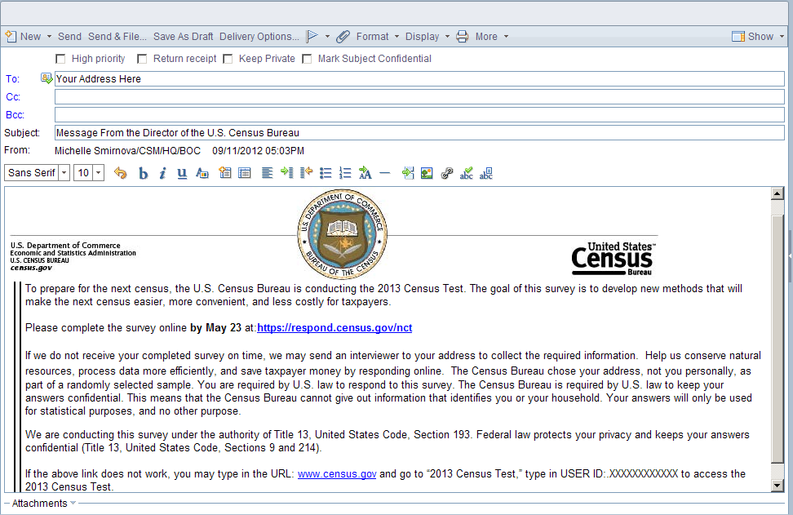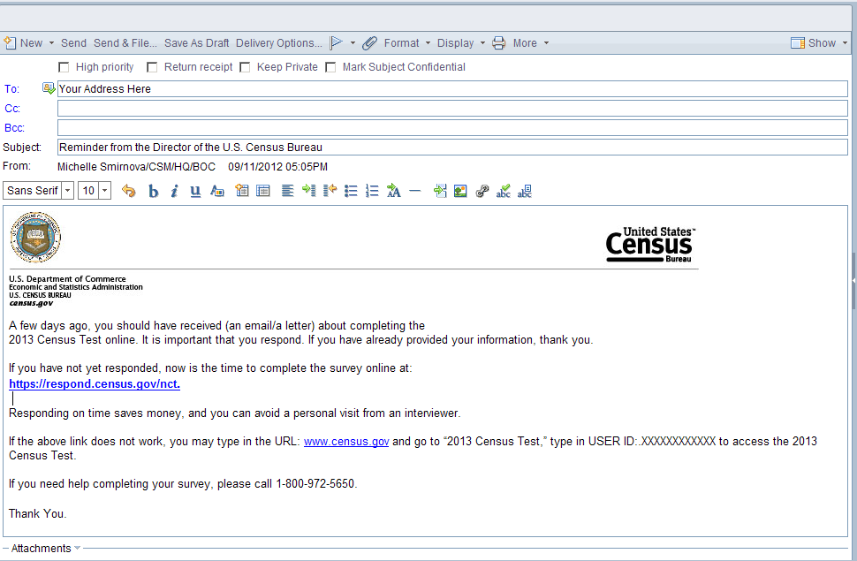
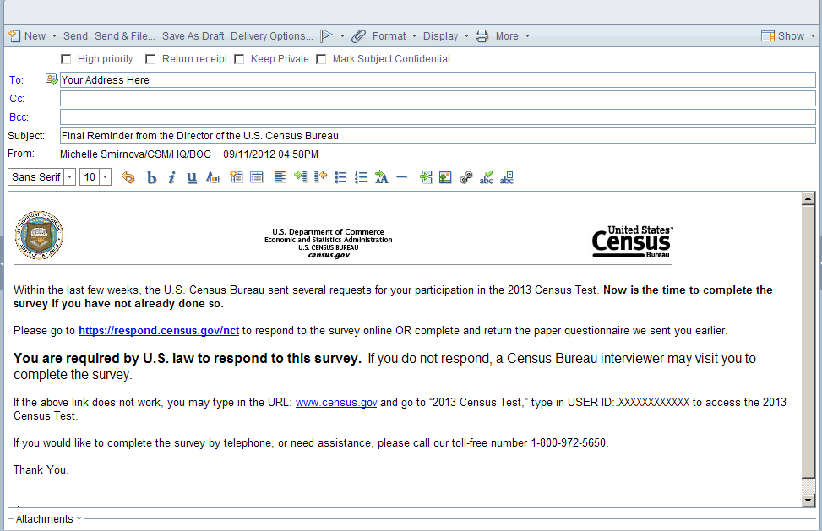
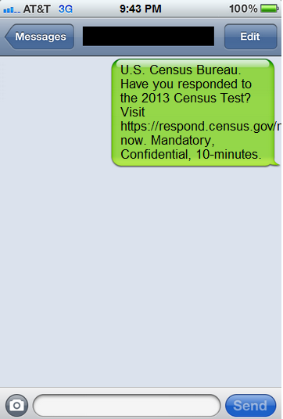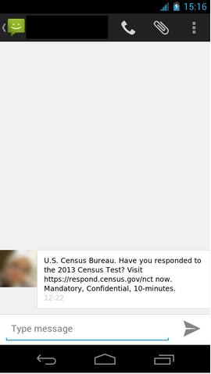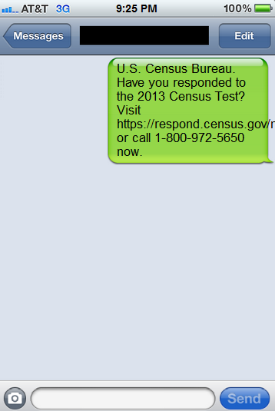
Probes: In your own words, what is this email/text message saying?
If you had received this email/text message, would you have believed that it was from the Census Bureau? Why or Why not?
If you had received this email or text message would you have clicked on the link? Why or why not?
How do you feel about the Census Bureau emailing or texting you to fill out a survey? Do you prefer one over the other?
Probe: Did you notice the difference between the three letterhead designs on the emails? Which looks the most credible? If all of them look equally credible which of the four do you prefer the most?

Part 2: Census Questionnaire
- Hello, I’m <fill enumerator name> from the U.S. Census Bureau. (Show ID).
Is this <fill address of case>?
○ Yes
○ No
- On <CENSUSDAY>, were you living or staying here at <ADDRESS>?
○ Yes (go to 3)
○ No (go to 4)
- What is your full name? (go to 6)
- Did anyone live at < address> on <CENSUSDAY>?
○ Yes <go to 6>
○ No <go to 5>
- Where did you live on <CENSUSDAY>?
_____________________________________
_____________________________________
_____________________________________

- Please list the name of each person who was living and sleeping at <ADDRESS> on <CENSUSDAY>.
_____________________________________________
_____________________________________________
_____________________________________________
_____________________________________________
_____________________________________________

Note: Babies, Foster Children, Any other relatives or Roommates or people not related to you will be reordered based on the targeted demographic information we have about this household.
- Were there any additional people living or staying at [STREET] on [DATE] who you did not include yet? for example:

Babies? (pause) ○ Yes ○ No
Foster children? (pause) ○ Yes ○ No
Any other relatives? (pause) ○ Yes ○ No
Roommates or people not related to you? (pause) ○ Yes ○ No

For any yes go to 10, otherwise go to 11

Probe: In your own words, what is this question asking?
If yes for any of the additional people categories, please tell me more about NAME and their living situation.
- What are the names of the babies, foster children, other relatives or people not related to you?
_________________________________
_________________________________

- Was there anyone else staying at <street> on <CENSUSDAY> who had no permanent place to live?
○ Yes What was their name _____________________________________
○ No

Probe: In your own words, what do you think this question was asking about? Can you give me an example of someone who has no permanent place to live?
If yes, please tell me more about NAME and their living situation.
- Was there anyone else living or staying at <street> on <CENSUSDAY> who is no longer living there?
○ Yes What was their name _____________________________________
○ No

Probe: Can you give me an example of someone who may no longer be here?
If yes, please tell me more about NAME and their living situation.
- Do you or does someone in this household own, rent, or occupy this <house, apartment, mobile home> without having to pay rent?
○ Yes I/someone else own it (go to 12)
○ Yes I/someone else rent it (go to 13)
○ Yes I/someone else occupy it without having to pay rent (Go to 14)
○ No (go to 14)

- Of the people who lived at <address>, who owned the <house, apartment, or mobile home> on <CENSUSDAY>?
__________________________________
- Does <insert name here> own it free and clear or with a mortgage or loan (including home equity loans)
- Free and clear
- With loan

(go to 18)
- Of the people who lived at <ADDRESS>, who rented this house, apartment, or mobile home on <CENSUSDAY>?
__________________________________
(go to 18)

- Next, we need to record each person’s relationship to <reference person>.
Looking at the screen, <roster person> is <reference person>’s _______.
Interviewer Note – Show list to respondent

Opposite-sex husband/wife/spouse | Same-sex husband/wife/spouse
Opposite-sex unmarried partner | Same-sex unmarried partner
Biological son or daughter | Adopted son or daughter
Brother or sister | Stepson or stepdaughter
Father or mother | Parent-in-law
Grandchild | Son-in-law or daughter-in-law
Other relative | Roomer or boarder
Foster child | Housemate or roommate
 | Other nonrelative

Probe: How did you choose your answers?
▪ Did you have any difficultly finding a category that fit?
▪ Was looking at the options helpful?
- What is <roster name>’s sex?
○Male
○Female
- What is < NAME>’s date of birth?
Omitted verify age and relationship, since we are not testing an automated instrument.
- I'm going to read you a list of race and origin categories. If you are multiracial or multiethnic, you may choose more than one.
<Is ROSTER NAME/Are you> White; Black or African American; Hispanic, Latino, or Spanish; American Indian or Alaska Native; Asian; Native Hawaiian or Other Pacific Islander; or Some other race or origin?
Check boxes for each category, and specify your ancestry, tribe, or country of origin.
□ White
□ Black or African American
□ Hispanic, Latino, or Spanish
□ American Indian or Alaska Native
□ Asian
□ Native Hawaiian or Other Pacific Islander
□ Some other race or origin
If White, Black, Hispanic or Asian is chosen: You said <you are/NAME is> ________. Do you have a specific ancestry, ethnicity or country of origin?
If American Indian or Alaska Native is chosen: You said <you are/NAME is> ________. What is that specific tribe?
If Native Hawaiian or Other Pacific Islander or Some other race or Origin is chosen: You said <you are/NAME is> ________. Do you have a specific ancestry, ethnicity, tribe, or country of origin?

Probe: Was this question easy or difficult to answer?

Overcount /Undercount
Note: We will re-order Questions 18-27 depending on the demographic information that we have about the household. The more likely populations to be overcounted or undercounted will be targeted in the first question in the series.
- Some people live or stay in more than one place and we would like to make sure everyone is only counted once. The following questions will be about: READ ENTIRE ROSTER

Did you/anyone move during <March> or <April>?
[] Yes
[] No

[Note: If “Yes” and more than one person in the HH, ask Who?]

Who? List

Probe: In your own words, what was this question asking about?

- If there are people 18 or under: < Do you/does anyone> sometimes live or stay at another home, like a seasonal or second residence?
[] Yes
[] No

[Note: If “Yes” and more than one person in the HH, ask Who?]

Who? List

Probe: In your own words, what was this question asking about? Can you give me an example of situations where people might live or stay at another home?

- <Do you/does anyone> sometimes live or stay somewhere else with a parent, grandparent or other person?
[] Yes
[] No

[Note: If “Yes” and more than one person in the HH, ask Who?]

Who? List

Probe: In your own words, what was this question asking about? Can you give me an example of situations where people might live or stay somewhere else with a relative?

- If there are people ages 18-25 <Were you/ was anyone> staying away from <address> while living in college housing - on or off campus?
[] Yes
[] No

[Note: If “Yes” and more than one person in the HH, ask Who?]

Who? List

Probe: In your own words, what was this question asking about? What does “on or off campus” mean to you in this question?
- If there are people ages 18-60 <Were you/ was anyone> staying away from <address> to be closer to a job (including military assignments)?
[] Yes
[] No

[Note: If “Yes” and more than one person in the HH, ask Who?]

Who? List

Probe: In your own words, what was this question asking about? Can you give me an example of situations where people might stay away to be closer to a job or military assignment?

- <Do you/ does anyone> sometimes stay in a place like a nursing home or a group home?
[] Yes
[] No

[Note: If “Yes” and more than one person in the HH, ask Who?]

Who? List

Probe: In your own words, what was this question asking about? Can you give me an example of other places like a nursing home or group home?

- <Were you/Was anyone> recently in a jail or prison?
[] Yes
[] No
[Note: If “Yes” and more than one person in the HH, ask Who?]

Who? List

Probe: In your own words, what was this question asking about? What do you think is meant by “recently” in this question?

- < Do you/ does anyone > sometimes live away from <ADDRESS> for any reason other than those just mentioned?
[] Yes
[] No

[Note: If “Yes” and more than one person in the HH, ask Who?]

Who? List

Probe: In your own words, what was this question asking about? What sorts of situations can you think of here? If yes, Why didn’t you mention this person before?

Please provide the full address <flag_location1> where <person> sometimes lived or stayed around <CENSUSDAY> <flag_location2>. Fill in as much information as the respondent can provide.

Address (Number and street name)
________________________________

City
___________________

State
_______

Zip Code
_______

If there is no street address or if this is a facility, please type a description in the box below.

_________________________
_________________________

Probe: Was this easy or difficult for you?
- Where does/do <person/you> live and sleep most of the time?

- Write Address__________________________________________
- Equal time at all places
- Some other place
- Don’t know

Probe: How did you come up with your answer? Was this easy or difficult for you?
- Where was/were <person/you> staying on <CENSUSDAY>?

- Write Address__________________________________________
- Equal time at all places
- Some other place
- Don’t know

Probe: How did you come up with your answer? Was this easy or difficult for you?
Thank you for your help. We would like to collect just a few last bits of information if we need to obtain more information about this household in the future.
- Could you please provide an email address where we can contact you about this household?

Enter address: ______________

Repeat back the email address to the respondent to confirm it was entered correctly.
Probe: In your own words what was this question asking? Is this a person email address or a work address? Is it yours alone or shared with others in the household?
(Ask or confirm.)
- What is your name?

- In case I need to contact you again to clarify any information, what is your phone number?

- What is the address or place where I can best find you again?

- Another Census employee may contact you to evaluate my work. What would be the best mode and time to contact you?

Thanks. Now I have a few follow-up questions for you.

- Other than what we have already talked about, did you find any of the questions difficult? Are there questions that you think some people would find difficult?

- Did you find any of the questions sensitive? Are there questions that you think some people would find sensitive?

For analysis purposes, we need to get a little more information from you:
- Do you use a cellular phone or smartphone?
❑YesGo to 2
❑NoSkip to 3
❑DK/RFSkip to 3

- When you use your cellular phone or smartphone, do you…
Read and select all that apply
❑Send/receive text messages?
❑Browse the Web?
❑E-mail?
❑DK/RF

- How often do you use or visit the Internet for paying bills, shopping or other financial transactions? (Is it very often, often, sometimes, rarely, or never?)
❑Very often
❑Often
❑Sometimes
❑Rarely
❑Never
- Do you receive notifications about upcoming bills by email?
❑Yes
❑No
❑DK/RF
- How often do you use or visit the Internet for… Filling out surveys? (Is it very often, often, sometimes, rarely, or never?)
❑Very often
❑Often
❑Sometimes
❑Rarely
❑Never
- Have you ever gone to a website of a company or organization for which you have received mail?
❑Yes
❑No
❑DK/RF
[Probe for Cognitive Testing: What factors influence your decision <to go/not to go> to these links?]
- Do you open all of your mail?
❑Yes
❑No
❑DK/RF
[Probe for Cognitive Interview: How do you determine which mail to open?]
- If someone came to your door to do a census, would you talk to them or would someone else in your household be more likely to talk to them?
❑Respondent would talk to them
❑Someone else would talk to them
❑No one would talk to them
❑Respondent would talk to them
❑DK/RF

- What is the highest level of education you have completed?
  - Less than high school?
  - High school diploma or GED?
  - Some college?
  - Bachelors’ Degree?
  - Graduate Degree?

Those are all of the questions I have. Thank you for your time.

