Advanced Monthly Retail Trade Survey (MARTS) & Monthly Retail Trade Survey (MRTS) Screen Shots

Login Screen
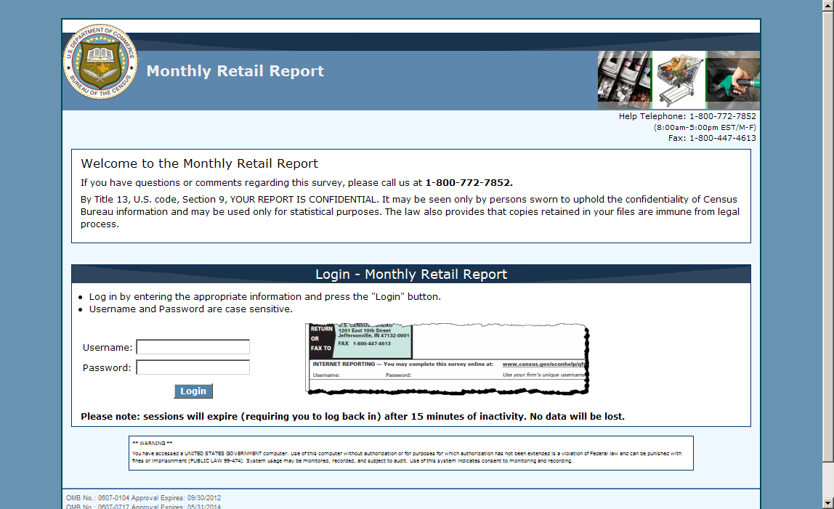
Main Menu screen (under construction)
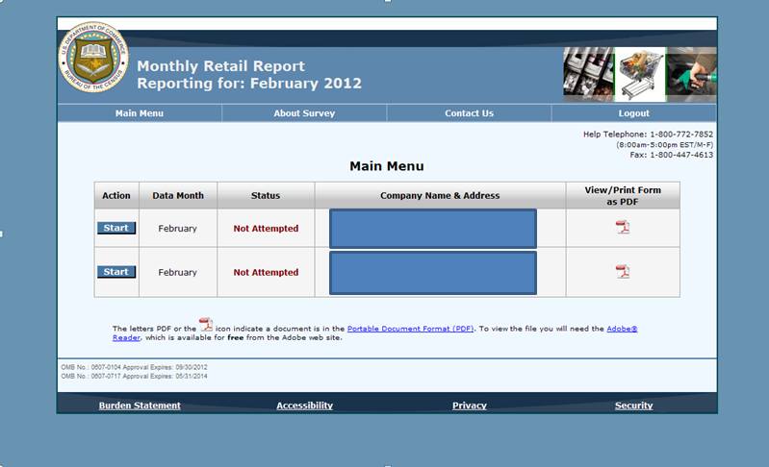
Contact Information Screen
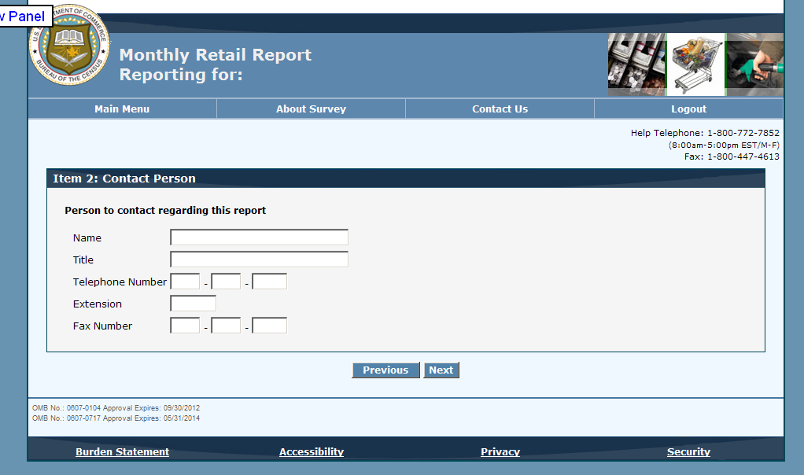
Sales Item
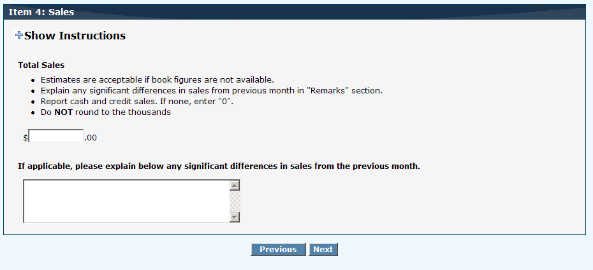
Sales Item for Department Stores
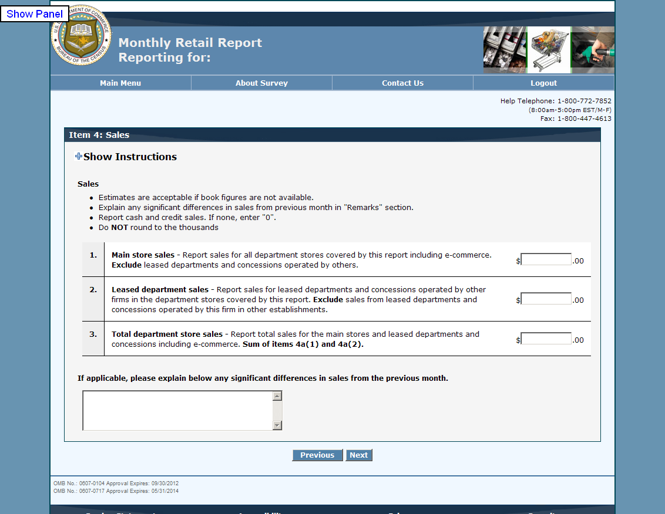
Inventory Item
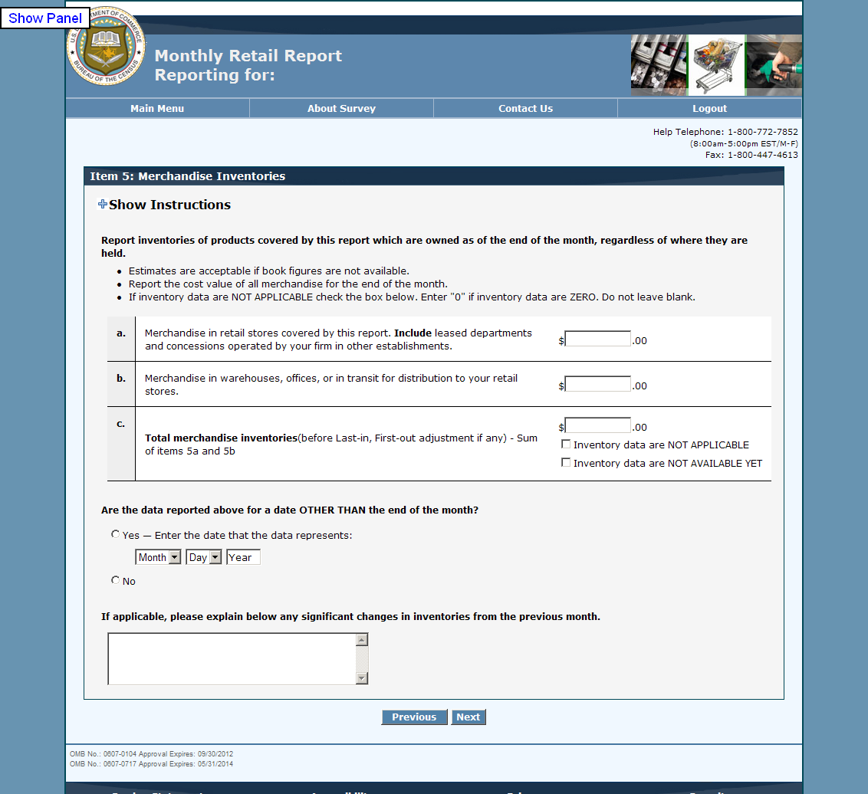

Reporting Period Item
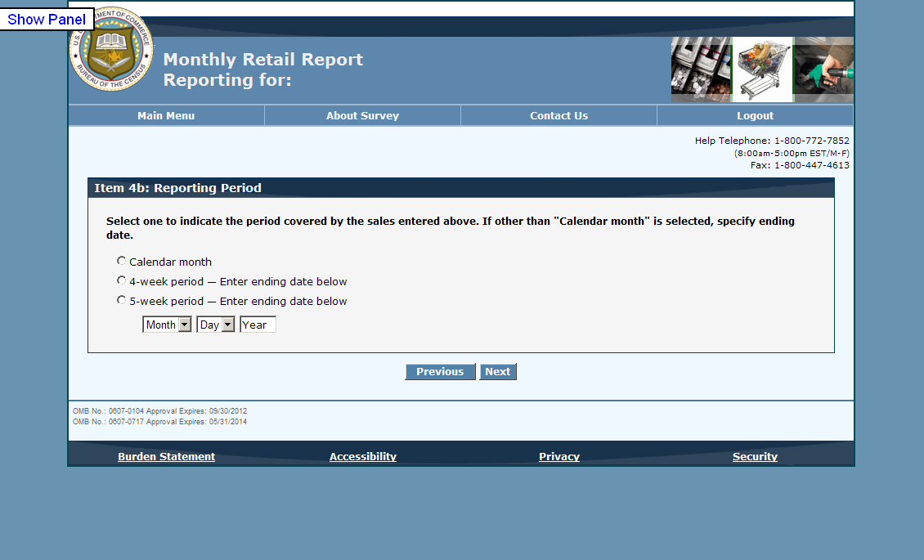
Review Screen (under construction)
