Settings (free version)
This is where the Instructions and Thank You screens can be customized. The settings include login prompt, maximum number of participants allowed, and randomizing the cards.
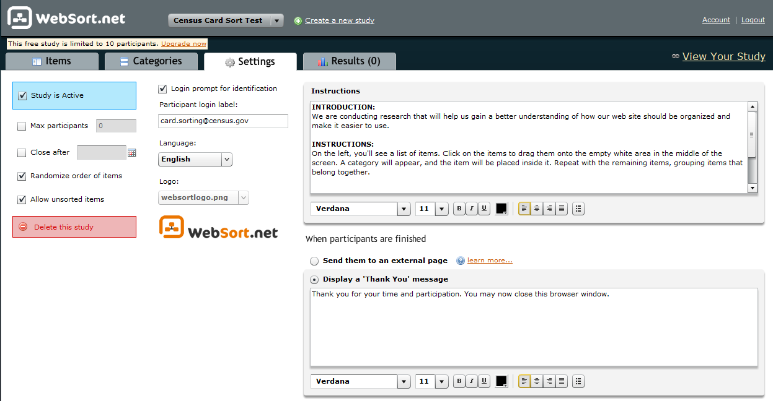

Email Containing the Link
The Usability Lab sends the Card Sort link to the participants via e-mail.
Instruction Screen
The instructions are the first thing the user sees after clicking the link. The instructions are then hidden.
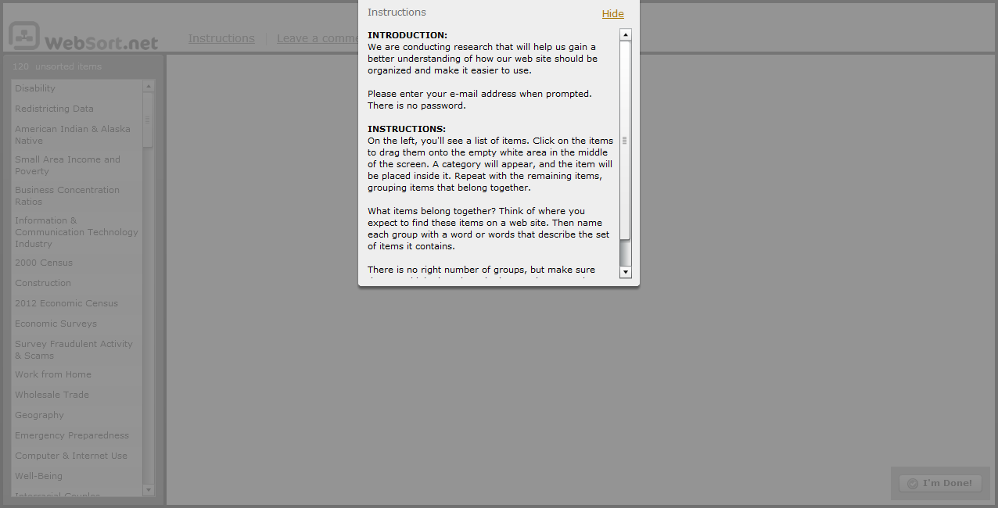
“Login” Screen
User is prompted for e-mail address, but no password is required.
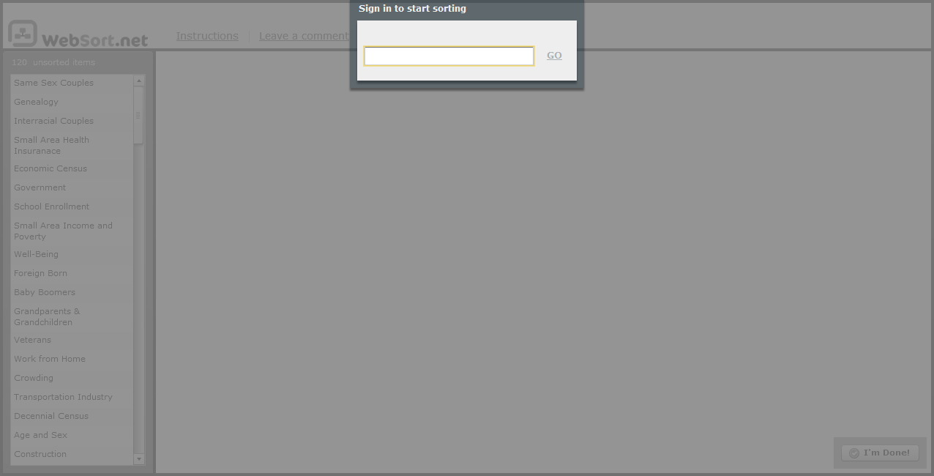

User Performs the Card Sort
The user performs the card sort on this screen.
