Screen Shots from the Consumer Expenditure Diary Survey

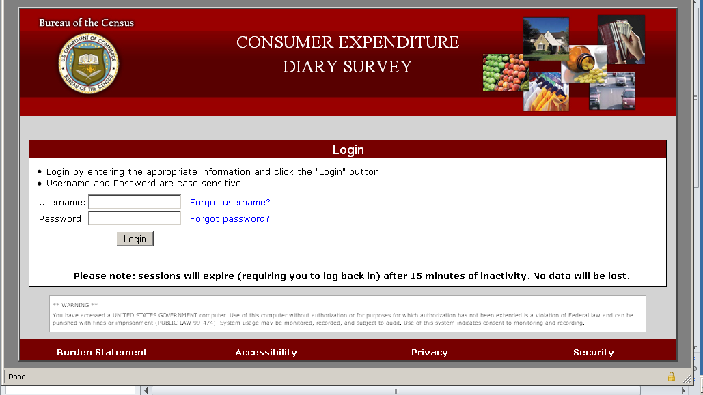
Figure 1: Login Screen

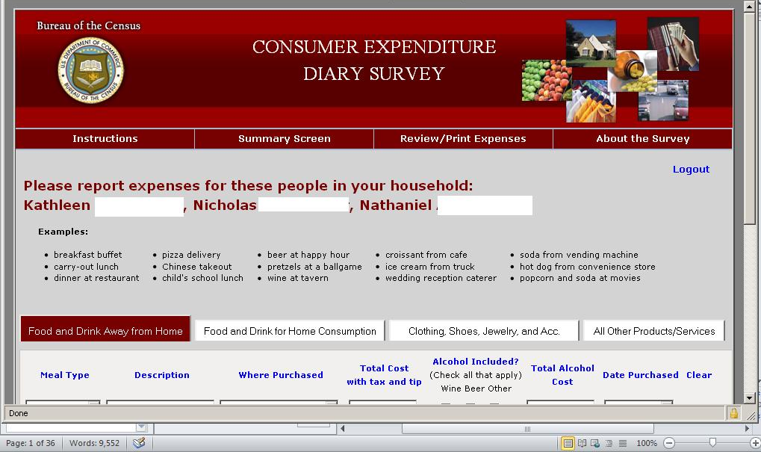
Figure 2: Food and Drink Away From Home (No Scrolling)

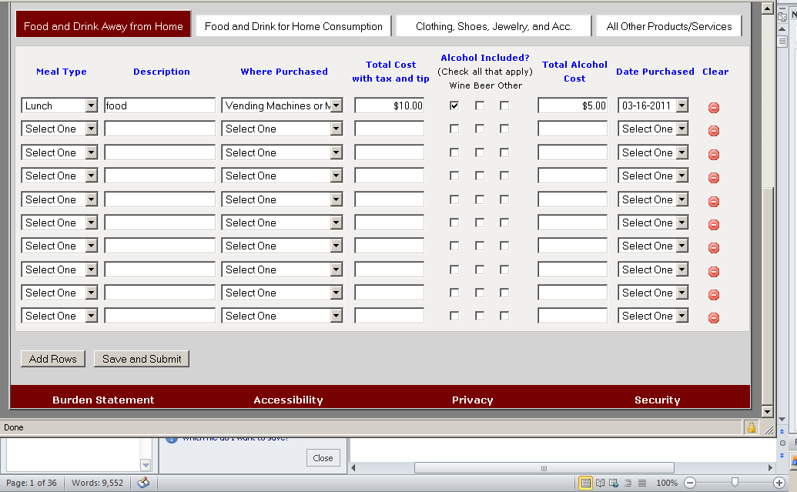
Figure 3: Food and Drink Away From Home (Scrolled Down)

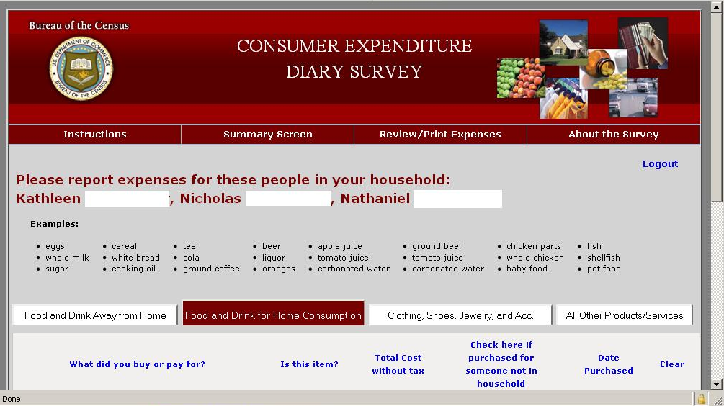
Figure 4: Food and Drink for Home Consumption (No Scrolling)

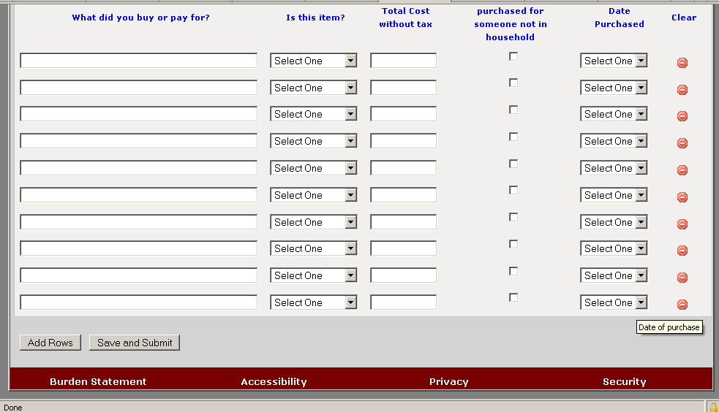
Figure 5: Food and Drink for Home Consumption (Scrolled Down)

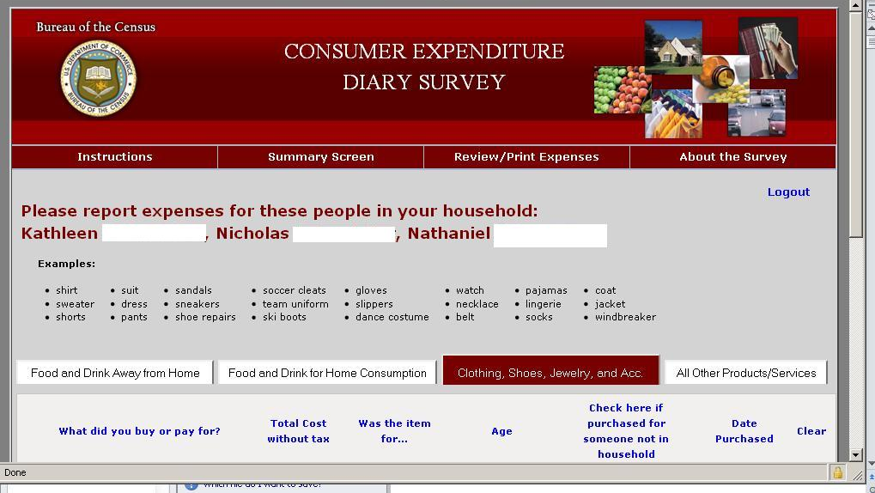
Figure 6: Clothing, Shoes, Jewelry, and Accessories (No Scrolling)

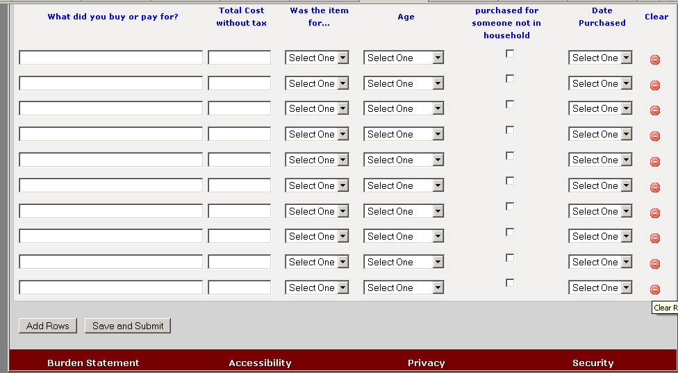
Figure 7: Clothing, Shoes, Jewelry, and Accessories (Scrolled Down)

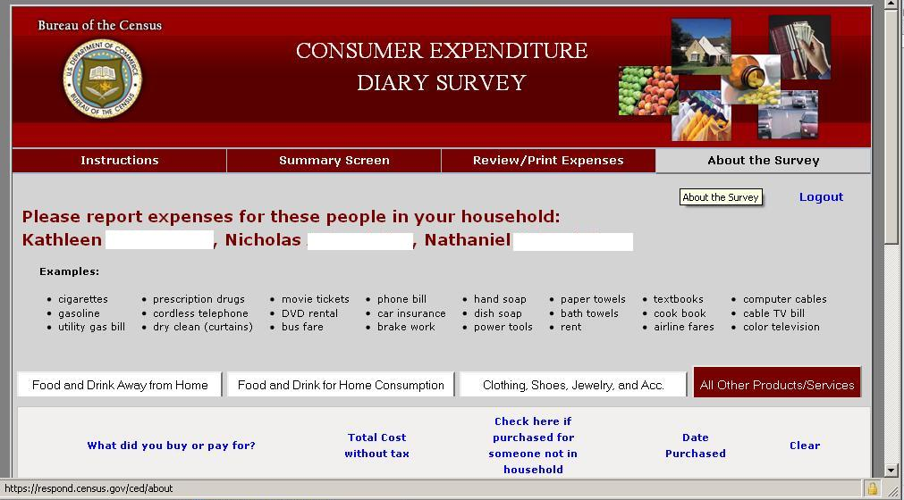
Figure 8: All Other Products/Services (No Scrolling)

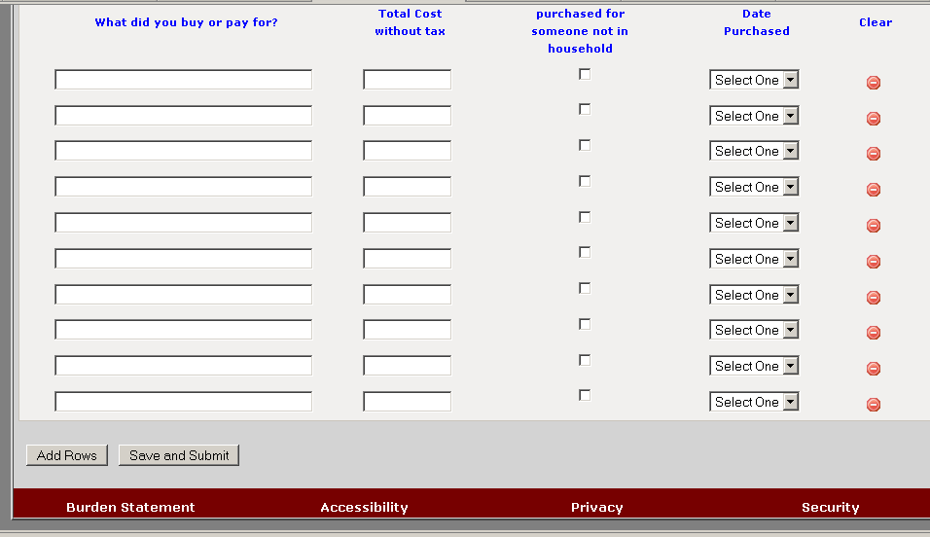
Figure 9: All Other Products/Services (Scrolled Down)

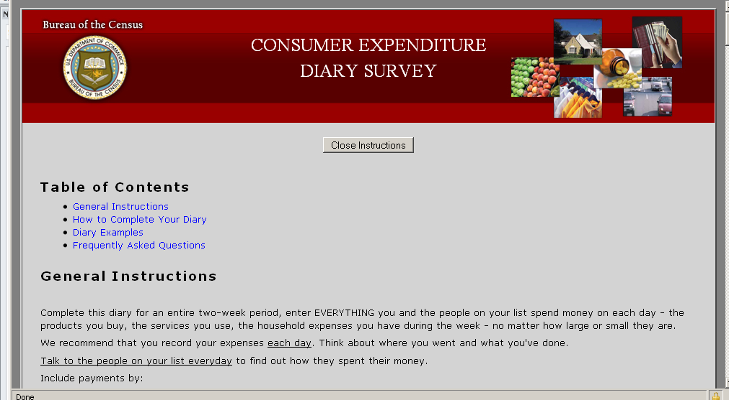
Figure 10: Instructions Tab (No Scrolling)

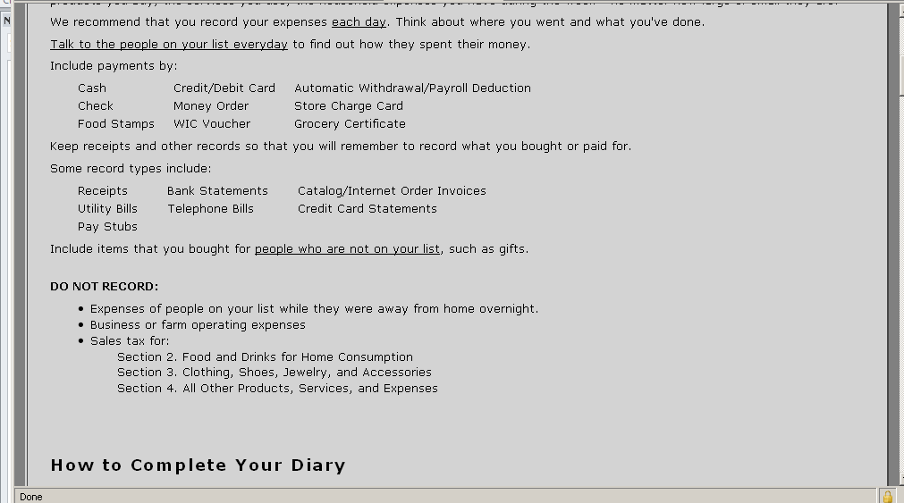
Figure 11: Instructions Tab (Scroll Down 1)

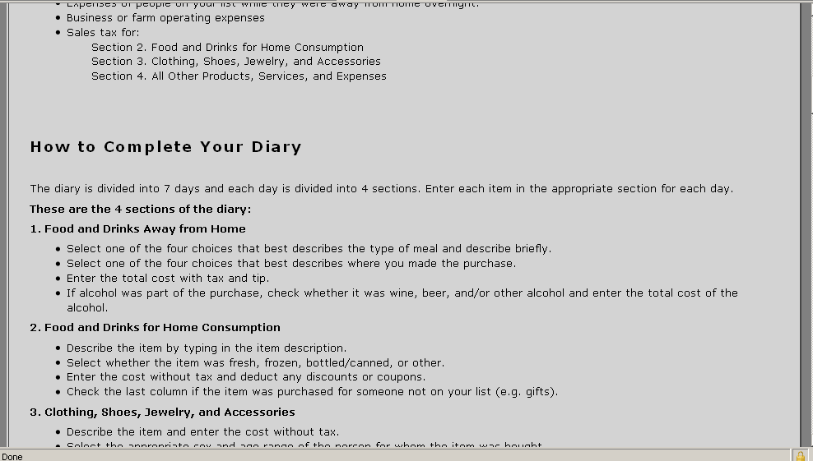
Figure 12: Instructions Tab (Scroll Down 2)

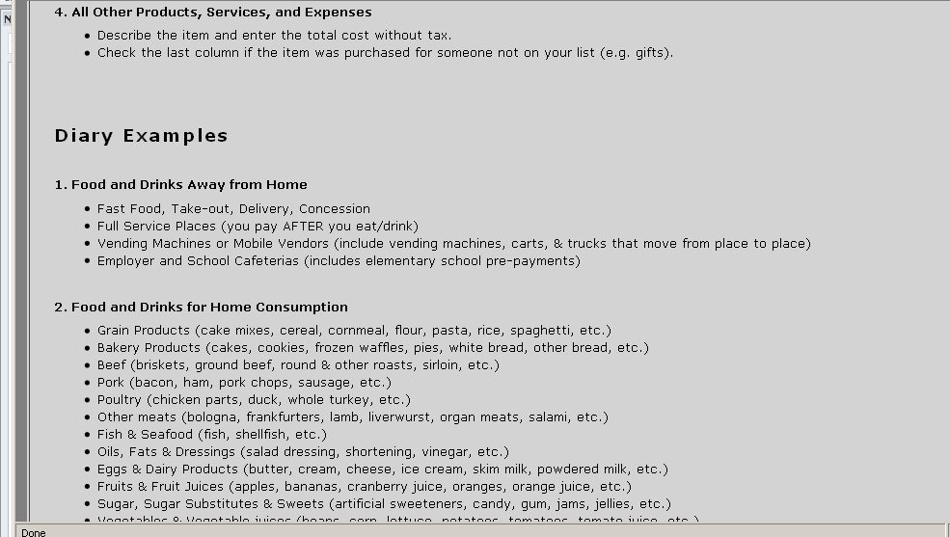
Figure 13: Instructions Tab (Scroll Down 3)

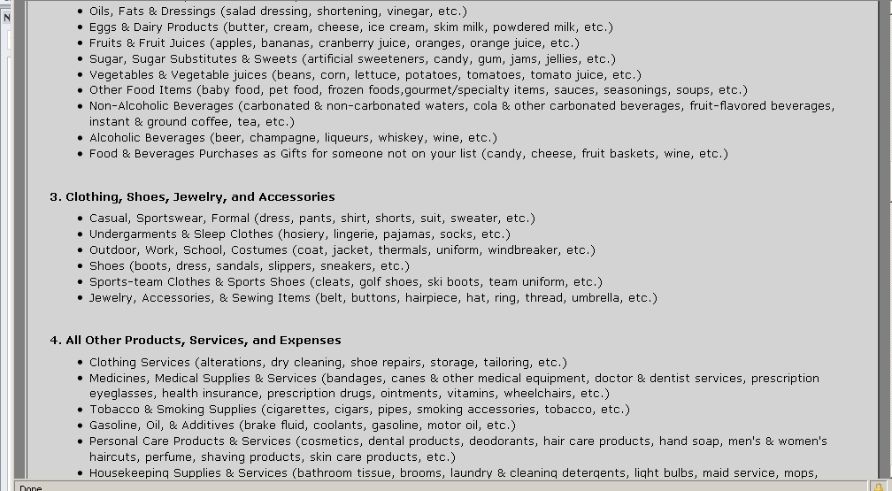
Figure 14: Instructions Tab (Scroll Down 4)

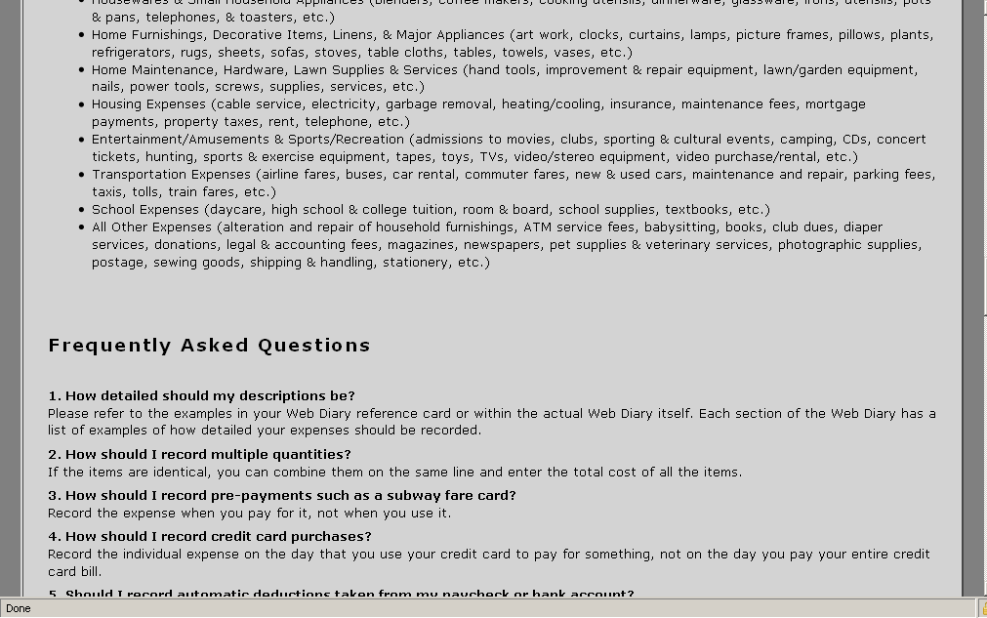
Figure 15: Instructions Tab (Scroll Down 5)

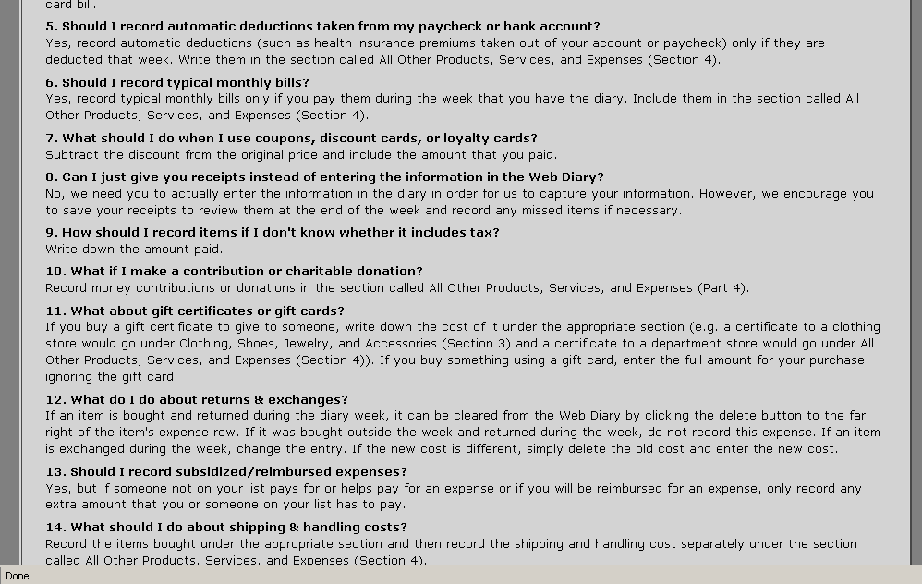
Figure 16: Instructions Tab (Scroll Down 6)

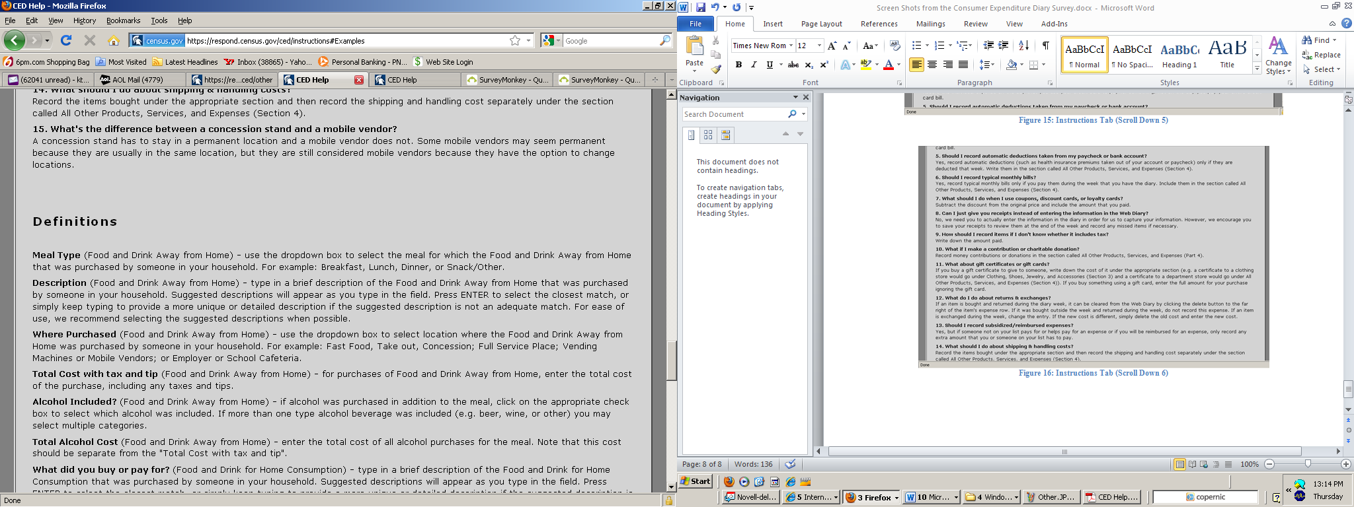
Figure 17: Instructions Tab (Scroll Down 7)

Figure 18: Instructions Tab (Scroll Down 8)

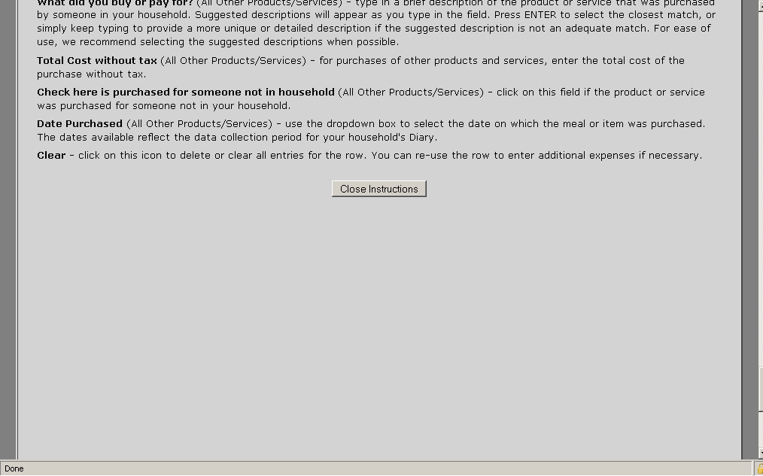
Figure 19: Instructions Tab (Scroll Down 9)

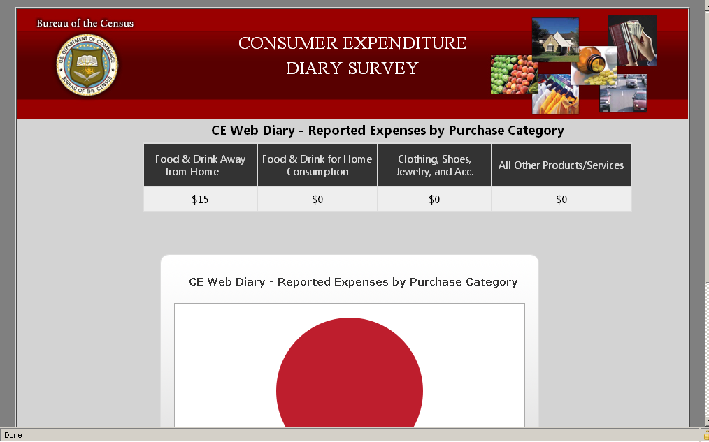
Figure 20: Summary Screen (No Scrolling)

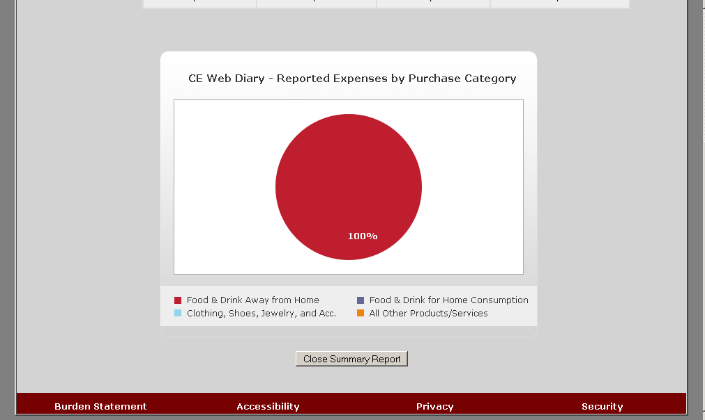
Figure 21: Summary Screen (Scrolled Down)
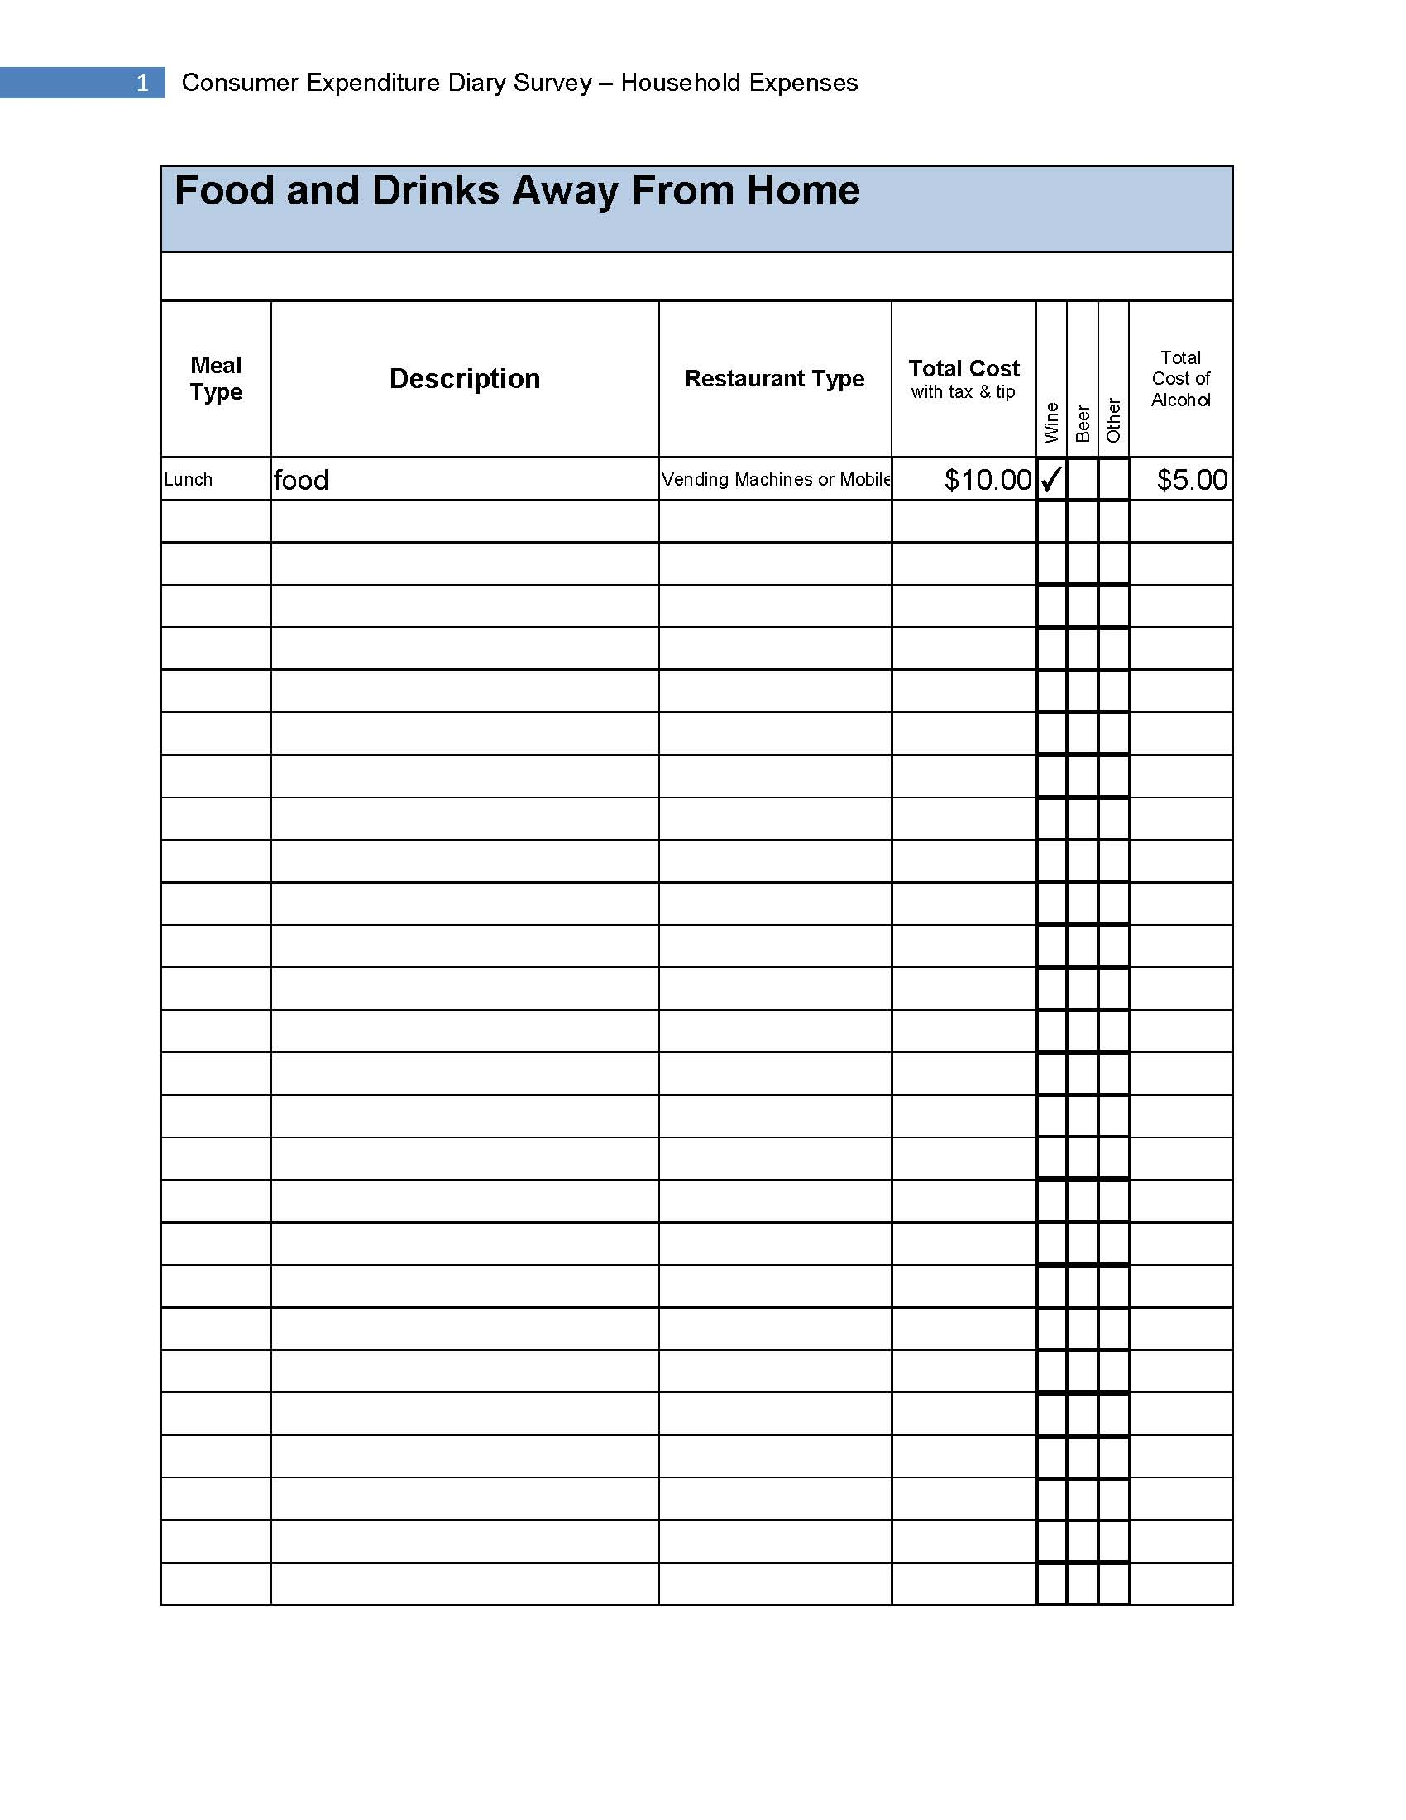
Figure 22: Review/Print Expenses: Food and Drinks Away from Home
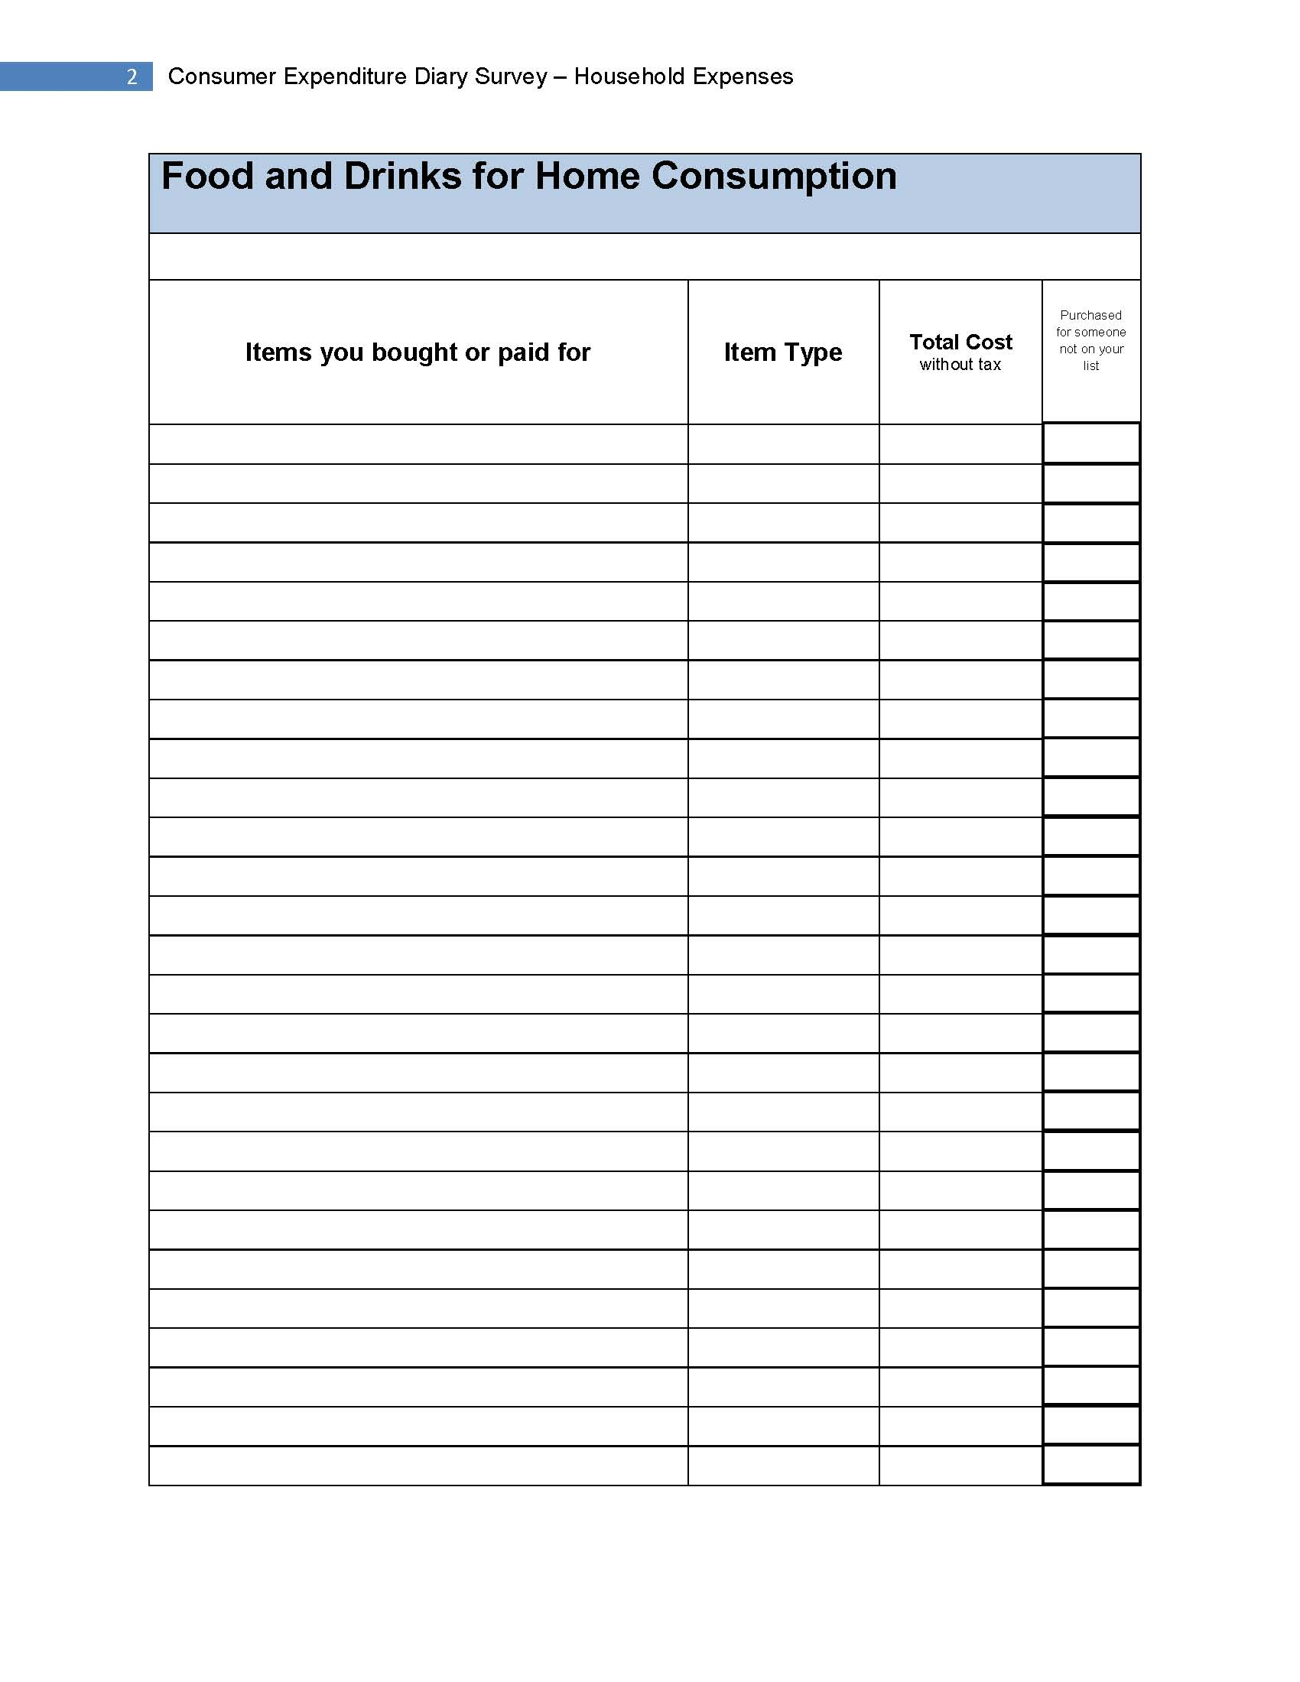
Figure 23: Review/Print Expenses: Food and Drink for Home Consumption
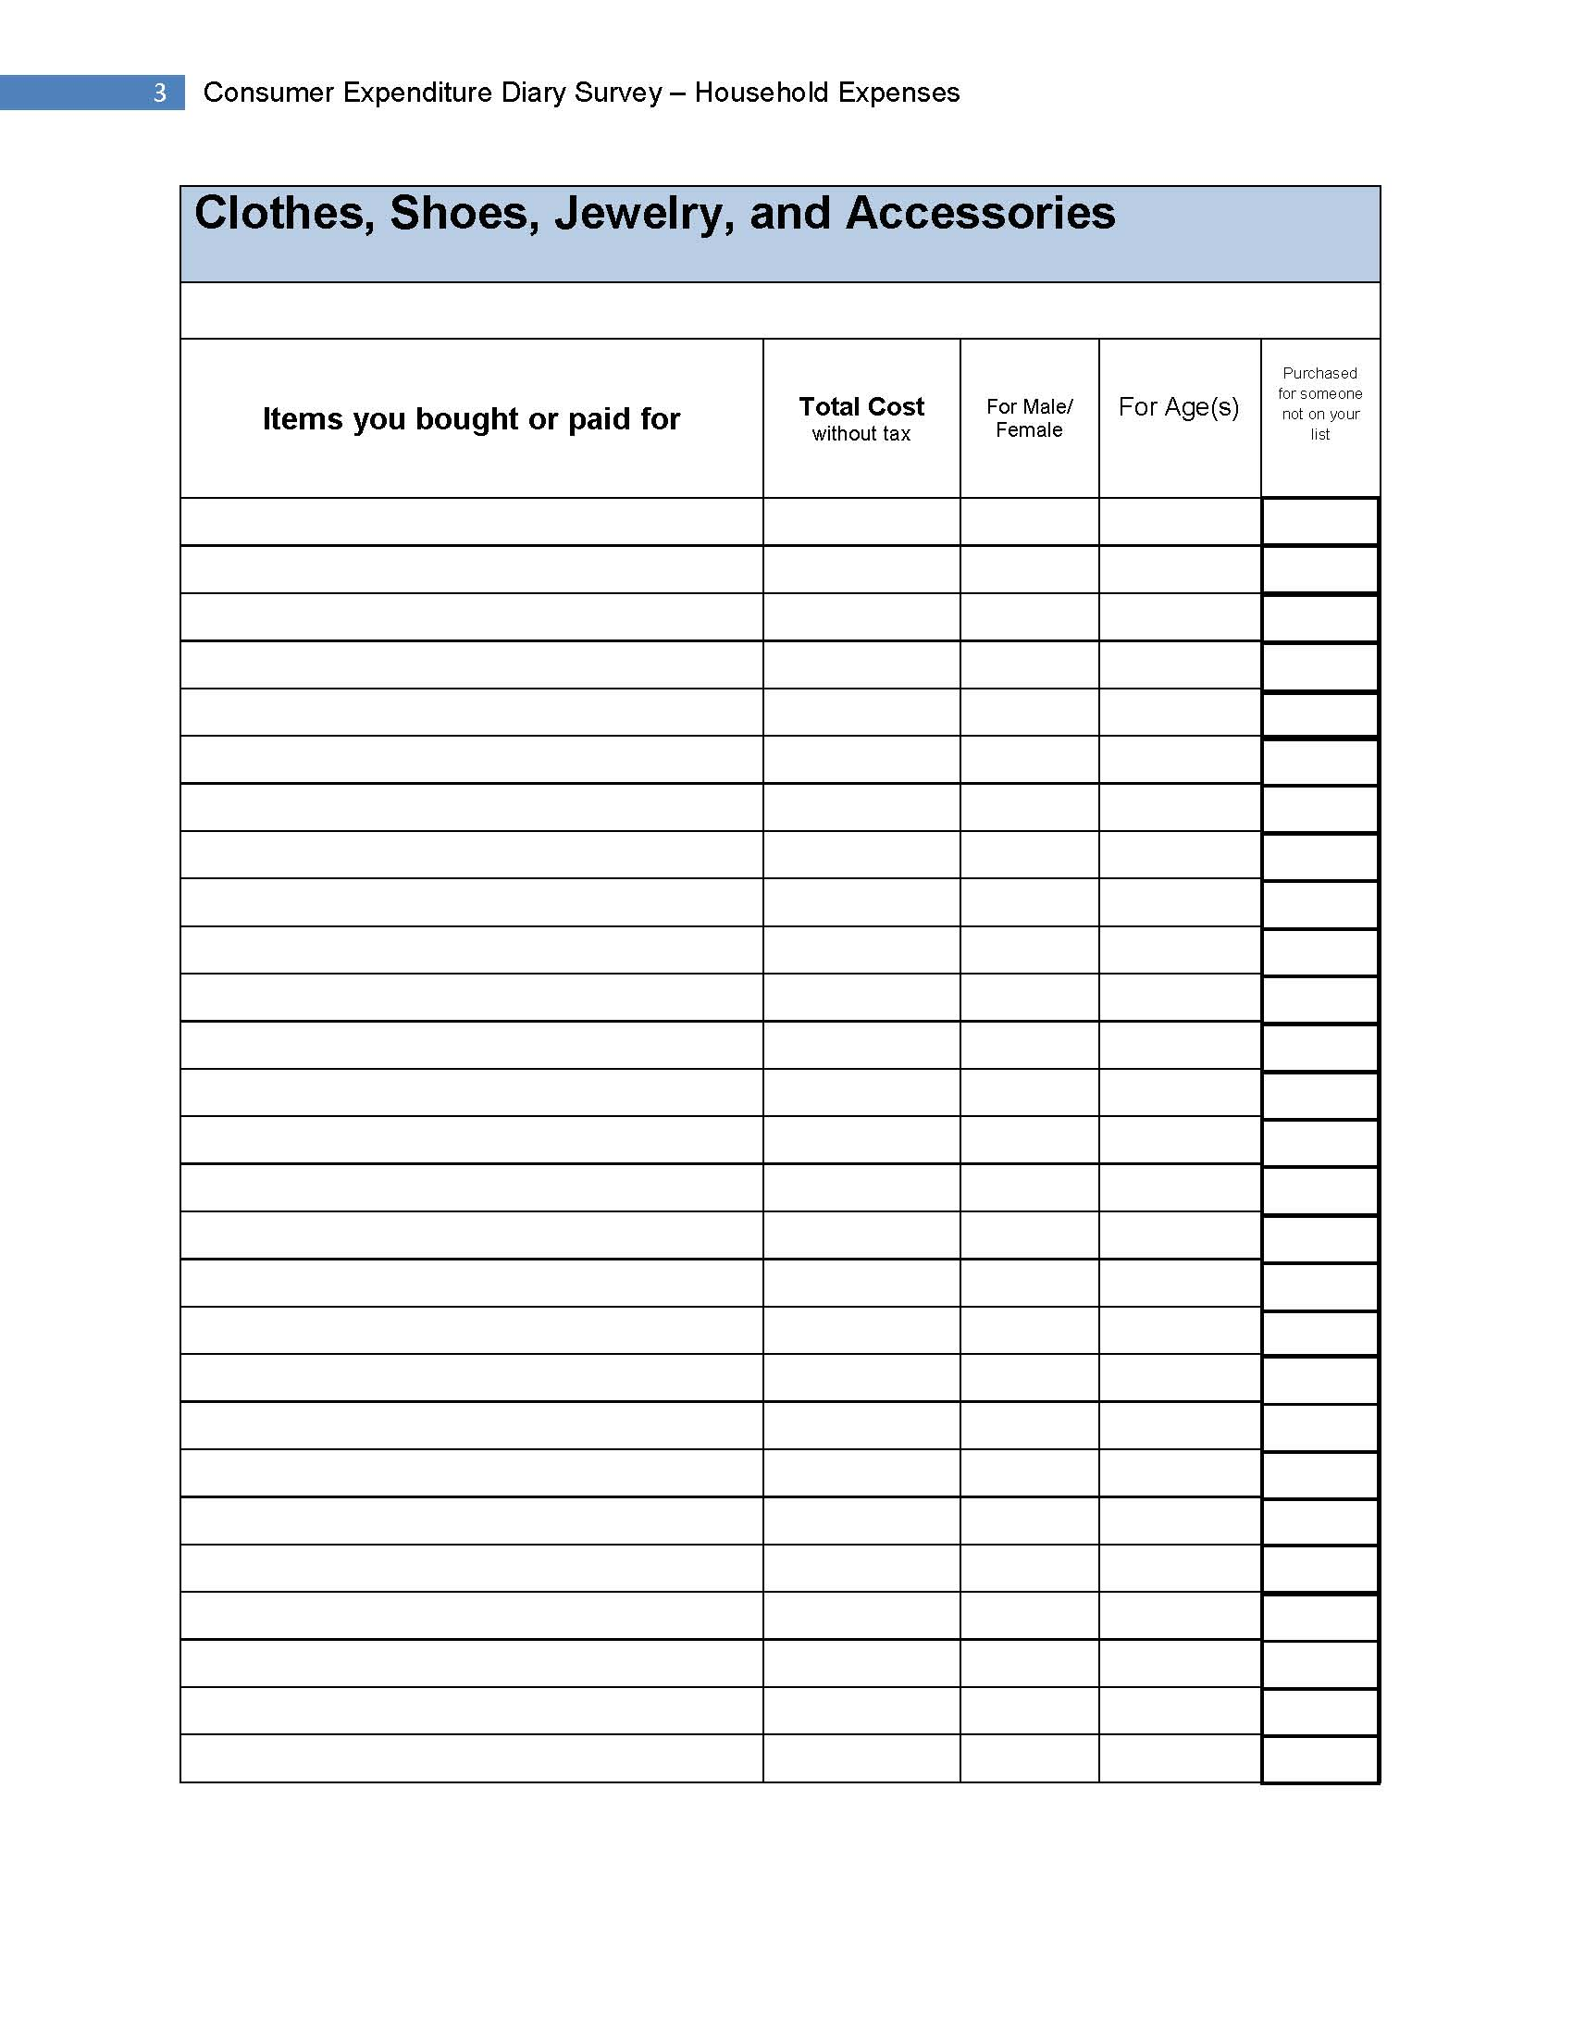
Figure 24: Review/Print Expenses: Clothing, Shoes, Jewelry, and Acc.

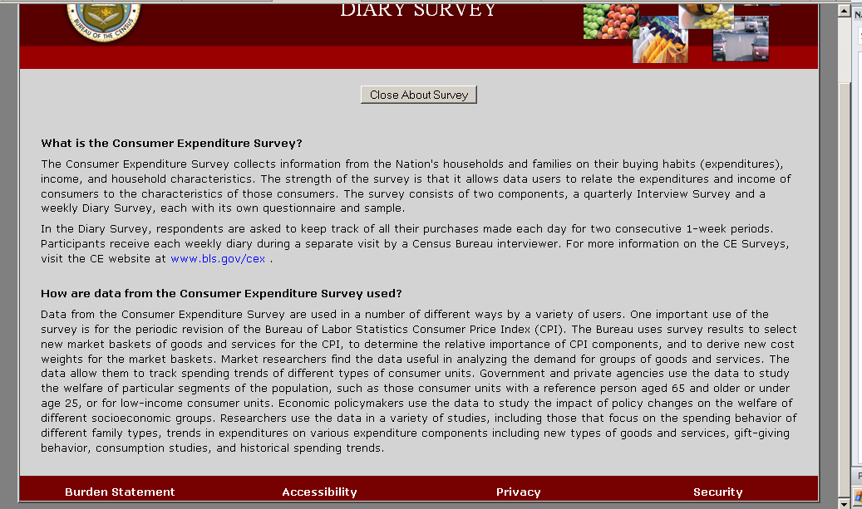
Figure 25: About the Survey Tab
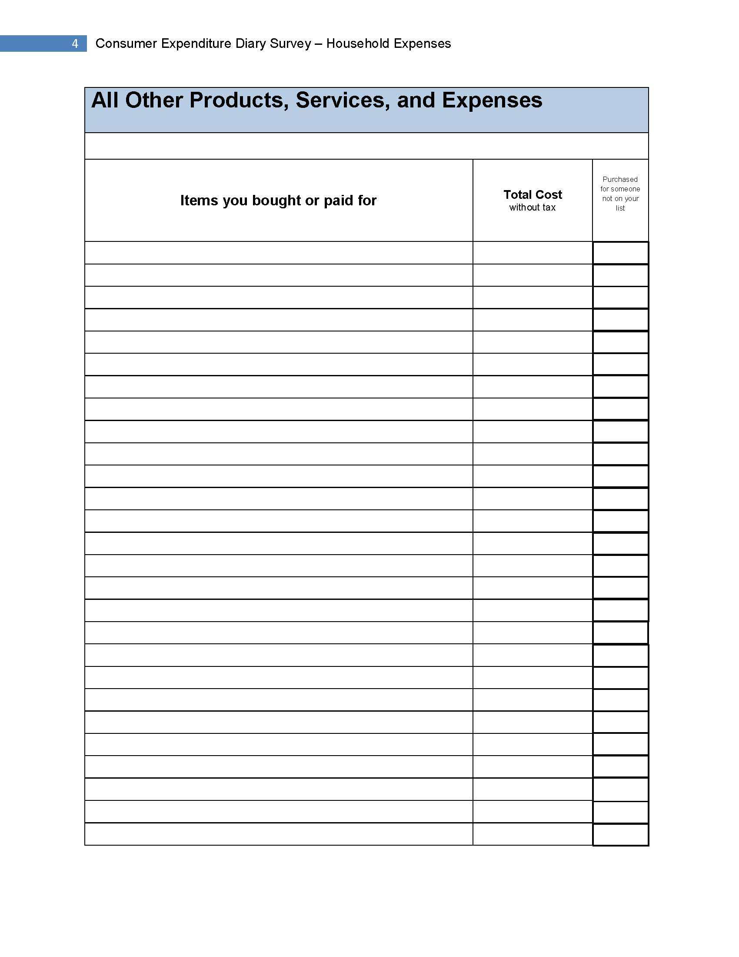
Figure 26: Review/Print Expenses: All Other Products/Services

Clicking the link opens a new page in the browser.
A PDF with one page for each of the 4 categories is generated with this tab is clicked.
This is scrolled down a little because only the header, which is the same throughout the survey, is cut off. Clicking this tab opens a new page in the browser.

