Attachment A: URLs and screenshots of the Web pages we will be testing. Although participants may see other Web pages from the Regional Office Website, the participants will obtain their answers from these Web pages.

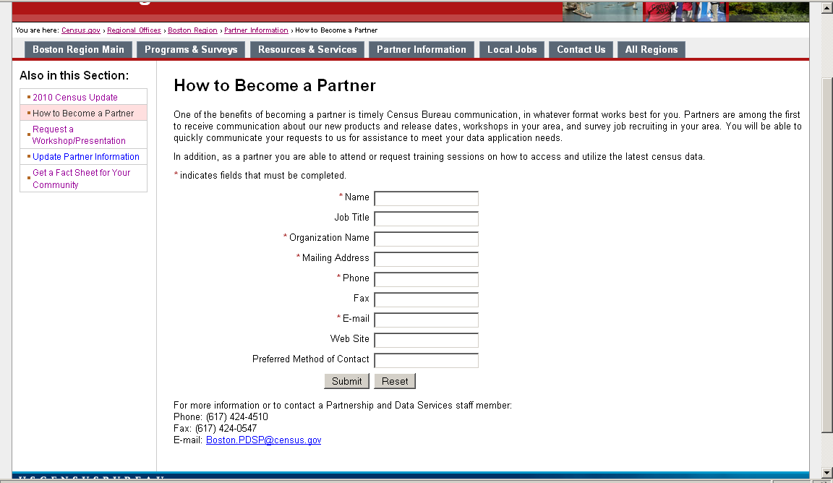

Figure 1: Task 1 asks participants to become a partner with the Boston Regional Office. (http://webdev.ssd.census.gov/regions/boston/www/partner_information/become_a_partner.php)

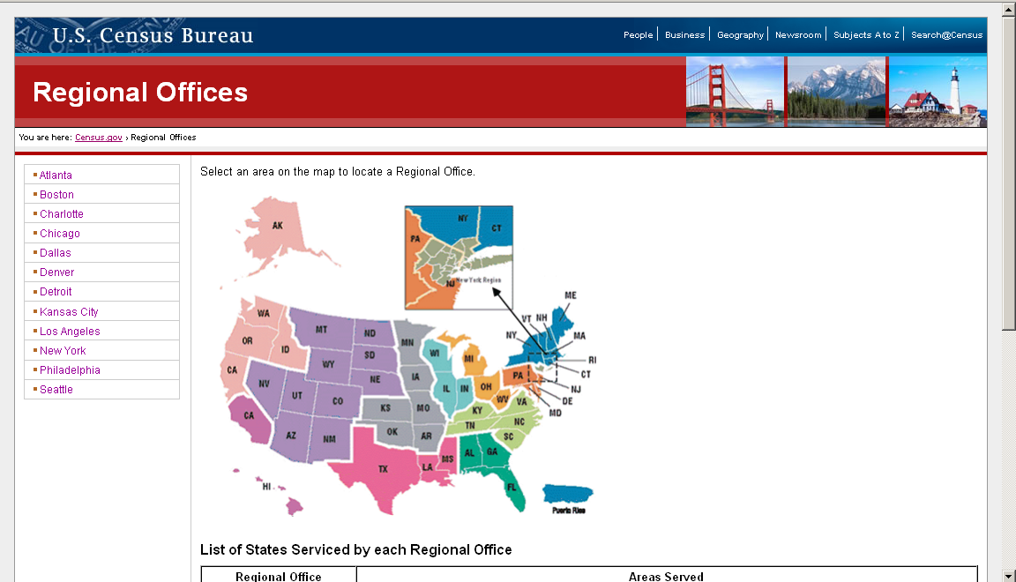

Figure 2: The Regional Map does not show territories such as the Commonwealth of the Northern Mariana Islands (CNMI). The first part of Task 2 asks participants to find information using the Regional Office for the CNMI territory. (http://webdev.ssd.census.gov/regions/)

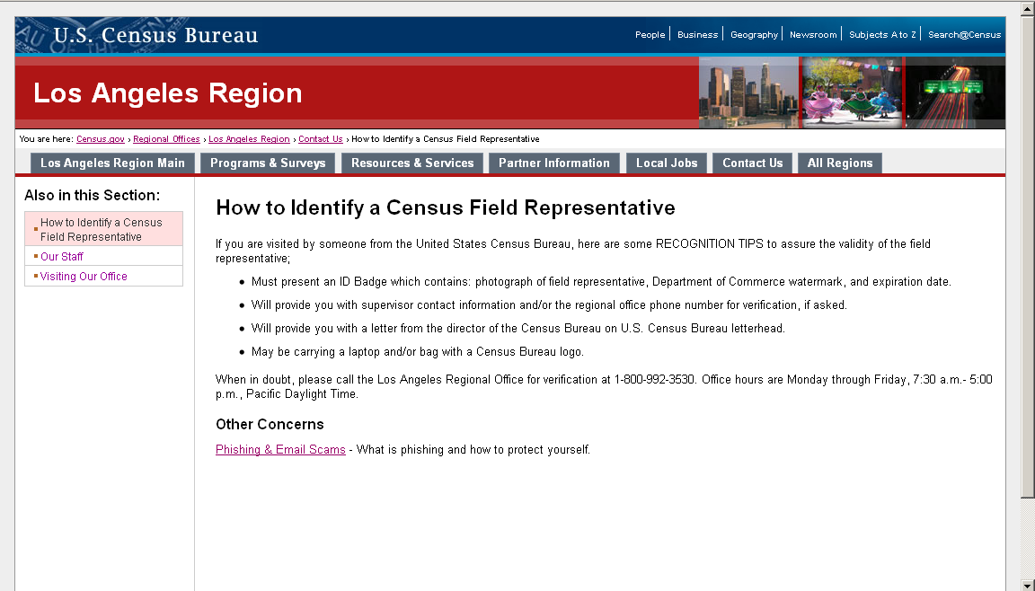

Figure 3: The second part of Task 2 asks participants to find information regarding how to identify a Census Field Representative. Information regarding the identification of a Census Field Representative is located inside Contact Us. Users can also get to this page from the homepage of the Los Angeles Regional Office Web page. (http://webdev.ssd.census.gov/regions/los_angeles/www/contact_us/how_to_identify_a_census_field_representative.php)
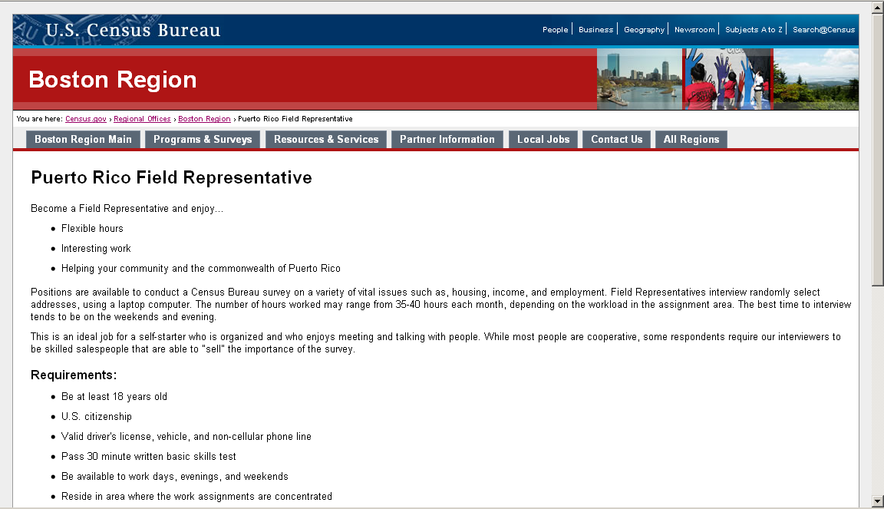
Figure 4: Task 3 asks the participant to find the workload hours and qualifications for the Field Representative position in Puerto Rico. (http://webdev.ssd.census.gov/regions/boston/www/jobs/pr_field_representative.php)

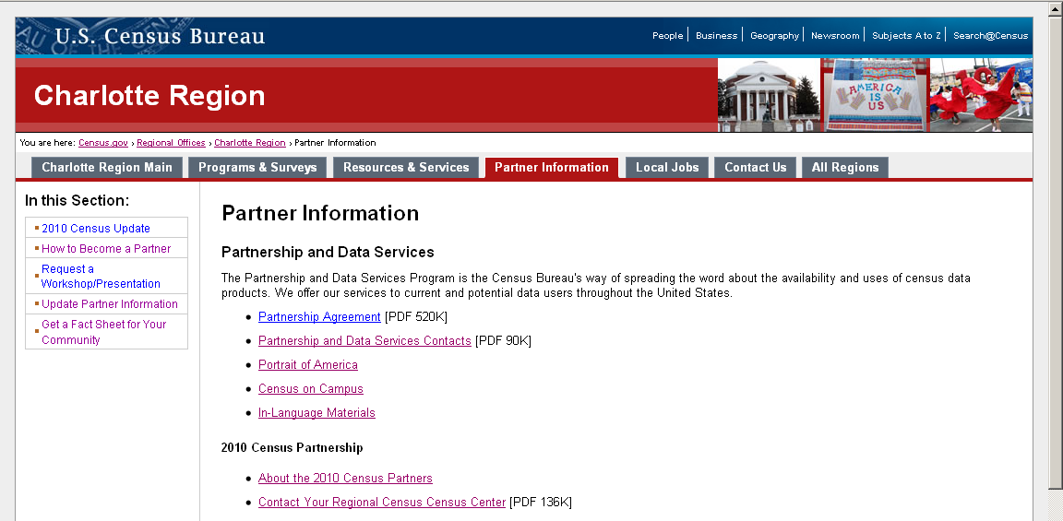

Figure 5: Task 4 asks participants to find the phone number for the Partnership and Data Services Contacts. Task 9 asks participants to find the number of people living in Rockville in the year 2000. Participants may also go through the “Resources & Services” links. Task 9 will evaluate where participants look for statistical data about their community. (http://webdev.ssd.census.gov/regions/charlotte/www/partner_information/)
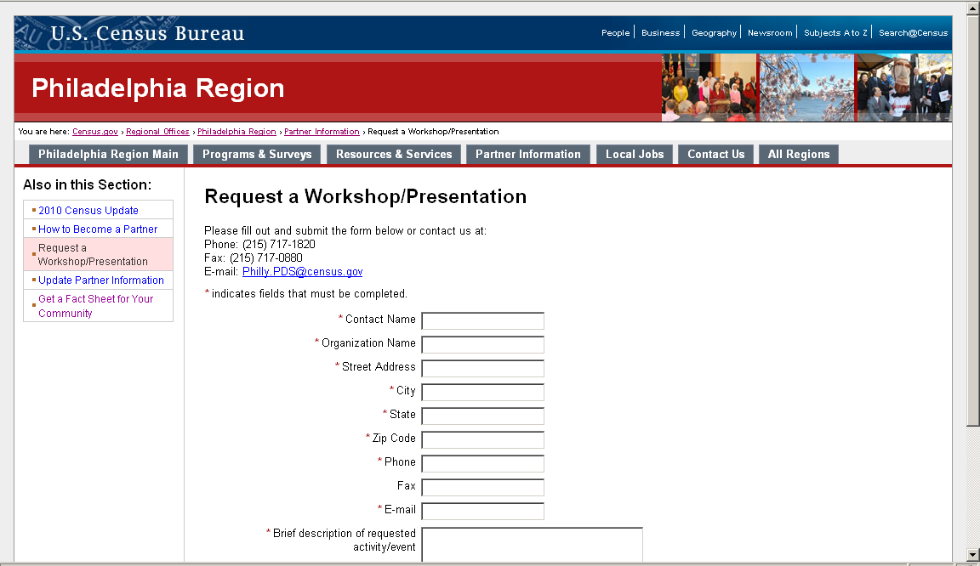

Figure 6: Task 5 asks participants to request a workshop or presentation from the Philadelphia Regional Office. (http://webdev.ssd.census.gov/regions/philadelphia/www/partner_information/request_a_workshoppresentation.php)
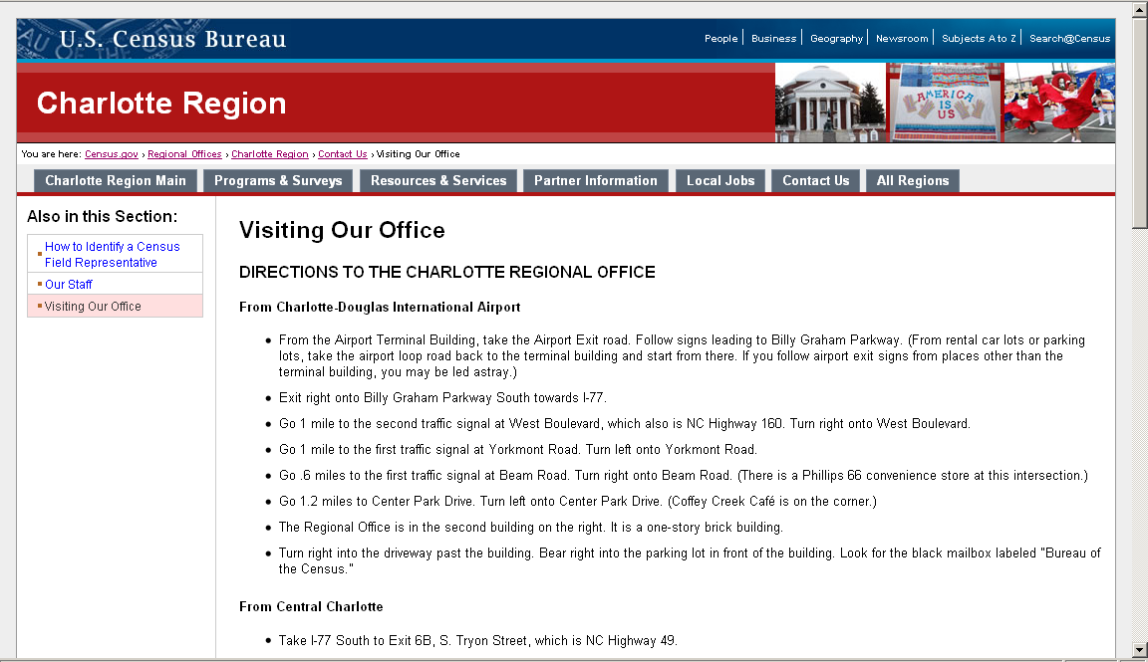

Figure 7: Task 6 asks participants to find directions to the Charlotte Regional Office. (http://webdev.ssd.census.gov/regions/charlotte/www/contact_us/visiting_our_office.php)
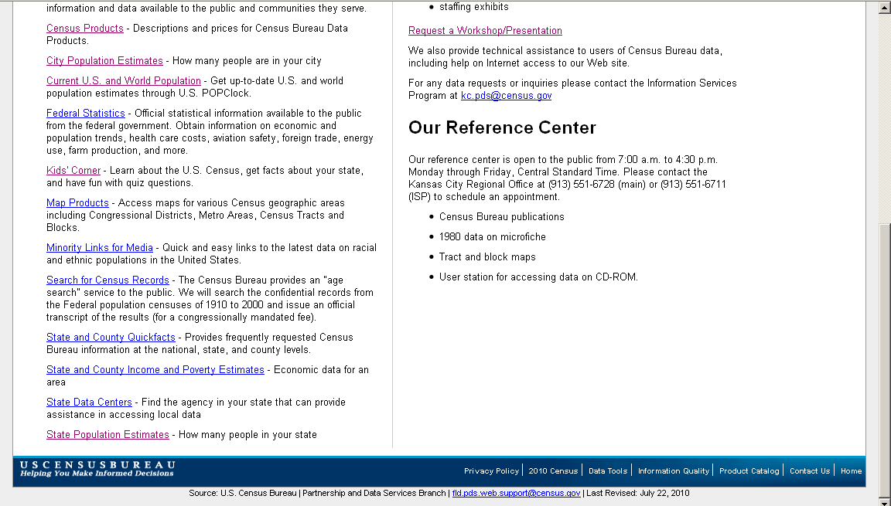

Figure 8: Links to resources such as State Population Estimates are located beneath the fold of the Website. Task 7 asks participants to find information on scheduling an appointment to access microfiche data. Task 9 asks participants to find the population of the city of Rockville in the year 2000. Task 11 asks participants to locate the population of the state of Kansas. (http://webdev.ssd.census.gov/regions/kansas_city/www/resources_services/)
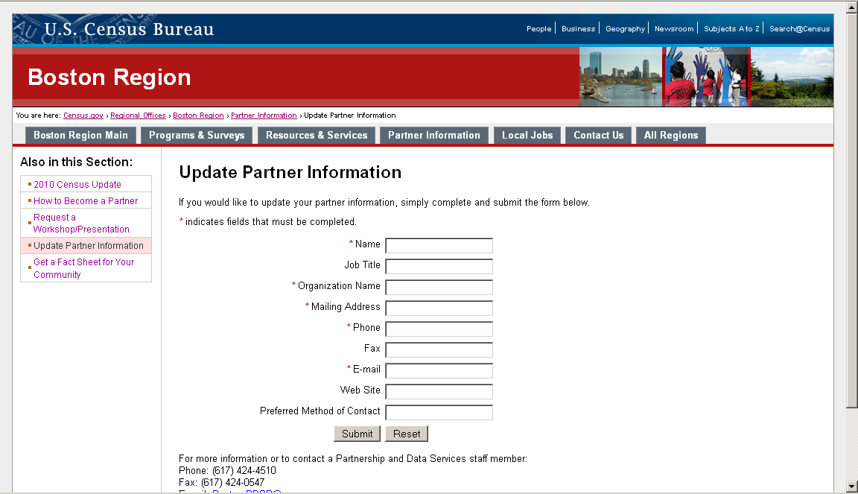

Figure 9: Task 8 asks participants to update their partnership information with the Boston Regional Office that they had previously submitted in Task 1. (http://webdev.ssd.census.gov/regions/boston/www/partner_information/update_partner_information.php)

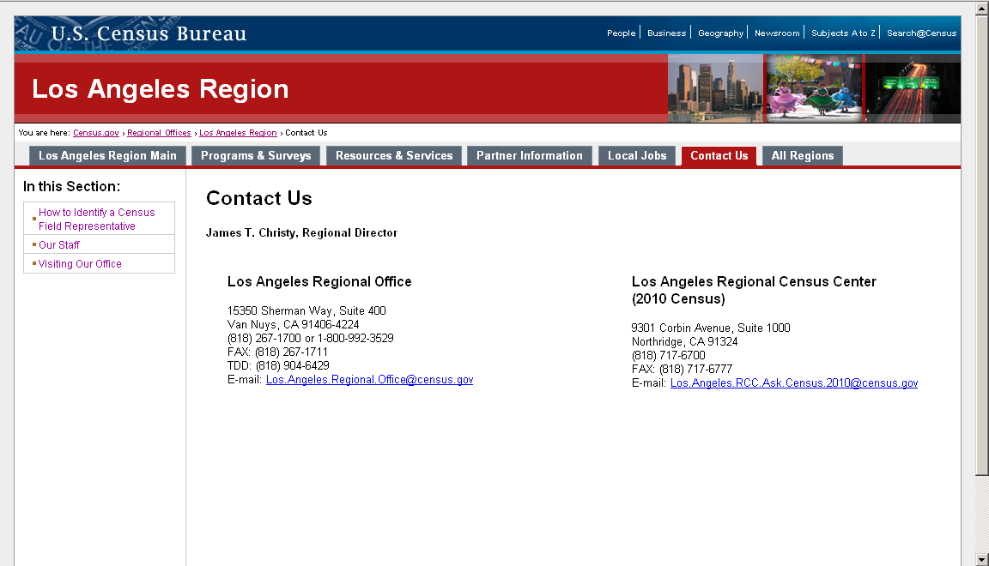

Figure 10: Task 10 asks participants to find the Los Angeles’ Regional Office director’s name and phone number. (http://webdev.ssd.census.gov/regions/los_angeles/www/contact_us/)
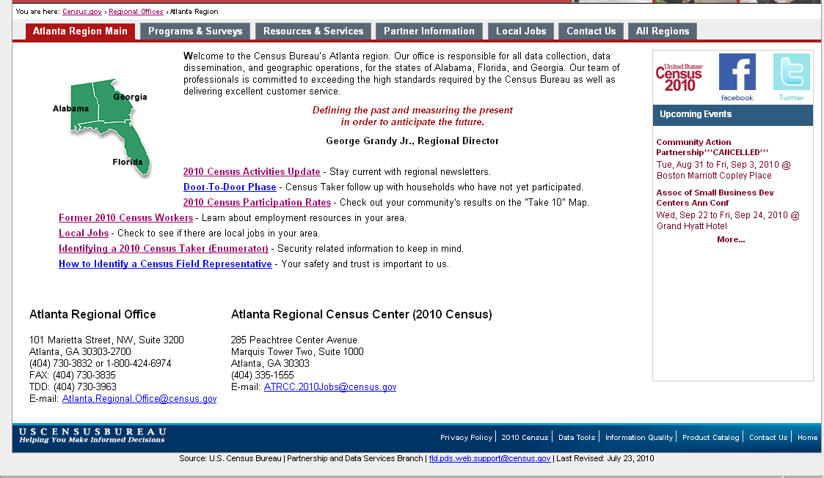

Figure 11: A debriefing question will ask the participants what they would expect to see on a home page of a Regional Office. (http://webdev.ssd.census.gov/regions/atlanta/)

