
OMB No. 0915-0212
Exp. Date: XX/XX/20XX

Attachment E: Items to be Tested
Draft Mission Statement
To deliver quality health care to medically underserved communities by engaging primary care clinicians, through the offer of an extraordinary career opportunity and financial incentives, to provide their skills to the neediest Americans.
Logo A
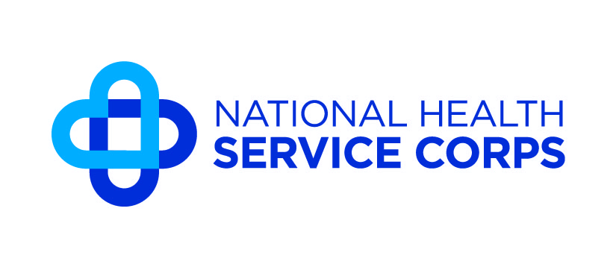
Logo B
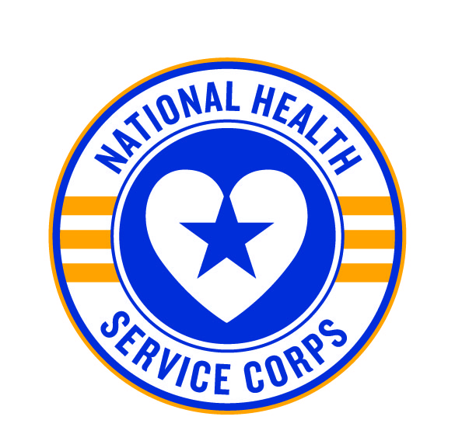

Logo C
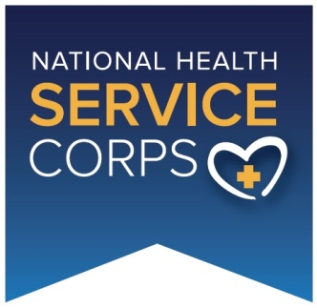
Tagline A
Care to Make a Difference
Tagline B
One corps. Infinite opportunities.
Tagline C
More than Just Medicine
Loan Repayment Offer A
You may receive up to $145‚000 in loan repayment for completing a five-year service commitment. The program starts with an initial award of $50‚000 for two years of service.
Loan Repayment Offer B
You may receive $35,000 in loan repayment for each year of service until you have paid off all of your student loan debt. The program starts with a minimum two-year service commitment.
Loan Repayment Offer C
You may receive $35,000 in loan repayment for each year of service and up to $175,000 in loan repayment for completing a five-year service commitment. The program starts with an initial
two-year service commitment.

Loan Repayment Offer D
You may receive $70,000 in loan repayment for a two-year service commitment. You may choose to extend your service period and receive up to $145,000 in total loan repayment.
Site Decal A
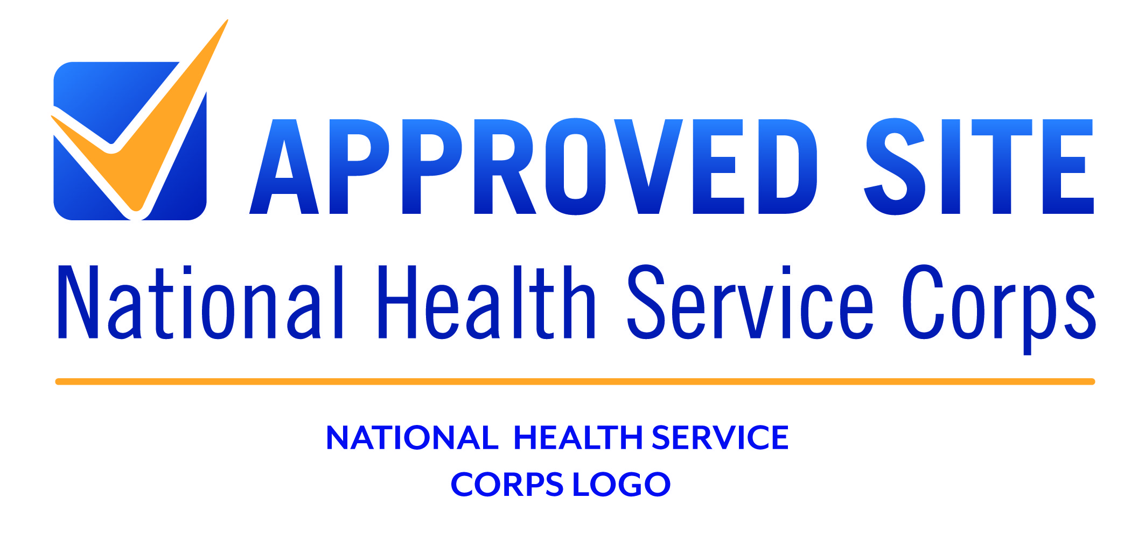

Site Decal B

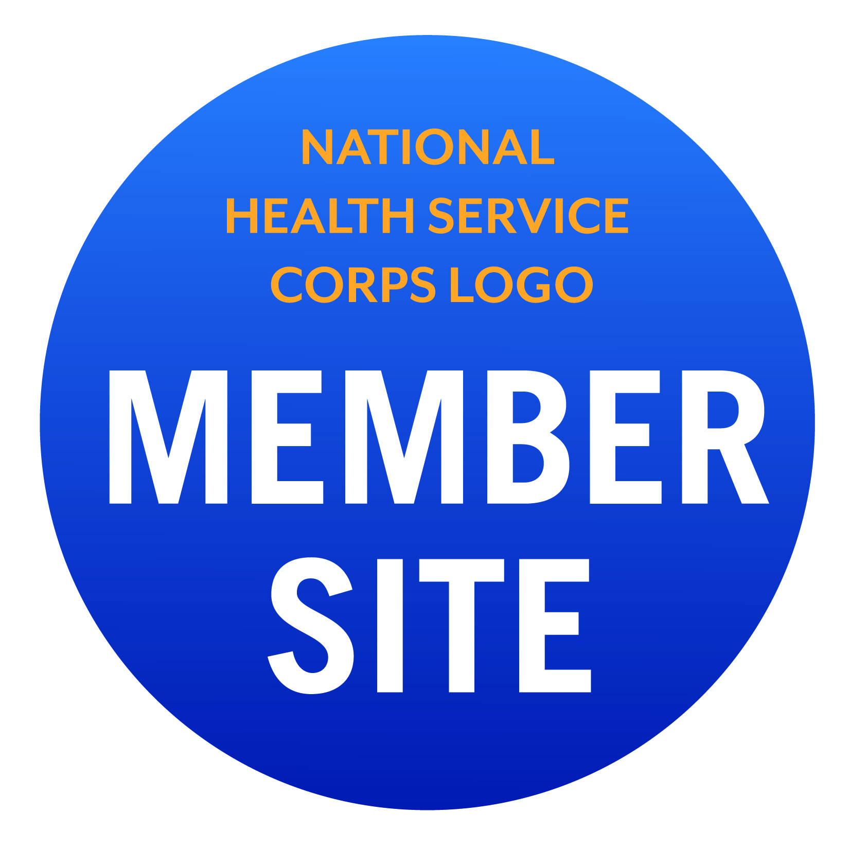

Site Decal C
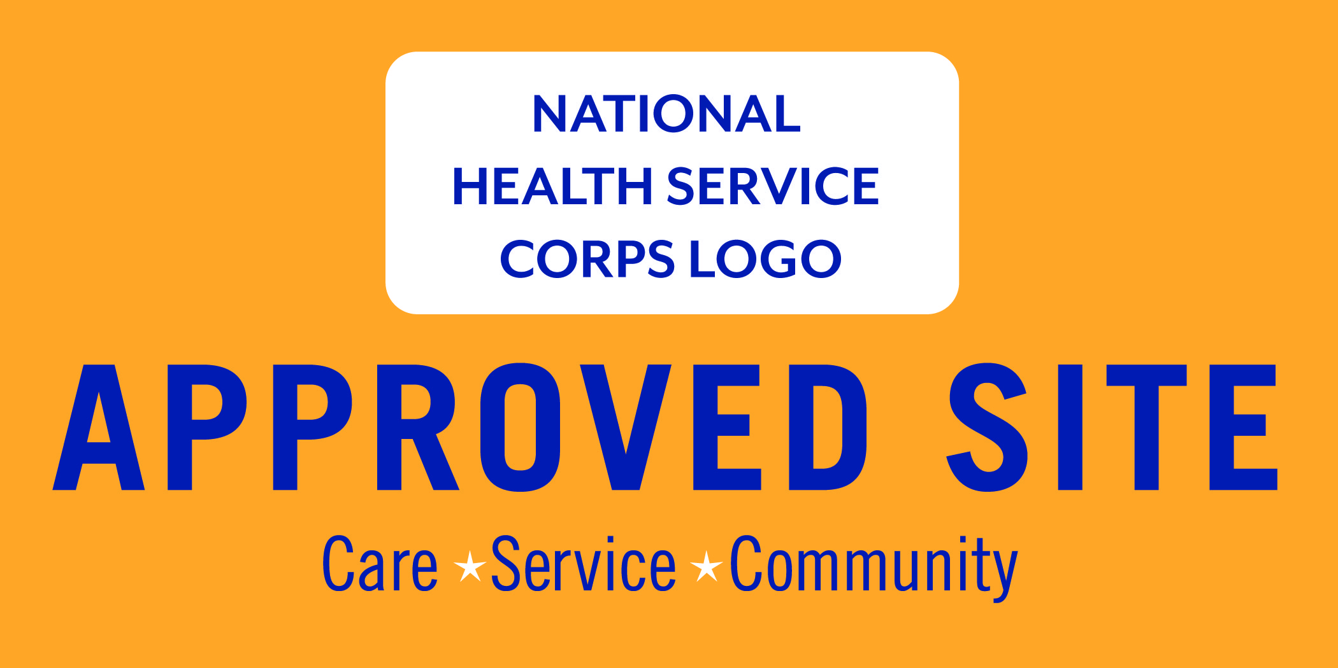

Site Decal D
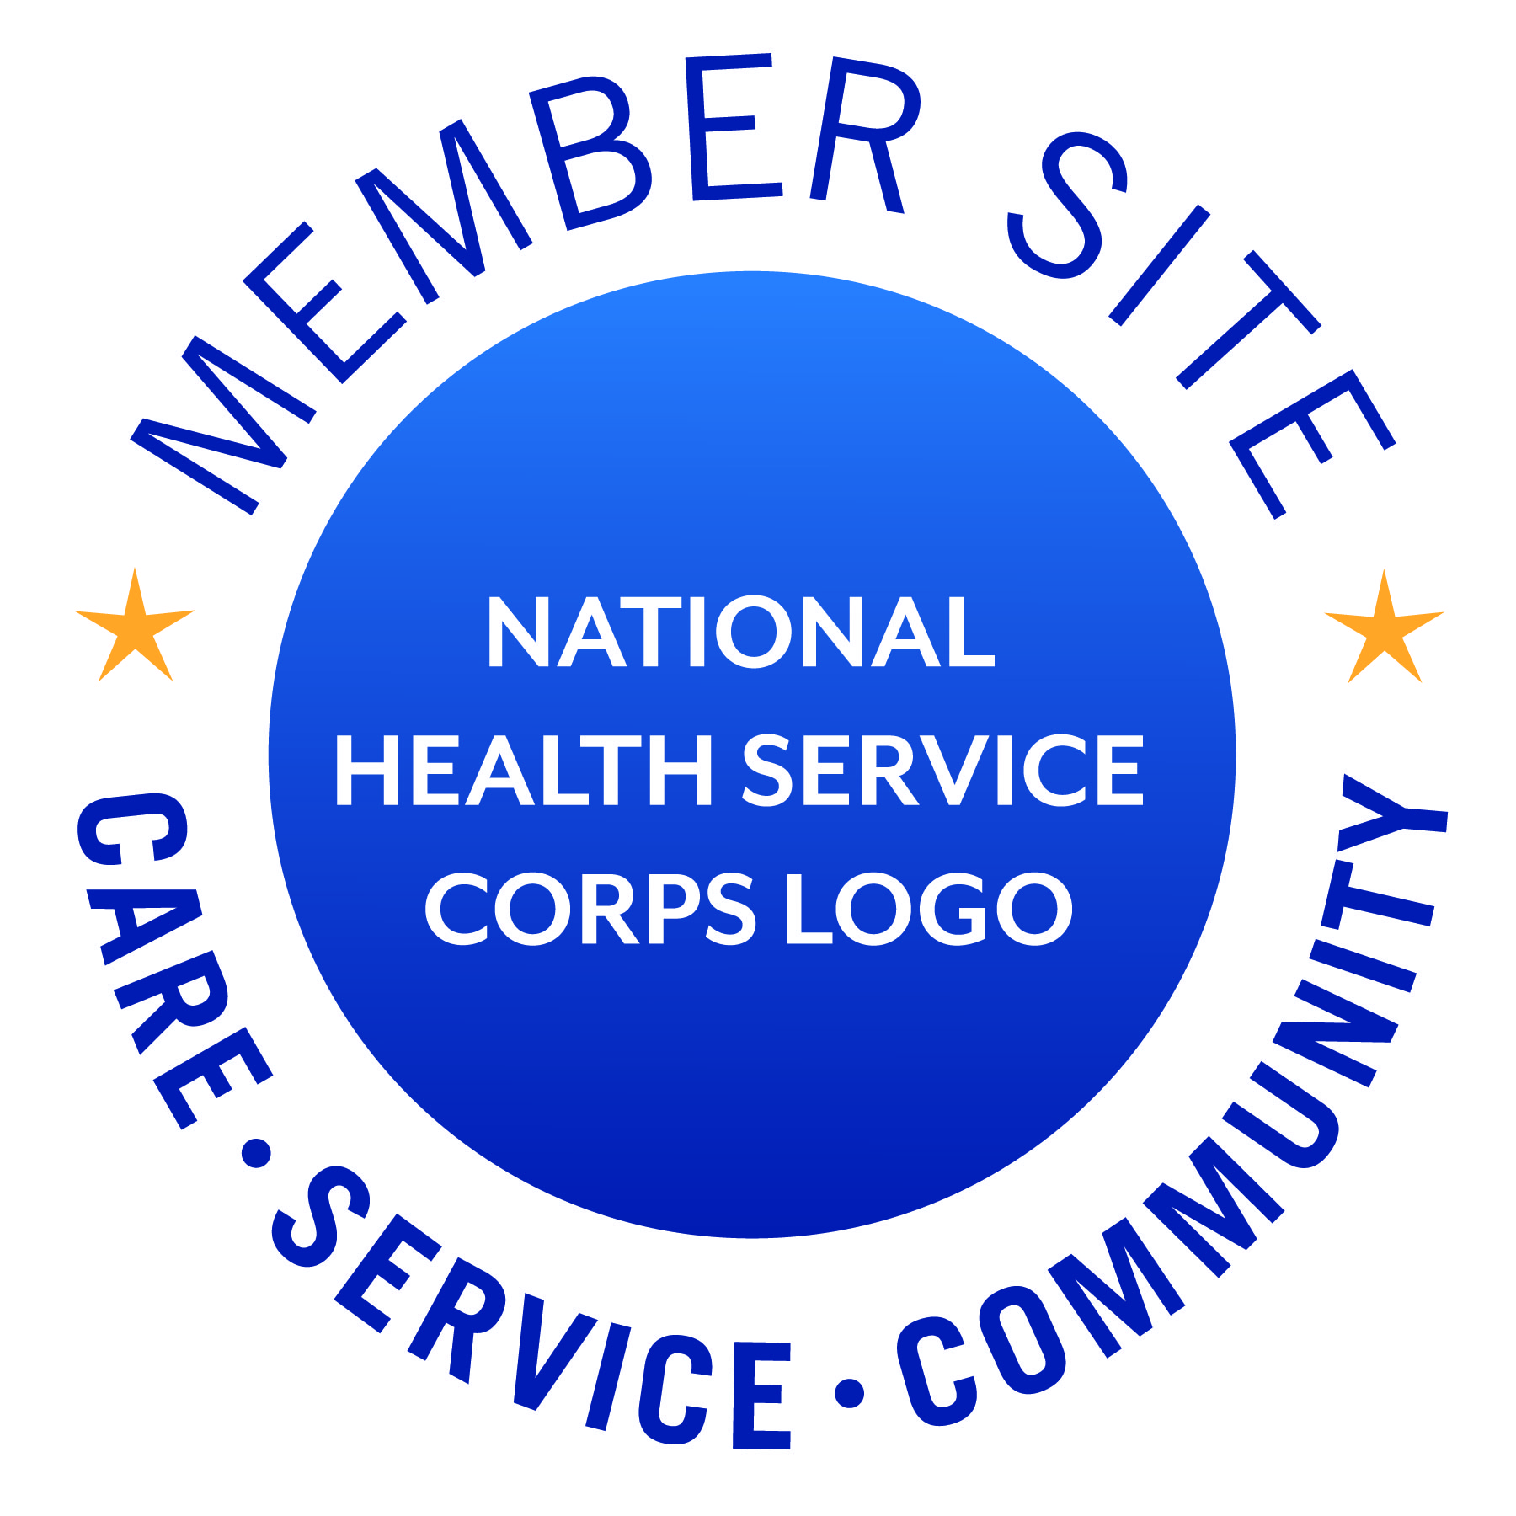

NHSC Corps Experience Web Page
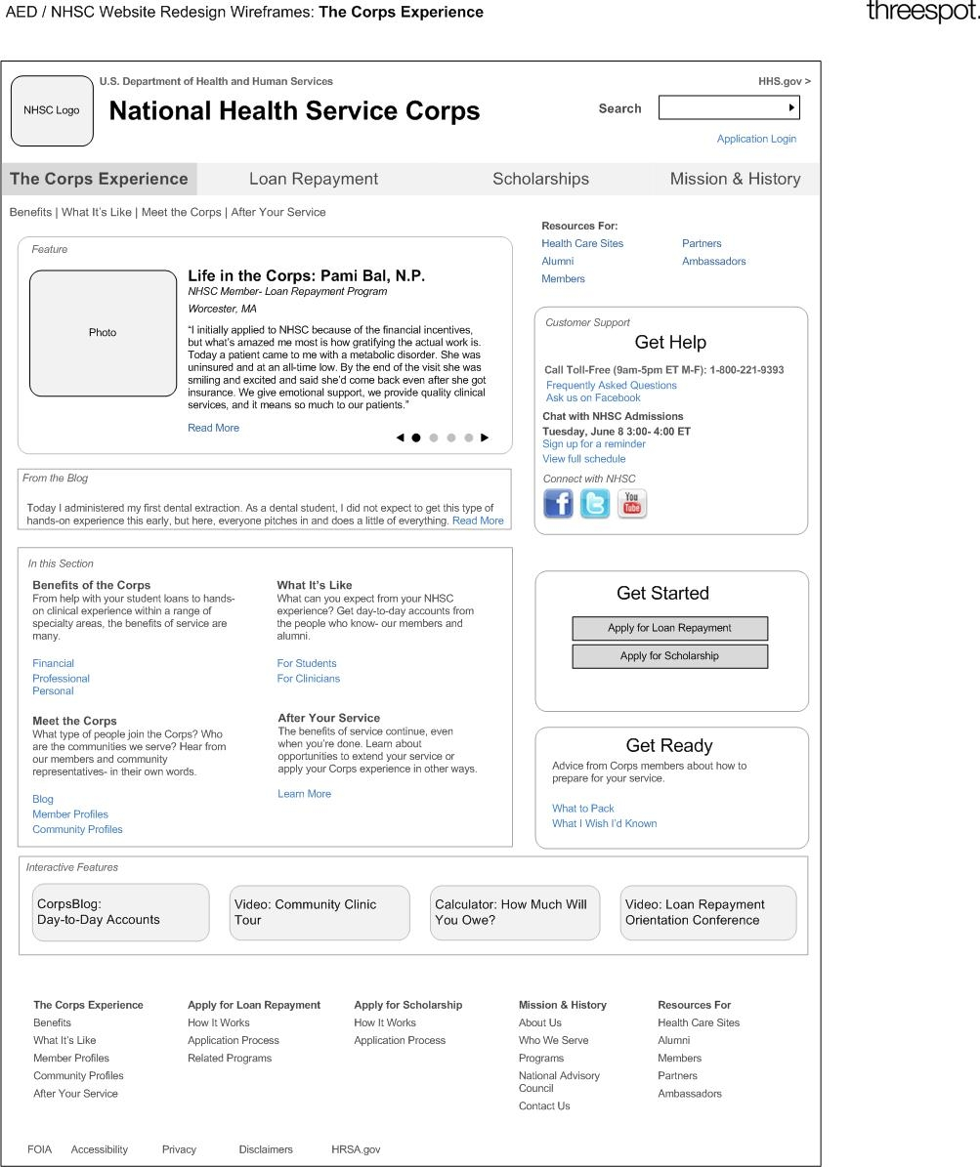

NHSC Loan Repayment Web Page
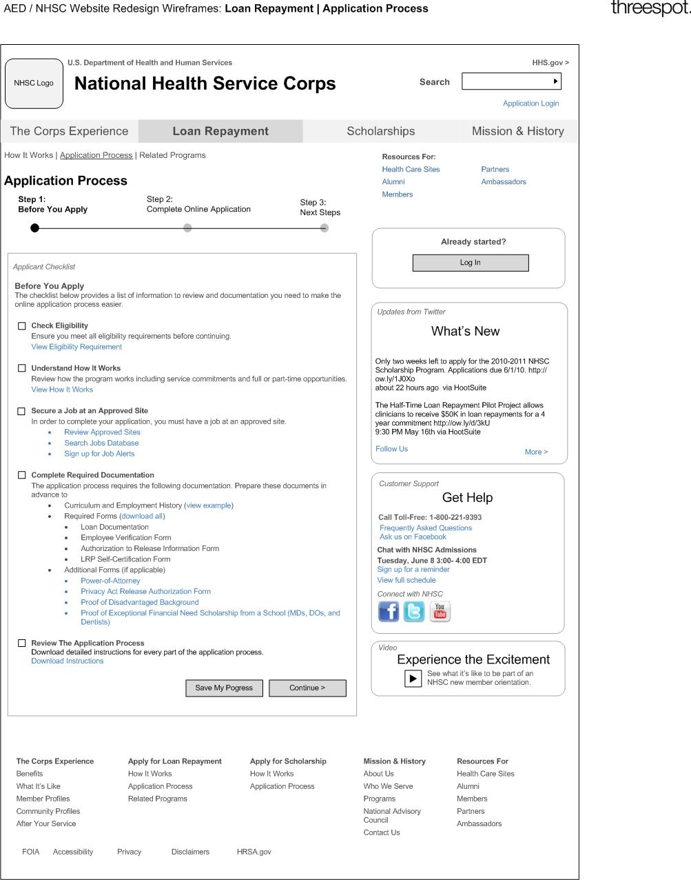

NHSC Blog Web Page
