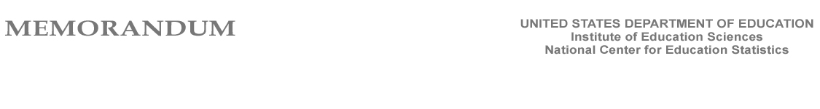

To: Rochelle W. Martinez, Office of Statistical and Science Policy, Office of Management and Budget
From: Thomas Weko, Associate Commissioner, Postsecondary Studies Division
Elise S. Miller, Program Director, Postsecondary Institutional Studies
Re: Amendment to current 3-year clearance for IPEDS (OMB No. 1850-0582)
Date: June 5, 2009

The purpose of this memorandum is to update OMB on NCES’ efforts to improve collaboration between NCES and other areas of the Department of Education on postsecondary data systems. Specifically, the January 16th terms of clearance stated that OMB “strongly encourages NCES to continue its efforts to collaborate with other areas within the Department, including the Office of Postsecondary Education and Federal Student Aid, to better integrate, use, and disseminate postsecondary data collected by the different offices, and will require that a progress report on these efforts be included in the next IPEDS clearance package.”

As noted on page 2 of the supporting statement for clearance, NCES continues to pursue options for better integrating IPEDS with other ED data collections such as the National Student Loan Data Set (NSLDS). Staff at NCES, the Office of Postsecondary Education (OPE), and the office of Federal Student Aid (FSA) have had conversations about how to work more collaboratively on financial aid data. These discussions include ways that we can better integrate, use, and disseminate data collected by the different offices.

NCES has taken concrete steps to advance data integration. Since the January clearance, these steps include:

- NCES has shared with FSA its data dictionary for the IEPDS Student Financial Aid survey component. FSA is currently performing analysis of the dictionary to see where our data elements align with data in the NSLDS.
- NCES has requested and received from FSA data on Pell Grants and Federal student loans. Specifically, we have received a data file that includes:

- Total number of Pell Grant recipients by institution for the 2007-08 financial aid year
- Total Pell grant dollars awarded by institution for the 2007-08 financial aid year
- Total number of undergraduate borrowers for FFEL and Direct subsidized and unsubsidized loans by institution for the 2007-08 financial aid year
- Total FFEL and Direct loan dollars disbursed to those undergraduate borrowers by institution for the 2007-08 financial aid year

We are in the preliminary stages of reviewing and comparing these data to IPEDS collected data to see if it can be used to reduce reporting burden in IPEDS in future years. NSLDS data are organized on the basis of the OPE ID rather than the IPEDS unit ID, and there are some differences between the two that must be addressed.

A major issue is in the different universes and definitions of institutions in the two data sources that cause problems when attempting to align the data. In IPEDS, any institution that has a Program Participation Agreement (PPA) with the Department of Education and is primarily postsecondary and is open to the public must be listed as a separate entity. Any branch campus or location that shares a PPA with a main campus may be listed as a separate entity in IPEDS if it satisfies the following definition: A branch campus is a campus or site of an educational institution that is not temporary, is located in a community beyond a reasonable commuting distance from its parent institution, and offers organized programs of study, not just courses. For federal student aid purposes, however, the Office of Postsecondary Education includes further restrictions such as: the institution must have its own faculty; its own budgetary and hiring authority, and its own systems/administrative organization (i.e., its own financial aid office, registration system, student record system, and financial accounting system (if possible).

This leads to alignment issues across the IPEDS and FSA and OPE databases that will require further exploration by our staff, and additional time to address. For example, there are at least 300 records for institutions in the FSA data that are not in the IPEDS institution universe. Some are foreign institutions (which are eligible to participate in title IV student aid programs but outside the IPEDS universe); others are institutions that are undergoing sale, closure, or reorganization; still others don’t meet the IPEDS definition of a postsecondary institution.

We will continue our efforts to resolve these issues and hope to have a solution before the 2010-11 IPEDS data collection.

