National Assessment of Educational Progress

Volume 1
Supporting Statement

Request for Clearance for 2011 School Reports
Focus Group Studies



OMB# 1800-0011 v.152
(Generic Clearance of Customer Service Satisfaction Collections)

5/4/11

Supporting Statement Table of Contents
1) Submittal-Related Information 2
2) Background and Study Rationale 2
3) Study Design and Context 3
4) Data Collection, Analysis and Report 5
5) Consultations Outside of the Agency 6
6) Assurance of Confidentiality 6
7) Justification for Sensitive Questions 6
8) Estimate of Hourly Burden 7
9) Estimate of Costs for Paying Respondents 7
10) Cost to Federal Government 8
11) Project Schedule 8
Appendix A - Prototype of Grade 8 Survey Responses Report 9
Appendix B - Prototype of Grade 8 MCBS Report 10
Appendix C - Prototype of Grade 12 WCBA Report 11
Appendix D: Sample Recruitment Email/Letter for School Principals 12
Appendix E: School Principals Focus Group Consent/Non-Disclosure Form 14
Appendix F: Sample Email Granting School Principals Access to School Report 15
Appendix G: Sample Invitation to WebEx Focus Group for School Principals 16
Appendix H: Sample Thank You Letter for School Principals 18
Appendix I: Sample Screening Questionnaire for Teachers/Subject Specialists 19
Appendix J: Sample Confirmation Email/Letter for Teachers/Subject Specialists 22
Appendix K: Sample Follow-up Email/Letter for Teachers/Subject Specialists 23
Appendix L: Consent Form for Teachers/Subject Specialists 24

- Submittal-Related Information
This material is being submitted under the generic U.S. Department of Education clearance agreement (OMB #1800-0011). This generic clearance provides for the Department to conduct surveys and other studies to evaluate customer satisfaction.
- Background and Study Rationale
The National Assessment of Educational Progress (NAEP) is designed to provide achievement and education context information about the nation, geographic regions, states, large districts and groups of students. The National Center for Education Statistics (NCES) and the National Assessment Governing Board are interested in exploring ways to respond to school and policymaker requests for more focused feedback on the performance of students that participate in NAEP. Historically, NAEP results have only been reported for large groups of students, such as for a state, the nation, or for racial/ethnic groups. However, as part of the current “future of NAEP” discussions and as an added benefit for the time and effort staff and students contribute to the assessment, NCES would like to pursue the option of individual school results.
To that end, the NAEP 2011 Pilot School Feedback Project will produce three different sample school reports using data from the NAEP 2011 assessment. NCES will conduct a focus group study with principals and teachers/subject specialists to evaluate and provide feedback on these three different sample reports.
The focus groups described in this submission will seek to acquire more information about the attitudes and beliefs of the participants concerning the utility of the reports and the presentation of the data. More specifically, the focus groups will set out to collect information on:
- interpretation of the reports,
- understanding of the limitations regarding generalization of the data and results presented in the reports,
- levels of interest in the content, and
- perceived uses of report data.
The following three prototype reports will be piloted in this study:
- Grade 8 Survey Responses- will include responses to several of the student survey questions about reading and mathematics;
- Grade 8 Mathematics Computer-Based Study (MCBS) - will provide student responses to five sample questions and select survey responses; and,
- Grade 12 Writing Computer-Based Assessment (WCBA) - will include responses to student survey questions about writing.
Each report will also feature comparisons to the nation and similar schools. Prototypes of the reports are shown in Appendices A-C. Note that for data and item security concerns, these prototypes do not contain the actual sample questions that will be used, nor actual data.
Once completed, the focus groups will have provided needed feedback on the content, presentation, and usability of the reports, which will be used to improve them going forward. A report that summarizes the focus group findings will be produced for NCES.
- Study Design and Context
The focus group method is a qualitative, group approach to data collection. It involves holding group sessions guided by a moderator, who follows a topical outline containing questions or topics focused on a particular issue. The questions are purposefully open-ended in nature, incorporating several prompts to encourage a deeper, multifaceted exploration of an issue or topic. The method is useful for going beneath the surface of a response. As a research tool, focus groups are useful for understanding a targeted group’s views on complex social issues such as challenges and issues surrounding cultural issues and education.
To ensure that appropriate and relevant feedback is obtained from meaningful sources, participation will be sought from principals and teachers/subject specialists. The study design will be comprised of two types of focus groups:
- 60-75 school principals
- 20-24 teachers and 20-24 subject-area specialists
In addition to specific questions gauging reactions to the reports, the discussions will gain some additional information on the respondents in order to provide context in which to analyze their reactions. Questions that deal with respondents' engagement within their profession (e.g. their sources of information on education-related news) will help to understand their perspective in reviewing the reports.
Focus Groups among School Principals
For the school principal focus group component, a total of 60-75 schools are needed for the project, 20-25 for each type of report. Schools that participated in the main paper and pencil NAEP assessment at grade 8 are eligible to receive the Grade 8 Survey Responses report and, thus, participate in the focus group. Schools that participated in MCBS or WCBA are eligible to receive the relevant computer-based assessment reports and, thus, participate in the relevant focus groups.
Six virtual focus groups will be conducted via WebEx with school principals from across the country; two sessions will be held for each report type. The selection of schools will be representative of type of location (e.g., urban and rural), minority enrollment, and percentage of students that receive free or reduced price lunch.
NAEP State Coordinators (see Section 5 for additional information regarding NAEP State Coordinators) will leverage their relationships within the states to contact and identify schools/principals willing to participate in the study. Should they agree to assist in the effort, each Coordinator will be asked to recruit approximately four principals from schools within their state. See Appendix D for a sample recruitment email from NAEP State Coordinators to school principals. The NAEP State Coordinators will remain the point person for all communication regarding the study with the principals in their state.
Principals who agree to participate in the study will sign a non-disclosure agreement requiring that they keep confidential the data they review, and that they will not print, copy, or distribute the reports (see Appendix E). The principals will then be sent a report for his or her particular school. They will be asked to become familiar with the reports prior to the WebEx discussion (see Appendix F). See Appendix G for a sample communication with the selected principals which invites them to their WebEx focus group. No further preparation prior to the group discussion will be required for the principals. Upon completion of the focus group, each principal will be sent a thank you letter, as shown in Appendix H.
Focus Groups among Teachers and Subject Specialists
A separate set of focus groups will be held in the Greater Baltimore/Washington area with teachers and content specialists. A total of four focus groups will be conducted with two groups of teachers and two groups of specialists. These groups will be conducted in person.
The teachers/subject specialists groups will provide a different perspective to the objectives of this research. These individuals are important in the NAEP process and will likely work with principals to apply any learning from the reports to their curriculum and classrooms.
The nature of these groups will be somewhat different, however, than that of the principals. These teachers/subject specialists will not be provided with actual reports for their schools. Instead these groups will explore the concept of school-based reporting, its utility/value, the interaction with principals/administrators with regard to this type of data, and the best format to present the information. Respondents for these groups will not be provided any advance information for examination prior to the groups as the principals will, but they will be shown prototypes for the reports (without any school identifiable particular data) in the groups themselves. In addition, to avoid any pre-existing bias, participants will not be informed that the study relates to NAEP or is being conducted by NCES. The objective for these groups is to focus on their reactions to the reports without being influenced by the origins or perceived purposes of the reports.
Teachers and subject specialists will be recruited by the focus group facilities where the groups will be held. Standard industry procedures will be used for recruitment, including proprietary databases that each facility may have that categorizes potential respondents into demographic/employment and other groups. The procedures may also involve network sampling and contacting schools in the area to supplement the database. Potential participants will be contacted initially via telephone and a brief screening questionnaire will be administered (see Appendix I). If the participant qualifies for the study, he or she will be invited to attend the group discussion on the specified date. Once respondents agree to participate, they will be provided additional information about the location via email or regular mail (their choice; see Appendix J for the templates for these communications). Additional follow up phone calls or emails may be made as reminders prior to the groups (see Appendix K). Respondents will not be told details about the study or the discussions, but will be told that the study will cover issues relevant to their schools. Consent and non-disclosure forms will be obtained prior to the start of the interviews (see Appendix L).
Two of the groups will be among teachers of language arts, writing, or mathematics in grades 8 or 12. The other two groups will be among subject specialists for these subjects and grades. One group among teachers and one among the specialists will be held in each of the two locations for this study (Washington, DC metro area and Baltimore). These participants may or may not have prior interactions with NAEP.
As is standard practice, we will over-recruit for these groups. The ideal focus group size is 8-10 individuals, but we will recruit twelve for each group to allow for last minute cancellations. The 8-10 group size enables discussion and provides for a diversity of ideas to be heard. With more participants, it is not possible to ensure all views are heard. It also has the potential of limiting the number of questions that can be addressed in the time allotted. Having a group with fewer than eight individuals limits the number of perspectives that are heard and the group dynamics can become strained when there are very few participants engaged in the process. It is anticipated that the teacher/subject specialist focus groups will have 10 participants each, for a total of 40 people engaged in the study, but as many as 48 individuals will be recruited.
- Data Collection, Analysis and Report
At the start of each of the groups, the moderator will explain the process, including confidentiality, recording, issues regarding peer pressure and group dynamics, etc. The focus groups will be moderated by an experienced researcher, Maria Ivancin, trained in conducting focus groups (see Section 5 for additional information). It is important that the focus group be conducted with sensitivity such as not to present bias or opinion during the session. The moderator will use the appropriate focus group guide for each of the sessions (see Volume II).
The focus groups will be audio recorded. In addition, two Hager Sharp team members will observe and take notes of the participants’ comments and suggestions.
The analysis will be appropriate for the qualitative nature of this methodology. The audio recordings and transcripts will be reviewed to determine any trends. Conclusions will be drawn and supported with findings and verbatim comments from respondents. The report will include recommendations as well.

- Consultations Outside of the Agency
Hager Sharp
Hager Sharp will coordinate the focus groups. Hager Sharp has worked as a contractor for NCES since 2002, providing publication, outreach, and dissemination support for NAEP. The firm is familiar with the processes of NCES, IES, and the Governing Board and has supported each of these entities over the last several years.
Maria Ivancin, Market Research Bureau LLC
Maria Ivancin will serve as the moderator for each of the focus groups. Ms. Ivancin has experience facilitating prior working groups and panels for NCES and Hager Sharp, including efforts with superintendents, principals, teachers, and students. Ms. Ivancin will also be responsible for the analysis and report for this study.
NAEP State Coordinators
The NAEP State Coordinator serves as the liaison between the state education agency and NAEP, coordinating NAEP activities in his or her state.
- Assurance of Confidentiality
NCES has policies and procedures that ensure privacy, security, and confidentiality, in compliance with the Education Sciences Reform Act of 2002 (20 U.S.C. §9573). This legislation ensures that security and confidentiality policies and procedures of all NCES studies, including the NAEP project, are in compliance with the Privacy Act of 1974 and its amendments, NCES confidentiality procedures, and the Department of Education ADP Security Manual.
Participation in this research is voluntary and personally identifiable information will not be maintained for the participants. However, the comments from the principals will be associated with the demographics of their school to determine any possible patterns. Principals will be informed of this in the confidentiality agreement (see Appendix E). The focus group interviews will be audio recorded. The recorded files will be secured for the duration of the study and will be destroyed after the final report is submitted.
- Justification for Sensitive Questions
This study does not involve sensitive questions.
- Estimate of Hourly Burden
This study includes two audiences for focus group interviews: principals and teachers/subject specialists. There will be six focus group interviews involving principals and four involving teachers/subject specialists. The total number of respondents will be 100-123 (depending on the total who agree to participate).
The principal focus group participants’ total response burden is comprised of 1 hour to review a sample of the report prior to the focus group and 1.5 hours for the focus group interviews.
Teacher/subject specialist focus group participants’ burden for responding to a telephone screening questionnaire to determine their qualifications and to gain agreement to participate in the groups is comprised of .083 hours (5 minutes on average). A 25% cooperation rate has been estimated (based on a $75 incentive), requiring contacting 192 potential respondents. For the 40-48 respondents who will be recruited the focus group will last up to 2 hours.
The estimated total response burden is 300 hours, as shown below in Table 1.

Table 1. Estimated Burden Hours
Respondent Type | Maximum Number of Respondents | Burden Hours Per Respondent | Total Hours
Principals-Time to review reports before focus group | 75 | 1 | 75
Focus Group Participants – Principals | 75 | 1.5 | 113
Teachers/Subject Specialists Contacted During Recruitment | 192 | .083 (5 minutes) | 16
Focus Group Participants – Teachers/Subject Specialists | 48 | 2 | 96
Total Respondents | 267 |  | 300

- Estimate of Costs for Paying Respondents
The total estimated cost for paying respondents is $7,550. The principals who participate in WebEx sessions will receive a $50 gift card to a major office/school supply store for their school as a token of appreciation for their time and feedback. To thank the in-person focus group participants for their time and effort; help cover their travel cost; and assure high quality of the recruiting, the cooperation, and the show rates (i.e. minimizing last minute cancellations), the teachers and content specialists will be offered $75. In addition, light refreshments will be offered at the in-person focus groups with the teachers and content specialists, valued at approximately $50 for each of the 4 sessions.
- Cost to Federal Government
The estimated cost to the government of all incentives and recruitment, data collection, analysis, and reporting activities for this study is $52,000.
- Project Schedule
The following table depicts the schedule for efforts related to the implementation of the focus groups.

Table 2. Project schedule
Activity | Date
Begin coordination with NAEP state coordinators for Principal recruitment process, upon approval from OMB | May 2011
Begin coordination for Teacher/Subject Specialists recruitment process, upon approval from OMB | May 2011
Conduct Principal focus groups | June 2011
Conduct Teacher/Subject Specialists focus groups | June 2011
Draft and submit to NCES a summary report on focus group studies | July 2011

Requested Approval Date: May 13, 2011

Appendix A - Prototype of Grade 8 Survey Responses Report

Appendix B - Prototype of Grade 8 MCBS Report
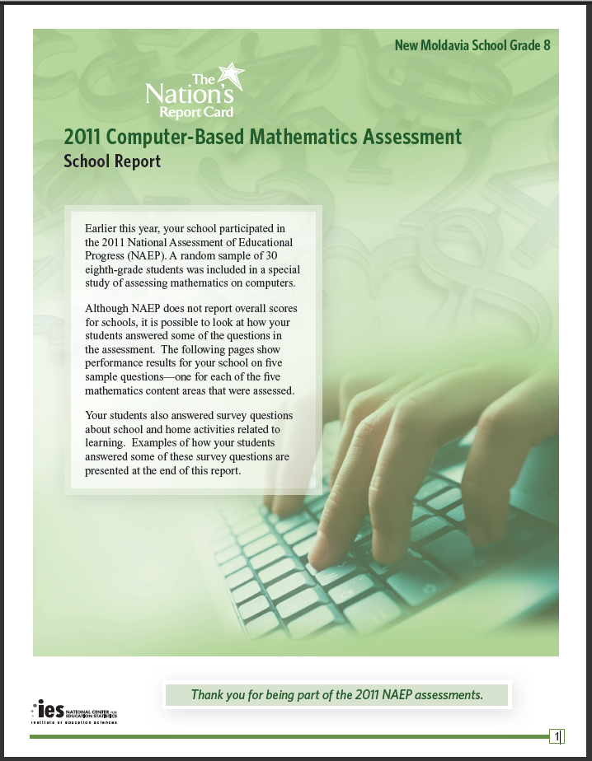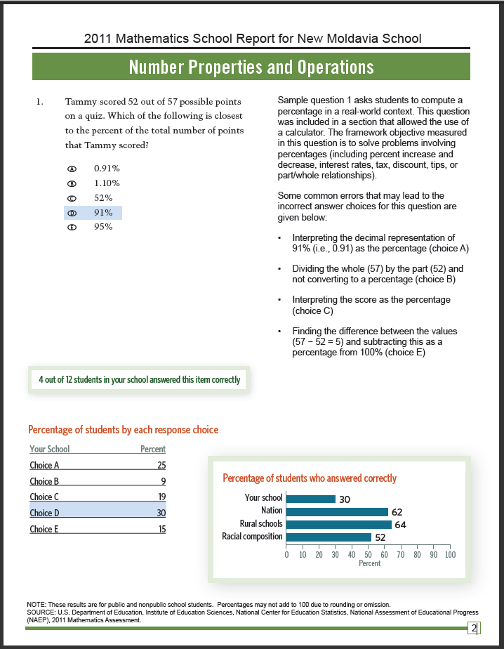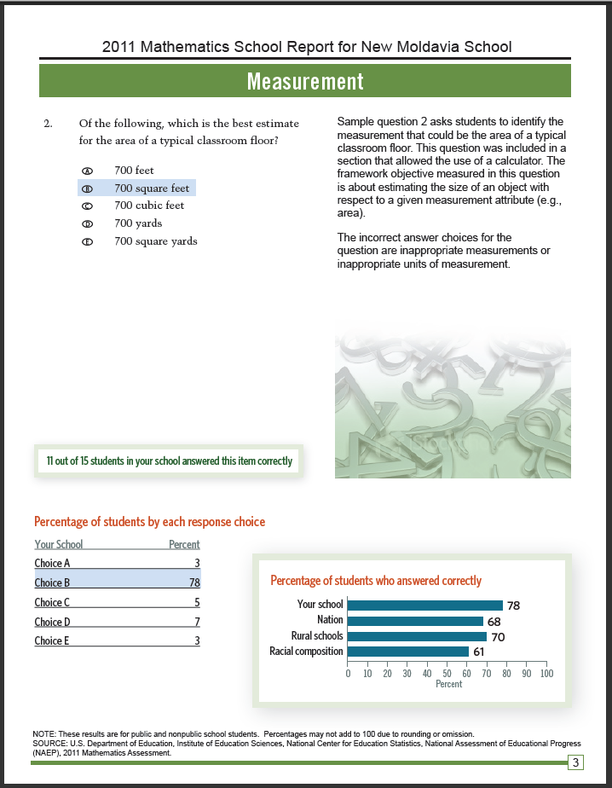
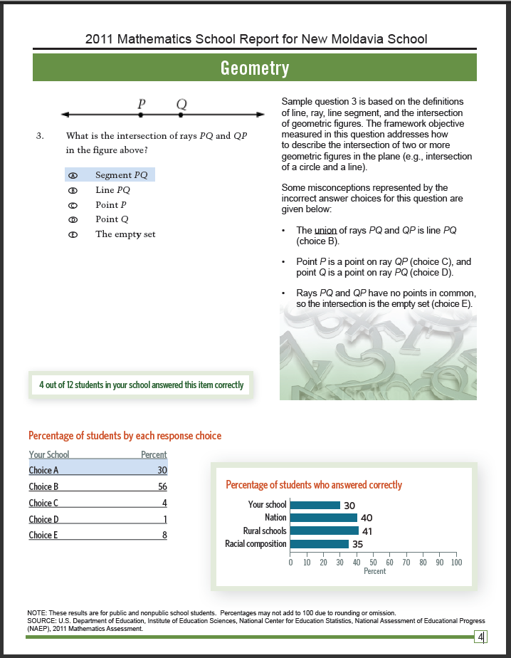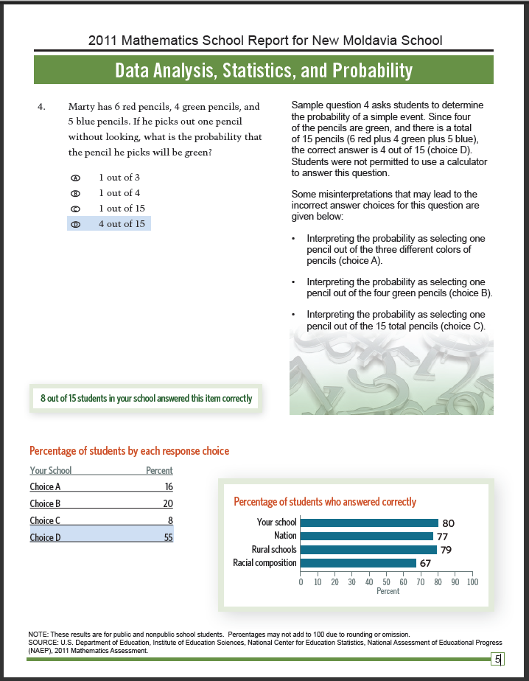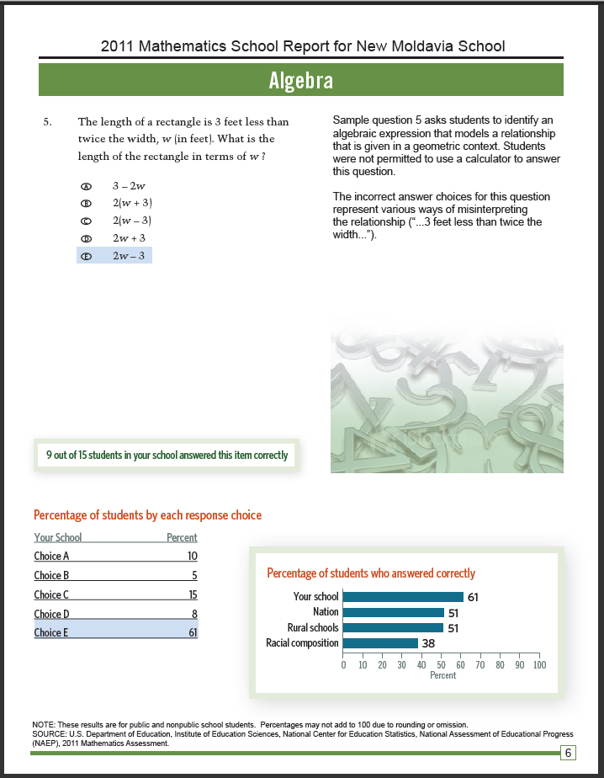
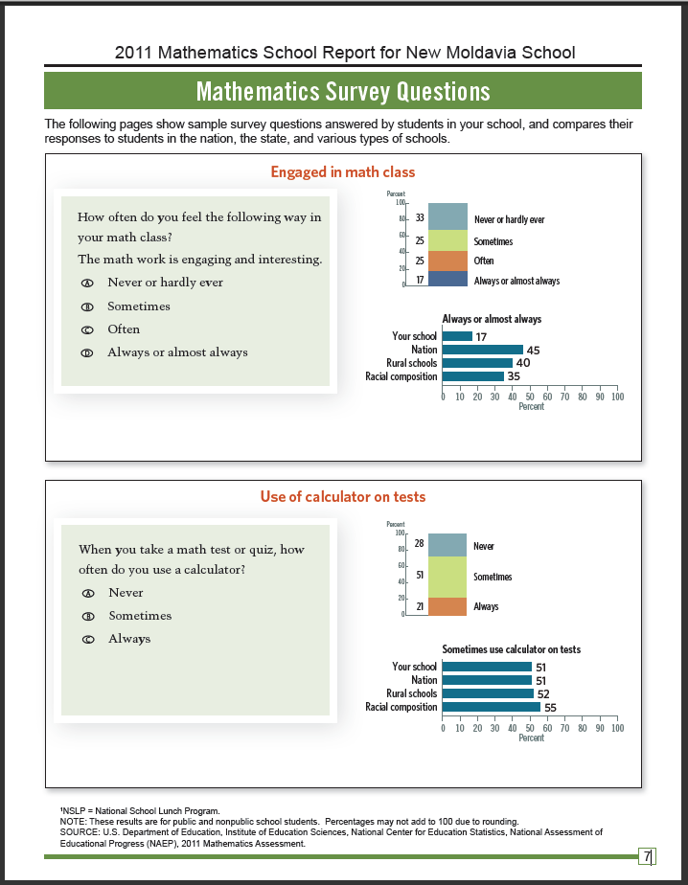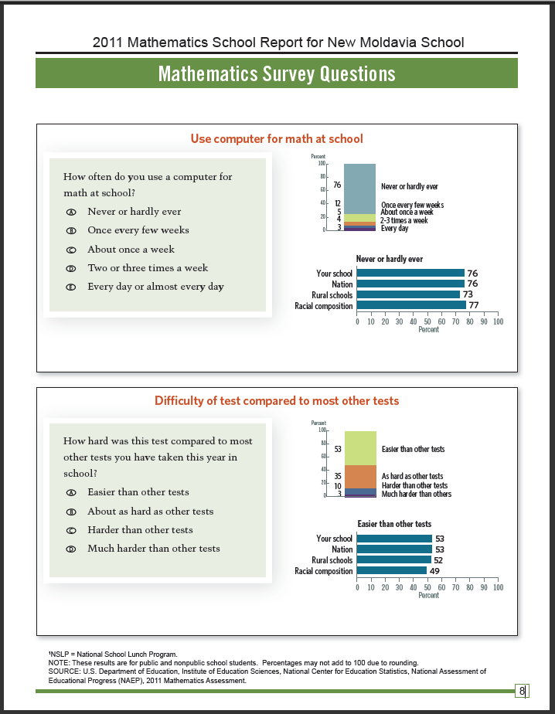

Appendix C - Prototype of Grade 12 WCBA Report
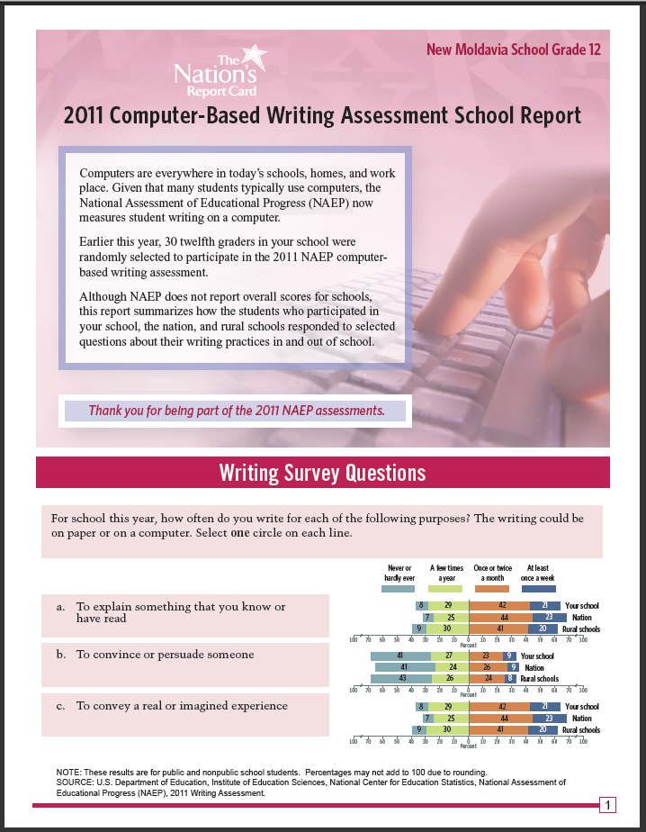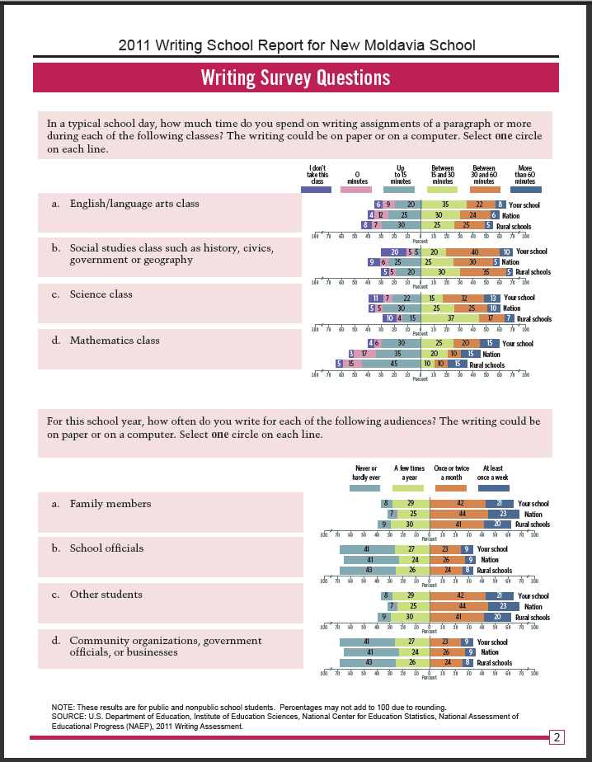
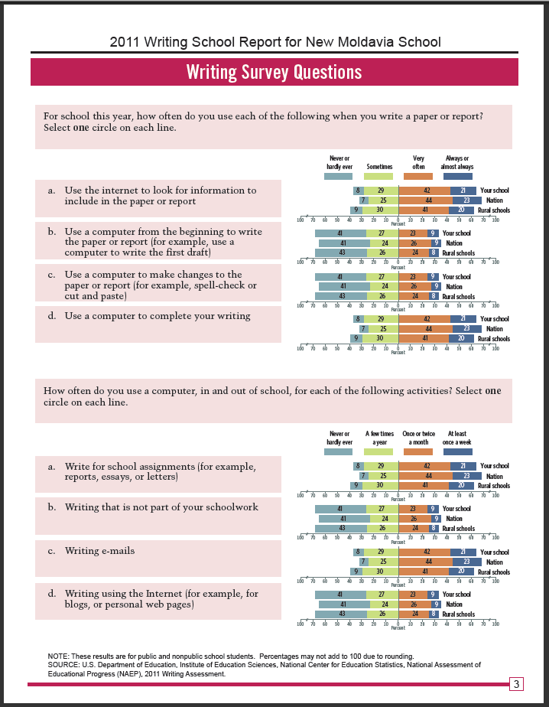

Appendix D: Sample Recruitment Email/Letter for School Principals

Dear <insert name of principal>
Thank you for participating in the National Assessment of Educational Progress (NAEP) 2011, and for expressing interest in participating in the NAEP 2011 Pilot School Feedback Study, which is being conducted on behalf of the National Center for Education Statistics (NCES) within the Department of Education. Your school has been selected for the study, and I hope you will be able to participate.
As a participant, you will:
- sign a confidentiality agreement
- access and review an electronic copy of a report for your school
- participate in a 90-minute virtual focus group to discuss and provide feedback on the report
- receive a $50 gift card for your school to use at an office/school supply store
Additional information about the pilot study is included in the attachment.

The virtual focus groups will be held on: (1) <insert date/time for focus group 1 here> and (2) <insert date/time for focus group 2 here>. You may participate in either focus group.

Please email me by <insert date> to let me know of your continued interest and ability to participate in the study.

Again, thank you for your interest in helping NAEP evaluate the value of providing feedback to schools about their participation in NAEP.

Best regards,

NAEP State Coordinator

Appendix D continued: Attachment to Sample Recruitment Email/Letter for School Principals

NAEP 2011 Pilot School Feedback Project Overview

What is the Pilot School Feedback Project?
The National Assessment of Educational Progress (NAEP) is designed to provide achievement and education context information about the nation, geographic regions, states, large districts participating in the Trial Urban District Assessment, and groups of students. The National Center for Education Statistics and the National Assessment Governing Board are interested in exploring ways to provide some feedback to schools that participate in NAEP, as a benefit of the effort and time their school staff and students contribute to the assessment. To that end, the NAEP 2011 Pilot School Feedback Project will produce three different sample school reports using data from the NAEP 2011 assessment for 60 schools to evaluate and provide feedback.

What are the three reports?
- Grade 8 Survey Responses: This report will include responses to several of the student survey questions about reading and mathematics, with comparison to the nation and similar schools.
- Grade 8 Mathematics Computer-Based Study (MCBS): This report will provide student responses to five sample questions and select survey responses, with comparisons to the nation and similar schools.
- Grade 12 Writing Computer-Based Assessment (WCBA): This report will include responses to student survey questions about writing, with comparison to the nation and similar schools.

Who can participate?
A total of 60 schools are needed for the project, 20 for each type of report. Schools that participated in the main paper and pencil NAEP assessment at grade 8 are eligible to participate in the Grade 8 Survey Responses. Schools that participated in MCBS or WCBA are eligible for the relevant computer-based reports.

What does participation in the project involve?
School principals who volunteer to participate will sign a non-disclosure agreement requiring that they keep confidential data they review, and that they will not print, copy, or distribute the reports. NAEP 2011 results will not be released until fall of 2011 for reading and math, and spring 2012 for writing and science. It is essential that data are not disclosed before the official releases. Each principal will be given access via the web to their school report to review during a two-day window. Then, principals will participate in a virtual, 90-minute focus group. The focus groups will be conducted via the web using WebEx, so access to a computer and internet will be required. During the focus groups principals will provide feedback and comments on the content and usefulness of the reports and how they interpret the results. Principals will be able to choose one of two focus groups scheduled for each type of report.

What are the advantages of participating?
While principals will not be able to print or keep copies of these preliminary, sample reports, they will be the first ever principals to see any NAEP results for their schools. Principals will provide valuable feedback on the reports that will help NAEP evaluate whether to continue exploring ways to provide results to schools. In addition, schools that participate will receive a $50 gift card for the school to use at an office/school supply store.

Appendix E: School Principals Focus Group Consent/Non-Disclosure Form


UNITED STATES DEPARTMENT OF EDUCATION
INSTITUTE OF EDUCATION SCIENCES
NATIONAL CENTER FOR EDUCATION STATISTICS

CONFIDENTIALITY AGREEMENT:
<Insert Specific Prototype Report Name Here>
Under this agreement you will have access to secure National Center for Education Statistics data that you agree to keep confidential as outlined below.
By participating in this focus group, you will be given access to an electronic copy of a report with the National Assessment of Educational Progress (NAEP) 2011 data for your school. You may not download, copy, or print any of the information presented. The data from the report: <Insert Specific Prototype Report Name Here> and statements, commentary, and other materials garnered from this focus group may not be shared with anyone—including print or internet distribution.
This study is authorized by law under the Education Sciences Reform Act (Public Law 107-279). Your responses are protected from disclosure by federal statute (P.L. 107-279, Title 1, Part E, Sec. 183). All responses that relate to or describe identifiable characteristics of individuals may be used only for statistical purposes and may not be disclosed, or used, in identifiable form for any other purpose, unless otherwise compelled by law.
I hereby voluntarily agree to participate in this focus group discussion and to offer my opinions on the topic discussed. I understand that the group discussion will be audio recorded and that the discussion may be observed. I understand that the sponsors of this research will not use my name or any other identifying information in any reports of this study, but may associate my comments with the demographics/characteristics of my school.
By signing this agreement you are agreeing that you will abide by the terms above. Please sign below and fax to <fax number> or E-mail <contact name> at <email address>.
Accepted by:

Appendix F: Sample Email Granting School Principals Access to School Report

Hello <insert name of school principal>,
Thank you for agreeing to participate in the National Assessment of Educational Progress (NAEP) 2011 Pilot School Feedback Project, which is being conducted on behalf of the National Center for Education Statistics (NCES) within the Department of Education. The school report for your school is available for you to view by clicking the link below. We ask that you review the report and become familiar with it prior to the virtual focus group discussion, which will be held on <date> at <time>. You will receive a separate email with instructions of how to join the virtual focus group, using WebEx.
<insert link>

If you have any questions, please call the NAEP State Service Center support desk at the number below.

Thank you,
NSSC Support
888.689.7060

Appendix G: Sample Invitation to WebEx Focus Group for School Principals

Hello <insert name of school principal>,
The National Assessment of Educational Progress (NAEP) invites you to participate in a WebEx focus group to discuss the NAEP school feedback report, a project being conducted on behalf of the National Center for Education Statistics (NCES) within the Department of Education. You will be able to view an electronic copy of the report for your school for two days prior to this WebEx.
You will need a computer, high speed internet connection, and telephone to join the WebEx.
Topic: NAEP 2011 Pilot School Feedback Focus Group
Host: NAEP State Service Center
Date: <insert date>
Time: <insert time>, Eastern Daylight Time (New York, GMT-04:00)
Session number: <insert session number>
Session password: <insert password>
~~~~~~~~~~~~~~~~~~~~~~~~~~~~~~~~~~~~~~~~~~~~~~~~~~~~~~~~~~~~~~~~~~~~~~~~~~~~
BEFORE JOINING THE WEBEX: RECOMMENDED FOR FIRST TIME WEBEX USERS
If this is the first time you are using WebEx on your computer, please follow the instructions below. We recommend you download and install this software at least 4 hours before the WebEx is scheduled to start. It will take only a few minutes to download and install the software. If you do not have administrator rights on your computer, you may need to ask your IT person to install this software for you.
- Go to https://naepnet.webex.com
- Under More Services, click Training Center.
- At the bottom left, click Support, then Downloads.
- Next to WebEx Training Manager, download the appropriate Installer for your operating system.
- Click run. If you get a security warning, click on it to resume the download.
- Once download is complete, follow the instructions to install WebEx Training Manager.
- After installing WebEx Training Manager, go to the next section of this email when you are ready to join the WebEx.
~~~~~~~~~~~~~~~~~~~~~~~~~~~~~~~~~~~~~~~~~~~~~~~~~~~~~~~~~~~~~~~~~~~~~~~~~~~
JOINING THE WEBEX
- 10 minutes before the session is scheduled to start, click on the session link below. (We recommend using Internet Explorer 6, 7, or 8, Firefox 3.6, or MAC OS X (Intel MACs only).
https://naepnet.webex.com/naepnet/ <insert link information>
- Enter your name and the state in which you reside, e.g. John Doe (NC).

- Click Join Now. You may get a pop-up message/bar to run ActiveX control or Install WebEx training manager. Click to run/install it. After you see the Session in Progress window, you should see the WebEx session page.

- In the Audio Conference window that pops up, select the Use Phone: I will call in option. Dial 866-469-3239. Enter the session/access code and your attendee id number that appears on that window.
If you see your name in the Participants Panel with a phone next to it, then you have successfully joined the WebEx session.
~~~~~~~~~~~~~~~~~~~~~~~~~~~~~~~~~~~~~~~~~~~~~~~~~~~~~~~~~~~~~~~~~~~~~~~~~~~~
DURING THE WEBEX SESSION
- Please mute your phone after you join the WebEx. You can mute your phone by using the mute feature on your phone or by clicking on your name in the Participants Panel and clicking Mute.
- If you have a question, please click the raise hand icon.
- If you would like to ask a question privately, please use the chat window to speak to the host and presenter.

IMPORTANT NOTICE: This WebEx service includes a feature that allows audio and any documents and other materials viewed during the session to be recorded. By joining this session, you automatically consent to such recordings. If you do not consent to the recording, discuss your concerns with the meeting host prior to the start of the recording or do not join the session. If you have any questions, please call the NSSC support desk at the number below. If you are having problems logging in after the session has started, call WebEx tech support: 866-229-3239.

Thank you,
NSSC Support
888.689.7060

Appendix H: Sample Thank You Letter for School Principals

Dear <insert name of principal>,
I would like to thank you for your participation in the National Assessment of Educational Progress (NAEP) 2011 Pilot School Feedback Study, conducted on behalf of the National Center for Education Statistics (NCES) within the Department of Education. Your assistance allowed NAEP to evaluate whether to continue exploring ways to provide results to schools. Your input, combined with input from other principals like you, was incredibly useful and informative.
As a token of NCES’ appreciation, attached is a gift card to an office supply store for your school.
Again, thank you for your assistance.

Best regards,

NAEP State Coordinator

Appendix I: Sample Screening Questionnaire for Teachers/Subject Specialists

Hello, my name is <INTERVIEWER’S NAME> from <RESEARCH COMPANY>. We are conducting a short survey among teachers and subject or curriculum specialists and would like to ask you a few questions. We are not selling anything. We are simply interested in your opinions.

- Are you currently an active classroom teacher?

[ ] Yes -- CONTINUE WITH QUESTION 3
[ ] No -- CONTINUE WITH QUESTION 2

- Are you a subject, content, or curriculum specialist?

[ ] Yes
[ ] No -- THANK AND TERMINATE

- Are you currently in a public school, a charter school, or at a private school?

[ ] Public ---- |
| -- CONTINUE
[ ] Charter --- |

[ ] Private ---- | -- THANK AND TERMINATE

- What subjects are you currently teaching/do you have responsibility for?

[ ] English/language arts --- |
[ ] Writing | --- CONTINUE
[ ] Mathematics ------------------ |

[ ] Other ---- THANK AND TERMINATE

- What grades do you teach/are you involved with? RECRUIT ONLY THOSE WHO TEACH OR ARE INVOLVED WITH EIGHTH AND TWELFTH GRADES.

[ ] Kindergarten through Seventh grade – THANK AND TERMINATE

[ ] Eighth -- CONTINUE WITH QUESTION 6

[ ] Ninth through Eleventh -- THANK AND TERMINATE

[ ] Twelfth -- CONTINUE WITH QUESTION 6

- How long have you been teaching or involved in education?

[ ] 3 years or less -------- |
[ ] 4-6 years |
[ ] 7-10 years |----RECRUIT A MIX
[ ] 10 years or more -------- |

- Are you of either Hispanic or Latino origin? → RECRUIT A MIX
[ ] Yes
[ ] No
- What is your race? (You may select one or more.) → RECRUIT A MIX
[ ] White
[ ] Black or African American
[ ] Asian
[ ] American Indian or Alaska Native
[ ] Native Hawaiian or Other Pacific Islander

- RECORD GENDER. DO NOT ASK → RECRUIT A MIX
[ ] Female
[ ] Male

- Do you or anyone in your family work (READ LIST):

[ ] In market research ------------------------------------------------| THANK
[ ] In advertising or public relations | AND
[ ] In journalism or the news media ----------------------------|TERMINATE

- In the past 6 months, have you participated in a market research group discussion?

[ ] Yes -- THANK AND TERMINATE
[ ] No -- CONTINUE

We would like to invite you to a group discussion among teachers such as you. The discussion will last approximately 1½ to 2 hours and will be held at <LOCATION> on <DATE> at <TIME>. Your opinions are very important to us and to compensate you for your time, we will give you $75 as a token of our appreciation. Are you able to join us?

RESPONDENT NAME: ___________________________________

SCHOOL NAME: _________________________________________

TELEPHONE/EMAIL: ____________________________________

[ ] GROUP A: Teachers
[ ] GROUP B: Subject/content/curriculum specialists

Appendix J: Sample Confirmation Email/Letter for Teachers/Subject Specialists

Thank you very much for agreeing to participate in the group discussion scheduled for <DATE>. Enclosed/attached are directions to the facility where the focus group will be held.
Please arrive at <ARRIVAL TIME>. The group discussion will last 1½ to 2 hours. You do not need to prepare anything prior to the discussion. Light refreshments will be served prior to the focus group. As indicated when we invited you, you will be given $75 as a token of our appreciation for your participating in the discussion. The discussion will be audio recorded and may be observed, but no names will be used in our report.
If you have any questions before the group discussion, please contact <CONTACT NAME> at <CONTACT PHONE NUMBER> or by email at <CONTACT EMAIL>.
We look forward to seeing you on <DATE>.

Appendix K: Sample Follow-up Email/Call for Teachers/Subject Specialists
FOR EMAIL:
Hello <PARTICIPANT’S NAME>:
If you recall, you spoke with one of my colleagues from <RESEARCH COMPANY> on <DATE> and answered a few survey questions. We would like to remind you of the group discussion that you agree to attend at <TIME> on <DATE>.
Please arrive at <ARRIVAL TIME>. The group discussion will last 1½ to 2 hours. You do not need to prepare anything prior to the discussion. Light refreshments will be served prior to the focus group. As indicated when we invited you, you will be given $75 as a token of our appreciation for your participating in the discussion. The discussion will be audio recorded and may be observed, but no names will be used in our report.
Please confirm that you will be attending the discussion by contacting <CONTACT NAME> at <CONTACT PHONE NUMBER> or by email at <CONTACT EMAIL>.
If you have any questions before the group discussion, please contact <CONTACT NAME> at <CONTACT PHONE NUMBER> or by email at <CONTACT EMAIL>.
Thank you very much for agreeing to participate, and we look forward to seeing you on <DATE>.
Sincerely,
<NAME>

BY PHONE:
Hello, my name is <INTERVIEWER’S NAME> from <RESEARCH COMPANY>. If you recall, you spoke with one of my colleagues on <DATE> and answered a few survey questions. We would like to remind you of the group discussion that you agree to attend at <TIME> on <DATE>.
Are you still planning to attend on <DATE>?
Please arrive at <ARRIVAL TIME>. The group discussion will last 1½ to 2 hour. You do not need to prepare anything prior to the discussion. Light refreshments will be served prior to the focus group. As indicated when we invited you, you will be given $75 as a token of our appreciation for your participating in the discussion. The discussion will be audio recorded and may be observed, but no names will be used in our report.
If you have any questions before the group discussion, please contact <CONTACT NAME> at <CONTACT PHONE NUMBER> or by email at <CONTACT EMAIL>.
Thank you very much for agreeing to participate, and we look forward to seeing you on <DATE>.

Appendix L: Consent Form for Teachers/Subject Specialists

CONSENT TO PARTICIPATE IN RESEARCH DISCUSSION

I hereby voluntarily agree to participate in this focus group discussion and to offer my opinions on the topic discussed. I understand that the group discussion will be audio recorded and that the discussion may be observed.
This study is authorized by law under the Education Sciences Reform Act (Public Law 107-279). My responses are protected from disclosure by federal statute (P.L. 107-279, Title 1, Part E, Sec. 183). All responses that relate to or describe identifiable characteristics of individuals may be used only for statistical purposes and may not be disclosed, or used, in identifiable form for any other purpose, unless otherwise compelled by law.
I also understand that I will be asked my opinions about topics that may be of a confidential nature to the sponsors of this research. I promise not to disclose the details of this discussion to anyone outside of the focus group.

Accepted by:

__________________________________ ___________________________________
Signature Date

___________________________________
Print name

WebEx is a web conferencing tool that combines desktop sharing through a web browser with phone conferencing.

